

# **NETAJI SUBHAS UNIVERSITY OF TECHNOLOGY**

ENGINEERING ANALYSIS AND DESIGN PROJECT REPORT

( Subject Code : EEEEC06 )

SESSION 2023-2024 ( EE-2 )

Submitted by:

2022UEE4611 - RAHUL SINGH

2022UEE4667 - VISHAKHA SINGH

2022UEE3641 - YASHASWI

Submitted to :

Dr. Anuradha Tomar

( Assistant Professor )

**ACKNOWLEDGEMENT :**

This project is the combined effort of all our group members of EE-2. I would like to thank all my teammates for the completion of this project who have put their immense effort for its completion . I would also like to thank my professor whose guidance helped me achieve the expected result and made my experience a memorable one.

**INDEX :**

|  |  |  |
| --- | --- | --- |
| **S.No** | **Title** | **Page no.** |
| 1. | Introduction | 1 |
| 2. | Theory | 2 |
|  | Objective | 4 |
| 4. | Simulink Model | 5 |
| 5. | Block Used | 7 |
| 6. | Result | 10 |
| 7. | Graph Output | 11 |
| 8. | Bibliography | 12 |

**AIM :**

DC MOTOR CONTROL CONSIDERING DC SOURCE AS INPUT

**INTRODUCTION :**

DC motors function on the principle of electromagnetic interaction, utilizing the Lorentz force to generate mechanical motion. When a direct current is applied to the motor, it passes through a coil or armature that is situated within a magnetic field. This interaction between the magnetic field and the current-carrying conductor creates a rotational force, causing the motor's shaft to spin. The direction and speed of the rotation can be controlled by varying the magnitude and polarity of the applied DC voltage.

One of the major advantages of DC motors is their ability to offer precise speed and position control, making them suitable for applications that require accurate motion control. Furthermore, DC motors are known for their high starting torque, making them well-suited for tasks that demand initial power to overcome inertia, such as in electric vehicles and conveyor systems.

**Theory :**

DC motors play a crucial role in various industrial applications due to their simplicity and controllability. Achieving precise control of a DC motor's speed or position is essential in many systems. To ensure accurate and stable operation, closed-loop control systems are often employed, which continuously measure and adjust the motor's performance in response to feedback.

**Components of the System:**

* **DC Motor:** The heart of the system, the DC motor, converts electrical energy from the DC power source into mechanical motion. Its behavior is described by mathematical equations that relate voltage, current, speed, and torque**.**
* **DC Power Source:** A stable DC power source is required to energize the motor. This power source can be established using components like a full-bridge rectifier, filters, and voltage regulators.
* **Control System:** The control system includes a controller, which is responsible for generating control signals based on feedback. Common control algorithms include Proportional-Integral-Derivative (PID) control, which adjusts the motor's input voltage to maintain desired speed or position**.**
* **Feedback Sensors:** Sensors, such as encoders or tachometers, continuously measure the motor's speed or position and provide feedback to the control system. This feedback is essential for the closed-loop control mechanism.

**Closed-Loop Control:**

Closed-loop control is a feedback control system that compares the desired motor speed or position (the setpoint) with the actual motor performance (the process variable). The controller calculates an error signal, which represents the difference between the setpoint and the actual performance. This error signal is used to adjust the motor's input voltage, ensuring that it reaches and maintains the desired operating point.

**Advantages of Closed-Loop Control:**

* **Stability:** Closed-loop control systems are inherently stable and capable of handling disturbances, making them ideal for applications where precision is critical.
* **Error Correction:** By continuously monitoring performance and making real-time adjustments, closed-loop control systems eliminate steady-state errors, resulting in more accurate control.
* **Adaptability:** These systems can adapt to changing load conditions or variations in the system, maintaining performance in dynamic environments.

DC motor control systems using closed-loop control offer a reliable and efficient way to achieve precise speed or position control. The integration of a stable DC power source, control algorithms, and feedback mechanisms ensures that the motor operates as desired, making it a crucial technology in numerous industrial applications.

**OBJECTIVE :**

1. Simulink model for DC motor control utilizing a DC source as the input to accurately regulate the motor's speed and direction.
2. Implement closed-loop control strategies within the Simulink model to achieve precise speed and direction control of the DC motor, considering the characteristics of the DC source.

* **Feedback Mechanism :** Closed-loop control relies on a feedback mechanism where sensors or measurements provide information about the actual state of the system. This feedback is compared to a desired setpoint or reference value.
* **Error Correction :** When a difference or error is detected between the desired setpoint and the actual system output, a controller calculates the necessary corrective actions to minimize or eliminate this error. These actions are typically adjustments to the control input.
* **Continuous Monitoring :** The system's performance is continuously monitored and adjusted in real-time. This ensures that the system remains stable and accurate, even when faced with disturbances or changes in its environment.
* **Improved Accuracy :** Closed-loop control systems are often more accurate than open-loop systems because they can adapt to changes and correct errors. This is especially important in applications where precision and consistency are critical.
* **Adaptability :** Closed-loop control systems can adapt to varying conditions, such as changes in load, temperature, or other external factors, to maintain the desired output.
* **Stability :** Closed-loop control systems are designed to be stable, meaning they should not oscillate or exhibit erratic behavior when faced with disturbances or changes. The controller's design is crucial in achieving system stability.

1. Evaluate the Simulink model's performance in terms of speed regulation, responsiveness, and efficiency, while accounting for variations in the DC source voltage and motor load conditions.

**Simulink Model**

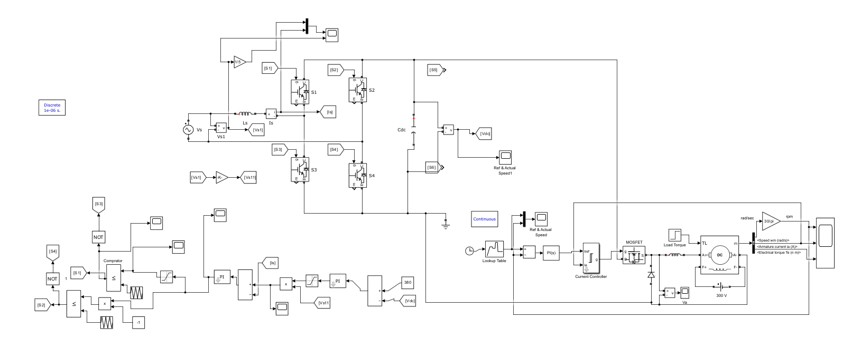

**DC motor control ( closed loop ) model**

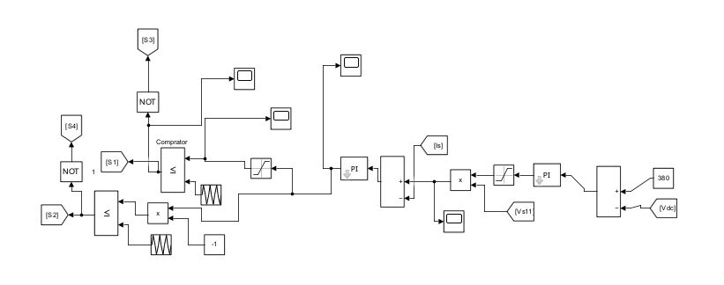

**Control Circuit**

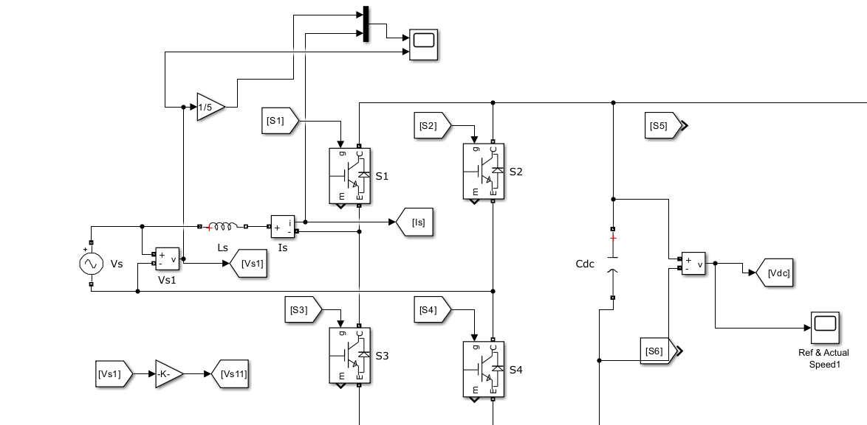

**Full Bridge Rectifier**

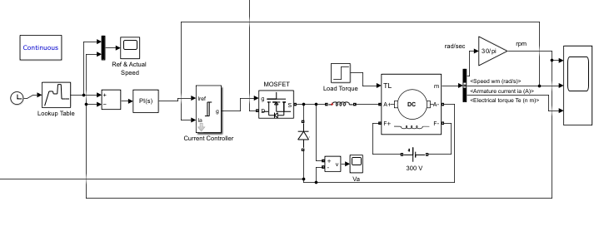

**DC Machine Control Circuit**

**Block Used :**

**1. Gain :** The gain component refers to a scaling factor applied to a signal or system. It multiplies the input by a constant value, amplifying or attenuating it. This is often used in control systems to adjust the response of a system, making it more sensitive or less sensitive to input changes.

**2. From :** The From componentReceives signals from the Goto block with the specified tag. If the tag is defined as 'scoped' in the Goto block, then a Goto Tag Visibility block must be used to define the visibility of the tag. After 'Update Diagram', the block icon displays the selected tag name (local tags are enclosed in brackets, [], and scoped tag names are enclosed in braces, {}).

**3. Mux :** The mux component is a digital circuit component used to select one of several input signals and route it to the output. It functions like a data switch, allowing you to choose the desired input data for processing. This is commonly used in digital signal processing and communications systems to manage multiple data sources efficiently.

**4. Voltage Measurement** : The voltage measurement component involves using various components such as analog-to-digital converters (ADCs), voltage dividers, and sensors to acquire and process voltage data. MATLAB provides tools and functions for data acquisition, signal conditioning, and analysis, making it a versatile platform for voltage measurement and analysis in a wide range of applications.

**5. Goto :** The goto component Send signals to From blocks that have the specified tag. If tag visibility is 'scoped', then a Goto Tag Visibility block must be used to define the visibility of the tag. The block icon displays the selected tag name (local tags are enclosed in brackets, [], and scoped tag names are enclosed in braces, {}).

**6. CDC :** In MATLAB, the cdc component Implements a series branch of RLC elements.

Use the 'Branch type' parameter to add or remove elements from the branch.

**7. Lookup :** The lookup component Perform the 1-D linear interpolation of input values using the specified table. Extrapolation is performed outside the table boundaries.

**8. Clock :** The clock component Output the current simulation time.

**9. Add :** The Add or subtract inputs Specifies one of the following:

1. character vector containing + or - for each input port, | for spacer between ports (e.g. ++|-

|++)

1. scalar, >= 1, specifies the number of input ports to be summed.

When there is only one input port, add or subtract elements over all dimensions or one

specified dimension.

1. **PID Controller** : This COMPONENT implements continuous- and discrete-time PID control algorithms and includes advanced features such as anti-windup, external reset, and signal tracking. You can tune the PID gains automatically using the 'Tune...' button (requires Simulink Control Design).

**11. Current Controller :** A current controller is a crucial component of a control system for electric motors. It regulates the motor current to achieve desired performance. It typically employs Proportional-Integral (PI) or Proportional-Integral-Derivative (PID) control algorithms to maintain precise current levels, ensuring motor stability and responsiveness in applications such as robotics and industrial automation.

**12. Mosfet :** The MOSFET component and internal diode in parallel with a series RC snubber circuit. When a gate signal is applied the MOSFET conducts and acts as a resistance (Ron) in both directions. If the gate signal falls to zero when current is negative, current is transferred to the antiparallel diode.

**13. Load Torque :** The load torque component represents the opposing mechanical force exerted on a rotating system, such as a motor. It's typically modeled as a function of time and angular velocity, affecting the system's dynamics and performance in various engineering simulations and control applications.

**14. Diode :** The diode component Implements a diode in parallel with a series RC snubber circuit. In on-state the Diode model has an internal resistance (Ron) and inductance (Lon).For most applications the internal inductance should be set to zero.

The Diode impedance is infinite in off-state mode.

1. **DC Machine :** The dc machine component Implements a (wound-field or permanent magnet) DC machine. For the wound-field DC machine, access is provided to the field connections so that the machine can be used as a separately excited, shunt-connected or a series-connected DC machine.
2. **Bus Selector :** Bus Selector is a block used to extract specific elements or signals from a bus signal. It allows you to access individual components of a bus, like variables or sub-signals, and use them in your model. This simplifies complex models by providing a convenient way to work with structured data, such as buses, and select only the information needed for a particular part of the simulation.
3. **Scope :** A "scope" typically refers to a visualization tool used for observing and analyzing signals, data, or simulation results in real-time or post-simulation. It provides graphical representations, such as waveforms and plots, to help users understand and evaluate the behavior of signals and systems, making it a valuable tool for debugging, analysis, and visualization of data during various engineering and scientific tasks.
4. **Logical Operator :** Logical operators are used to perform logical comparisons on values or expressions, resulting in a logical (Boolean) outcome, either true or false. Common logical operators include "&&" (logical AND), "||" (logical OR), and "not" (logical NOT). These operators are essential for making decisions in conditional statements, controlling program flow, and filtering data based on specific criteria in MATLAB code. Logical operators help determine the truth or falsity of conditions, enabling the creation of logical expressions and conditional logic in programming.
5. **Comprator :** A comparator is a logical operator or function used to compare two values or expressions. It returns a logical (boolean) result, either true (1) or false (0), indicating whether the comparison is true or false. Common comparators include "greater than" (>), "less than" (<), "equal to" (==), and others, and they are often used in conditional statements to make decisions based on the outcome of these comparisons.
6. **Repeating Sequence :** A repeating sequence refers to a data pattern that recurs periodically in a sequence. This can be achieved using functions like "repmat" or "circshift" to replicate a vector or signal multiple times. Repeating sequences are useful for simulating periodic phenomena, generating test data, or applying periodic modulation to signals in various engineering and scientific applications.
7. **Product :** The "product" typically refers to the result obtained from mathematical operations or functions applied to data. It can be the outcome of basic arithmetic operations, the result of matrix multiplications, or the solution to complex numerical problems. MATLAB is a versatile platform that allows users to manipulate and analyze data, making it useful for a wide range of scientific, engineering, and data analysis tasks where products of calculations are often essential.
8. **Constant :** A constant component refers to a fixed or unchanging value that remains constant throughout the execution of a program or script. These values are typically defined as variables with assigned fixed values and are not modified during the program's execution. Constants are often used to store parameters, settings, or values that should remain unchanged, making the code more readable and adaptable**.**
9. **Saturation :** It refers to a situation where the output of a signal or system is limited or "clipped" to a specific range, preventing values from exceeding predefined upper and lower bounds. This is commonly used to model physical limitations in real-world systems, ensuring that signals or variables do not go beyond certain limits, which is essential for accurate simulations and control design.
10. **PI Controller :** A Proportional-Integral (PI) controller is a widely used feedback control algorithm implemented in MATLAB. It combines proportional and integral control actions to regulate a system's output. The proportional component responds to the current error, while the integral component considers the accumulated past errors to eliminate steady-state errors. PI controllers are effective in achieving stable and accurate control in various applications, such as temperature regulation or motor speed control, by adjusting control signals based on the error between the desired setpoint and the actual system output.

**Result :**

In this project, we developed a comprehensive model that integrated a full-bridge rectifier, a control system, and a DC machine. The full-bridge rectifier efficiently converted AC input to DC, providing a stable DC voltage source for the control system. The control system, employing a closed-loop control strategy like PID, effectively regulated the DC motor's speed or position, ensuring precise and reliable operation. The combination of these components demonstrated a successful implementation of a closed-loop control system for DC motor control, emphasizing the importance of proper power conversion and control in industrial applications.

This project showcased the seamless integration of electrical components, control systems, and mechanical systems in the context of a DC motor control application. It underscored the significance of reliable power conversion through the full-bridge rectifier and the efficacy of feedback control in achieving desired motor performance. By combining these elements, we demonstrated a practical and efficient solution for real-world applications that depend on precise DC motor control, highlighting the importance of interdisciplinary engineering solutions in modern technology.

**Graph Output :**

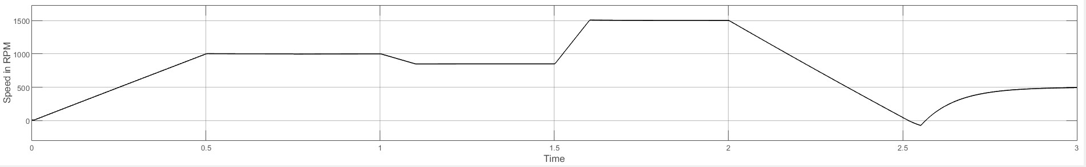

**Graph of Speed Control**

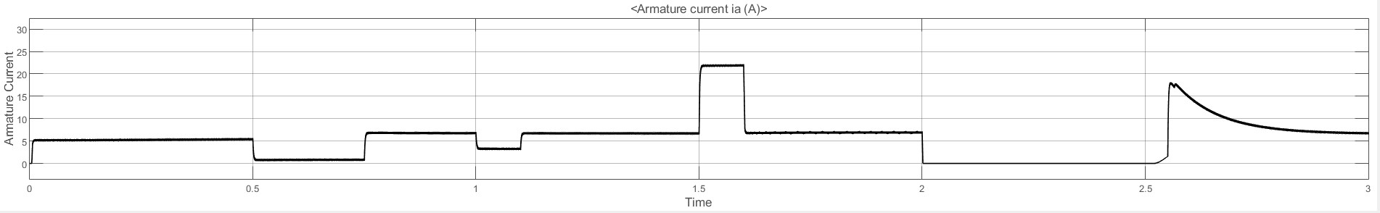

**Armature Current**

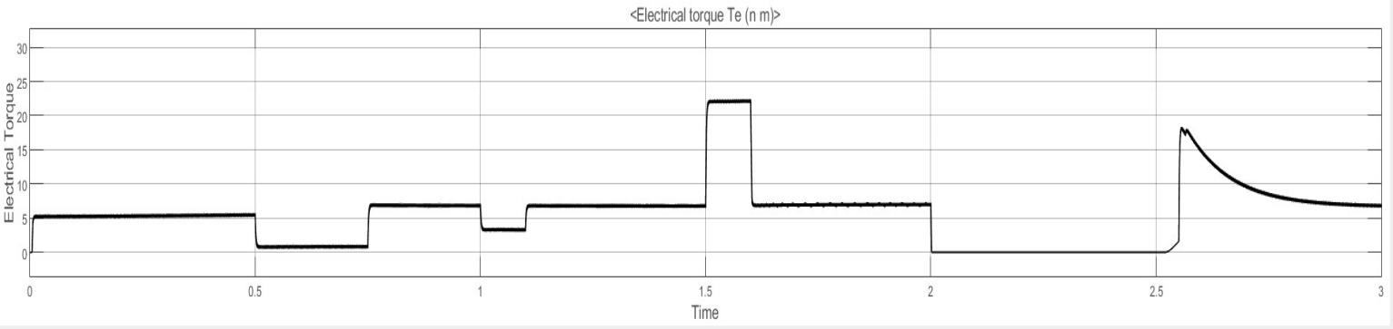

**Electrical Torque**

**BiblioGraphy :**

* *"Control Systems Engineering" by Norman S. Nise.*
* *"Feedback Control of Dynamic Systems" by G.F. Franklin, J.D. Powell, and A. Emami-Naeini.*
* *"Electric Drives" by Ion Boldea and Syed A. Nasar.*
* *"Electric Motor Drives: Modeling, Analysis, and Control" by R. Krishnan.*
* *"Feedback Systems: An Introduction for Scientists and Engineers" by Karl J. Astrom and Richard M. Murray.*
* *Research papers on PID control and other control algorithms for DC motor control.*
* *"Power Electronics: Converters, Applications, and Design" by Ned Mohan, Tore M. Undeland, and William P. Robbins.*
* *"Power Electronics and Motor Drives" by Bogdan M. Wilamowski and J. David Irwin.*
* *"MATLAB for Engineers" by Holly Moore.*
* *Online resources and tutorials related to Simulink and MATLAB for control system simulation.*