PUNJAB ENGINEERING COLLEGE, CHANDIGARH



Electronics and Communication Engineering Department

PEC, Chandigarh

Project report for

Ardunio Bases Obstacle Avoiding Robot Car

Submitted By:

Rahul Tikoo (19105052)

Akhil Bhatia (19105042)

Acknowledgement

Acknowledgement We would like to thank Mr. Sukhwinder Singh , (Professor Electronics and Communication Department) who guided and helped us throughout the project. It was because of Arun Sir that we made this project successfully. We would also like to thank Punjab Engineering College (PEC) for giving us the opportunity to work on this project.

We sincerely would like to thank all the people that believed in us and made possible this period of professional and personal growth. First of all, our parents who supported us during difficulties. Even if they do not have a clear idea of what we are actually doing, they were always excited to share with us satisfactions and great results.

We would also want to thank Punjab Engineering College, and in particular, the Electronics and Communication Department, that offers an extremely high level of teaching and that brings willing people to a successful carrier.

We would also like to thank all the group members who did all the work through day and night to successfully complete the project even in the covid times. We hope that this wonderful friendship, in and outside the lab, will last forever.

Lastly, we want to thank everyone that appreciated or criticized our work. The process of research needs your support to go ahead and to get always new incitement.

**Abstract**

In today’s world ROBOTICS is a fast growing and interesting field. ROBOT has sufficient intelligence to cover the maximum area of provided space.

Obstacle avoidance is one of the most important aspects of mobile robotics. Without it, robot movement would be very restrictive and fragile. This project proposes robotic vehicle that has an intelligence built in it such that directs itself whenever an obstacle comes in its path. So, to protect the robot from any physical damages. We can design an obstacle avoidance robotic vehicle using ultrasonic sensors for its movement. A micro-controller (AT mega 328P) L used to achieve the desired operation. An ultrasonic sensor L used to detect any obstacle ahead of it and sends a command to the micro - controller.

Depending on the signal receive micro-controller redirects the robot to move in an alternate direction by actuating the motors which are interfaced to it through a motor driver.

**Chapter 1.**

**INTRODUCTION**

Robotics is part of Todays communication. In today’s world ROBOTICS is fast growing and interesting field. It is simplest way for latest technology modification. Now a day’s communication is part of advancement of technology, so I decided to work on ROBOTICS field, and design something which will make human life simpler in today aspect.

An autonomous robot is a robot that is capable of moving on its own in an unknown and unstructured environment. An autonomous robot is equipped with software intelligence to sense its environment, detect obstacles in its path and move around an unknown environment overcoming the obstacles. There are many robotic designs that are employed in designing of autonomous robots. These designs are usually developed considering the physical environment in which the robot has to be deployed. There are autonomous robots like snake robots, walking robots, autonomous drones and autonomous robotic cars or rovers.

This ROBOT has sufficient intelligence to cover the maximum area of provided space. It has an infrared sensor which are used to sense the obstacles coming in between the path of ROBOT.

It will move in a particular direction and avoid the obstacle which is coming in its path. The main motto of designing such type of Robot or the technology is that this technology can be used in today’s very fast transportation to avoid the accident generally happen in congested by applying emergency break. If we use this technology in the car or any vehicle, it will automatically sense the obstacles then it will take a side to the available free space.

An obstacle may be a living things or any object. Autonomous Intelligent Robots are robots that can perform desired tasks in unstructured environments without continuous human guidance. Thus, by using this technology in vehicles we make the drive safe.

**The Main Objectives**

The main objectives of the project are comprehended as follows:

* The obstacle avoidance robot is able to move around in an unknown environment without colliding with surrounding objects.
* The robot would have the capacity to detect obstacles in its path based on a predetermined threshold distance.
* After obstacle detection, the robot would change its course to a relatively open path by making autonomous decision.
* It would require no external control during its operation.
* It can measure the distance between itself and the surrounding objects in real-time.
* It would be able to operate effectively in unknown environment.
* Obstacle avoiding robots can be used in almost all mobile robot navigation systems
* They can be used for household work like automatic vacuum cleaning.
* They can also be used in dangerous environments, where human penetration could be fatal.

**Chapter 2.**

**Block Diagram**

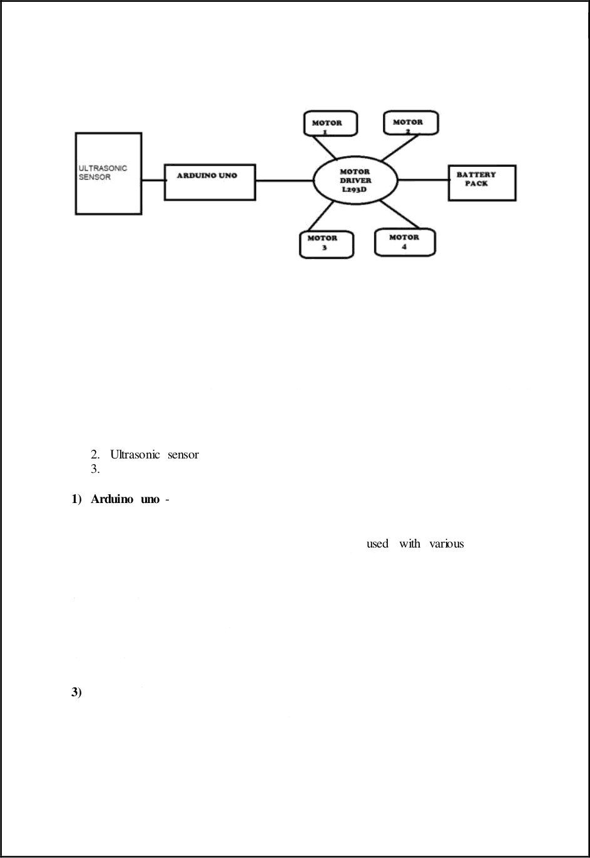

**HARDWARE USED**

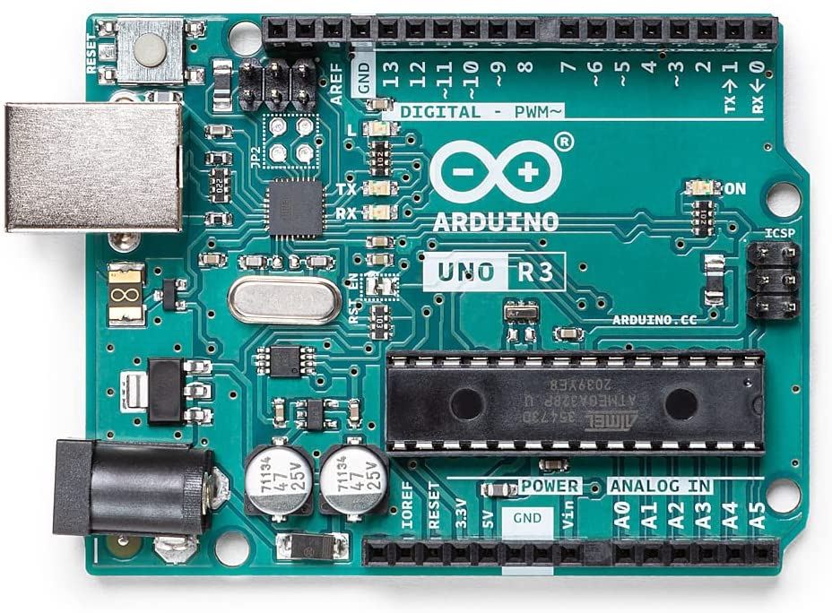

1. **Arduino Uno**

Arduino is a popular programmable board used to create projects. It consists of a simple hardware platform as well as a free source code editor which has a “one click compiles or upload” feature. Hence it is designed in way that one can use it without necessarily being an expert programmer (Kushner 1987). Arduino offers an open-source electronic prototyping platform that is easy to use and flexible for both the software and hardware. Arduino is able to sense the environment through receiving input from several sensors.

It is also able to control its surrounding through controlling motors, lights and other actuators. The Arduino programming language that is based on the wiring and the Arduino development environment that is based on the processing are used to program the microcontroller found on the board (Banzi, 2005). Due to its open-source environment, one is able to easily write and upload codes to the I/O board. It is also worth to note that Arduino can be run on Linux, Mac OSX and Windows as its environment is written in Java

**Arduino Uno Pin Out Configuration are-:**

|  |  |  |
| --- | --- | --- |
| **Pin Category** | **Pin Name** | **Details** |
| Power | Vin, 3.3V, 5V, GND | Vin: Input voltage to Arduino when using an external power source.  5V: Regulated power supply used to power microcontroller and other components on the board.  3.3V: 3.3V supply generated by on-board voltage regulator. Maximum current draw is 50mA.  GND: ground pins. |
| Reset | Reset | Resets the microcontroller. |
| Analog Pins | A0 – A5 | Used to provide analog input in the range of 0-5V |
| Input/Output Pins | Digital Pins 0 - 13 | Can be used as input or output pins. |
| Serial | 0(Rx), 1(Tx) | Used to receive and transmit TTL serial data. |
| External Interrupts | 2, 3 | To trigger an interrupt. |
| PWM | 3, 5, 6, 9, 11 | Provides 8-bit PWM output. |
| SPI | 10 (SS), 11 (MOSI), 12 (MISO) and 13 (SCK) | Used for SPI communication. |
| Inbuilt LED | 13 | To turn on the inbuilt LED. |
| TWI | A4 (SDA), A5 (SCA) | Used for TWI communication. |
| AREF | AREF | To provide reference voltage for input voltage. |

**2.Servo Motor**

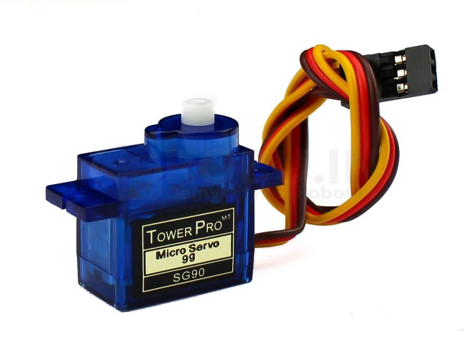

A servo motor is an electromechanical device that produces torque and velocity based on the supplied current and voltage. A servo motor works as part of a closed loop system providing torque and velocity as commanded from a servo controller utilizing a feedback device to close the loop. The feedback device supplies information such as current, velocity, or position to the servo controller, which adjusts the motor action depending on the commanded parameters.

A servomotor is a linear actuator or rotary actuator that allows for precise control of linear or angular position, acceleration, and velocity. It consists of a motor coupled to a sensor for position feedback. It also requires a relatively sophisticated controller, often a dedicated module designed specifically for use with servomotors.

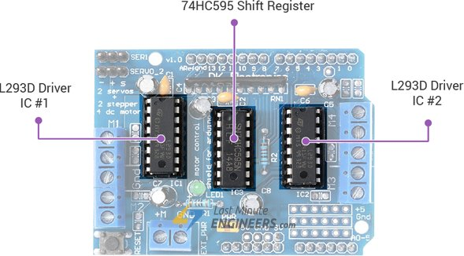

**3. L293D Motor Driving Shield IC**

L293D shield is a driver board based on L293 IC, which can drive 4 DC motors , 2 stepper motors , 2 Servo motors at the same time. Each channel of this module has the maximum current of 1.2A and doesn’t work if the voltage is more than 25v or less than 4.5v. So be careful with choosing the proper motor according to its nominal voltage and current. The L293D is a dual-channel H-Bridge motor driver capable of driving a pair of DC motors or single stepper motor. As the shield comes with two L293D motor driver chipsets, that means it can individually drive up to four DC motors making it ideal for building four-wheel robot platforms. The shield offers total **4 H-Bridges** and each H-bridge can deliver up to 0.6A to the motor. The shield also comes with a 74HC595 shift register that extends 4 digital pins of the Arduino to the 8 direction control pins of two L293D chips.

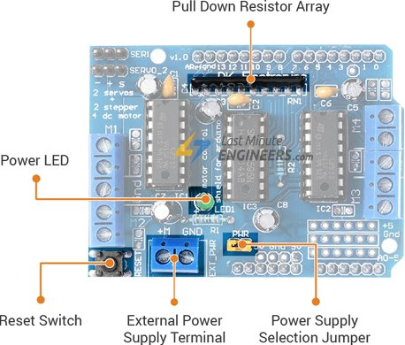

There exists three scenarios when it comes to supplying power for the motors through shield.

* **Single DC power supply for both Arduino and motors:-** If you would like to have a single DC power supply for both Arduino and motors, simply plug it into the DC jack on the Arduino or the 2-pin EXT_PWR block on the shield. Place the power jumper on the motor shield. You can employ this method only when motor supply voltage is less than 12V.
* **Arduino powered through USB and motors through a DC power supply:-** If you would like to have the Arduino powered off of USB and the motors powered off of a DC power supply, plug in the USB cable. Then connect the motor supply to the EXT_PWR block on the shield. Do not place the jumper on the shield.
* **Two separate DC power supplies for the Arduino and motors :-** If you would like to have 2 separate DC power supplies for the Arduino and motors. Plug in the supply for the Arduino into the DC jack, and connect the motor supply to the EXT_PWR block. Make sure the jumper is removed from the motor shield.

The output channels of both the L293D chips are broken out to the edge of the shield with two 5-pin screw terminals viz. **M1**, **M2**, **M3** & **M4**. We can connect four DC motors having voltages between 4.5 to 25V to these terminals. Each channel on the module can deliver up to 600mA to the DC motor. However, the amount of current supplied to the motor depends on system’s power supply. We can also connect two stepper motors to output terminals. One stepper motor to motor port **M1-M2** and other to **M3-M4**. In order to communicate with the shield, we need to install **AFMotor.h** library so that we can issue simple commands to control DC, stepper & servo motors.

**4.Ultrasonic sensor module**

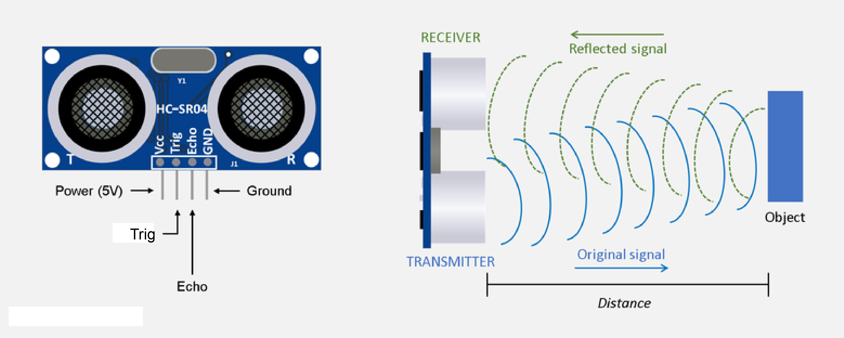

Why Ultrasonic Over Infrared Sensor

Infrared sensors work on the principle of reflected light waves while [Ultrasonic sensors](https://www.maxbotix.com/) work on the principle of reflected sound waves and are used to measure distance. There are a lot of limitations in infrared sensors, like the inability to use them in sunlight due to interference. It can make outdoor applications or dark indoor applications difficult. Ultrasonic sensors work using sound waves, detecting obstacles is not affected by as many factors.

**What is an ultrasonic sensor**

An ultrasonic sensor is an instrument that measures the distance to an object using ultrasonic sound waves. An ultrasonic sensor uses a transducer to send and receive ultrasonic pulses that relay back information about an object’s proximity. High-frequency sound waves reflect from boundaries to produce distinct echo patterns.

**How Ultrasonic Sensors Work.**

Ultrasonic sensors work by sending out a sound wave at a frequency above the range of human hearing.  The transducer of the sensor acts as a microphone to receive and send the ultrasonic sound. Our [ultrasonic sensors](https://www.maxbotix.com/SelectionGuide/Selection-Guide.htm), like many others, use a single transducer to send a pulse and to receive the echo.  The sensor determines the distance to a target by measuring time lapses between the sending and receiving of the ultrasonic pulse. The working principle of this module is simple.  It sends an ultrasonic pulse out at 40kHz which travels through the air and if there is an obstacle or object, it will bounce back to the sensor.  By calculating the travel time and the speed of sound, the distance can be calculated.

Ultrasonic sensors are a great solution for the detection of clear objects.  For liquid level measurement, applications that use infrared sensors, for instance, struggle with this particular use case because of target translucence.

For presence detection, ultrasonic sensors detect objects regardless of the color, surface, or material (unless the material is very soft like wool, as it would absorb sound.) To detect transparent and other items where optical technologies may fail, ultrasonic sensors are a reliable choice.

**5.Geared DC motors & Wheels**

A geared motor is a component whose mechanism adjusts the speed of the motor, leading them to operate at a certain speed. geared motor have the ability to deliver high torque at low speeds, as the gearhead functions as a torque multiplier and can allow small motors to generate higher speeds.

A geared motor can also be defined as a gear reducer because essentially, it is a combination of a speed reducer with a motor typically functioning as a gearbox, to reduce speed making more torque available. Geared motor can be classified based on the motor they are paired with, including bevel, helical, hypoid, spur and worm gears.

Each of these gears have advantages and disadvantages. For example, helical gears possess more torque capacity than spur gears, hence, generating less noise. Worm gears work efficiently in the low torque angel and are good for high speed reductions. Wheels are operated by the geared motors which regulate the movement of robot.

**6. 9-12V battery Pack**

A 9V block battery can’t usually produce enough current to drive the four motors. Rechargeable battery packs for RC cars tend to work best for this project.

**Chapter 3**

**Circuit Diagram**

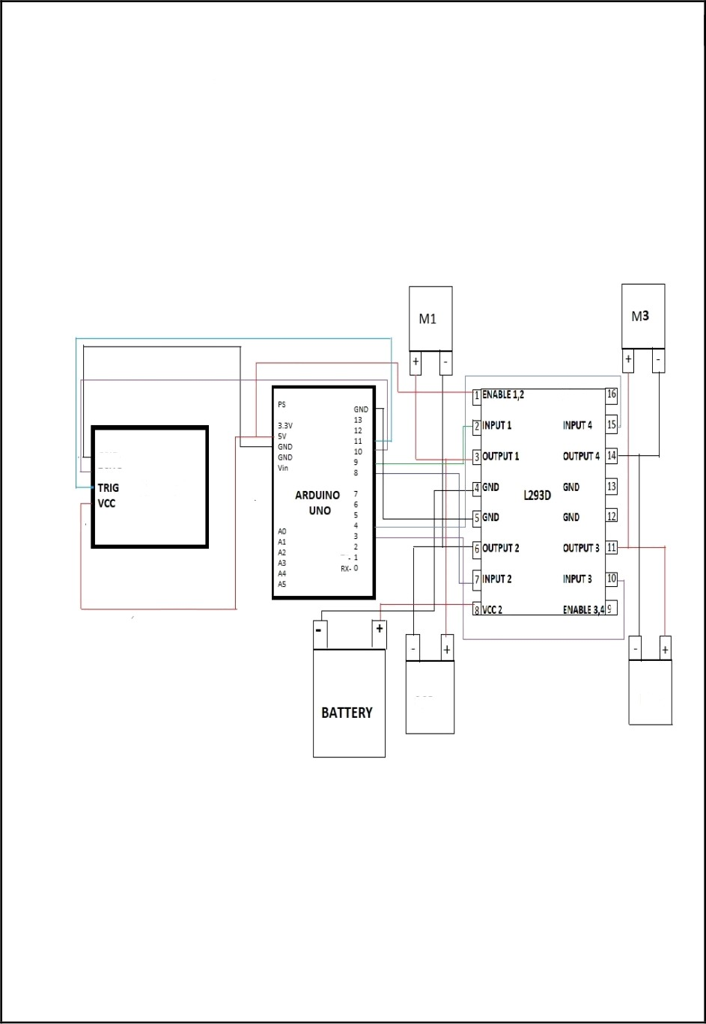

**Chapter 4**

**Applications**

* Obstacle avoiding robots can be used in almost all mobile robot navigation systems.
* They can be used for household work like automatic vacuum cleaning.
* They can also be used in dangerous environments, where human penetration could be fatal.

**Chapter 5**

**Experimental Results**

**Chapter 6**

**Conclusion**

The goal of our project is to create autonomous robot which automatically detects the obstacle in his path and navigate according to the set of instruction given through the code