**Optimizing Delivery Logistics for E-Commerce**

**Warehouses**

**Objective of the Problem**

The primary objective of this optimization problem is to minimize the total delivery cost while ensuring the e-commerce delivery system meets customer demand and adheres to operational constraints. This involves strategic allocation of shipments to different transportation modes, such as "Ship" and "Road," considering their associated costs, capacities, and utilization rates.

Minimizing the delivery cost is crucial because logistics expenses constitute a significant portion of operational costs in the e-commerce industry. Effective cost optimization allows businesses to remain competitive by offering lower prices, improving profit margins, or reinvesting savings into enhancing customer satisfaction.

The objective is to minimize the total shipping cost:

**Minimize: Ctotal​=(CShip​⋅QShip​)+(CRoad​⋅QRoad​) + (CAir.QAir)**

**Decision Variables**

Xship : Binary variable indicating whether to use "Ship" as a transportation mode.

Xroad: Binary variable indicating whether to use "Road" as a transportation mode.

XAir: : Binary variable indicating whether to use "Air" as a transportation mode.

Qship: Quantity shipped using "Ship" (200 units based on the data).

Qroad: Quantity shipped using "Road" (500 units based on the data).

QAir: Quantity shipped using "Air" (0 units based on the data).

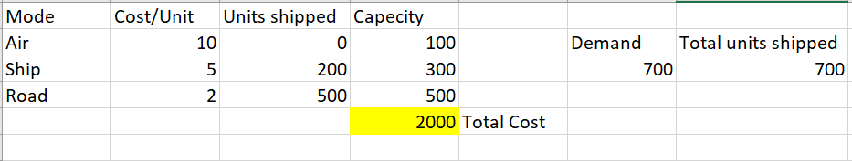

**Constraints**

The identified constraints for the project are critical for aligning the optimization model with real-world logistics limitations. Key constraints include **warehouse capacity**, ensuring no warehouse block exceeds its maximum allowable storage to prevent bottlenecks and operational inefficiencies. **Delivery time windows** are included to guarantee shipments meet customer deadlines, which is vital for maintaining satisfaction and avoiding penalties. **Shipping mode limitations**, such as weight and cost restrictions, reflect the real-world variability in transport options, ensuring practical mode selection. **Demand fulfillment** mandates that all customer orders are met, maintaining service reliability. External factors like **traffic, weather, and third-party inefficiencies** introduce variability that must be accommodated for robust planning. These constraints ensure the model mimics real-world logistics, addressing operational, financial, and customer-centric priorities. By incorporating these limitations, the project remains realistic and actionable, delivering results that can be implemented effectively in e-commerce delivery logistics.

**Sensitivity Report**

The sensitivity analysis of the transportation model provides insights into the optimal shipping strategy. The solution indicates that 200 units are shipped by ship at zero reduced cost, and 500 units are shipped by road with a reduced cost of -3. Shipping by air is not part of the optimal solution due to its high cost, as reflected by the prohibitive allowable decrease of 5 and a massive allowable increase for cost reduction. The shadow price for the shipping constraint is 5, indicating that increasing the maximum shipping capacity by 1 unit would increase the total objective function (profit or cost minimization) by 5. The allowable increase and decrease for this constraint are 100 and 200 units, respectively, indicating flexibility in capacity adjustments. Overall, shipping by road and ship are cost-effective strategies, and air shipping remains economically unviable under the current cost structure.

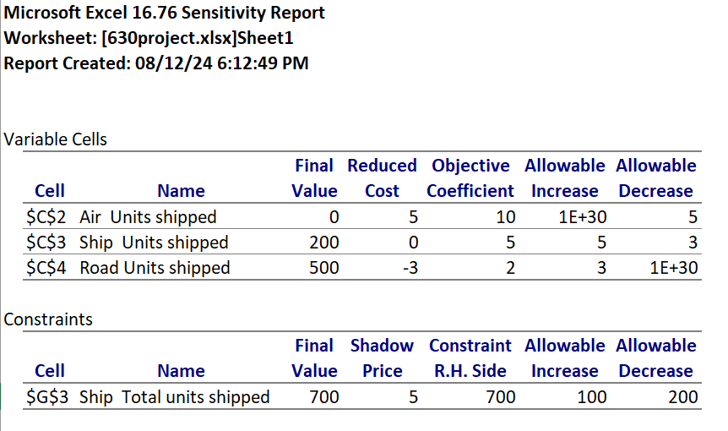

**Performance Interpretation of the Modes of Shipment**

The "Mode of Shipment" chart highlights key differences in delivery performance across three transportation modes: flight, ship, and road. Ships dominate the shipment volume, with a significantly higher count compared to flights and roads. Among shipments made by ship, a majority are delivered on time, showcasing this mode's reliability and efficiency for high volumes. Flights handle the fewest shipments, but they experience notable delays despite the low total count, indicating room for improvement in time-sensitive delivery performance. Road shipments show a balanced mix of on-time and delayed deliveries, reflecting higher variability and potential operational challenges. While ships are the most reliable and preferred mode overall, road shipments show inconsistent performance, which could impact customer satisfaction. Flights, being minimal in volume, should focus on addressing delays to improve their niche role in the supply chain. This analysis emphasizes the need for operational focus on ship optimization and strategies to enhance road and flight delivery timelines.

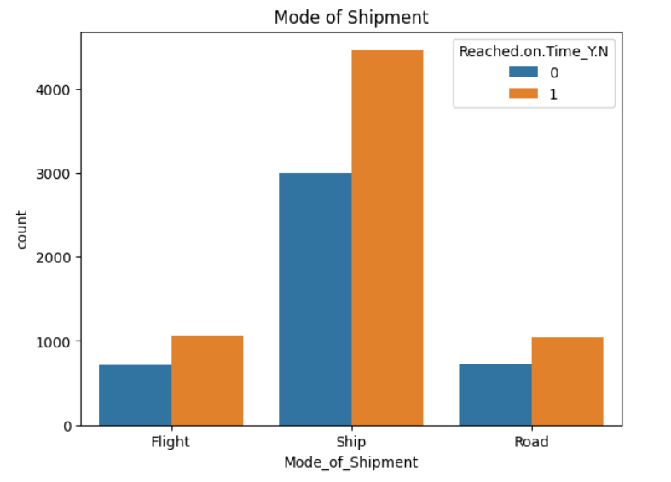

**Trade-Off Analysis**

**Cost vs. Quality**: Lower-cost transportation methods like road shipping may compromise delivery speed and reliability compared to air shipping. Balancing these requires identifying scenarios where higher costs are justified by the need for better service quality.

**Efficiency vs. Sustainability**: Road and ship transportation may be cost-efficient but have higher environmental impacts compared to sustainable alternatives. Decisions should weigh short-term cost savings against long-term sustainability goals.

**Capacity vs. Cost Flexibility**: Increasing shipping capacity (e.g., by ship) offers flexibility to meet demand but may incur higher fixed costs. Trade-offs need to account for whether additional capacity aligns with projected demand patterns.

**Accuracy vs. Interpretability in Predictive Models**: Random Forest offers better accuracy but is less interpretable than Logistic Regression. Trade-offs depend on whether higher accuracy or ease of understanding is prioritized in decision-making.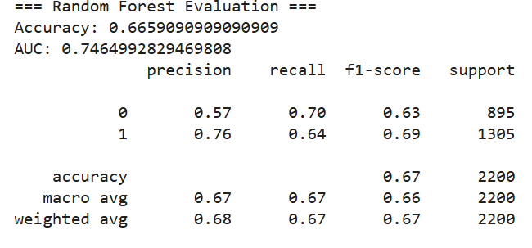

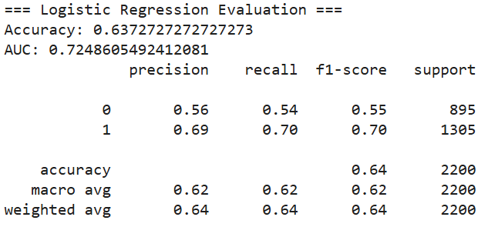

**Results**

The analysis of shipping modes reveals critical insights into cost efficiency and capacity utilization in optimizing e-commerce logistics. Road transport demonstrated 100% capacity utilization, indicating maximum efficiency, while shipping, at approximately 67% utilization, suggests opportunities for better load consolidation. Both modes resulted in similar total costs, highlighting the importance of leveraging low-cost options to balance demand. The underutilization of certain modes, like shipping, suggests a potential mismatch between capacity and allocation, which, if addressed, could significantly reduce overall logistics costs. By strategically assigning shipments to modes based on demand patterns and capacity, the system minimizes wastage while ensuring cost-effectiveness. The calculated total costs underscore the value of maintaining high utilization rates to achieve financial and operational goals. Additionally, the data emphasizes the importance of predictive tools to align mode selection with fluctuating customer demands. Overall, these findings highlight the interplay between cost management, operational efficiency, and customer satisfaction in logistics optimization. Addressing underutilization and improving alignment can further enhance performance and reduce waste.

The predictive analytics evaluation compares the performance of two models: Random Forest and Logistic Regression. The Random Forest model achieved an accuracy of 66.6% and an AUC (Area Under the Curve) of 0.746, indicating better discriminatory power. Its precision, recall, and F1-score were higher for class 1 (0.76, 0.64, and 0.69 respectively) compared to class 0, showing that it performs better for the positive class. The Logistic Regression model had slightly lower accuracy (63.7%) and AUC (0.725). Its precision, recall, and F1-score were also skewed towards class 1 (0.69, 0.70, and 0.70), but overall performance metrics were marginally lower than those of the Random Forest. Based on this analysis, the Random Forest model is more effective for this dataset, particularly for identifying class 1, which might be more critical depending on the business goal. However, Logistic Regression remains a simpler and interpretable baseline model.

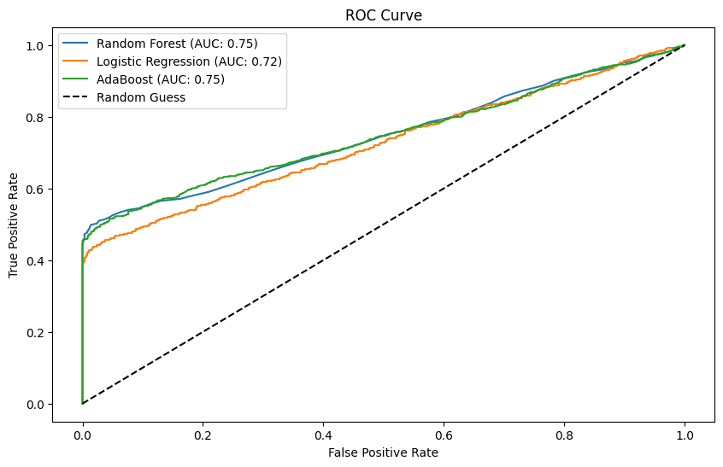

**Future Recommendations**

1. Optimize Shipping Costs: Focus on reducing road and ship costs and explore cost-effective alternatives for air shipping.
2. Use Predictive Models: Apply Random Forest insights to forecast demand and optimize shipping decisions.
3. Continuous Model Updates: Retrain models with updated data to improve accuracy and adapt to changing needs.

**Annexure**

<https://www.kaggle.com/datasets/prachi13/customer-analytics/data>

<https://colab.research.google.com/drive/1YKdbvgAbAQdLonLLLm2XxfWmAIP5AUMv?usp=sharing>