Customer Retention Intelligence: Machine-Learning-Based Churn Prediction, Risk Segmentation and Retention Recommendation
Rahul V  20241CSE1033  Computer Science and Engineering | Vivek GujaGonda  20241CSE1034  Computer Science and Engineering |  | Sudeep S Biradar  20241CSE1093  Computer Science and Engineering
Nagaraj M Gudda  20241CSE0149  Computer Science and Engineering |  | Nagaraj N Naik  20251LCS3009  Computer Science and Engineering

Abstract— Customer churn, the loss of subscribers to competitors, is a costly problem for subscription-based businesses because retaining an existing customer is generally cheaper than acquiring a new one. This work presents Customer Retention Intelligence, an end-to-end machine learning framework that predicts the probability that a customer will churn, assigns the customer a Low, Medium or High risk level, and recommends a personalised retention action. Customer attributes covering demographics, service subscriptions, contract type, billing and tenure are preprocessed using imputation, scaling and one-hot encoding, and three classifiers, Logistic Regression, Decision Tree and Random Forest, are compared using 5-fold stratified cross-validation on a 100-record customer sample. The models are evaluated using accuracy, precision, recall, F1-score and ROC-AUC. Random Forest obtained the best F1-score (61.5%) and recall (74.1%), and Logistic Regression obtained a comparable ROC-AUC of 0.79 with 74% accuracy. The Logistic Regression risk segments were well ordered: 6.1%, 30.0% and 58.1% of customers in the Low, Medium and High segments actually churned. Contract type, internet service type, tenure and monthly charges were the most influential factors. The framework is also deployed as an interactive Streamlit dashboard. Because the sample is small, the results are indicative rather than conclusive.
Keywords— Customer Churn; Retention Recommendation; Logistic Regression; Random Forest; Risk Segmentation; Cross-Validation.
I. Introduction
Customer churn is the event in which a customer stops using the products or services of a company. In subscription-driven sectors such as telecommunication, streaming and banking, churn directly reduces recurring revenue, and acquiring a new customer is typically far more expensive than keeping an existing one [1]. Companies therefore try to identify customers who are likely to leave early enough to intervene with a suitable offer.
Traditionally, retention teams have relied on manual rules or on the judgement of account managers, which does not scale and cannot capture interactions between many customer attributes. Machine learning offers a data-driven alternative: a classifier trained on historical customer records learns which combinations of tenure, contract, services and charges are associated with leaving, and outputs a churn probability for each customer [2], [3].
A probability alone is not enough for a retention team. Managers need to know which customers to contact first and what to offer them. Many studies stop at classification accuracy and do not connect the prediction to an action. Furthermore, churn datasets are imbalanced, since far fewer customers leave than stay, so plain accuracy can be misleading and recall and F1-score must be examined as well [5].
The major contributions of the proposed work are: (i) a preprocessing and modelling pipeline that compares Logistic Regression, Decision Tree and Random Forest using 5-fold stratified cross-validation; (ii) a risk segmentation scheme that converts out-of-fold churn probabilities into Low, Medium and High risk levels; (iii) a transparent rule-based engine that recommends retention offers from the risk level and the customer profile; and (iv) an interactive Streamlit dashboard for individual prediction and downloadable reports.
The organization of the paper is as follows: Section II presents the summary of related works on customer churn prediction and reviews existing machine learning approaches. Section III describes the proposed Customer Retention Intelligence framework, including data preparation, preprocessing, classification models, risk segmentation, and the recommendation mechanism. It also explains the implementation of the interactive Streamlit dashboard. Section IV presents the experimental analysis, including dataset characteristics, evaluation metrics, model performance comparison, risk segmentation results, and influential customer attributes. Section V discusses the conclusion and summarizes the major findings of the proposed framework. Finally, Section VI highlights the future scope and potential improvements that can enhance the accuracy, scalability, and practical application of the system.
II. Related Works
Churn prediction has been studied extensively. Verbeke et al. [2] applied advanced rule-induction techniques to build comprehensible churn models, showing that interpretable rules can be competitive with black-box classifiers. Vafeiadis et al. [3] compared neural networks, support vector machines, decision trees, naive Bayes and logistic regression on telecommunication data and found that boosting improved the performance of the base classifiers. Coussement and Van den Poel [4] used support vector machines for churn prediction in subscription services and examined parameter-selection techniques.
Class imbalance is a recurring difficulty. Burez and Van den Poel [5] studied sampling methods and boosting for imbalanced churn data and showed that the choice of evaluation measure and of the imbalance-handling strategy affects the conclusions. Ahmad et al. [6] built a churn model for a telecom operator on a big-data platform, using extensive feature engineering and tree-based ensembles, with XGBoost giving the best performance.
TABLE I. Summary of Representative Churn Studies
Study | Approach | Main observation
Verbeke et al. [2] | Rule induction (AntMiner+, ALBA) | Comprehensible models with competitive predictive power
Vafeiadis et al. [3] | ANN, SVM, DT, NB, LR with boosting | Boosted classifiers improved on base learners
Coussement & Van den Poel [4] | SVM with two parameter-selection techniques | SVM is effective for subscription-service churn
Burez & Van den Poel [5] | Sampling and boosting for class imbalance | Imbalance handling changes model ranking
Ahmad et al. [6] | Tree ensembles with feature engineering, big-data platform | XGBoost performed best on telecom data

Most of these works focus on improving the predictive model. The present work instead combines a deliberately simple and interpretable set of models with a downstream decision layer: the probabilities are turned into risk levels and concrete retention actions, and the whole workflow is exposed through a dashboard so that a non-technical user can apply it to a new customer.
III. The Proposed Methodology
The proposed Customer Retention Intelligence framework consists of five major stages: data preparation, model training with cross-validation, risk segmentation, retention recommendation, and deployment. The overall architecture of the proposed framework is illustrated in Fig. 1. Each stage is designed to contribute towards an integrated customer churn prediction and retention management system. Initially, historical customer records are collected and preprocessed to ensure data consistency, handle missing values, and transform categorical attributes into a suitable numerical representation. The numerical features are standardized, while categorical variables are encoded using one-hot encoding to make them suitable for machine learning algorithms.
Following the preprocessing stage, three different classification algorithms, namely Logistic Regression, Decision Tree, and Random Forest, are implemented to identify potential customer churn patterns. These models are trained and evaluated using stratified 5-fold cross-validation to ensure reliable performance estimation and reduce the possibility of overfitting. Out-of-fold predictions are generated to obtain churn probabilities for individual customers without using predictions from models trained on their own records. The resulting probabilities are subsequently used to categorize customers into three distinct risk levels: Low, Medium, and High, based on predefined probability thresholds.
Furthermore, a rule-based recommendation engine is integrated into the framework to generate suitable customer retention strategies according to the predicted risk level and individual customer characteristics. These recommendations may include personalized discounts, loyalty benefits, contract upgrades, and additional service support. Finally, the complete framework is deployed through an interactive Streamlit dashboard, allowing users to enter customer information, view predicted churn probabilities, identify high-risk customers, and obtain appropriate retention recommendations. The dashboard also provides downloadable customer reports, making the proposed system a practical and accessible solution for data-driven customer retention management.
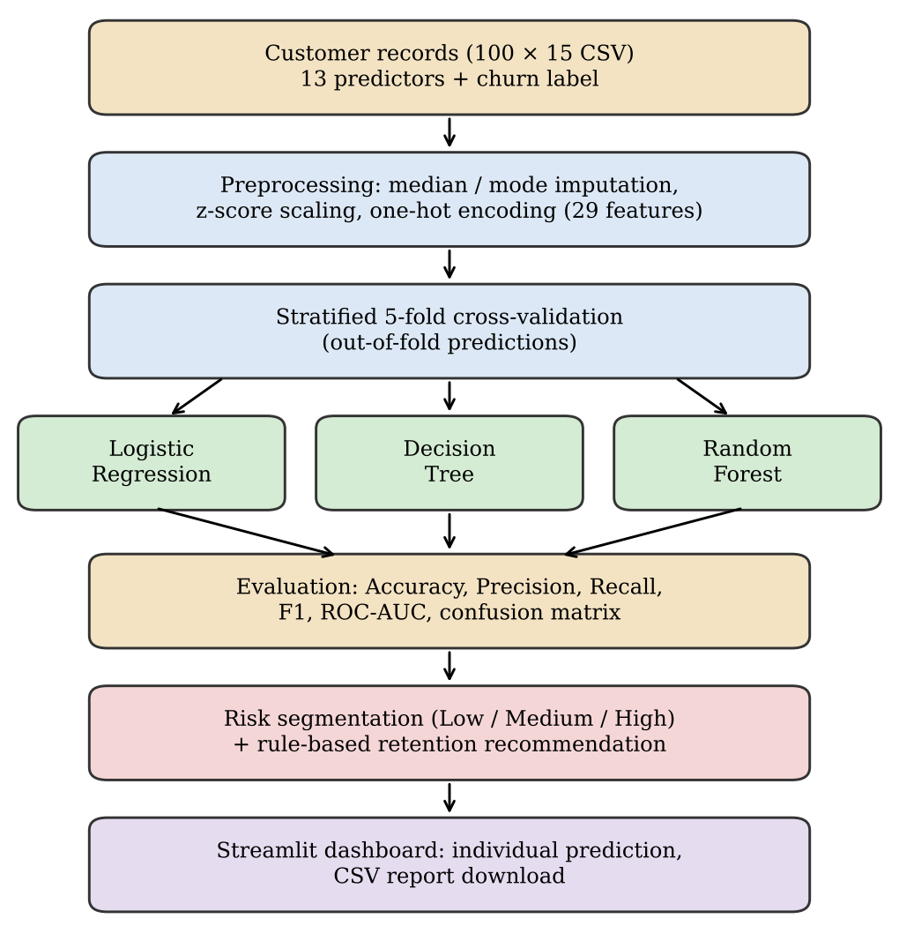
Fig. 1. Overall architecture of the Customer Retention Intelligence framework
A. Data preparation
Each record describes one customer with 13 predictor attributes and a binary label, Churn (Yes if the customer left, No otherwise). The identifier Customer_ID is not used for prediction. Numeric attributes (SeniorCitizen, tenure, MonthlyCharges, TotalCharges) are converted to numbers, missing values are filled with the median, and the values are standardised to zero mean and unit variance. Categorical attributes are filled with the most frequent value and one-hot encoded, giving 29 model inputs. The whole preprocessing step is wrapped in a pipeline together with the classifier so that every statistic is learned from the training folds only, which prevents information leakage.
Algorithm 1: Data preparation and preprocessing
Input: Customer records (CSV)
Output: Encoded feature matrix X and label vector y
- Import pandas and scikit-learn; read the CSV file.
- Convert tenure, MonthlyCharges and TotalCharges to numeric values.
- Map Churn: Yes → 1, No → 0 to obtain y.
- Drop Customer_ID and Churn to obtain X.
- Numeric columns: median imputation, then StandardScaler.
- Categorical columns: most-frequent imputation, then OneHotEncoder.
- Combine both branches using a ColumnTransformer.

B. Classification models
Three classifiers with different inductive biases are compared. Logistic Regression [7] models the churn probability of a customer with feature vector x as
P(churn | x) = 1 / (1 + exp(−(wᵀx + b))) (1)
where w and b are learned weights. Its coefficients are directly interpretable. A Decision Tree [8] with maximum depth 4 splits the customers by attribute thresholds and yields human-readable rules. A Random Forest [9] with 200 trees of maximum depth 5 averages many decorrelated trees and usually generalises better than one tree. All models use balanced class weights, which penalise errors on the minority churn class more heavily, and the implementation uses scikit-learn [10].
C. Risk segmentation and recommendation
The churn probability p of every customer is generated out-of-fold, so that no customer is scored by a model trained on that customer's own label. A customer is predicted to churn if p ≥ 0.50, and is assigned a risk level: High if p ≥ 0.60, Medium if 0.30 ≤ p < 0.60, and Low otherwise. The recommendation engine then builds a list of actions from two sources, as summarised in Table II.
TABLE II. Retention Recommendation Rules
Condition | Recommended action
Risk = High | 15% bill discount for 3 months; personal retention call within 24 hours
Risk = Medium | 10% bill discount for 2 months; plan review
Risk = Low | 5% loyalty discount; loyalty appreciation message
Contract = Month-to-month | Discount for switching to a 1-year contract
TechSupport = No | One month of free technical support
OnlineSecurity = No | One month of free online security
MonthlyCharges ≥ median | Review plan for a lower-cost package

Algorithm 2: Training, risk segmentation and recommendation
Input: X, y from Algorithm 1
Output: Metrics, risk level and offers per customer
- Define Logistic Regression, Decision Tree (depth 4) and Random Forest (200 trees, depth 5), all with class_weight = balanced.
- Wrap preprocessing and each classifier in a Pipeline.
- Create StratifiedKFold with 5 splits, shuffle = True, seed = 42.
- Obtain out-of-fold labels and probabilities with cross_val_predict.
- Compute accuracy, precision, recall, F1-score, ROC-AUC and the confusion matrix for each model.
- Assign Low / Medium / High risk from the Logistic Regression probabilities using thresholds 0.30 and 0.60.
- Apply the rules of Table II to build the retention offer.
- Save the customer-wise results as CSV.

D. Interactive dashboard
The framework is deployed as a Streamlit application. It trains Logistic Regression on the complete sample, shows the customer-wise retention report, and provides a form in which a user enters the attributes of an individual customer. The application returns the estimated churn probability, the risk level and the recommended actions, and allows both the full report and the individual prediction to be downloaded as CSV files.
IV. Experimental Analysis
A. Dataset
The experiments use a sample of 100 customer records with 15 columns, following the structure of the common telecommunication customer churn format. There are no missing values. Of the 100 customers, 27 churned and 73 stayed (27% churn rate), so the data is moderately imbalanced. Table III lists the attributes.
TABLE III. Dataset Attributes
Group | Attributes
Demographic | SeniorCitizen, Partner, Dependents
Account | tenure, Contract, PaperlessBilling, PaymentMethod
Services | InternetService, OnlineSecurity, OnlineBackup, TechSupport
Charges | MonthlyCharges, TotalCharges
Target | Churn (Yes / No)

The implementation uses Python with pandas, scikit-learn and matplotlib. Fig. 2 summarises the data. Month-to-month customers account for 25 of the 27 churners: 25 of 63 month-to-month customers (39.7%) churned, against 1 of 23 (4.3%) on one-year and 1 of 14 (7.1%) on two-year contracts. Customers with fiber optic internet churned far more often (24 of 47, 51.1%) than DSL customers (2 of 30, 6.7%). Churners had a shorter average tenure (19.2 against 32.4 months) and paid more each month (80.4 against 57.3). Only 3 of 22 customers with technical support churned (13.6%), against 23 of 55 without it (41.8%) among customers with internet service.
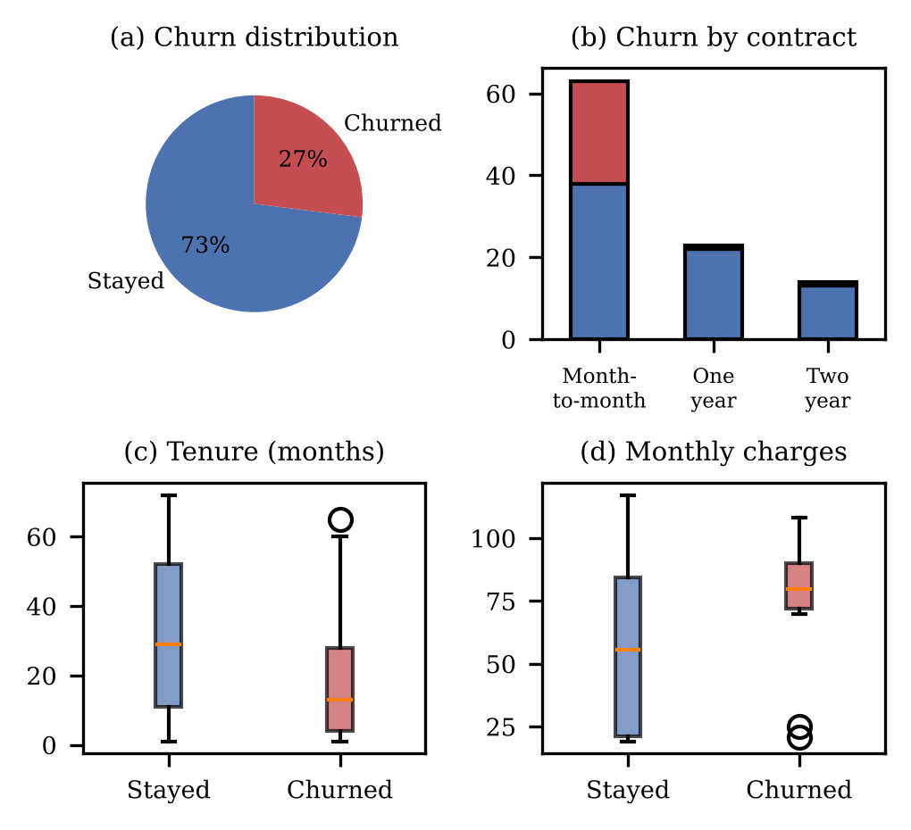
Fig. 2. Exploratory analysis of the customer sample
B. Evaluation protocol and metrics
Because 100 records are too few for a reliable single train–test split, 5-fold stratified cross-validation is used [11]. Each customer is predicted by a fold model that has not seen that customer, and metrics are computed on the pooled out-of-fold predictions. With TP, TN, FP and FN denoting the true positives, true negatives, false positives and false negatives, where churn is the positive class, the metrics are
Accuracy = (TP + TN) / (TP + TN + FP + FN) (2)
Precision = TP / (TP + FP) (3)
Recall = TP / (TP + FN) (4)
F1-score = 2 × Precision × Recall / (Precision + Recall) (5)
Recall is the fraction of churners that are detected, and precision is the fraction of churn alerts that are correct. ROC-AUC measures how well the predicted probabilities rank churners above non-churners [12].
C. Model comparison
Table IV and Fig. 3 compare the three models. Random Forest achieved the highest F1-score (61.5%) and recall (74.1%), identifying 20 of the 27 churners. Logistic Regression had accuracy of 74.0% and an F1-score of 58.1%, and its ROC-AUC of 0.792 is practically equal to that of Random Forest (0.795). The Decision Tree was the weakest model (accuracy 70.0%, AUC 0.672), which is expected for a single shallow tree on a small sample. The confusion matrices are given in Fig. 4 and the ROC curves in Fig. 5.
TABLE IV. Five-Fold Cross-Validated Performance (%)
Model | Acc. | Prec. | Rec. | F1 | AUC
Logistic Regression | 74.0 | 51.4 | 66.7 | 58.1 | 0.792
Decision Tree | 70.0 | 46.3 | 70.4 | 55.9 | 0.672
Random Forest | 75.0 | 52.6 | 74.1 | 61.5 | 0.795

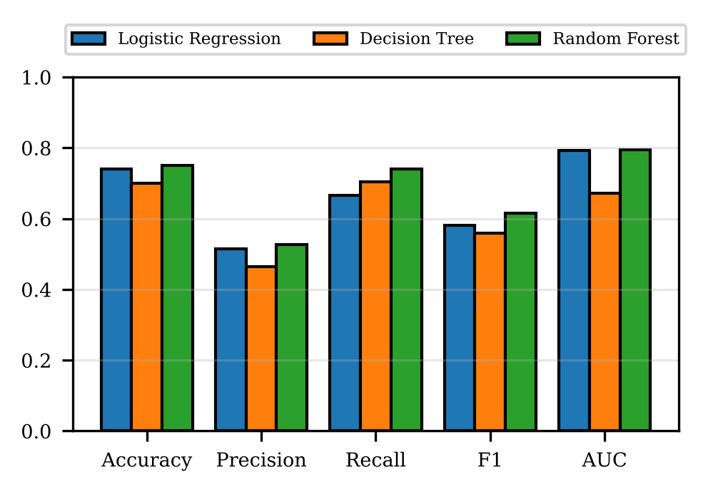
Fig. 3. Performance comparison of the models
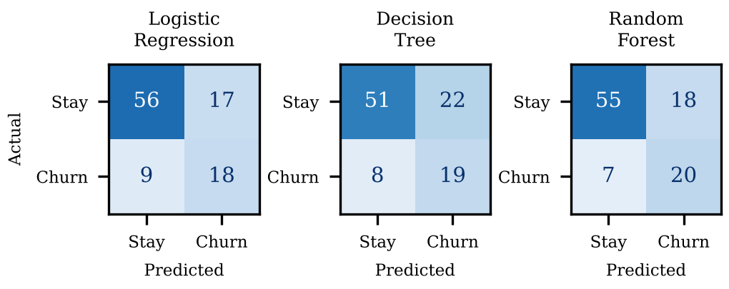
Fig. 4. Confusion matrices (out-of-fold predictions)
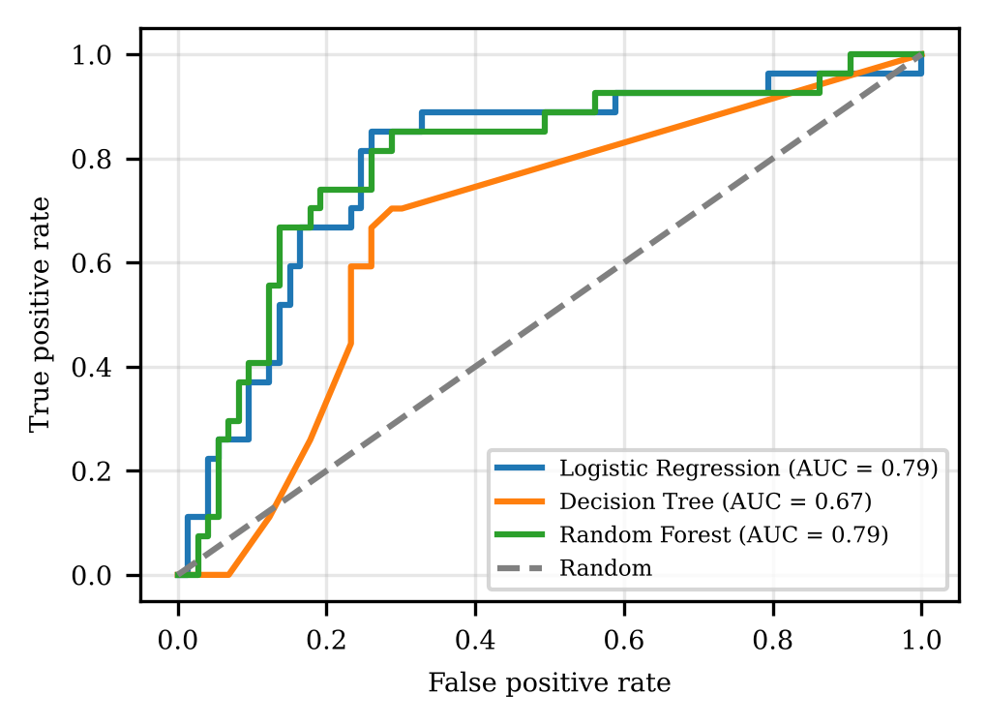
Fig. 5. ROC curves of the three models
D. Risk segmentation
The Logistic Regression probabilities were grouped into risk levels (Table V). The segments are well ordered: the observed churn rate rises from 6.1% in the Low segment to 30.0% in the Medium segment and 58.1% in the High segment. The High segment holds 31 customers and captures 18 of the 27 churners, so a retention team that contacts only the High-risk customers reaches two-thirds of the churners while approaching less than one-third of the customer base.
TABLE V. Observed Churn by Predicted Risk Level
Risk level | Customers | Churned | Churn rate
Low (p < 0.30) | 49 | 3 | 6.1%
Medium (0.30–0.60) | 20 | 6 | 30.0%
High (p ≥ 0.60) | 31 | 18 | 58.1%

E. Influential factors
Fig. 6 shows the largest Logistic Regression coefficients and the Random Forest importances, both fitted on the complete sample. Both models highlight fiber optic internet service, tenure, monthly charges and contract type. Higher tenure and a one-year contract reduce the churn probability, whereas fiber optic service and higher monthly charges increase it, which agrees with Fig. 2. The positive coefficient of the two-year contract is counter-intuitive and is an artefact of the small sample (only 14 such customers) and of correlation between the contract indicators. These coefficients and importances describe associations in the data and do not establish causes.
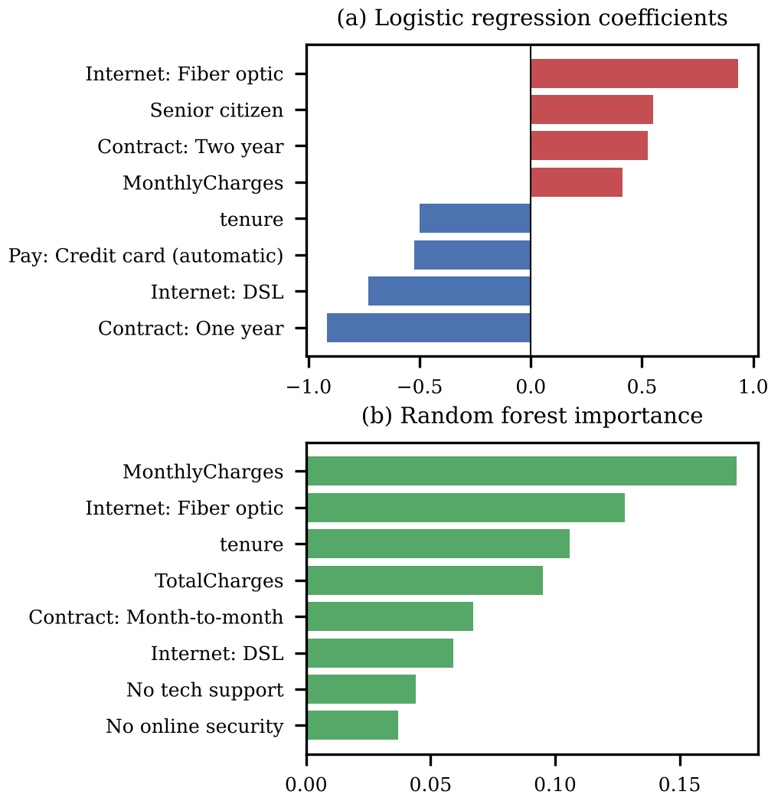
Fig. 6. Most influential factors
F. Discussion and limitations
The experimental results demonstrate that even relatively simple machine learning models can provide useful insights into customer behaviour and effectively rank customers according to their likelihood of churning. The proposed framework successfully combines churn prediction, risk segmentation, and personalized retention recommendations into a unified system. However, several limitations must be considered when interpreting the results. The dataset used in this study contains only 100 customer records, including 27 churners and 73 non-churners. This relatively small sample size limits the generalizability of the findings, as even a single correctly or incorrectly classified customer can change the recall value by approximately 3.7 percentage points. Consequently, the observed performance differences between Logistic Regression and Random Forest may be influenced by sampling variation rather than representing
V. Conclusion
This work proposed Customer Retention Intelligence, a framework that predicts customer churn, segments customers into Low, Medium and High risk, and recommends retention actions, and which is deployed as a Streamlit dashboard. In 5-fold cross-validation on a 100-customer sample, Random Forest achieved the best F1-score (61.5%) and recall (74.1%), and Logistic Regression achieved 74.0% accuracy with an ROC-AUC of 0.79. The risk levels were well ordered, with observed churn of 6.1%, 30.0% and 58.1% for the Low, Medium and High segments. Contract type, internet service type, tenure and monthly charges were the main drivers of churn. The results indicate that the framework can support a prioritised retention workflow by helping managers focus attention on customers with higher estimated churn risk rather than relying only on broad customer-level rules. The comparison also shows that model selection should consider more than overall accuracy: recall and F1-score are important when the objective is to identify customers who may leave, while ROC-AUC provides a complementary view of ranking ability. The risk segments and recommendation rules make the model outputs easier to interpret and translate into possible retention actions. Nevertheless, the recommendations are rule-based and their actual effect on customer behaviour has not been tested in a live campaign. Therefore, the framework should be treated as a decision-support prototype, with human review before offers are issued. Its usefulness and reliability will depend on validation with larger, representative business data and on measuring retention outcomes over time. In practical use, the probability score should be interpreted as a prioritisation signal rather than a guarantee that an individual customer will leave. Retention teams can combine the score with customer context, service history and the cost of a proposed offer before deciding on an intervention. Future evaluation should compare targeted campaigns with an appropriate control group and report both customer retention and the financial cost of incentives. Such testing would establish whether the recommendations create measurable value, rather than merely improving the identification of at-risk customers. These steps can help turn the present prototype into a more dependable retention-support tool.
Future work will validate the framework on a larger real-world dataset, add imbalance handling such as SMOTE [13] and gradient-boosted models such as XGBoost [14], tune the risk thresholds against the cost of an offer, and measure the effect of the recommended actions through controlled retention campaigns.
VI. Future Scope
The proposed Customer Retention Intelligence framework provides a foundation for developing more advanced and reliable customer churn prediction and retention management systems. Although the current implementation successfully combines machine learning-based churn prediction, risk segmentation, and personalized retention recommendations, several improvements can be introduced in future work to enhance its accuracy, scalability, and practical applicability.
First, the framework can be evaluated using larger and more diverse real-world customer datasets collected from different organizations, industries, and geographical regions. The current study uses a sample of only 100 customer records, including 27 churners and 73 non-churners. Therefore, testing the proposed approach on larger datasets would provide a better understanding of its generalization capability and reliability. Data collected over longer periods could also help identify changes in customer behaviour and churn patterns over time.
Second, future implementations can incorporate additional customer-related attributes to improve prediction quality. Apart from demographic information, contract details, internet services, tenure, and monthly charges, features such as customer complaints, service usage frequency, payment delays, subscription changes, customer support interactions, service interruptions, and previous retention offers could provide valuable information. These additional features may help identify early warning signs of customer dissatisfaction and improve the identification of customers who are likely to discontinue a service.
Third, the existing framework can be enhanced by implementing more advanced machine learning algorithms. Models such as XGBoost, LightGBM, Gradient Boosting, and other ensemble learning techniques can be evaluated alongside Logistic Regression, Decision Tree, and Random Forest. Deep learning approaches may also be explored when sufficiently large datasets are available. A systematic comparison using accuracy, precision, recall, F1-score, ROC-AUC, and computational efficiency would help determine the most suitable model for different customer churn scenarios.
Another important direction is improving model interpretability using techniques such as SHAP and LIME. These methods can explain individual churn predictions by identifying the key factors influencing customer risk, helping retention teams make more informed decisions.
References
- Reichheld, F. F., & Sasser, W. E., "Zero defections: Quality comes to services", Harvard Business Review, vol. 68, no. 5, pp. 105-111, 1990.
- Verbeke, W., Martens, D., Mues, C., & Baesens, B., "Building comprehensible customer churn prediction models with advanced rule induction techniques", Expert Systems with Applications, vol. 38, no. 3, pp. 2354-2364, 2011.
- Vafeiadis, T., Diamantaras, K. I., Sarigiannidis, G., & Chatzisavvas, K. C., "A comparison of machine learning techniques for customer churn prediction", Simulation Modelling Practice and Theory, vol. 55, pp. 1-9, 2015.
- Coussement, K., & Van den Poel, D., "Churn prediction in subscription services: An application of support vector machines while comparing two parameter-selection techniques", Expert Systems with Applications, vol. 34, no. 1, pp. 313-327, 2008.
- Burez, J., & Van den Poel, D., "Handling class imbalance in customer churn prediction", Expert Systems with Applications, vol. 36, no. 3, pp. 4626-4636, 2009.
- Ahmad, A. K., Jafar, A., & Aljoumaa, K., "Customer churn prediction in telecom using machine learning in big data platform", Journal of Big Data, vol. 6, article 28, 2019.
- Hosmer, D. W., Lemeshow, S., & Sturdivant, R. X., Applied Logistic Regression, 3rd ed., Wiley, 2013.
- Quinlan, J. R., "Induction of decision trees", Machine Learning, vol. 1, no. 1, pp. 81-106, 1986.
- Breiman, L., "Random forests", Machine Learning, vol. 45, no. 1, pp. 5-32, 2001.
- Pedregosa, F., et al., "Scikit-learn: Machine learning in Python", Journal of Machine Learning Research, vol. 12, pp. 2825-2830, 2011.
- Kohavi, R., "A study of cross-validation and bootstrap for accuracy estimation and model selection", in Proceedings of the 14th International Joint Conference on Artificial Intelligence (IJCAI), pp. 1137-1145, 1995.
- Fawcett, T., "An introduction to ROC analysis", Pattern Recognition Letters, vol. 27, no. 8, pp. 861-874, 2006.
- Chawla, N. V., Bowyer, K. W., Hall, L. O., & Kegelmeyer, W. P., "SMOTE: Synthetic minority over-sampling technique", Journal of Artificial Intelligence Research, vol. 16, pp. 321-357, 2002.
- Chen, T., & Guestrin, C., "XGBoost: A scalable tree boosting system", in Proceedings of the 22nd ACM SIGKDD International Conference on Knowledge Discovery and Data Mining, pp. 785-794, 2016.
- Wei, C. P., & Chiu, I. T., "Turning telecommunications call details to churn prediction: A data mining approach", Expert Systems with Applications, vol. 23, no. 2, pp. 103–112, 2002.
- Hadden, J., Tiwari, A., Roy, R., & Ruta, D., "Computer assisted customer churn management: State-of-the-art and future trends", Computers & Operations Research, vol. 34, no. 10, pp. 2902–2917, 2007.
- Backiel, A., Baesens, B., & Claeskens, G., "Predicting time-to-churn of prepaid mobile telephone customers using social network analysis", Journal of the Operational Research Society, vol. 67, no. 9, pp. 1135–1145, 2016.
- Zhu, B., Baesens, B., & Vanden Broucke, S. K., "An empirical comparison of techniques for the class imbalance problem in churn prediction", Information Sciences, vol. 408, pp. 84–99, 2017.
- Vijaya, J., & Sivasankar, E., "Computing efficient features using rough set theory combined with ensemble classification techniques to improve the customer churn prediction in telecommunication sector", Computing, vol. 100, no. 8, pp. 839–860, 2018.
- Rajamohamed, R., & Manokaran, J., "Improved credit card churn prediction based on rough clustering and supervised learning techniques", Cluster Computing, vol. 21, no. 1, pp. 65–77, 2018.
- Lalwani, P., Mishra, M. K., Chadha, J. S., & Sethi, P., "Customer churn prediction system: A machine learning approach", Computing, vol. 104, no. 2, pp. 271–294, 2022.
- Shrestha, S. M., & Shakya, A., "A customer churn prediction model using XGBoost for the telecommunication industry in Nepal", Procedia Computer Science, vol. 215, pp. 652–661, 2022.
- Sikri, A., Jameel, R., Idrees, S. M., & Kaur, H., "Enhancing customer retention in telecom industry with machine learning driven churn prediction", Scientific Reports, vol. 14, article 13097, 2024.
- Chang, V., Hall, K., Xu, Q. A., Amao, F. O., Ganatra, M. A., & Benson, V., "Prediction of customer churn behavior in the telecommunication industry using machine learning models", Algorithms, vol. 17, no. 6, article 231, 2024.
- Wagh, S. K., Andhale, A. A., Wagh, K. S., Pansare, J. R., Ambadekar, S. P., & Gawande, S. H., "Customer churn prediction in telecom sector using machine learning techniques", Results in Control and Optimization, vol. 14, article 100342, 2024.
- Krishna, R., Jayanthi, D., Shylu Sam, D. S., Kavitha, K., Maurya, N. K., & Benil, T., "Application of machine learning techniques for churn prediction in the telecom business", Results in Engineering, vol. 24, article 103165, 2024.
- Poudel, S. S., Pokharel, S., & Timilsina, M., "Explaining customer churn prediction in telecom industry using tabular machine learning models", Machine Learning with Applications, vol. 17, article 100567, 2024.
- Amiri, B., & Hosseini, S. H., "Unveiling the power of social influence: A machine learning framework for churn prediction with network analysis", IEEE Access, vol. 12, pp. 71271–71285, 2024.
- Saha, S., Saha, C., Haque, M. M., Alam, M. G. R., & Talukder, A., "ChurnNet: Deep learning enhanced customer churn prediction in telecommunication industry", IEEE Access, vol. 12, pp. 4471–4484, 2024.
- Bugajev, A., Kriauzienė, R., Vasilecas, O., & Chadyšas, V., "The impact of churn labelling rules on churn prediction in telecommunications", Informatica, vol. 33, no. 2, pp. 247–277, 2022.

