RentEase
Furniture & Appliance Rental Platform
Product Requirements Document & Technical Overview

1. Context & Problem Statement
Students and working professionals who relocate frequently for education or jobs often avoid buying furniture and appliances due to high upfront cost, the difficulty of transporting items, and the limited usefulness of owning items they'll only need temporarily. RentEase addresses this with an affordable monthly rental model for furniture and appliances, delivered and supported locally.

Key Challenges Addressed
- High upfront cost of buying furniture/appliances
- Difficulty transporting items during relocation
- Lack of flexible rental plans in the market
- Limited local rental options
- Poor maintenance and support services from existing providers

2. Objectives

Primary
- Provide affordable monthly rental options
- Offer flexible tenure plans (3 / 6 / 12 months)
- Simplify furniture & appliance access for renters
- Improve urban living convenience

Secondary
- Reduce unnecessary purchases
- Promote sustainable consumption
- Enable easy relocation support
- Create a scalable rental ecosystem across cities

3. Scope

In Scope
- Web-based, responsive platform
- Product catalog for furniture & appliances
- Monthly rental plans with selectable tenure
- Delivery and pickup scheduling

Out of Scope (this release)
- Native mobile applications
- Cross-border rentals
- Advanced AI-based pricing
- Second-hand resale marketplace

4. System Architecture
RentEase follows a standard three-tier architecture: a React single-page application, a stateless REST API, and a MongoDB document store. JWT tokens authenticate requests; the admin dashboard and the customer-facing storefront are both served from the same client and gated by role.
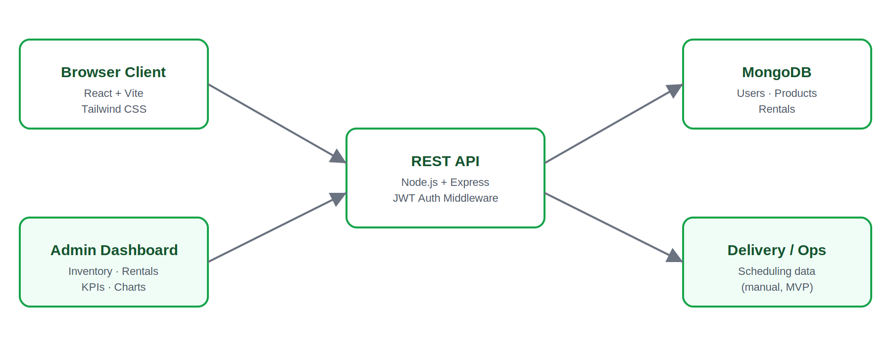

5. Data Model
Three primary collections back the application: Users, Products, and Rentals. A Rental embeds line items referencing Products and tracks status through its lifecycle, plus an embedded list of maintenance requests.
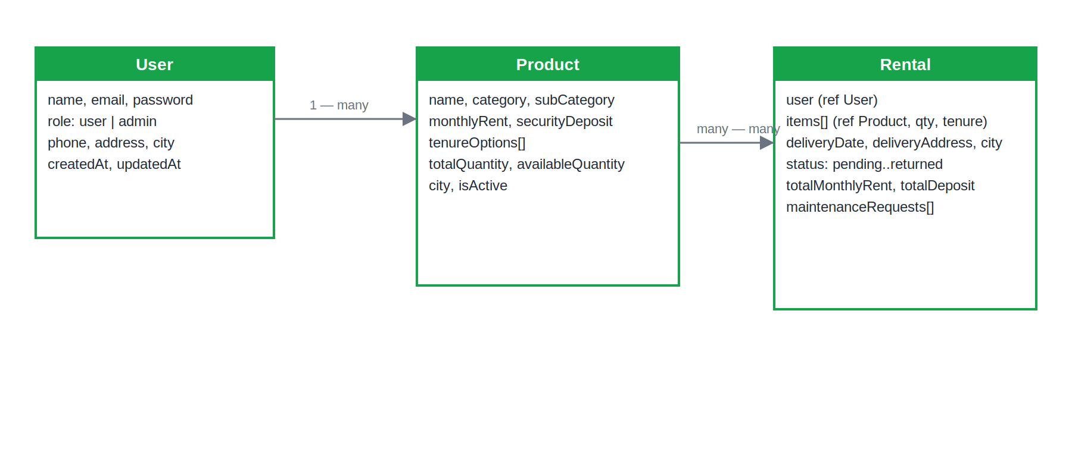

6. Functional Requirements

6.1 User Features
- User registration & login (JWT-based)
- Browse products by category: Furniture (bed, sofa, table), Appliances (fridge, washing machine, TV)
- View product detail: rental price, security deposit, tenure options
- Add to cart & checkout, with a simulated payment step
- Choose delivery date and location
- Manage active rentals and view rental history
- Request maintenance support on an active rental
- Request a return

6.2 Admin / Vendor Features
- Add, edit, and deactivate product inventory
- Set rental pricing, deposit, and tenure options
- Track product availability in real time
- Manage and update rental status across its lifecycle
- Handle and resolve maintenance requests
- Monitor returns and cancellations
- Dashboard with KPIs and visual analytics (charts)

7. Non-Functional Requirements
Category | Requirement
Performance | Target page load time under 3 seconds
Security | JWT-secured endpoints; passwords hashed with bcrypt; payment-ready checkout flow
Reliability | Atomic inventory updates on checkout/return to keep stock counts accurate
Usability | Simple, mobile-first responsive UI
Scalability | Stateless API design supports multi-city expansion

8. Technology Stack
Layer | Technology
Frontend | React (Vite), Tailwind CSS, React Router, Recharts
Backend | Node.js, Express.js, REST API
Database | MongoDB (Mongoose ODM)
Auth | JSON Web Tokens (JWT), bcrypt password hashing
Deployment (suggested) | Vercel/Netlify (frontend), Render/Railway (backend), MongoDB Atlas

9. Key Performance Indicators
- Number of active rentals
- Monthly recurring revenue (MRR)
- Product utilization rate
- Customer retention rate
- Maintenance request resolution time
All KPIs except retention rate are computed live from the database and surfaced on the admin dashboard with supporting charts (revenue by category, rentals by status).

10. Assumptions & Constraints

Assumptions
- Users prefer rentals over ownership for short-to-medium stays
- Reliable delivery partners exist in each serviced city
- Inventory is stored locally per service area

Constraints
- Logistics and maintenance costs scale with fleet size
- Product wear and tear over rental cycles
- Inventory availability limits growth in new cities

11. Deliverables
- Functional web application (customer storefront)
- Admin dashboard with inventory, rental, and analytics management
- This PRD & technical documentation
- Deployment-ready build with setup instructions

12. Future Enhancements
- Native mobile applications (iOS/Android)
- Subscription bundles across product categories
- Live online payments & auto-renewals (Razorpay/Stripe integration)
- Smart appliance usage tracking via IoT
- Furniture customization options
- Automated tests and CI/CD pipeline

