Networking Lab -Exercise-2

ls ,mkdir, cd,Command

ls- Purpose

Displays the contents of a directory.

Mkdir-Purpose

To create a new directory newdir you

would run the following command:

$mkdir newdir

cd Command-Purpose

Changes the current directory.

Syntax

cd [directory]

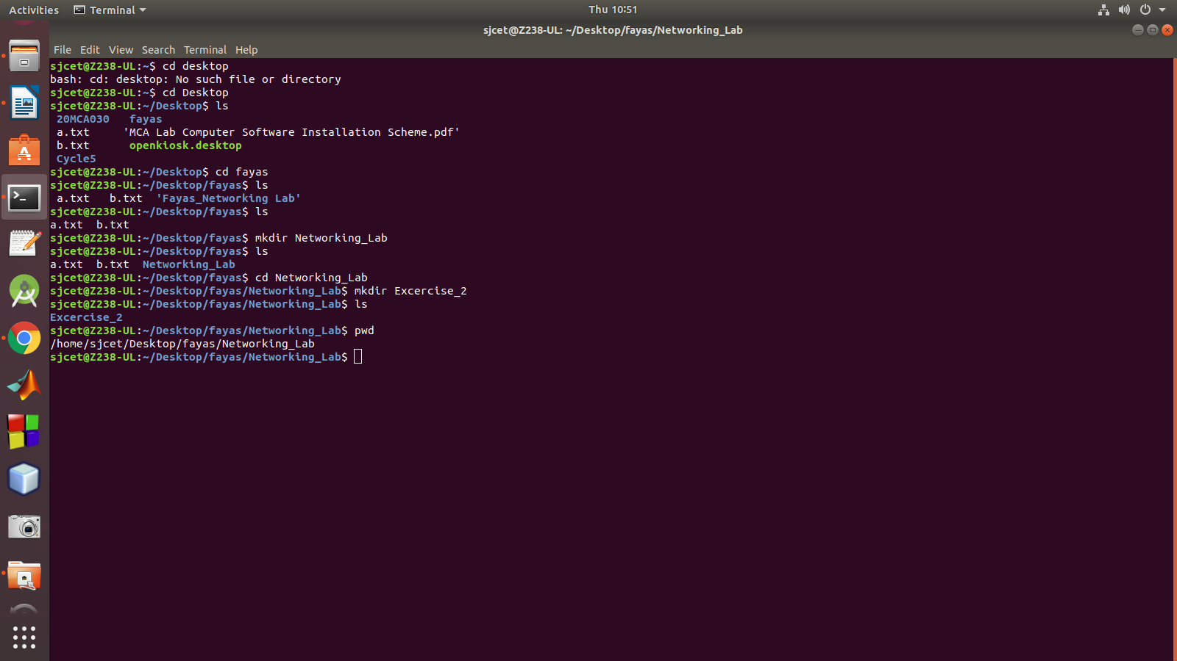

pwd

Displays the current directory

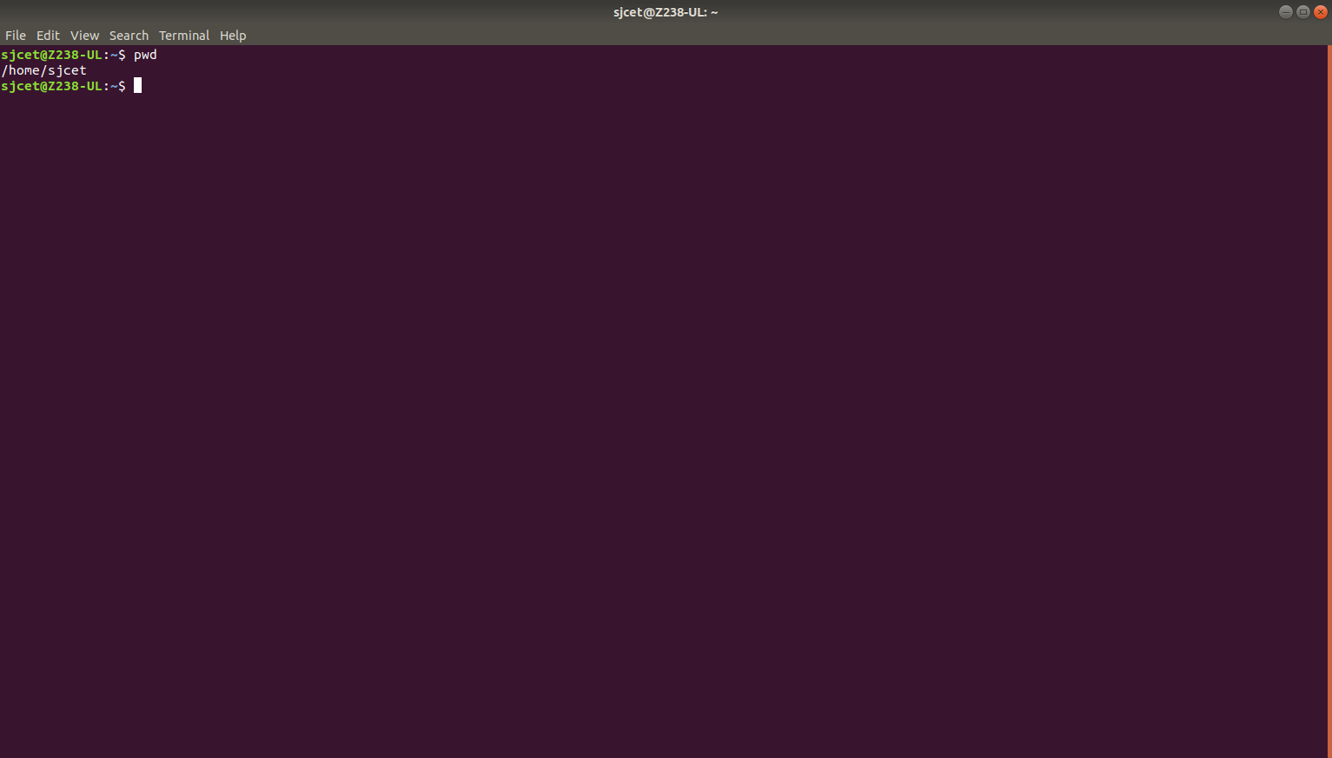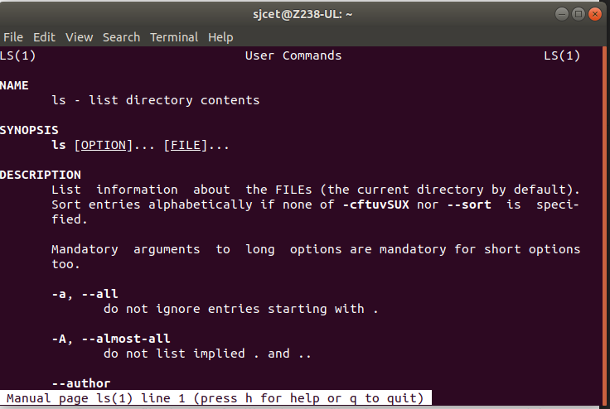

man

man command in Linux is used to display the user manual of any command that we can run on the terminal

man ls