2nd cycle

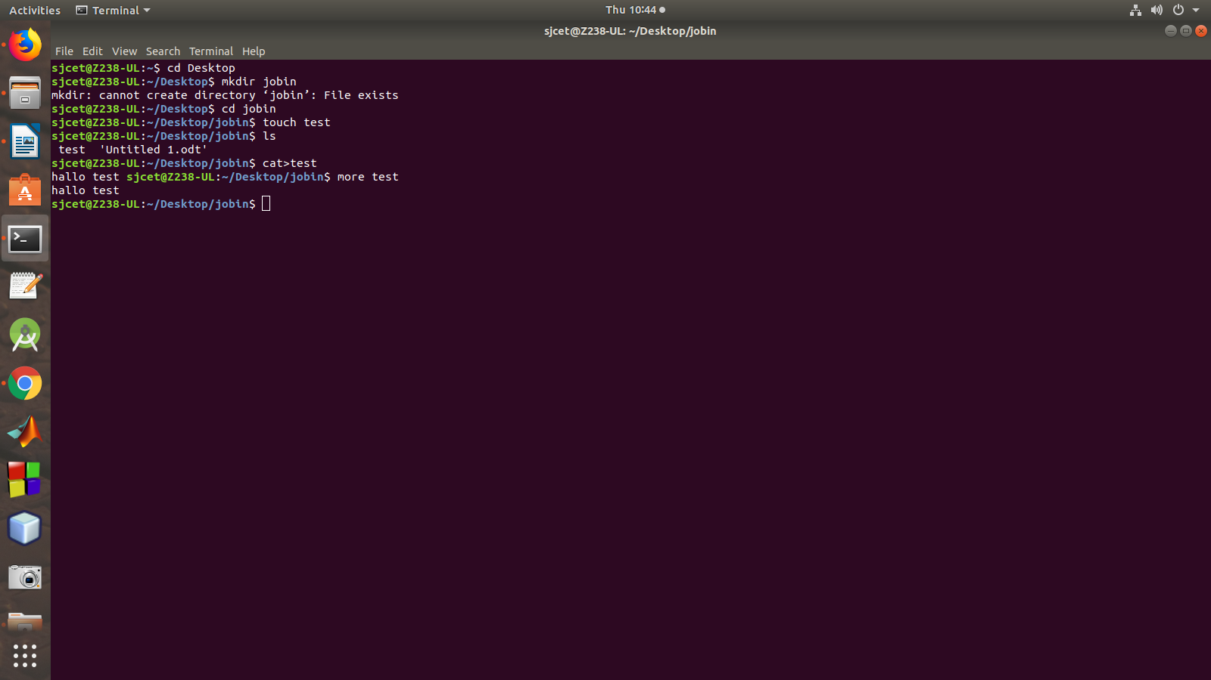
ls- list all in directory
mkdir – create a new directory
cd- change directory
touch- to create a new file
cat>file name- to insert values or data into the file
more file name-- to display the file content

+++++++++++++++++++++++++++++++++++++++

man
man command in Linux is used to display the user manual of any command that we can run on the terminal
man ls

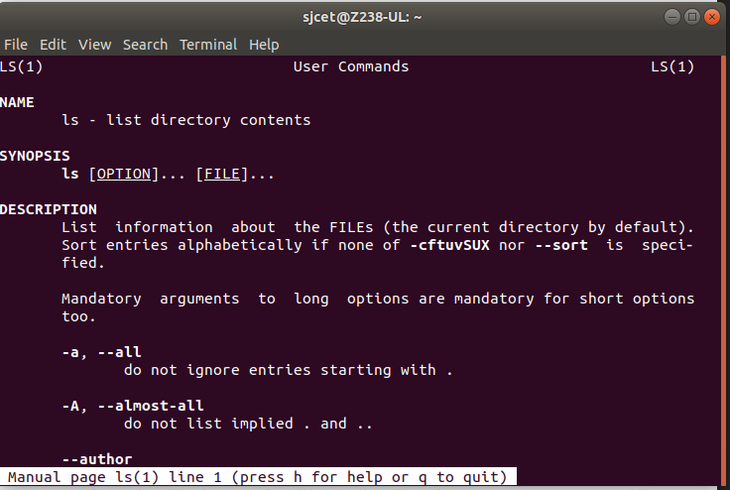

ECHO:

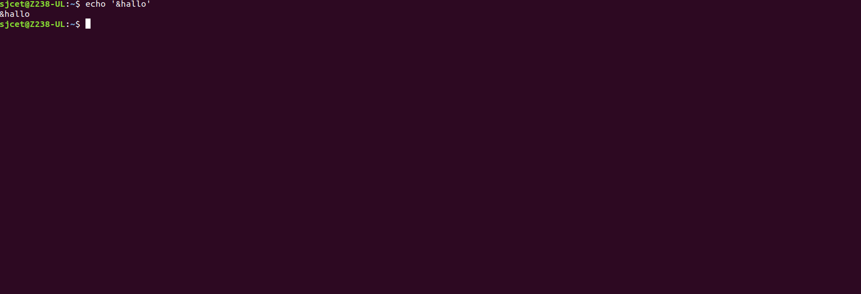

2. Declare a variable and echo its value. For example, Declare a variable of
x and assign a value:

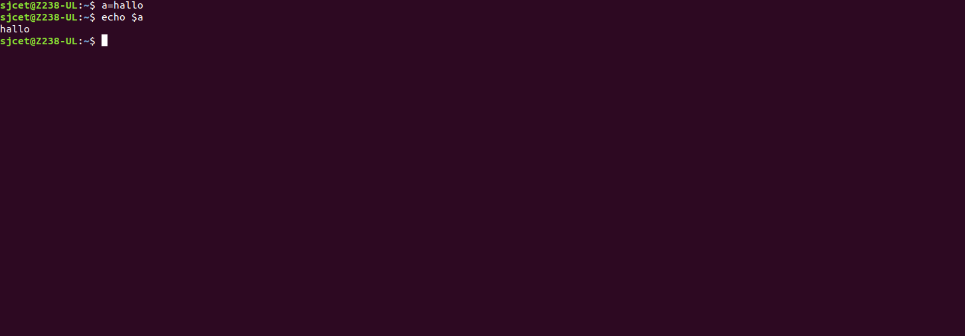
3. Using option ‘\b‘ – backspace with backslash interpretor ‘-e‘ which
removes all the spaces in between.
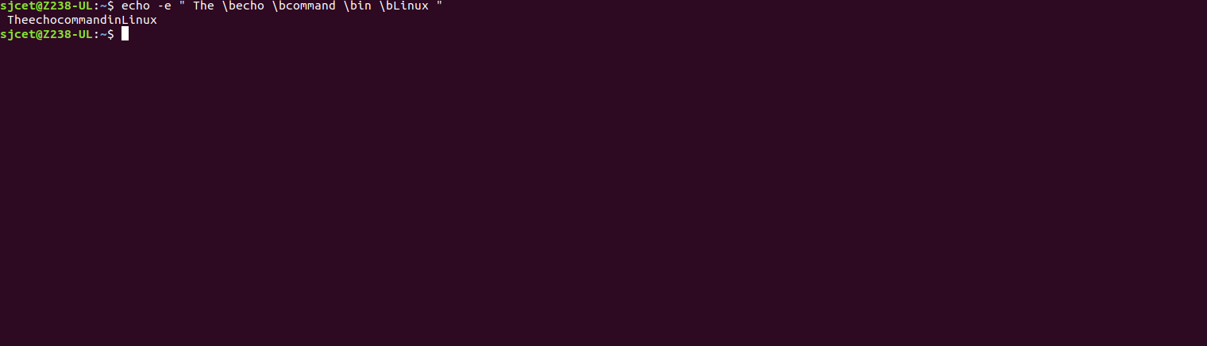
4. Using option ‘\n‘ – New line with backspace interpretor ‘-e‘ treats new
line from where it is used.
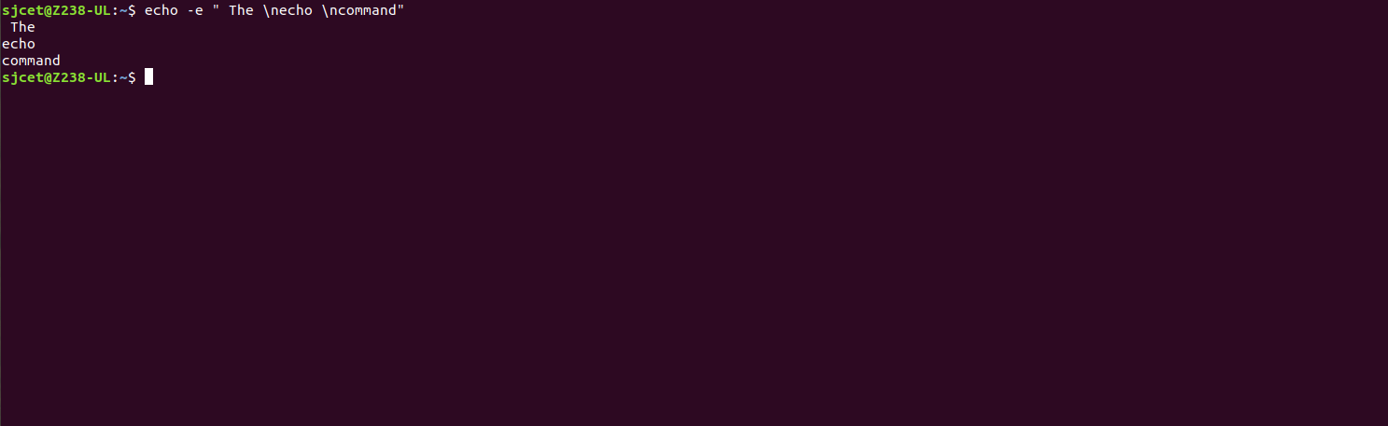

5. Using option ‘\t‘ – horizontal tab with backspace interpretor ‘-e‘ to
have horizontal tab spaces.
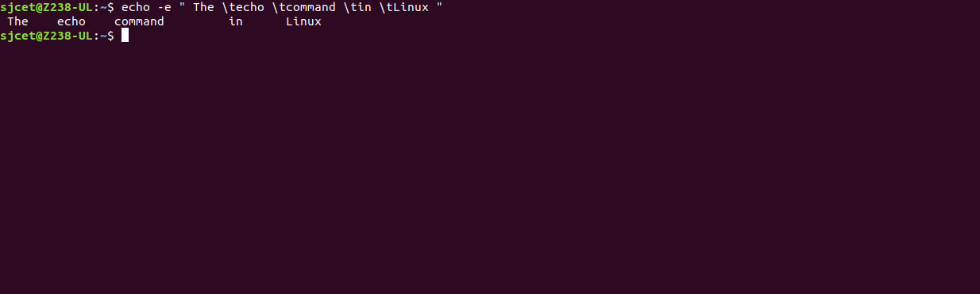
6.Using option ‘\v‘ – vertical tab with backspace interpretor ‘-e‘ to have
vertical tab spaces.
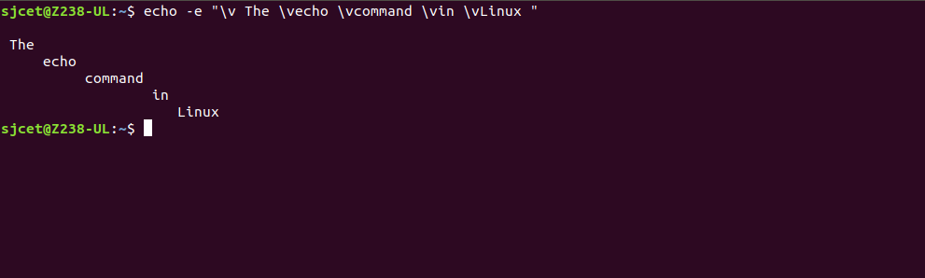
7.Using option ‘\r‘ – carriage return with backspace interpretor ‘-e‘ to have specified
carriage return in output.

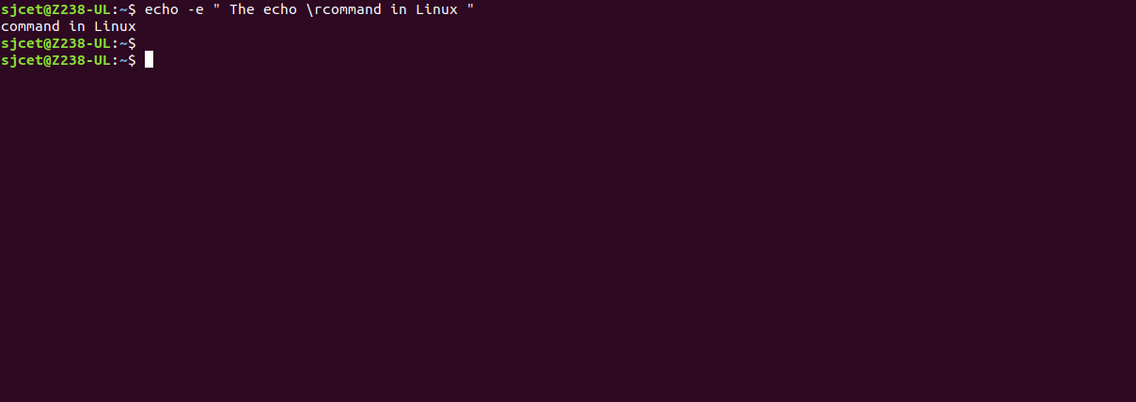

READ

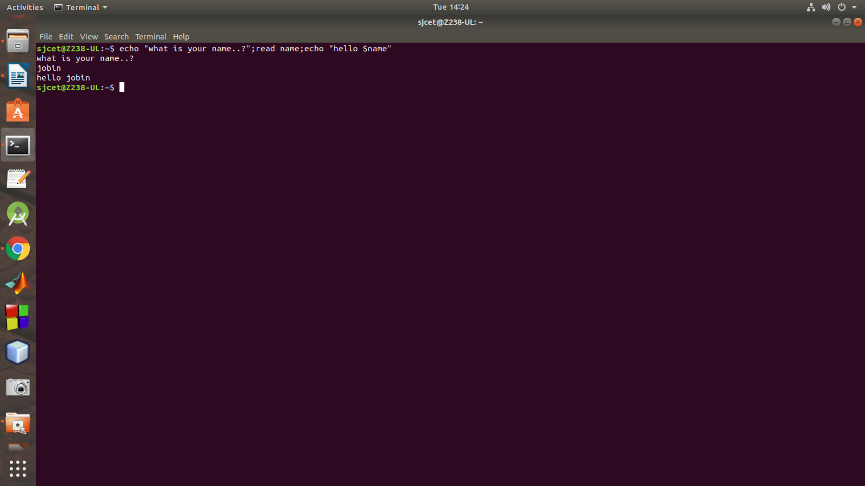
1 split the user input into different variables by adding multiple
arguments.
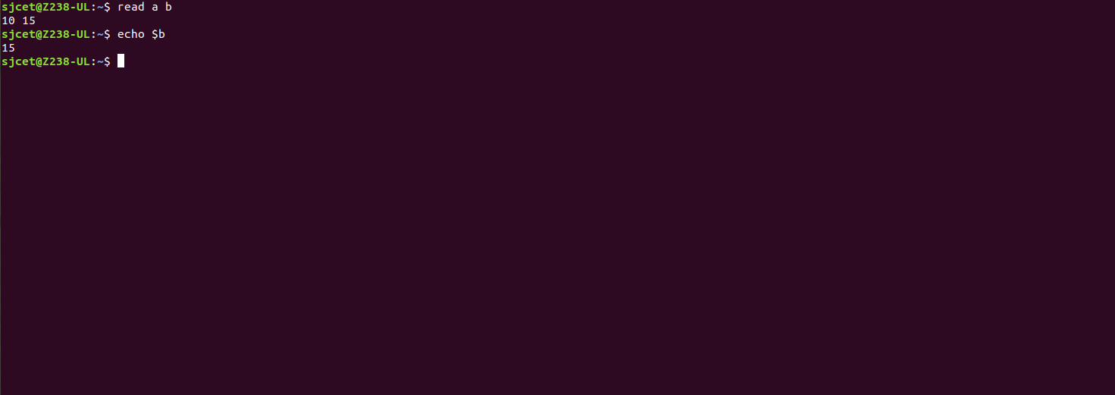
2 When the user input has more words than there are variables, the extra words are
assigned to the last provided variable:
