**DATA STRUCTURES LAB**

**(PRACTICAL LAB)**

**Manav Rachna International Institute of Research and**

**Studies**

School of Computer Applications

**Department of Computer Applications**

| ***Submitted By*** | |
| --- | --- |
| ***Student Name*** | ***Rahul Patel*** |
| ***Roll No*** | ***24/SCA/BCA(AI&ML)/056*** |
| ***Programme*** | ***B.C.A. AI&ML*** |
| ***Semester*** | ***2nd Semester*** |
| ***Section/Group*** | ***II D*** |
| ***Department*** | ***Computer Applications*** |
| ***Batch*** | ***2024-2028*** |
|  | |
| ***Submitted To*** | |
| ***Faculty Name*** | ***Mrs. Anupama*** |

Q1. write a program for passing arrays to the functions.

Output:

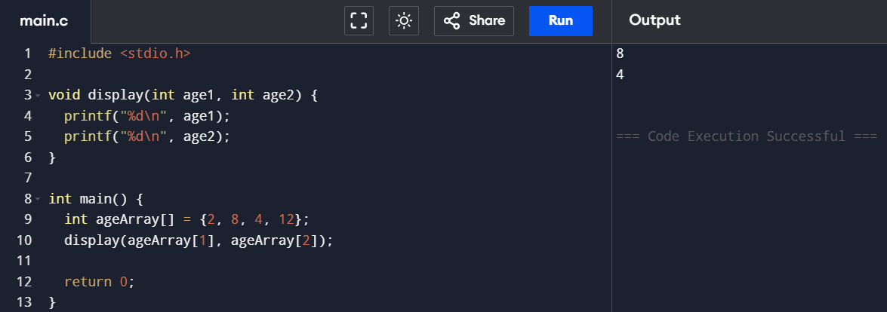

Q2. Program to calculate the sum of array elements by passing to a function.

Output:

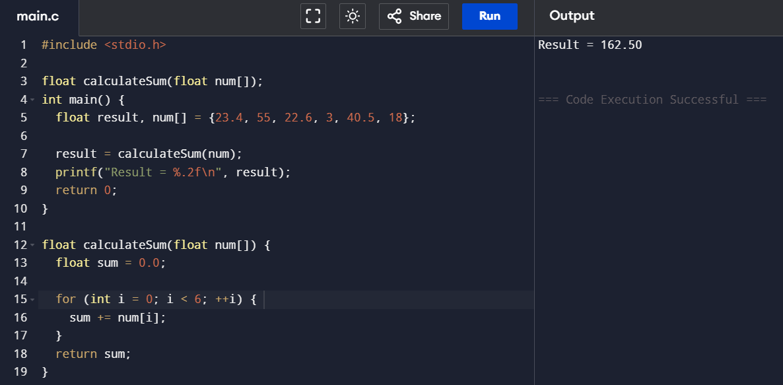

Q3.write a program for passing 2D arrays to the functions.

Output:

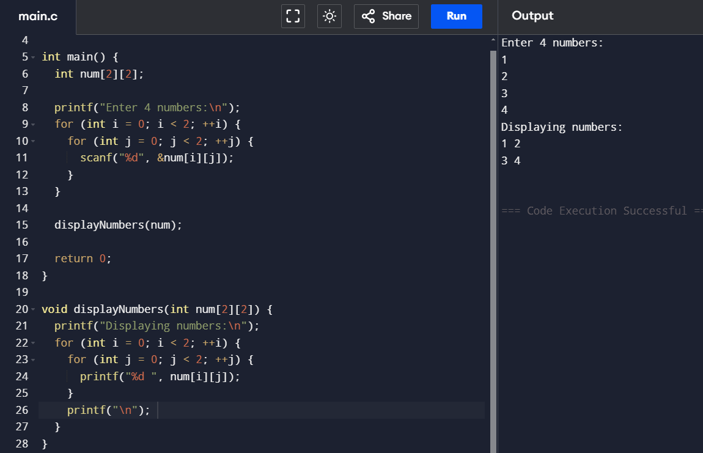

Q4. Write a program for swapping using pointers.

Output:

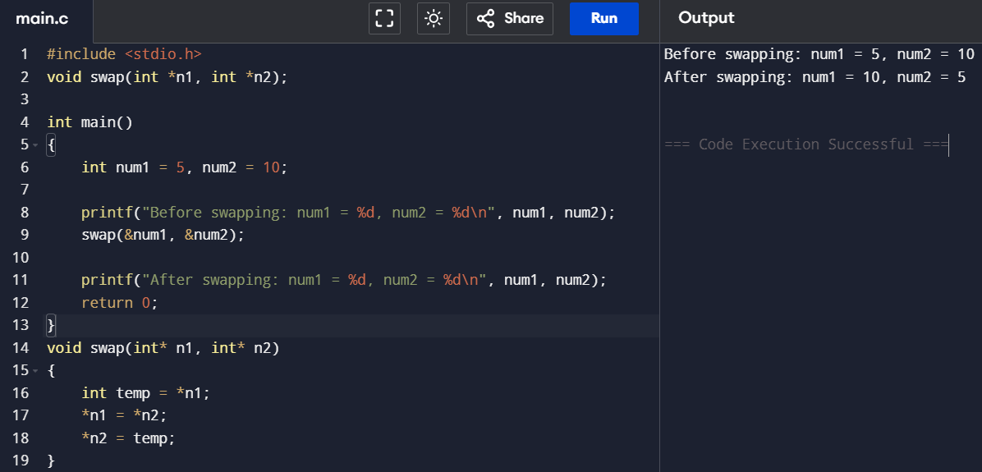

Q5. Write a program to returning an array from a function using pointers.

Output:

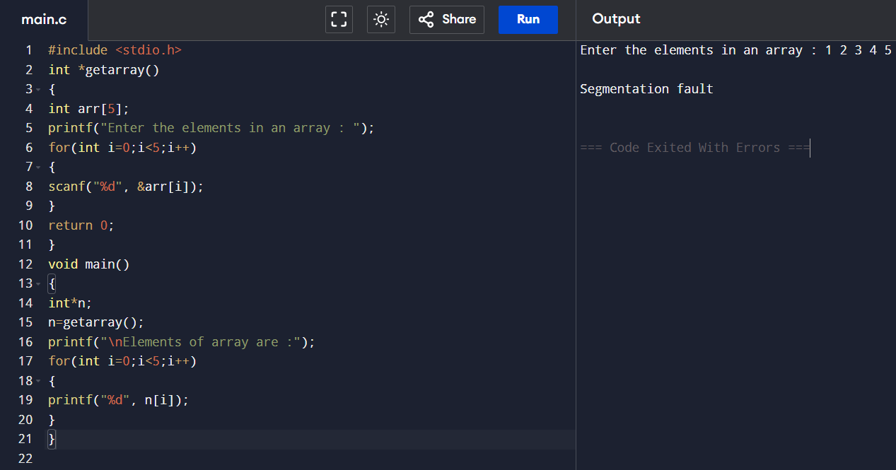

Q6.Binary Search.

Output:

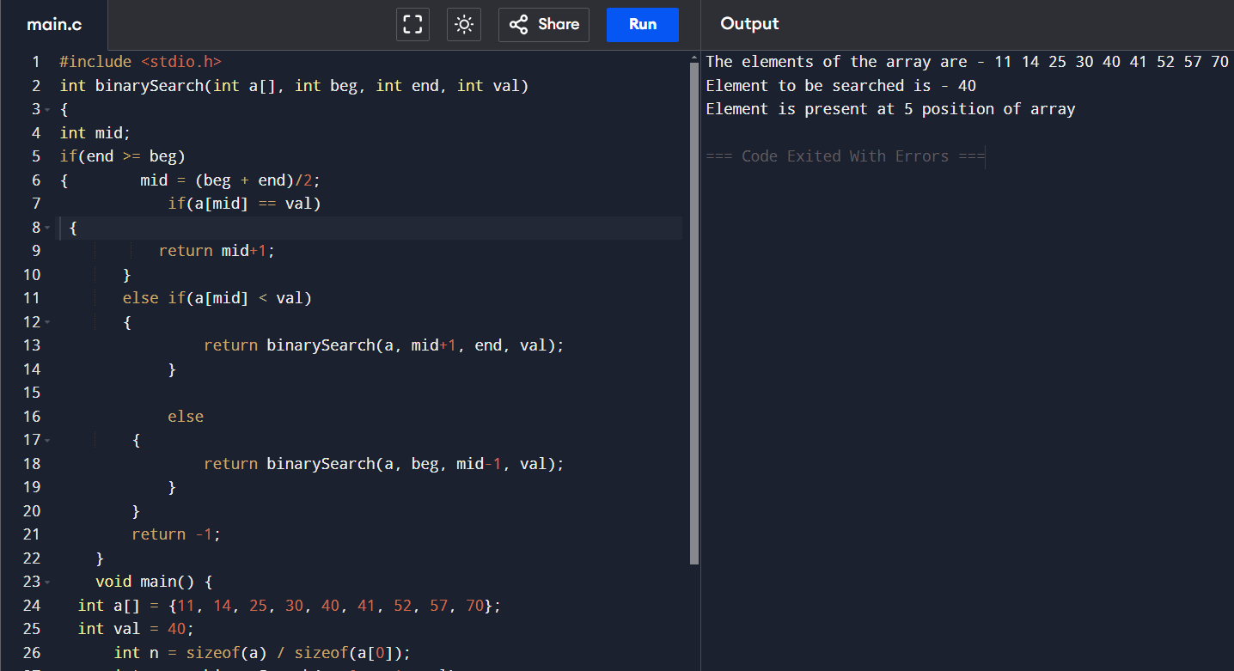

Q7. Linear Search.

Output:

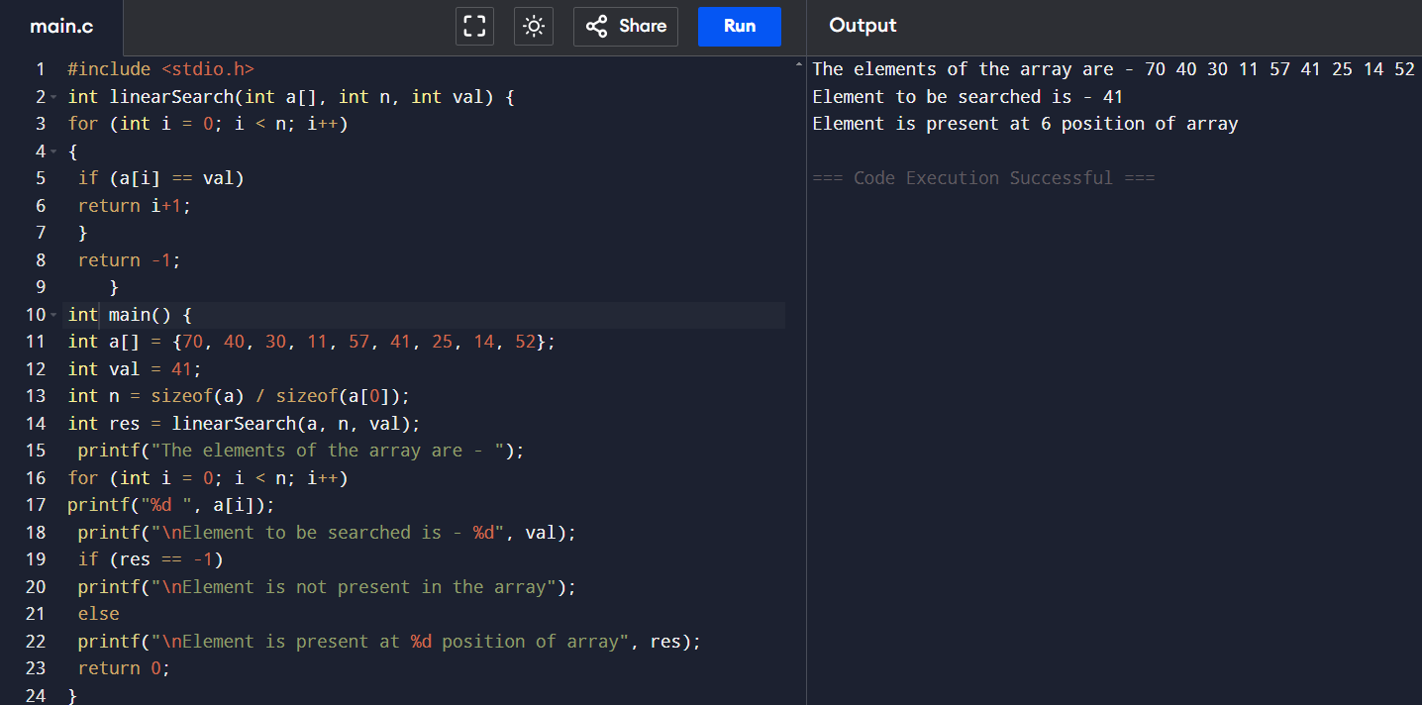

Q8. Stacks

Output:

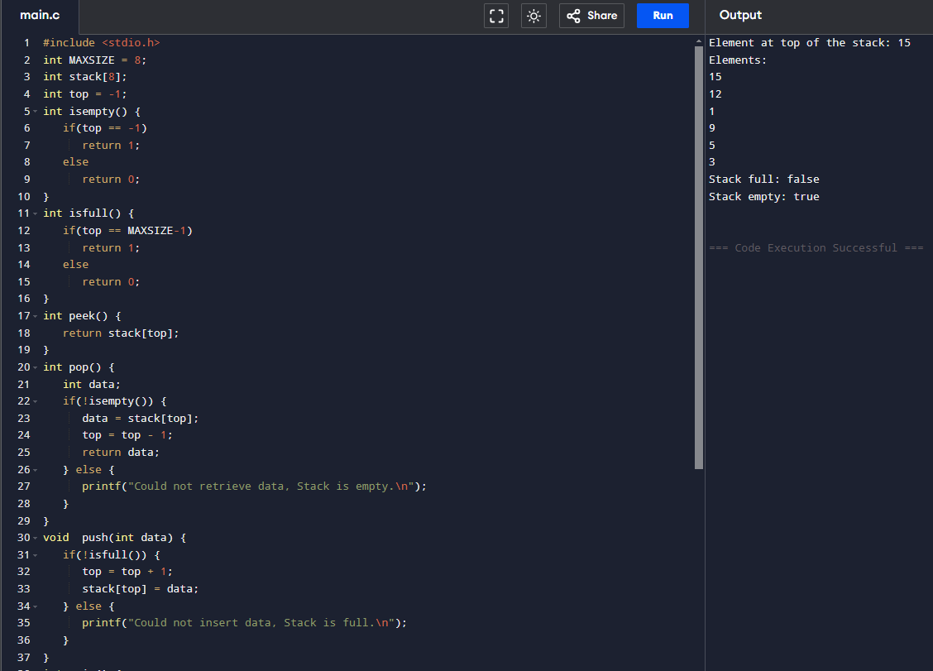

Q9.

Output:

