Pre-trained fakes were used for this code.

If we train using more number of images the accuracy would be higher.

For the purpose of training the model we have used 500 real images from the CELEBA dataset and pretrained 500 fakes.

**SVM is used as the classifier.**

The funct **img_operation** depicts the step by step process of generating the co-occurrence matrix.

As stated in the paper instead of using Gray level cooccurrence matrix, we just apply the same concept to the different color components of the image. Below you can find the main statistical features that provide information about the texture of the image :-

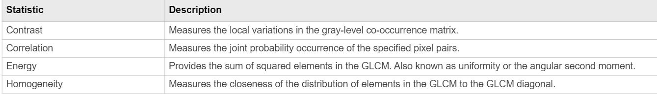

The formula to calculate each is given below :-

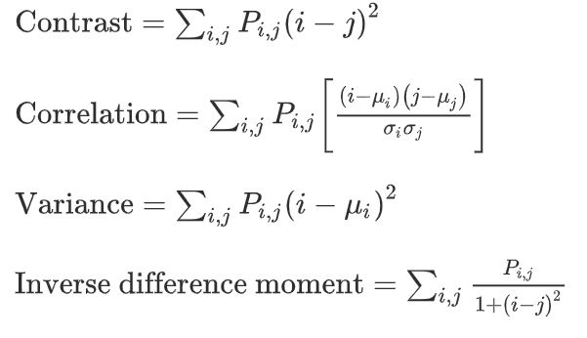

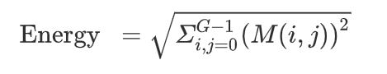

**Variance and mean and denoted by z and u respectively. Inverse difference moment is also known as homogeneity.**

**M and P represent the co occurrence matrix.**

**Formulas were taken from** [**https://www.sciencedirect.com/topics/engineering/cooccurrence-matrix**](https://www.sciencedirect.com/topics/engineering/cooccurrence-matrix)