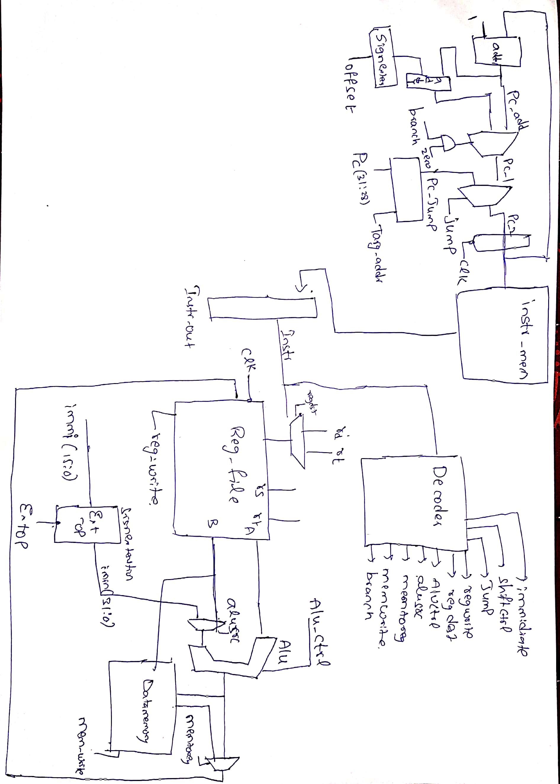

Intro to processor Architecture
Processor -report

Architectural Design:

- 2–stage pipelined processor with separate blocks for Fetch unit and the Decode and Execute unit.
- ALU implemented with 15 operations including arithmetic, logical ,shifting operations.
- Decode unit implemented with 27 instructions which gives the control signals.

Main Memory Design:

- Main memory is implemented using 2-d array in verilog.
- Main memory is a word based memory(32-bits).
- Harward type architecture is implemented with seperate memory for instructions and data
- Word length of instruction unit is 8bits.
- Word length of memory unit is 32bits.
- The size of the Main memory is declared to 2KB.
- The size of the Instruction memory is declared to 128 bytes.

Instructions Supported:

- ADD, SUB, AND ,OR, NOR, XOR, SLT, SLTU, SLL, SLLV, SRA, SRAV, SRL, SRLV,ADDI, ANDI, ORI, XORI, SLTI, SLTIU, LW, SW, BEQ, BNE, BGTZ, BLEZ ,J,greater than, less than equal .
- These are instructions given by TA on the moodle.

Instructions Not Supported:

- Divsion ,Multiplication, Remainder Modulo etc.

Processor Clock Frequency:

- The maximum clock frequency supported is 1.2GHz and hence the minimum clock period is 0.833ns.

Other things about the processor:

- Pros:

- 2-stage pipelined architecture.
- Regfiles and Data memory realised using 2-D array.
- Basic arithematic and logical programs canbe executed.
- Loop can be implemented using branch and jump instructions.
- Harvard architecture based memory management implemented which is ideal for embedded computer systems.

- Cons:

- Only using two stage pipeline which increases maximum clock frequency.
- Overflow flag not raised properly.
- Branch delay slot generated in the processorin which a NOP command should be generated.

- Arithmetic operations like multiplication, division etc. not implemented.
- Instructions should be pre-programmed into the memory can’t be given through test-bench.
- Only can support word alligned read and write.

Rahul kashyap
2018102037

