1. Program to convert temperature from Fahrenheit to Celsius

class Demo

{

static public void Main()

{

double num;

string val;

Boolean flag = true;

Console.Write("Please enter Temperature in Fahrenheit = ");

val = Console.ReadLine();

num = Convert.ToDouble(val);

double temp = ((num - 32) * 5) / 9;

Console.Write("Temperature in Celcius = "+temp);

//Console.Write(temp);

}

}



1. Program to check if a string is palindrome or not

class Demo

{

static public void Main()

{

Console.Write("Enter a string to check if it is palindrome = ");

string s = Console.ReadLine();

char[] arr = s.ToCharArray();

bool flag=true;

for (int i=0;i<arr.Length/2;i++)

{

if (arr[i] != arr[arr.Length - i - 1])

{

flag = false;

break;

}

}

if (flag)

Console.WriteLine("String is a palindrome");

else

Console.WriteLine("String is not a palindrome");

}

}



class Demo

{

static public bool Palindrome(char[] arr, int i, int n)

{

Console.WriteLine(arr[i].ToString() + ", "+ arr[n].ToString() + " " + i + " " + n);

if (arr[i] != arr[n])

{

return false;

}

if (i<n+1)

Palindrome(arr, i + 1, n - 1);

return true;

}

static public void Main()

{

Console.Write("Enter a string to check if it is palindrome = ");

string s = Console.ReadLine();

char[] arr = s.ToCharArray();

bool flag = Palindrome(arr, 0, arr.Length-1);

if (flag)

Console.WriteLine("String is a palindrome");

else

Console.WriteLine("String is not a palindrome");

}

}

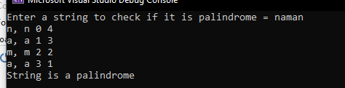

1. Program to find out vowels of string

class Demo

{

static public void Main()

{

Console.Write("Enter a string to count number of vowels = ");

string s = Console.ReadLine();

char[] arr = s.ToCharArray();

int cnta=0, cnte=0, cnti=0, cnto=0, cntu = 0;

for (int i=0;i<arr.Length; i++)

{

switch (arr[i])

{

case 'a':

case 'A':

cnta++;

break;

case 'e':

case 'E':

cnte++;

break;

case 'i':

case 'I':

cnti++;

break;

case 'o':

case 'O':

cnto++;

break;

case 'u':

case 'U':

cntu++;

break;

}

}

Console.WriteLine("Vowels in the given string is = ");

Console.WriteLine("a or A = " + cnta);

Console.WriteLine("e or E = " + cnte);

Console.WriteLine("i or I = " + cnti);

Console.WriteLine("o or O = " + cnto);

Console.WriteLine("u or U = " + cntu);

}

}

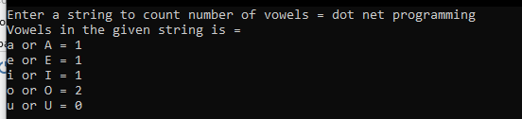

1. Fibonacci series of n numbers

class Demo

{

static int Fibonacci(int n)

{

if (n == 0 || n == 1)

{

return n;

}

return (Fibonacci(n-2)+Fibonacci(n-1));

}

static public void Main()

{

Console.Write("Enter number = ");

string s = Console.ReadLine();

int num = Convert.ToInt32(s);

for (int i = 0; i < num; i++)

{

Console.WriteLine(Fibonacci(i));

}

}

}

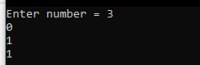

1. Factorial

class Demo

{

static int Factorial(int n)

{

if (n == 0)

{

return 1;

}

return Factorial(n-1)*n;

}

static public void Main()

{

Console.Write("Enter number = ");

string s = Console.ReadLine();

int num = Convert.ToInt32(s);

Console.WriteLine("Factorial of given number = "+ Factorial(num));

}

}



1. Program to input value in integer and print its corresponding text value

using System.ComponentModel.DataAnnotations;

class Demo

{

static public void Main()

{

int v1=0, v2=0, value;

bool f1 = false, f2 = false, f3 = false; //f1 = 1 to 9, f2 = 10 to 19, f3 = 20, 30, 40, etc.

Console.Write("Enter number between 1 to 99 = ");

string s = Console.ReadLine();

value = Convert.ToInt32(s);

if (value > 19)

{

f1 = true;

f3 = true;

v1 = value / 10;

v2 = value % 10;

}

else if (value > 9)

{

f2 = true;

v2 = value;

}

else

{

f1 = true;

v2 = value;

}

if (f3)

{

switch (v1)

{

case 2: Console.Write(" Twenty"); break;

case 3: Console.Write(" Thirty"); break;

case 4: Console.Write(" Forty"); break;

case 5: Console.Write(" Fifty"); break;

case 6: Console.Write(" Sixty"); break;

case 7: Console.Write(" Seventy"); break;

case 8: Console.Write(" Eighty"); break;

case 9: Console.Write(" Ninety"); break;

}

}

if (f2)

{

switch (v2)

{

case 10: Console.Write(" Ten"); break;

case 11: Console.Write(" Eleven"); break;

case 12: Console.Write(" Twelve"); break;

case 13: Console.Write(" Thirteen"); break;

case 14: Console.Write(" Fourteen"); break;

case 15: Console.Write(" Fifteen"); break;

case 16: Console.Write(" Sixteen"); break;

case 17: Console.Write(" Seventeen"); break;

case 18: Console.Write(" Eighteen"); break;

case 19: Console.Write(" Nineteen"); break;

}

}

if (f1)

{

switch (v2)

{

case 1: Console.Write(" One"); break;

case 2: Console.Write(" Two"); break;

case 3: Console.Write(" Three"); break;

case 4: Console.Write(" Four"); break;

case 5: Console.Write(" Five"); break;

case 6: Console.Write(" Six"); break;

case 7: Console.Write(" Seven"); break;

case 8: Console.Write(" Eight"); break;

case 9: Console.Write(" Nine"); break;

}

}

}

}

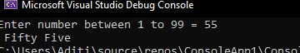

1. Program of conversion of number systems

using System;

using System.Runtime.Intrinsics.X86;

class Demo

{

public static void Bin_To_Dec(string bin)

{

int cnt = 1, dec = 0;

for (int i=bin.Length-1;i>=0;i--)

{

if (bin[i] == '1')

dec += cnt;

cnt *= 2;

}

Console.WriteLine(dec);

}

public static void Dec_To_Bin(int dec)

{

if (dec == 0)

return;

Dec_To_Bin(dec / 2);

Console.Write(dec % 2);

}

public static void Dec_To_Oct(int d_oct)

{

if (d_oct == 0)

return;

Dec_To_Oct(d_oct / 8);

Console.Write(d_oct % 8);

}

public static void Hex_To_Oct(string hexa)

{

string hex = "0123456789ABCDEF";

int cnt = 1, dec = 0;

for (int i = hexa.Length - 1; i >= 0; i--)

{

dec += (cnt * hex.IndexOf(hexa[i]));

cnt *= 16;

}

// Console.Write("\ndec = {0}\n", dec);

Dec_To_Oct(dec);

return;

}

public static void Oct_To_Dec(string oct)

{

int cnt = 1, dec = 0;

int octal = Convert.ToInt32(oct);

for (int i = oct.Length - 1; i >= 0; i--)

{

// Console.WriteLine("{0}, {1}, {2}", oct[i], cnt, octal%10);

dec = dec + (cnt * (octal % 10));

cnt *= 8;

octal /= 10;

}

Console.WriteLine(dec);

}

public static void Main()

{

// Dec_To_Oct(1999);

int ch = 0;

do

{

Console.Write("\nConversion \n1. Binary to decimal\n2. Decimal to Binary\n3. Hex to Octal\n4. Octal to Dec\n5. Exit\nEnter your choice = ");

string s = Console.ReadLine();

ch = Convert.ToInt32(s);

switch (ch)

{

case 1:

//binary to decimal conversion

Console.Write("\nEnter binary number = ");

string bin = Console.ReadLine();

Bin_To_Dec(bin);

break;

case 2:

//decimal to binary conversion

Console.Write("\nEnter decimal number = ");

string s_dec = Console.ReadLine();

int dec = Convert.ToInt32(s_dec);

Console.WriteLine("\n");

Dec_To_Bin(dec);

break;

case 3:

//hexadecimal to octal conversion

Console.Write("\nEnter hexadecimal number = ");

string hex = Console.ReadLine();

Hex_To_Oct(hex);

break;

case 4:

//octal to decimal

Console.Write("\nEnter octal number = ");

string oct = Console.ReadLine();

Oct_To_Dec(oct);

break;

case 5:

break;

}

} while (ch != 5);

}

}

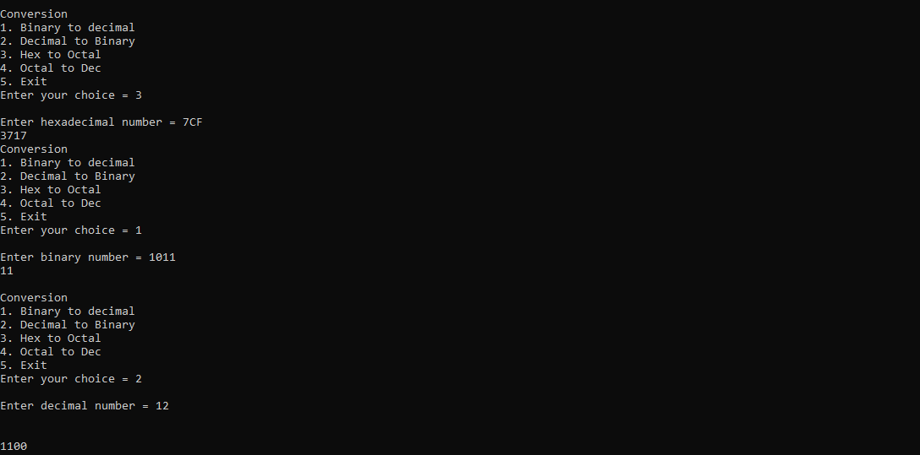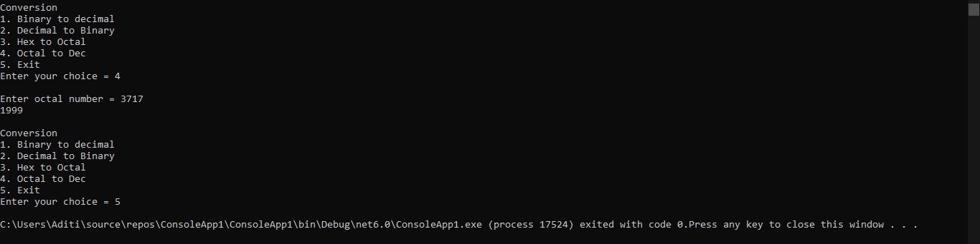

# Unit 2

1. WAP to multiply two values by using the concept of parameterized constructor

using System;

using System.Runtime.CompilerServices;

namespace Test

{

class Calculation

{

int a, b;

public Calculation(int x, int y)

{

a = x; b = y;

}

public int multiply()

{ return a * b; }

}

class Program

{

static void Main(string[] args)

{

Calculation i = new Calculation(10,20);

Console.WriteLine(i.multiply());

Console.ReadLine() ;

}

}

}

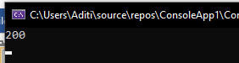

1. WAP to demonstrate operator overloading in C#

using System;

namespace Test

{

class Distance

{

public int values;

public static Distance operator +(Distance d1, Distance d2)

{

Distance d = new Distance();

d.values = d1.values + d2.values;

return d;

}

}

class Program

{

static void Main(string[] args)

{

Distance d1 = new Distance();

Distance d2 = new Distance();

d1.values = 10;

d2.values = 20;

Distance d3 = d1 + d2;

Console.WriteLine("Sum is {0}", d3.values);

Console.Read();

}

}

}

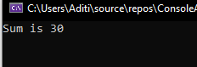

using System;

namespace Test

{

class Calculation

{

int a, b, c;

public Calculation()

{

a = b = c = 0;

}

public Calculation(int x, int y, int z)

{

this.a = x;

this.b = y;

this.c = z;

}

public static Calculation operator ++ (Calculation op1)

{

op1.a++;

op1.b++;

op1.c++;

return op1;

}

public void ShowResult()

{

Console.WriteLine(a+","+b+","+c);

Console.ReadLine();

}

}

class Program

{

static void Main(string[] args)

{

Calculation i = new Calculation(10, 20, 30);

i++;

i.ShowResult();

Console.ReadLine() ;

}

}

}

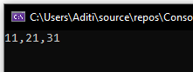

1. WAP to add two values by using concept of function overloading

using System;

namespace Test

{

class Calculation

{

int a, b;

public int Addition(int a, int b)

{

return a + b;

}

public double Addition(double a, double b)

{

return a + b;

}

}

class Program

{

static void Main(string[] args)

{

Calculation i = new Calculation();

Console.WriteLine(i.Addition(1, 2));

Console.WriteLine(i.Addition(2.5, 3.0));

Console.ReadLine() ;

}

}

}



1. WAP to demonstrate the concept of multiple inheritance

using System;

using System.Runtime.CompilerServices;

namespace Test

{

class A

{

A() { Console.WriteLine("A's constructor"); }

public void function() {

Console.WriteLine("Base class A function called");

}

}

class B

{

B() { Console.WriteLine("B's constructor"); }

}

class C : A , B

{

C() { Console.WriteLine("C's constructor"); }

}

class Program

{

C obj = new C();

}

}



1. WAP to demonstrate the concept of multilevel inheritance

using System;

using System.Runtime.CompilerServices;

namespace Demo

{

class A

{

public A() { Console.WriteLine("A's constructor"); }

}

class B : A

{

public B() { Console.WriteLine("B's constructor"); }

}

class C : A

{

public C() { Console.WriteLine("C's constructor"); }

}

class Program

{

static void Main(string[] args) {

B objb = new B();

C obj = new C(); }

}

}

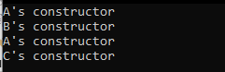

1. WAP to demonstrate the concept of hybrid inheritance

using System;

using System.Runtime.CompilerServices;

namespace Demo

{

class A

{

public A() { Console.WriteLine("A's constructor"); }

}

class B : A

{

public B() { Console.WriteLine("B's constructor"); }

}

class C : B

{

public C() { Console.WriteLine("C's constructor"); }

}

class D : B

{

public D() { Console.WriteLine("D's constructor"); }

}

class Program

{

static void Main(string[] args) {

C obj = new C();

D objd = new D();

}

}

}

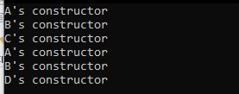

7. WAP to use collections

using System;

using System.Collections;

using System.Security.Cryptography;

namespace First_Prog

{

class MainClass

{

public static void Main(string[] args)

{

ArrayList Al = new ArrayList();

Al.Add(10);

Al.Add("Hello");

Al.Add(true);

Console.WriteLine(Al.Count);

Console.WriteLine(Al.Contains(10));

Console.WriteLine("---------------");

Console.WriteLine(Al[1]);

Al.RemoveAt(1);

Console.WriteLine(Al[1]);

}

}

}

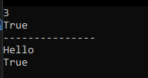

using System;

using System.Collections;

using System.Security.Cryptography;

namespace First_Prog

{

class MainClass

{

public static void Main(string[] args)

{

Stack st = new Stack();

st.Push(1);

st.Push(2);

st.Push(3);

foreach (Object obj in st)

{

Console.WriteLine(obj);

}

Console.WriteLine("Total elements in the stack " + st.Count);

Console.WriteLine("Stack contain element 3? " + st.Contains(3));

}

}

}

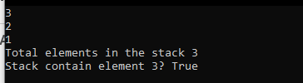

using System;

using System.Collections;

using System.Diagnostics;

using System.Security.Cryptography;

namespace First_Prog

{

class MainClass

{

public static void Main(string[] args)

{

Stack st = new Stack();

st.Push("https://www.nfsu.ac.in/admission");

st.Push("https://www.programiz.com/cpp-programming/online-compiler/");

//Process.Start("explorer", "https://www.nfsu.ac.in/admission");

//System.Diagnostics.Process.Start(https://www.nfsu.ac.in/admission);

foreach (Object obj in st)

{

Process.Start("explorer", obj.ToString());

}

Console.WriteLine("Total elements in the stack " + st.Count);

Console.WriteLine("Stack contain element 3? " + st.Contains(3));

}

}

}

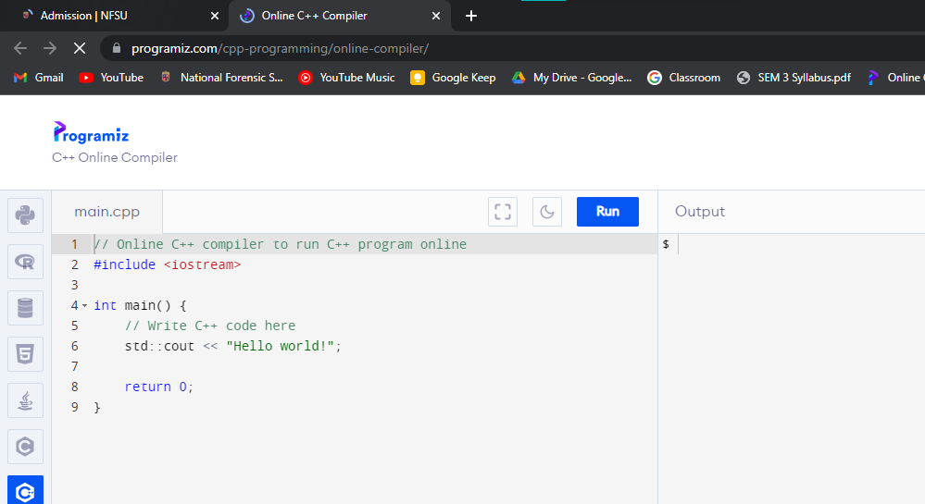

using System;

using System.Collections;

using System.Diagnostics;

using System.Security.Cryptography;

namespace First_Prog

{

class MainClass

{

public static void Main(string[] args)

{

Hashtable ht = new Hashtable();

ht.Add("1", "NFSU");

ht.Add("2", "IIT GANDHINAGAR");

ht.Add("3", "NIT SURAT");

ICollection keys = ht.Keys;

foreach(String key in keys)

{

//Console.WriteLine(ht[key]);

Console.WriteLine(key.ToString() +"\t"+ ht[key].ToString());

}

}

}

}

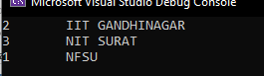

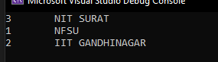

# UNIT 3

**1. basic windows form application (windows form .net framework)**

using System;

using System.Collections.Generic;

using System.ComponentModel;

using System.Data;

using System.Drawing;

using System.Linq;

using System.Text;

using System.Threading.Tasks;

using System.Windows.Forms;

namespace WindowsFormBasic

{

public partial class Form1 : Form

{

public Form1()

{

InitializeComponent();

}

private void button1_Click(object sender, EventArgs e)

{

string msg = "Hello";

msg = msg + " " + tbFirstName.Text + " " + tbLastName.Text;

lbMessage.Text = msg;

}

private void button2_Click(object sender, EventArgs e)

{

tbFirstName.Text = string.Empty; tbLastName.Text = string.Empty;

lbMessage.Text = string.Empty;

}

}

}

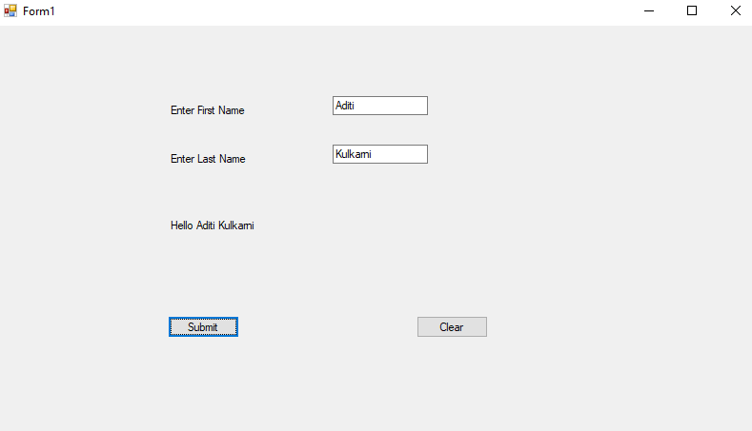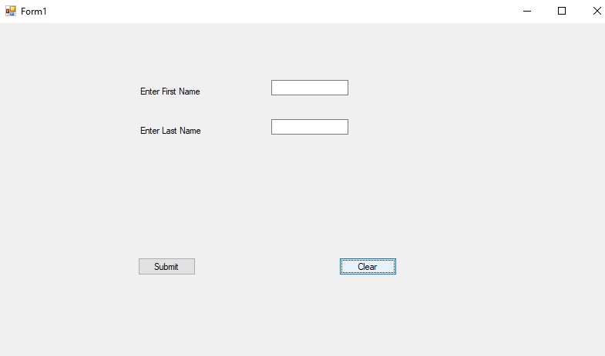

Q. program for selecting and transferring items from listbox like councelling time’s listbox or sql installation time choices listbox.

using System;

using System.Collections.Generic;

using System.ComponentModel;

using System.Data;

using System.Drawing;

using System.Linq;

using System.Text;

using System.Threading.Tasks;

using System.Windows.Forms;

namespace WindowsFormsApp1

{

public partial class Form1 : Form

{

public Form1()

{

InitializeComponent();

}

private void add_Click(object sender, EventArgs e)

{

if (lbLeft.SelectedIndex != -1)

{

lbRight.Items.Add(lbLeft.SelectedItem);

lbLeft.Items.Remove(lbLeft.SelectedItem);

}

}

private void remove_Click(object sender, EventArgs e)

{

if (lbRight.SelectedIndex != -1)

{

lbLeft.Items.Add(lbRight.SelectedItem);

lbRight.Items.Remove(lbRight.SelectedItem);

}

}

}

}