**NOOPUR KATHWAR**

**| Noopurkathwar75@gmail.com| Bhubaneswar, India| +91 85899800848|**

# PROFESSIONAL SUMMARY

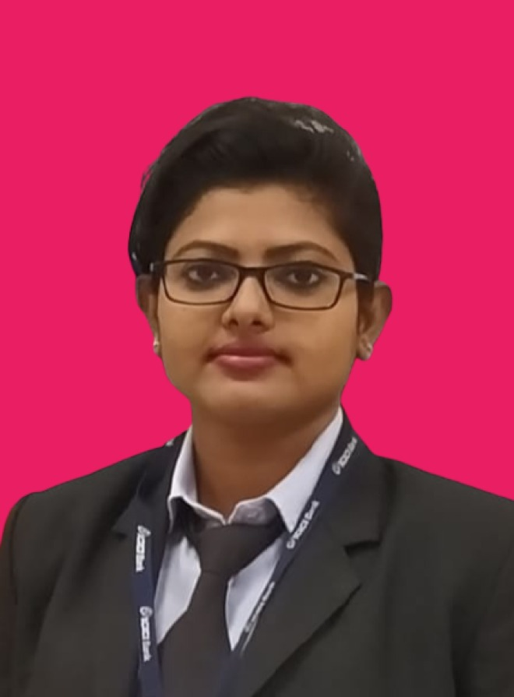

Have a high magnitude with sense of creative and innovation, Intuitive towards the economy, clients, management and co-workers. Perform well under pressure and short-notice demands. Having excellent Organizational skill with a particulars aptitude in time and multiple task management. Also have a strong desire to grow professionally and constantly ready to face the Challenge.

# SKILLS

* Project and Time Management Skills; well organize, structured approach, ability to achieve tight timelines on complex deliverables.
* Knowledge of basic statistics analysis methodology.
* Knowledge of Commercial Bank, Digital (Corporate Internet Group), and Treasury Services data systems and strong system Interactions.
* Ability to form strong relationships with external and internal data providers.
* Proficiency in Microsoft Office applications, including Power Point.
* Ability to be flexible, follow tight deadlines, organize and prioritize work.
* Strong Analytical (excellent understanding of how to use data to solve business problem) and Computer Skills.
* Data Analysis, Financial reporting, Auditing and budgeting skills.

# ACADEMICS

|  |
| --- |
| MBA ( FINANCE & MARKETING) 2017-19 C.V RAMAN GLOBAL UNIVERSITY, BHUBANESWAR |
| B.COM 2014-17 DALMIA COLLEGE RAJGANGPUR,(SAMBALPUR UNIVERSITY) |
| Class XII 2012-14 SRI AUROBINDO INTEGRAL EDUCATION AND RESEARCH  CENTER, RAJGANGPUR (CBSE) |
| Class X 2011-12 SRI AUROBINDO INTEGRAL EDUCATION AND RESEARCH  CENTER, RAJGANGPUR (CBSE) |

**WORK HISTORY**

**Assistant Manager ICICI Bank Ltd**. (August, 2019 to Till now)

# Corporate Banker

Opened n Advice to commercial and private clients about a variety of financial matters, as well as promoting financial services/products to help these clients run their operations.

# Customer Service Associate

Opened and closed the accounts, which includes counting cash drawers and making bank deposits. Answered customer’s questions and addressed problems and complaints in person and via phone. Educated customers on product and service offering. Provide training and development of direct reporting staff with coaching to improve performance and to assist in their own development.

# INTERNSHIP & DISSERTATION

1. Summer internship at Bhubaneswar Stock Exchange, on the topic “RISK MANAGEMENT MECHANISM IN STOCK EXCHANGE” duration of 45 days.
2. Dissertation on the topic “COMPARISON OF SUPPLY CHAIN MANAGEMENT BETWEEN VODAFONE AND DOCOMO”

# HOBBIES & INTERESTS

* Traveling
* Cooking

# EXTRACURRICULAR ACTIVITIES

* Led the Organization Committee as General Secretary (Student) in C.V. RAMAN GLOBAL UNIVERSITY technical festival VIDYANTIK.
* Won many prizes for dance competitions at School level.

# PERSONAL DETAILS

* Name
* Father’s name
* Gender
* Marital Status
* Date of Birth
* Nationality
* Languages Known
* Permanent Address

Date:

Place: Bhubaneswar

: NOOPUR KATHWAR

: OM PRAKASH KATHWAR

: Female

: Single

: 17/02/1995

: Indian

: English, Hindi and Odia

: Rajgangpur, Sundargarh,

Odisha

NOOPUR KATHWAR