Git Demo

1. Create Repository:
- Use GitHub to create a remote repository named demoX.
- Use GitHub to create the first commit.
  - Add README.
  - Modify the text to # DEMOX README # .
  - Click Commit. Change the commit message to add README .
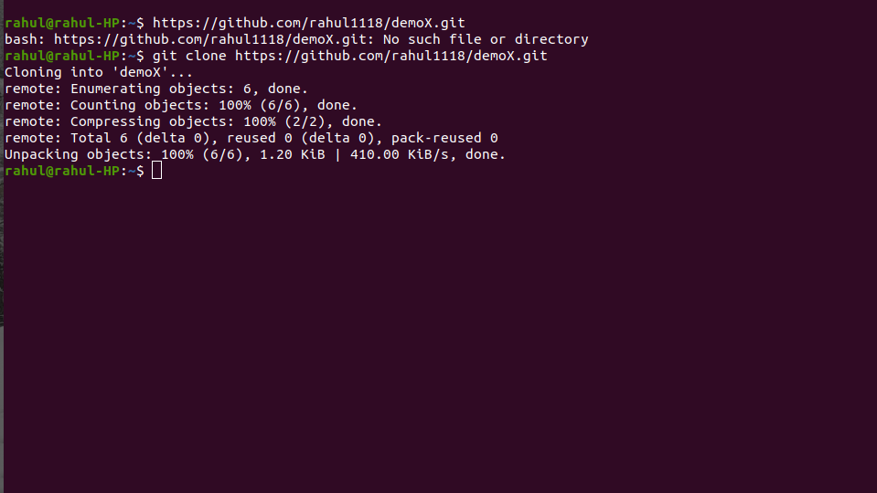

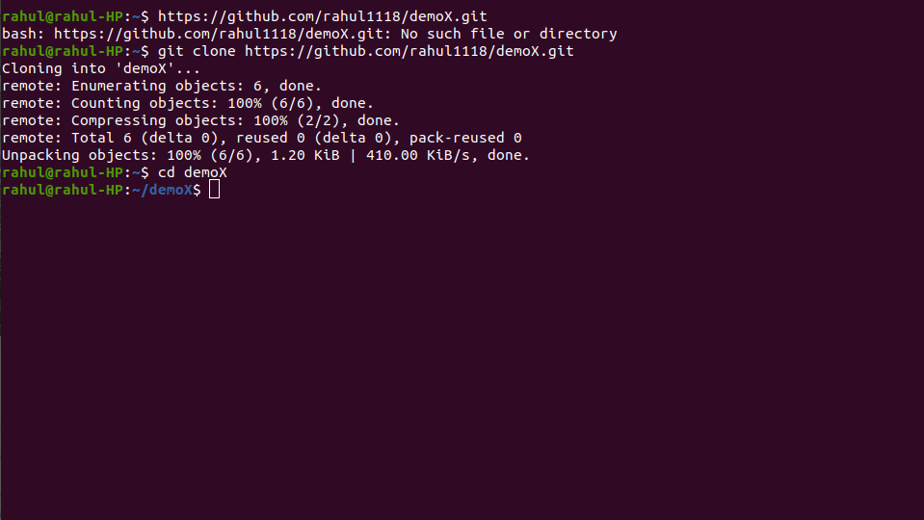

2. Clone Repository:
- Clone the remote repository to local using:
  - git clone [url]
  - cd demoX

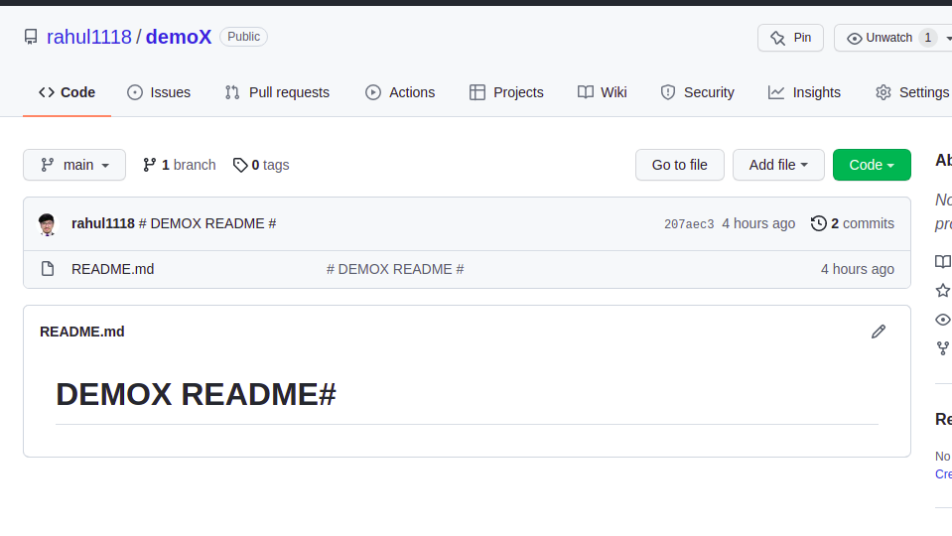
3. Commit To Repository:
- Create an file named fileA.txt in the projecta directory using:
  - echo “Git Demo” > fileA.txt
- Execute git status . You should see that Git notices the fileA.txt file and identifies it as untracked.
- Add fileA.txt to the staging area using:
  - git add fileA.txt
- Execute git status again. You should see that Git adds fileA.txt under "Changes to be committed".
- Execute git commit -m "added fileA.txt" to create a commit.
- Execute git log --oneline . A concise version of the history is displayed.

4. Push To Repository:
- View the contents of demoX using ls -a .
- Execute git remote -v . You should see the URL to remote repository, and see that the shortcut name of this remote repository is origin .
- Execute git push -u origin master . The -u flag sets up the local and remote branches as tracking branches.

5. Branching:
- Use git branch to verify that you have a single branch in your local repository, and its name is master .
- Create and checkout a branch:
  - # two command approach
    - git branch featureX
    - git checkout featureX
  - # one command approach
    - git checkout -b featureX
- In the local repository, create a commit on the featureX branch with the following:
  - Create an file named fileA.txt in the projecta directory using:
    - echo “Demo feature X” > fileB.txt
  - Add a commit message of "add feature X"
(Refer 3rd step Commit To Repository do to this)
  - Execute git log --oneline --graph and view your commit graph (the asterisks). You should see a straight line, with your featureX branch label and "add feature X" commit message on the most recent commit. You should see that the featureX branch is checked out ( HEAD -> featureX ).
  - Execute git checkout master to checkout the master branch.
  - View the contents of demoX using ls -a . You should see that fileB.txt is not there.

6. Merging:
- Let's assume that feature X is ready to be merged into the master branch.
- Execute git merge featureX . By default, this command will perform a fast-forward merge if possible.
- Now, execute git log --oneline --graph and view your commit graph.
- Perform a merge with a merge commit.
  - Execute git merge --no-ff featureX. The --no-ff option will create a merge commit, resulting in a non-linear history.

