Blackjack technical problem implementation details

- Simulation of the game of casino style Blackjack
- Implemented this Application (BlackJackCasinoGame) in java which will simulate the Blackjack Game.
- A card in a standard deck has a suit and a value. The suit may be one of the four following options: Club, Diamond, Heart, Spade. The value may be one of the following 13 options: Ace, 2, 3, 4, 5, 6, 7, 8, 9, 10, Jack, Queen, King
- I have implemented a very simple version of blackjack with one player (for testing purpose) or for more than one player(n) at a time and one dealer.
- The amount of money will be 100$ by default for each player, dealer has finite money. Players or dealer will play rounds of blackjack until either or all the player has no cash left or the player got 5 wins.
- Once amount is exhausted or wins becomes five for any user simulation will stop.
- If players win betting amount will going to be added to their respective Game amount or if player lose, amount will be deducted, or if there is a Tie/Push/Draw no deduction or addition will occur.
- Two Enums are created and five classes are created.
- Game Strategy will be configured at time of player creation i.e. Conservative or Aggressive
- Game Executer Class is the main entry point to kick off a game simulation.

Below is the Class and Enum Details for the same.

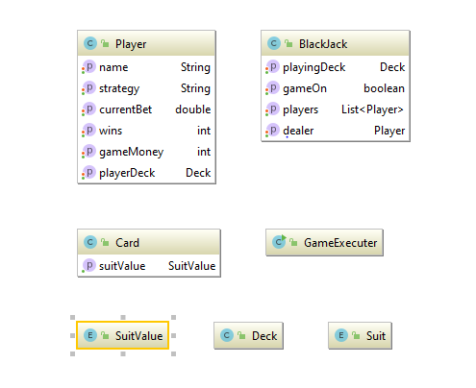
Basic Relationship Between the classes and Enum Demonstrated below: -

