NATIONAL INSTITUTE OF TECHNOLOGY TIRUCHIRAPPALLI



Department of Computer Applications

**Project Topic: Exam Registration**

**Subject: Database systems Lab**

Submitted By –

Rahul kaushal– 205119072

Under the guidance of-

Dr. R Balaji Ganesh

Signature

(Dr. R Balaji Ganesh)

**Index**

1. **Introduction**
2. **Objectives**
3. **Category**
4. **Tools/Platform**
5. **Hardware and Software requirement**
6. **System Design**
7. **Database structures**
8. **Main forms**
9. **Home Form**
10. **Signup form**
11. **Details form**
12. **Registration form**
13. **Submit form**

**Introduction:**

The title of the project is “Exam Registration System”. The project will handle the activities of exam registration. It helps to keep the records of the students who apply for the examination

**Project Category:**

This project as titled “Exam Registration” comes under

**Relational Database Management System.**

This application is developedwith the help of Netbeans 6.5.1 and SQL Plus.

**Tools/Platform:**

This project is developed using the tools, which are most suited for development of the ApplicationPackage. These tools are as follows: -

1. Netbeans 6.5.1 (For front end)

2. Sql Plus (For Database Storage as Back end)

**Hardware and Software :**

**Hardware:**

1. Processor Pentium-3 or higher
2. Processor Speed 533 MHZ
3. Hard Disk Space 20 GB (min.)
4. Ram Memory 32 MB (64 MB recommended)

**Software:**

1. Operating System: Windows 2000/NT/XP
2. Database Server: Mysql Server.

**System Design:**

System Design is the solution to the creation of a new system. This is the important aspect made up of several steps. The complete, efficient and successful system should provide the following in succession: -

1. From where should we start?
2. Where we have to go...
3. Where should we stop?

If the project is to be successful, we will need to answer these questions. The answer of these questions is schema manner and is known as system design. A systematic manner will be followed so as to achieve beneficial result at the end. It involves starting with a vague idea and ultimately developing it up into a useful system. The design phase is transition from a user oriented to a document oriented to the programmers. Software report can be broken into a series of steps starting with the basic ideas and ending with the finished project.

**Database Structure:**

**Users:**

|  |  |  |  |
| --- | --- | --- | --- |
| **Field Name** | **Field Type** | **Constraints** | **Description** |
| **Name** | **Varchar(30)** |  | **Store Name of applicant** |
| **Mail** | **Varchar(30)** | **Primary** | **Store Mail address** |
| **Password** | **Varchar(30)** |  | **Stores password** |
| **Flag** | **Varchar(30)** |  | **Stores the status** |

**Details:**

|  |  |  |  |
| --- | --- | --- | --- |
| **Field Name** | **Field Type** | **Constraints** | **Description** |
| **Fame** | **Varchar(30)** |  | **Store FirstName** |
| **Lname** | **Varchar(30)** |  | **Stores Last name** |
| **Blood Grp** | **Varchar(3)** |  | **Stores Blood Group** |
| **Phone Number** | **Varchar(30)** |  | **Stores Contact number** |
| **Address** | **Varchar(30)** |  | **Stores the status** |
| **Age** | **Integer(38)** |  | **Stores Age** |
| **Tenth** | **Float(126)** |  | **Stores 10th percent** |
| **Twelveth** | **Float(126)** |  | **Stores 12th percent** |
| **Graduation** | **Float(126)** |  | **Stores Graduation percent** |
| **Gender** | **Varchar(6)** |  | **Stores Gender** |
| **Tenth Board** | **Varchar(30)** |  | **Stores tenth Board** |
| **Twelveth Board** | **Varchar(30)** |  | **Stores twelveth Board** |
| **Degree** | **Varchar(30)** |  | **Stores Graduation Degree** |

**Main Forms:**

1. **Home Form:**

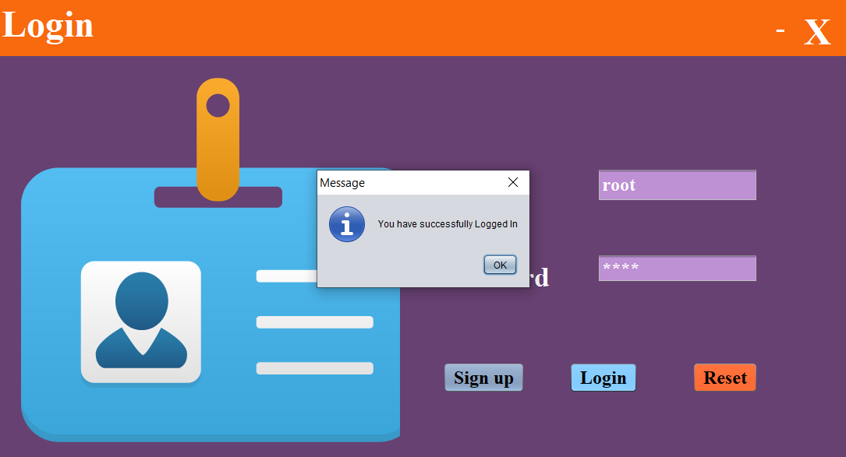

1. **Details Form:**

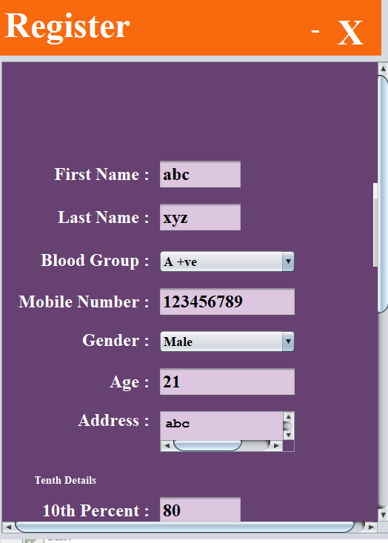

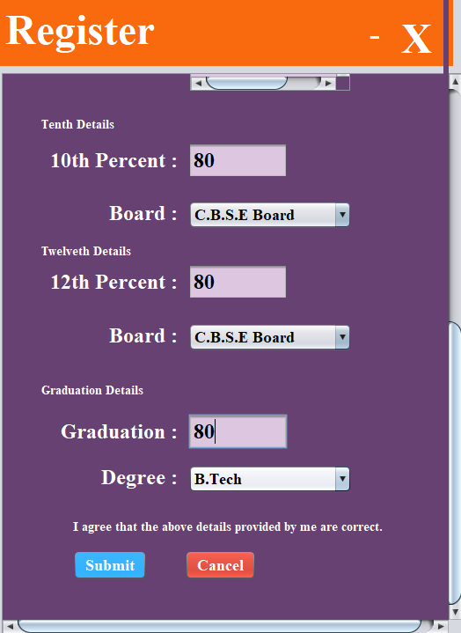

**3.Submit Form:**

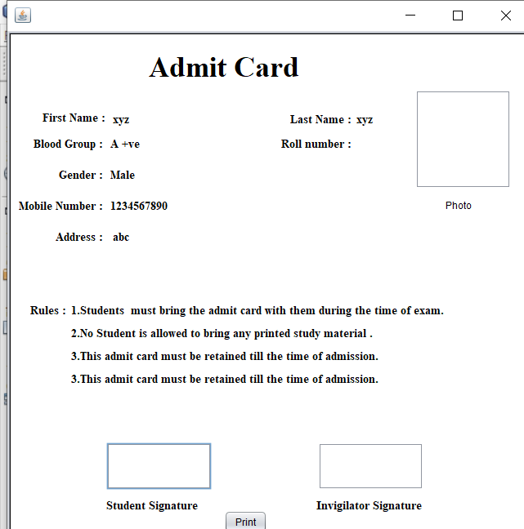

1. **SignUp form:**

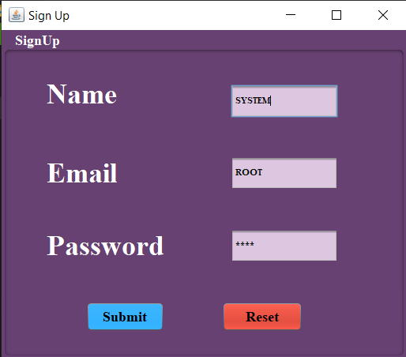

**Code Modules:**

1. **Home**

**import java.sql.* ;**

**import javax.swing.JOptionPane ;**

**private void jButton2ActionPerformed(java.awt.event.ActionEvent evt) {**

**// TODO add your handling code here:**

**if ("".equals(jTextField1.getText()) || "".equals(pas.getText())) {**

**JOptionPane.showMessageDialog(null, "Fields must not be empty");**

**} else {**

**try {**

**String u = jTextField1.getText();**

**String p = pas.getText();**

**Class.forName("oracle.jdbc.driver.OracleDriver");**

**Connection con = (Connection) DriverManager.getConnection("jdbc:oracle:thin:@localhost:1521:root", "system", "root");**

**java.sql.Statement stmt = con.createStatement();**

**String query = "Select * from users where mail='" + u + "'";**

**ResultSet rs = stmt.executeQuery(query);**

**if (rs.next()) {**

**String ps = rs.getString("PASS");**

**String flag;**

**if (p.equals(ps)) {**

**JOptionPane.showMessageDialog(null, "You have successfully Logged In");**

**desc field = new desc();**

**field.setVisible(true);**

**setVisible(false);**

**} else {**

**JOptionPane.showMessageDialog(null, "Please ensure that the entered user name & password is correct !");**

**jTextField1.setText("");**

**pas.setText("");**

**}**

**} else {**

**JOptionPane.showMessageDialog(null, "No Such Records are Found");**

**jTextField1.setText("");**

**pas.setText("");**

**}**

**rs.close();**

**stmt.close();**

**con.close();**

**} catch (Exception e) {**

**JOptionPane.showMessageDialog(null, e);**

**}**

**}**

**}**

**private void jButton1ActionPerformed(java.awt.event.ActionEvent evt) {**

**signup field = new signup();**

**field.setVisible(true);**

**setVisible(false);**

**}**

1. **Details**

**private void jButton1ActionPerformed(java.awt.event.ActionEvent evt) {**

**// TODO add your handling code here:**

**try {**

**Class.forName("oracle.jdbc.driver.OracleDriver");**

**Connection con = (Connection) DriverManager.getConnection("jdbc:oracle:thin:@localhost:1521:root", "system", "root");**

**Statement stmt = (Statement) con.createStatement();**

**String fname = f.getText();**

**String lname = l.getText();**

**String phone = phno.getText();**

**String address = add.getText();**

**String a = m1.getText();//Create a string to store the incoming data**

**float tenth = Float.parseFloat(a);**

**String b = m2.getText();//Create a string to store the incoming data**

**float twelveth = Float.parseFloat(b);**

**String blood = (String) bgrp.getSelectedItem();**

**String gender = (String) g.getSelectedItem();**

**String d = m3.getText();//Create a string to store the incoming data**

**float grad = Float.parseFloat(d);**

**int agee = Integer.parseInt(age.getText());**

**String tenboard = (String) b1.getSelectedItem();**

**String twelveboard = (String) b2.getSelectedItem();**

**String degree = (String) b3.getSelectedItem();**

**PreparedStatement ps = con.prepareStatement("insert into details values(?,?,?,?,?,?,?,?,?,?,?,?,?,?)");**

**ps.setString(1, fname);**

**ps.setString(2, lname);**

**ps.setString(3, blood);**

**ps.setString(4, phone);**

**ps.setString(5, address);**

**ps.setFloat(6, tenth);**

**ps.setFloat(7, twelveth);**

**ps.setFloat(8, grad);**

**ps.setInt(9, agee);**

**ps.setString(10, gender);**

**ps.setString(11, tenboard);**

**ps.setString(12, twelveboard);**

**ps.setString(13, degree);**

**ps.setString(14,"t");**

**int res = ps.executeUpdate();**

**if (res > 0) {**

**// ps=con.prepareStatement("update table users where ");**

**reg det = new reg(fname,lname,blood,gender,address,phone);**

**det.setVisible(true);**

**setVisible(false);**

**}**

**stmt.close();**

**con.close();**

**} catch (Exception e) {**

**JOptionPane.showMessageDialog(null, e);**

**}**

**}**

**private void jButton2ActionPerformed(java.awt.event.ActionEvent evt) {**

**// TODO add your handling code here:**

**this.setVisible(false);**

**}**

1. **Submit**

**public class reg extends javax.swing.JFrame {**

**private float m3,m1,m2;**

**private int age;**

**int sum=0;**

**public reg() {**

**initComponents();**

**}**

**public reg(String fname,String lname,String bloodgrp,String gender,String add,String phno)**

**{**

**initComponents();**

**l1.setText(fname);**

**l2.setText(bloodgrp);**

**l3.setText(gender);**

**l4.setText(phno);**

**l5.setText(add);**

**l6.setText(lname);**

**}**

1. **Sign Up**

**private void submitActionPerformed(java.awt.event.ActionEvent evt) {**

**try{**

**Class.forName("oracle.jdbc.driver.OracleDriver");**

**Connection con=(Connection)DriverManager.getConnection("jdbc:oracle:thin:@localhost:1521:root","system","root");**

**Statement stmt=(Statement) con.createStatement( );**

**String n=name.getText();**

**String p=pass.getText();**

**String m=mail.getText();**

**String query="insert into users values('"+n+"','"+m+"','"+p+"')";**

**stmt.executeUpdate(query);**

**JOptionPane.showMessageDialog(null,"Sign Up successful");**

**new home().setVisible(true);**

**dispose();**

**stmt.close( );**

**con.close( );**

**}**

**catch(Exception e){**

**JOptionPane.showMessageDialog(null,e);**

**}**

**}**

**FUTURE SCOPE**

Nothing is perfect in this world. So, we are also no exception. Although, we have tried our best to present the information effectively, yet, there can be further enhancement in the Application. Like report generation and all. We have taken care of all the critical aspects, which need to take care of during the development of the Project. Like the things this project also has some limitations and can further be enhances by someone, because there are certain drawbacks that do not permit the system to be 100% accurate.