OSOC INDUCTION TASK

Q1.Command for searching pattern line by line in any document with an exampl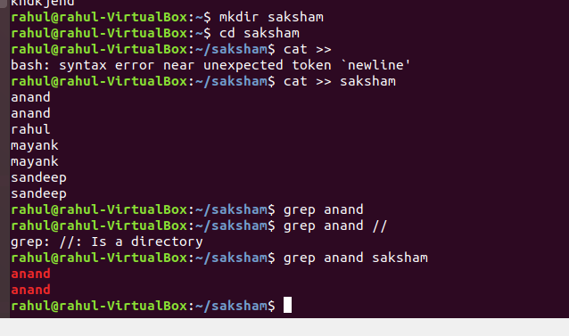e.

Q2. What all permissions are there in Linux?State all permission and different way of changing permission with example.

Ans. r- read, w- Write , x- execute

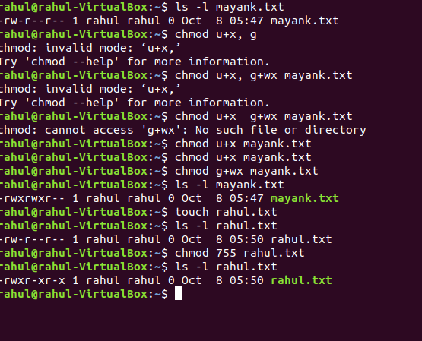

Q3.create a folder OSOC and inside that another folder Induction and now create a file task.txt

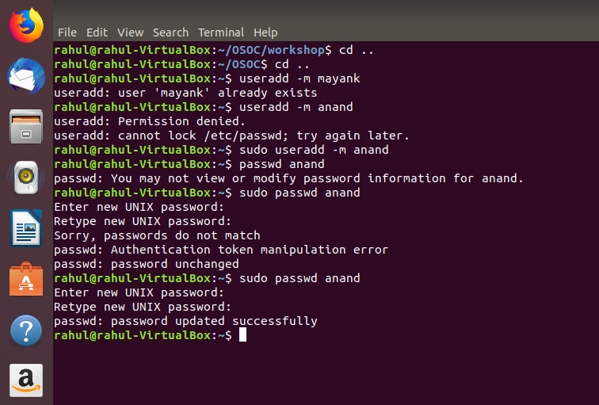

Q4. I want to check whether my system is connected to any network ao not,command for this.

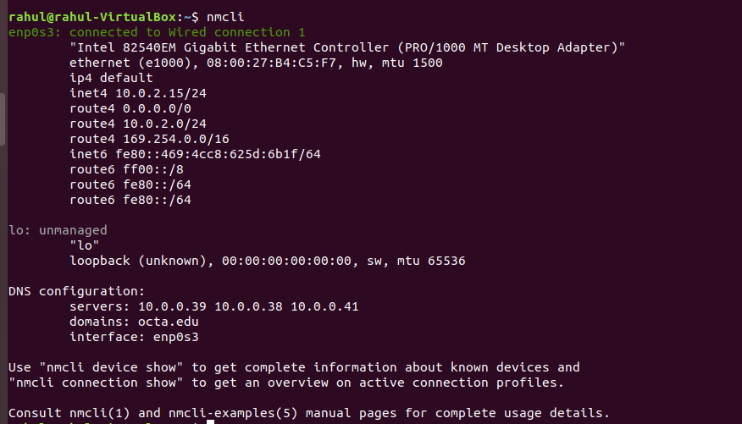

Q5. I want to change password of another user how will I do that ?

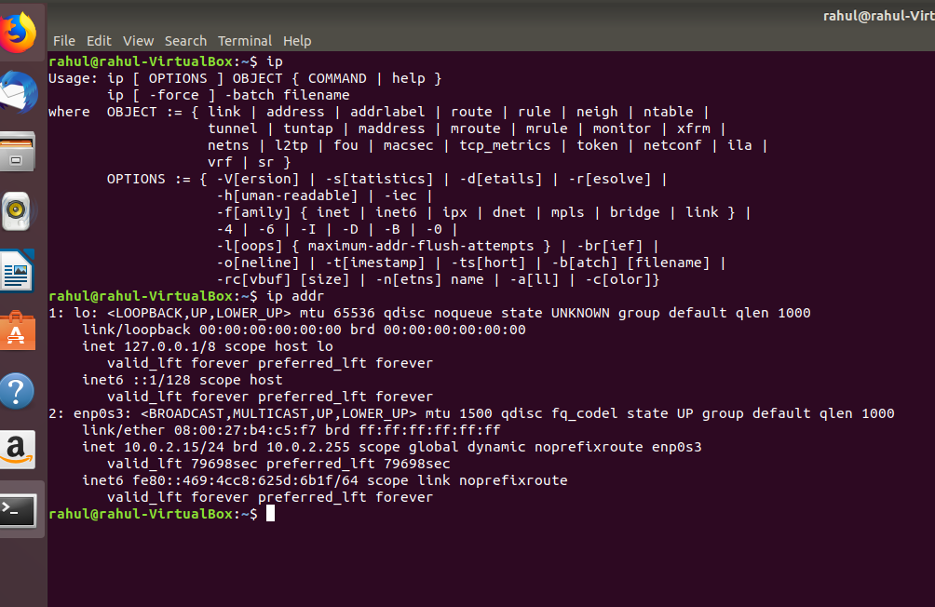

Q6.Using shell scripting

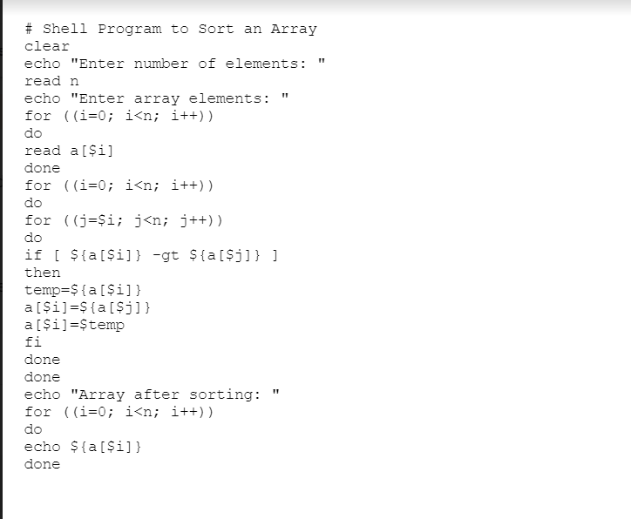

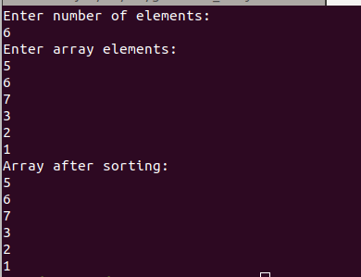

Q7.using shell scripting reverse a string

