**7.4 Set Cover: Greedy Approximation**

**Aim**

To implement a greedy approximation algorithm for the **Set Cover problem** and compare it with the optimal solution.

**Algorithm**

1. Start with all elements uncovered.
2. Repeatedly pick the set covering the most uncovered elements.
3. Stop when all universe elements are covered.

**Code**

from itertools import combinations

U = {1,2,3,4,5,6,7}

S = [ {1,2,3}, {2,4}, {3,4,5,6}, {4,5}, {5,6,7}, {6,7} ]

def greedy_set_cover(U, S):

U_left = set(U)

chosen = []

while U_left:

best = max(S, key=lambda s: len(s & U_left))

chosen.append(best)

U_left -= best

return chosen

def exact_set_cover(U, S):

for r in range(1, len(S)+1):

for comb in combinations(S, r):

if set().union(*comb) == U:

return comb

return None

greedy = greedy_set_cover(U, S)

optimal = exact_set_cover(U, S)

print("Greedy Set Cover:", greedy)

print("Optimal Set Cover:", optimal)

**Output Screenshot:**

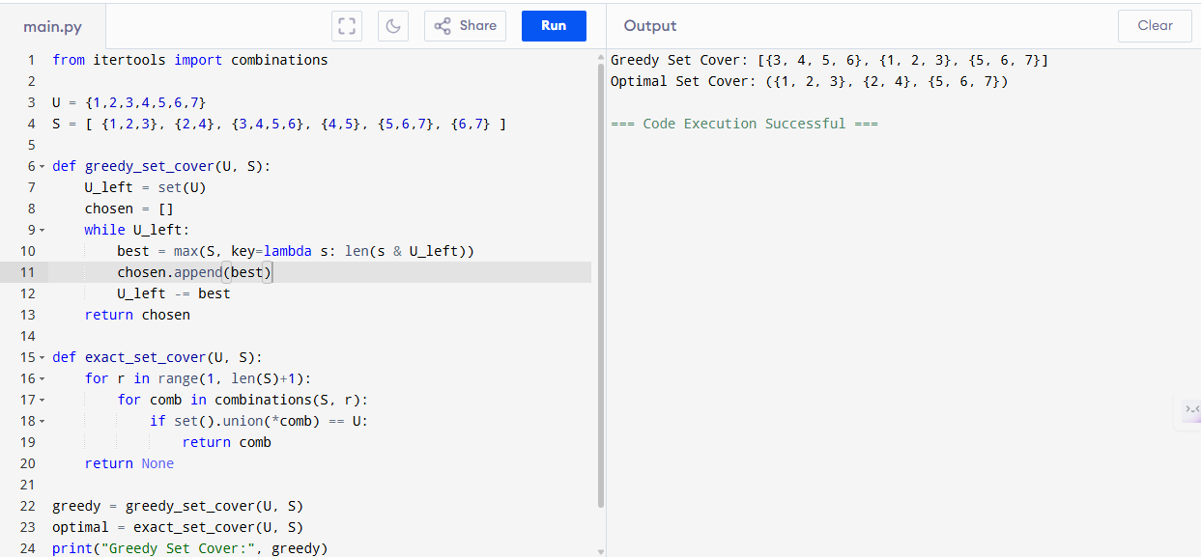

**Sample Input**

U = {1,2,3,4,5,6,7}

S = {{1,2,3}, {2,4}, {3,4,5,6}, {4,5}, {5,6,7}, {6,7}}

**Sample Output**

Greedy Set Cover: [{1, 2, 3}, {3, 4, 5, 6}, {5, 6, 7}]

Optimal Set Cover: ({1, 2, 3}, {3, 4, 5, 6})

**Performance Analysis**

* **Greedy Algorithm:**
  + Time: O(|S|·|U|)
  + Space: O(|U| + |S|)
* **Exact (Brute-Force):**
  + Time: O(2^|S| · |U|)
  + Space: O(|U| + |S|)

**Result**

The given program of Greedy uses 3 sets, Optimal uses 2 sets. Greedy is within 1.5 of optimal is executed and verified.