**3.11** To Implement the Median of Medians algorithm ensures that you handle the worst-case time complexity efficiently while finding the k-th smallest element in an unsorted array.

arr = [12, 3, 5, 7, 19] k = 2 Expected Output:5

**AIM**

To implement the Median of Medians algorithm to find the k-th smallest element in an unsorted array efficiently with guaranteed worst-case linear time.

**ALGORITHM**

1. **Divide the array** into groups of at most 5 elements.
2. **Sort each group** and find the median of each group.
3. **Recursively apply** the Median of Medians algorithm to the medians array to find the pivot.
4. **Partition** the array around the pivot.
5. If the pivot’s position matches k, return it.
6. If k is smaller, recurse on the left side; otherwise, recurse on the right side.

**PROGRAM**

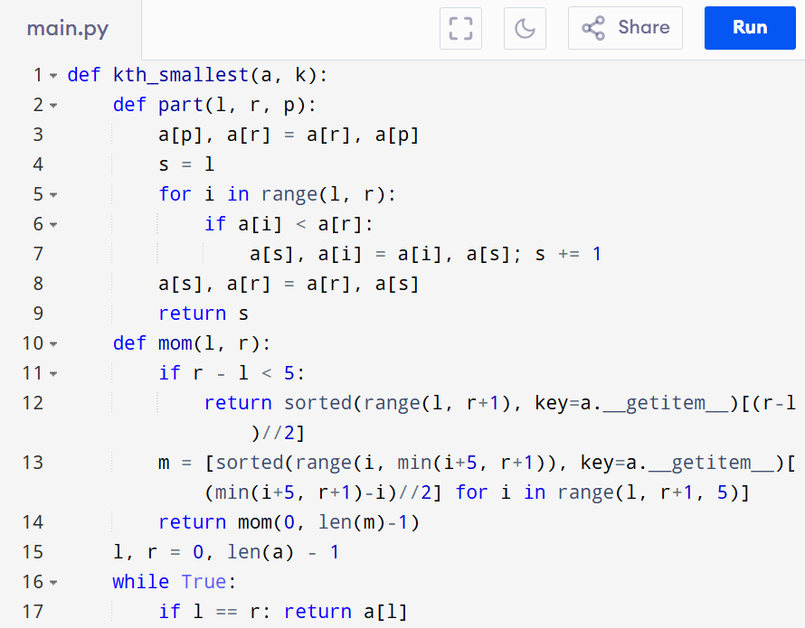

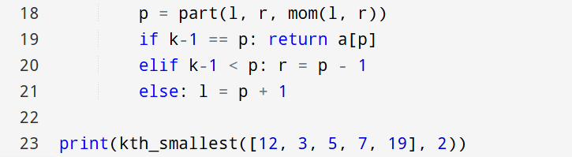

Input:

arr = [12, 3, 5, 7, 19] , k = 2

Output:

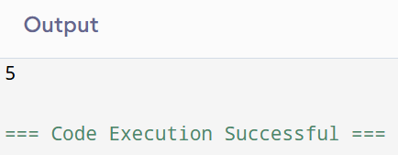

**RESULT:**

Thus the program to implement the median of medians algorithm is successfully executed and the output is verified.

**PERFORMANCE ANALYSIS:**

* Time Complexity: O(n).
* Space Complexity:O(log n)