**3.13** Write a program to implement Meet in the Middle Technique. Given an array of integers and a target sum, find the subset whose sum is closest to the target. You will use the Meet in the Middle technique to efficiently find this subset.

Set[] = {45, 34, 4, 12, 5, 2} Target Sum : 42

**AIM**

To implement the Meet in the Middle technique to find a subset whose sum is closest to a given target sum.

**ALGORITHM**

1. Split the array into two halves.
2. Generate all subset sums for each half.
3. Sort one half’s subset sums.
4. For each sum in the first half’s list, use binary search in the second half’s sorted list to find the sum that gets closest to the target.
5. Keep track of the best sum and the corresponding subset.

**PROGRAM**

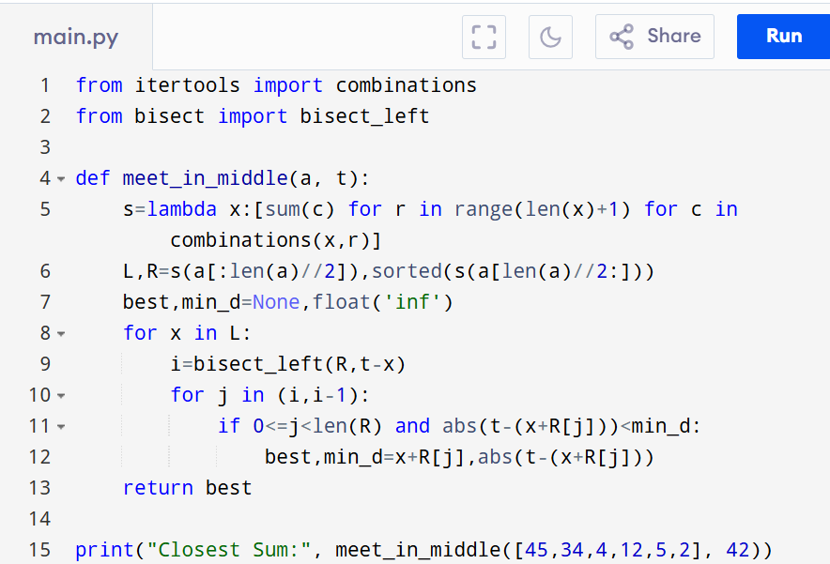

Input:

Set[] = {45, 34, 4, 12, 5, 2}

Output:

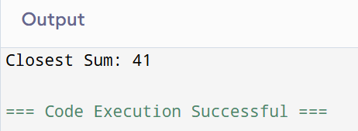

**RESULT:**

Thus the program to implement the meet in the middle technique is successfully executed and the output is verified.

**PERFORMANCE ANALYSIS:**

* + Time Complexity: O(2^n/2.n).
  + Space Complexity:O(2n/2).