**3.14 MEET IN MIDDLE TECHNIQUE**

**Aim:** To solve the Subset Sum Problem using the Meet in the Middle (MITM) technique.

**Algorithm:**

1. Split array into two halves: left, right.
2. Generate all possible subset sums of both halves.
3. Sort the right sums.
4. For each sum in the left, check if target - sum exists in right using binary search.
5. If found, return True; else, return False.

**Program:**

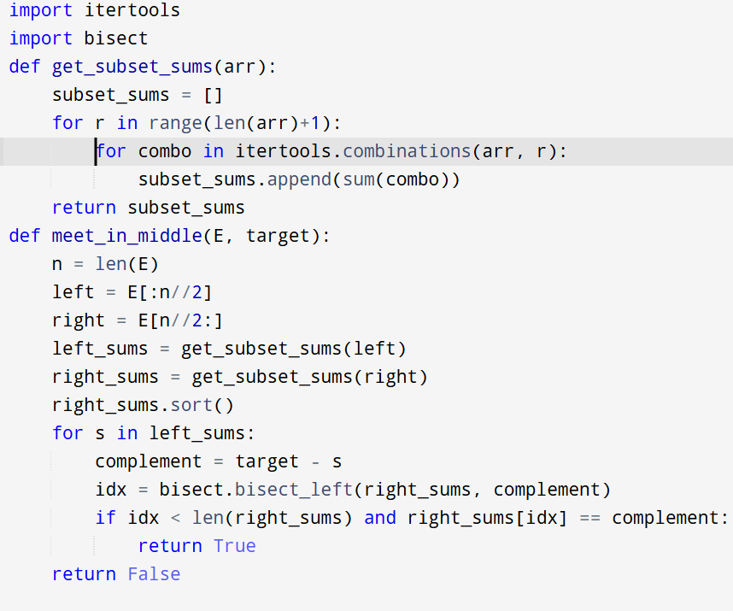

**Input:**

E = [1, 3, 9, 2, 7, 12]

**Output:**

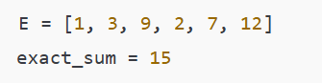

**Result:** Thus, the program is executed successfully and output is verified.

**Performance analysis:**

* Time Complexity: O(2^(n/2) * log(2^(n/2))) = O(2^(n/2) * n)
* Space Complexity: O(2^(n/2))