**3.15** Given two 2×2 Matrices A and B

A=(1 7​ , B=( 1 3

3 5) 7 5)

Use Strassen's matrix multiplication algorithm to compute the product matrix C such that C=A×B.

**AIM**

To multiply two 2×2 matrices using **Strassen’s algorithm**, which reduces the number of multiplications compared to the standard method.

**ALGORITHM**

1. Let A=[a​b​ B=[e​f

c d] g h]

1. Compute the following intermediate products:

M1=(a+d)(e+h)

M2=(c+d)e

M3=a(f−h)

M4=d(g−e)

M5=(a+b)h

M6=(c−a)(e+f)

M7=(b−d)(g+h)

1. Compute the result matrix:

C11​=M1+M4−M5+M7

C12​=M3+M5

C21​=M2+M4

C22​=M1−M2+M3+M6

**PROGRAM** 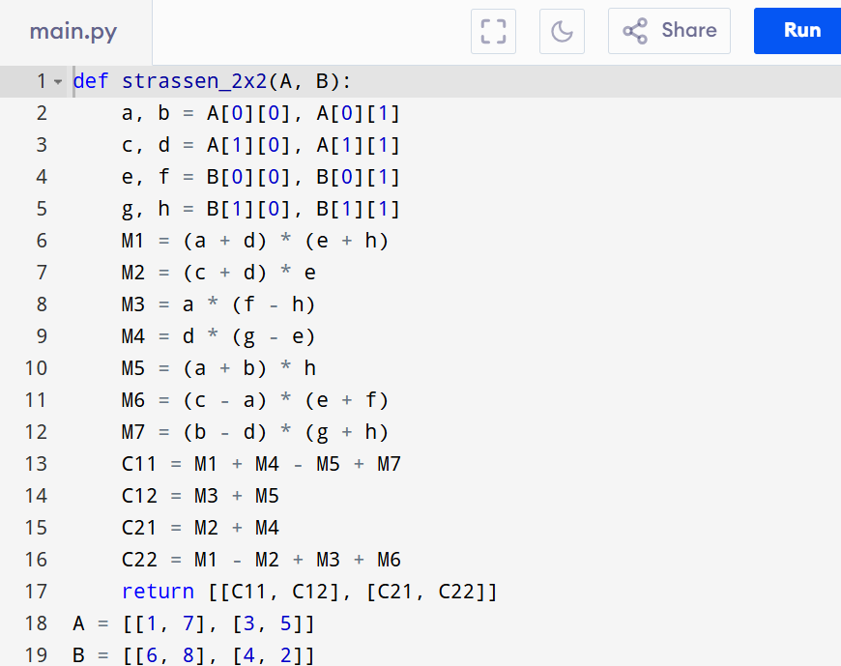

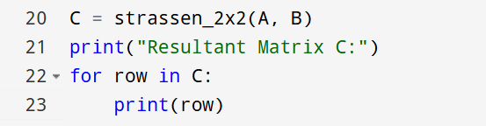

Input:

A=(1 7​ B=( 1 3

3 5) 7 5)

Output:

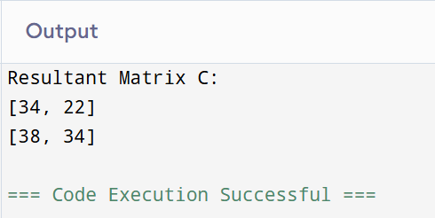

**RESULT:**

Thus the program to multiply two 2×2 matrices using s**trassen’s algorithm** is successfully executed and the output is verified.

**PERFORMANCE ANALYSIS:**

* Time Complexity: O(n^3).
* Space Complexity:O(n^2).