**3.16 Karatsuba algorithm**

**Aim:** To compute the product of two integers, X=1234 and Y=5678, using the Karatsuba algorithm and analyse its performance.

**Algorithm:**

1. For two numbers, X and Y, with n digits, they are split into two halves:
2. X=acdot10m+b
3. Y=ccdot10m+d
4. Where m is approximately n/2.
5. The product Z=XcdotY is given by the formula:
6. Z=(a⋅10m+b)(c⋅10m+d)=ac⋅102m+(ad+bc)⋅10m+bd
7. The standard method computes four products: ac, ad, bc, and bd. Karatsuba reduces this to three products by cleverly rearranging the terms:
8. P_1=ac
9. P_2=bd
10. P_3=(a+b)(c+d)
11. From these, we can find the middle term:
12. (a+b)(c+d)=ac+ad+bc+bd⟹ad+bc=(a+b)(c+d)−ac−bd=P3​−P1​−P2​
13. The final product is then:
14. Z=P1​⋅102m+(P3​−P1​−P2​)⋅10m+P2​

**Program:**

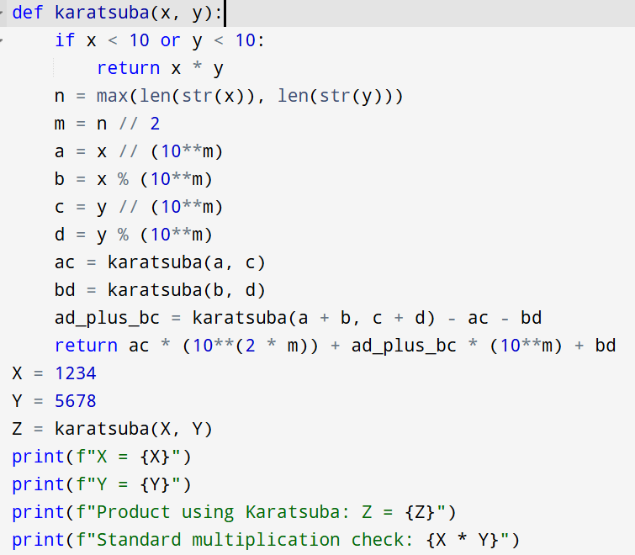

**Input:**

* X=1234
* Y=5678

**Output:**

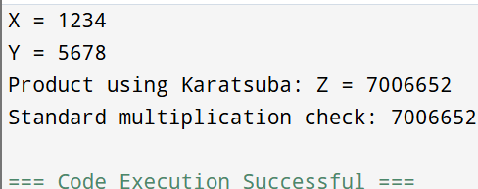

**Result:** Thus, the program is executed successfully and output is verified.

**Performance analysis:**

* Time Complexity: O(nlog_23)
* Space Complexity: O(n2).