**3.7** Implement the Binary Search algorithm in a programming language of your choice and test it on the array 5,10,15,20,25,30,35,40,45 to find the position of the element 20.Execute your code and provide the index of the element 20.Modify your implementation to count the number of comparisons made during the search process. Print this count along with the result.

**AIM**

To implement the binary search algorithm to find the position of a given element in a sorted array and count the number of comparisons made during the search.

**ALGORITHM**

1. Initialize low = 0 and high = N - 1, comparisons = 0.
2. While low <= high:

* Increment comparisons.
* Find mid = (low + high)

1. If a[mid] == key, return mid + 1 (position) and comparisons.
2. If a[mid] < key, set low = mid + 1.
3. Else set high = mid - 1.
4. If element not found, return -1 and comparisons.

**PROGRAM**

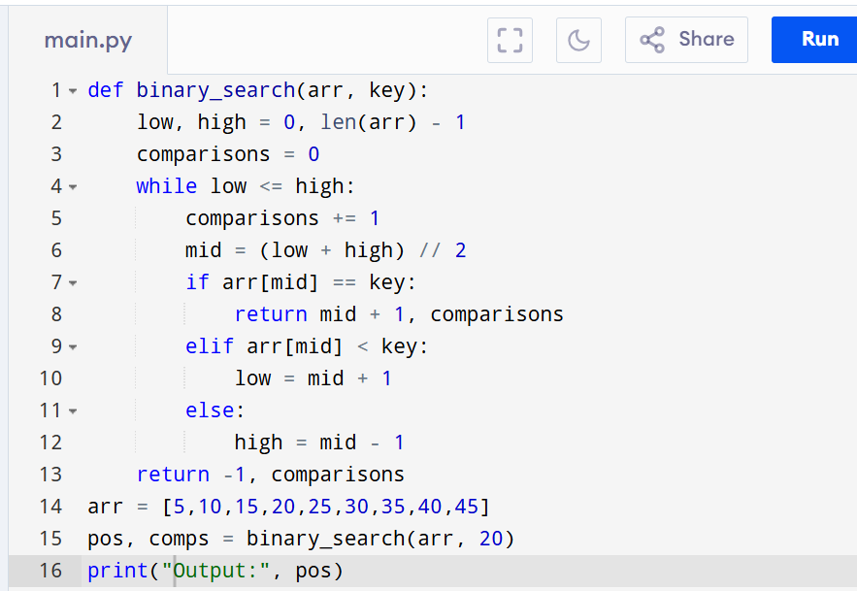

Input:

N = 9

a = [5,10,15,20,25,30,35,40,45]

search key = 20

Output:

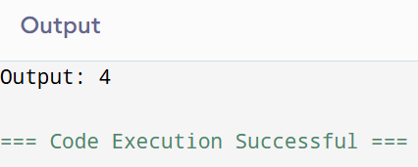

**RESULT:**

Thus the program for binary search algorithm with comparison count is successfully executed and the output is verified.

**PERFORMANCE ANALYSIS:**

· **Time Complexity:** O(log n)

· **Space Complexity:** O(1)