**3.9** Given an array of points where points[i] = [xi, yi] represents a point on the X-Y plane and an integer k, return the k closest points to the origin (0, 0).

**AIM**

To find the k closest points to the origin (0,0) from a given list of points using the Euclidean distance formula.

**ALGORITHM**

1. Read the list of points and the integer k.
2. For each point (x, y), compute its squared Euclidean distance from (0,0).
3. Sort all points in ascending order of distance.
4. Return the first k points from the sorted list.

·

**PROGRAM**

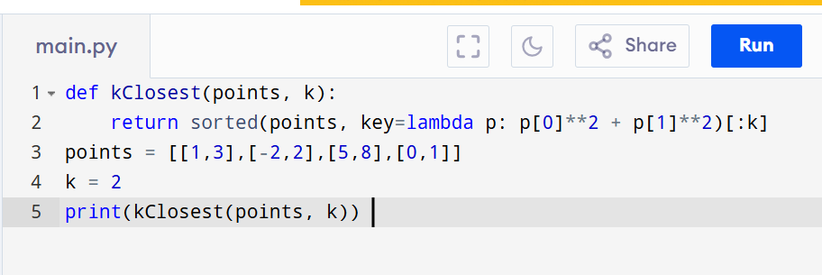

Input:

points = [[1,3],[-2,2],[5,8],[0,1]] , k=2

Output:

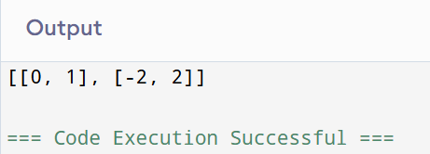

**RESULT:**

Thus the program for k closest points to origin is successfully executed and the output is verified.

**PERFORMANCE ANALYSIS:**

* + Time Complexity:O(n log n).
  + Space Complexity: O(n).