**4.1** You are given the number of sides on a die (num_sides), the number of dice to throw (num_dice), and a target sum (target). Develop a program that utilizes dynamic programming to solve the Dice Throw Problem.

**AIM**

To implement **Insertion Sort** to sort an array **containing duplicate elements**

**ALGORITHM**

1.Start from the second element.

2.Compare the current element with elements before it.

3. Shift larger elements one position ahead to make space.

4. Insert the current element at its correct position.

**PROGRAM**

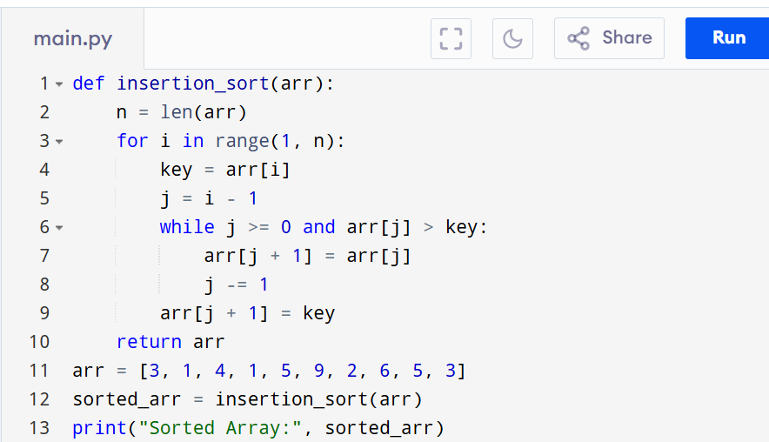

Input:

arr = [3, 1, 4, 1, 5, 9, 2, 6, 5, 3]

sorted_arr = insertion_sort(arr)

print("Sorted Array:", sorted_arr)

Output:

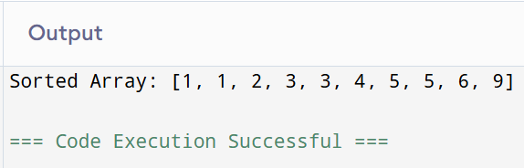

**RESULT:**

Thus the programo implement I**nsertion Sort** to sort an array **containing duplicate elements** is successfully executed and the output is verified.

**PERFORMANCE ANALYSIS:**

Time Complexity:O(n)

Space Complexity: O(1)