**4.2** In a factory, there are two assembly lines, each with n stations. Each station performs a specific task and takes a certain amount of time to complete. The task must go through each station in order, and there is also a transfer time for switching from one line to another. Given the time taken at each station on both lines and the transfer time between the lines, the goal is to find the minimum time required to process a product from start to end.

### **AIM**

Find the minimum time to process a product through two assembly lines with n stations each, considering processing times and transfer times.

**ALGORITHM**

1. **Start at the first station:**

* ·Calculate how much time it takes to enter and finish the first station on each assembly line. This is your starting time for each line.
* **Move to the next stations one by one:**
* For each next station on both lines, decide which is faster:
* Staying on the **same assembly line** as the previous station, or
* **Switching** from the other assembly line (which takes some extra transfer time).

1. Choose the option that results in the least total time up to that station.
2. **Repeat this decision for every station** until you reach the last station on both lines.
3. After finishing the last station, add the exit time from each line.
4. **Compare the total times:**

* Compare the total times of finishing on each line and select the smaller one.
* This smallest time is the minimum total time to process the product.

**PROGRAM**

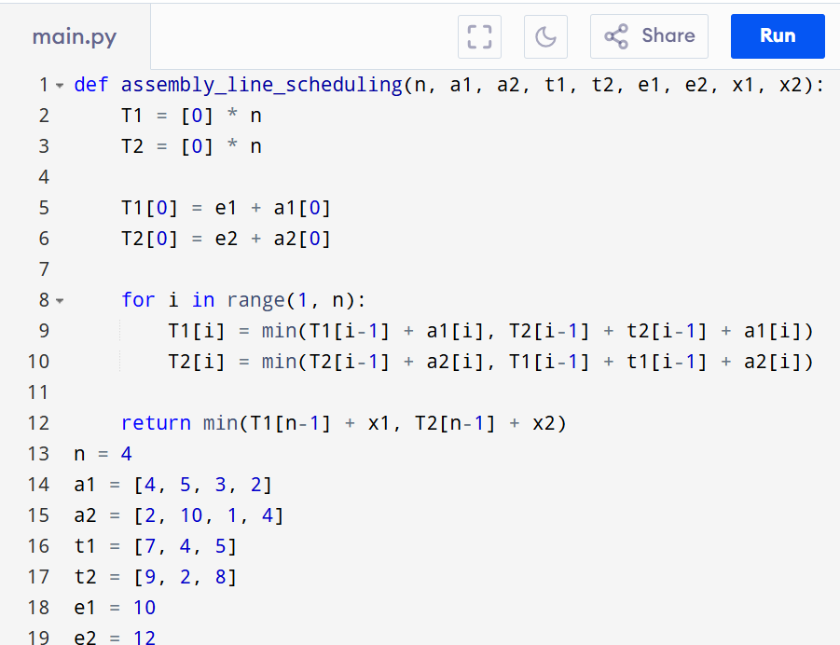

Input:

n: Number of stations on each line.

a1[i]: Time taken at station i on assembly line 1.

a2[i]: Time taken at station i on assembly line 2.

t1[i]: Transfer time from assembly line 1 to assembly line 2 after station i.

t2[i]: Transfer time from assembly line 2 to assembly line 1 after station i.

e1: Entry time to assembly line 1.

e2: Entry time to assembly line 2.

x1: Exit time from assembly line 1.

x2: Exit time from assembly line 2.

Output:

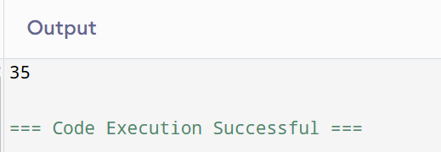

**RESULT:**

Thus the program to find the minimum time to process a product through two assembly linesis successfully executed and the output is verified.

**PERFORMANCE ANALYSIS:**

Time Complexity:

* Best Case: O(n)

Space Complexity:

* O(3*n)