**4.3** An automotive company has three assembly lines (Line 1, Line 2, Line 3) to produce different car models. Each line has a series of stations, and each station takes a certain amount of time to complete its task. Additionally, there are transfer times between lines, and certain dependencies must be respected due to the sequential nature of some tasks. Your goal is to minimize the total production time by determining the optimal scheduling of tasks across these lines, considering the transfer times and dependencies.

**AIM**

Minimize total production time for 3 assembly lines with station times, transfer times, and dependencies between stations.

**ALGORITHM**

1. For each station i, you must respect dependencies:  
   Here, (0,1), (1,2) means station 1 depends on station 0 and station 2 depends on station 1.
2. We can model this as dynamic programming for each line l and station i:  
   Let dp[l][i] = minimum time to complete station i on line l.
3. For station 0, dp[l][0] = a[l][0]
4. For station i > 0:

dp[l][i] = a[l][i] + min(

dp[l][i-1], # stay on same line

min(dp[other_lines][i-1] + transfer_time[other_lines][l][i-1]))

1. The final answer = min of dp over lines at the last station.

**PROGRAM**

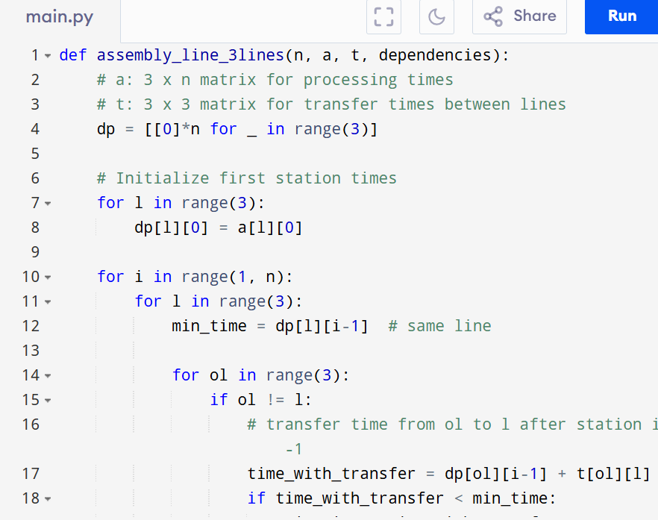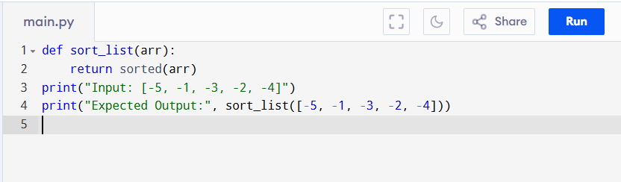

Input:

n = 3

a = [

[5, 9, 3],

[6, 8, 4],

[7, 6, 5]

]

t = [

[0, 2, 3],

[2, 0, 4],

[3, 4, 0]

]

dependencies = [(0,1), (1,2)]

Output:

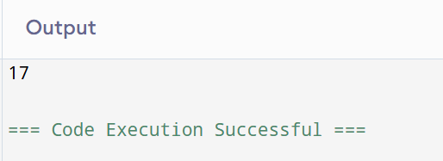

**RESULT:**

Thus the program that sorts a list containing negative numbers in ascending order is successfully executed and the output is verified.

**PERFORMANCE ANALYSIS:**

Time Complexity:Best Case: O(n)

Space Complexity:

* O(3*n)