BUILD FOR INDIA - SIH Internal Hackathon 2025
Theme: MedTech / Biotech / HealthTech
Team Name: Bit Blasters
Team Leader: Priyam Gupta
Team Members: Rahul Singh Bhandari, Niharika Bisht, Krishna Sharma, Harshita Pathak, Garvit Singh Negi

Problem Statement
"AyuNet" – An integrated digital platform for emergency response and Public Health
India struggles with two persistent healthcare issues: slow and uncoordinated emergency response (ambulance routing, hospital bed availability) and insufficient preventive health systems (outbreak monitoring, vaccination drives, and rural access). These gaps often cause preventable deaths, strain on medical infrastructure, and delayed government interventions. AyuNet is designed to directly tackle these issues.

Proposed Solution
AyuNet is a technology-driven health and emergency platform that unifies critical services on both web and mobile interfaces. It creates seamless connections between citizens, frontline workers, ambulances, hospitals, and government authorities. The system is designed to increase emergency medical response and community-level healthcare delivery.

Core Capabilities and Solution Components
1. Emergency Response Integration
- Live ambulance tracking using GPS, linked with information on real-time hospital bed and ICU availability.
- The system will feature dynamic hospital dashboards that provide real-time updates on emergency department facilities and resource availability.
- Smart diagnostic kits powered by IoT devices, enabling rural health workers to perform basic tests supported by AI-based triage recommendations.
2. Preventive and Public Health Strengthening
- Community engagement tools, including awareness drives, interactive reminders, and gamified features to promote healthy practices and vaccination uptake.
- Digital symptom assessment powered by AI/ML, helping detect early indications of potential outbreaks.
- Predictive data modelling that identifies vulnerable areas, maps hotspots, and generates insights for policy and planning.
- Mobile applications for frontline workers (ASHA/ANM) to record household health data, monitor risks, and ensure timely follow-ups.

How AyuNet Remoulds Healthcare
- It is beneficial for both rural and urban areas as it has scalability.
- Empowering community health workers (ASHA) equipped with tools and AI assistance.
- It also helps in early diseases detection.
- Ensures optimal use of hospital beds, ambulances etc.

Example:
- In a village, a patient with chest pain is assessed by a health worker using portable IoT medical devices. AyuNet evaluates urgency and directs the ambulance to the nearest hospital with free beds.

- It automatically notifies individuals about their due doses, incorporates engaging features to encourage wider participation, and offers real-time dashboards to track progress and outcomes.

System Architecture
Core Components: The Foundation
The AyuNet platform is built on four key elements that ensure smooth operation and reliability:
Frontend: The user facing layer, delivered through mobile applications and web dashboards. This is where citizens, healthcare professionals and administrators interact with the system. It is easy to use, and gives optimized solution at time of emergency.
Backend: The central processing hub that manages all the incoming requests, applies healthcare-specific business rules, connects services and ensures system reliability.
Database: The secure repository where all essential records are stored, including patient information, emergency request, and administrative data. It is optimised for fast access and capable of handling large volumes of dynamic data.
API Gateway: The single-entry point for all external requests. It verifies user identity, directs traffic to the appropriate backend services and enhances both security and efficiency of communication.
Architectural Layers: Functional Organisation
The system is organised into three main layers:
1- Presentation Layer (frontend) handles user interaction and displays information in a clear device friendly format.
2- Application Layer (backend) executes business logic, processes input, validates action and communicates with data layer.
3- The Data Layer (database) is designed to provide secure storage and efficient access to healthcare and administrative records.
End to End request flow
A typical request in AyuNet follows this path:
1- A user (e.g.- a patient requesting emergency help) submits am action through the frontend.
2- The request passes through the API Gateway, which authenticates the user and forwards it to the backend.
3- The backend processes the request, interacts with the database and prepares the response.
4- The frontend then displays the response in a clear and user-friendly way.
Guiding Principles of the System
1- Microservices Approach - Independent services, such as emergency response or patient record management, operate as part of a modular ecosystem.
2- API driven Integration - Standardized APIs enable seamless communication between internal services and with external healthcare systems.
3- Scalability- The platform is designed for horizontal scaling, allowing additional servers or instances to be added as demand grows without affecting performance.

Flowcharts

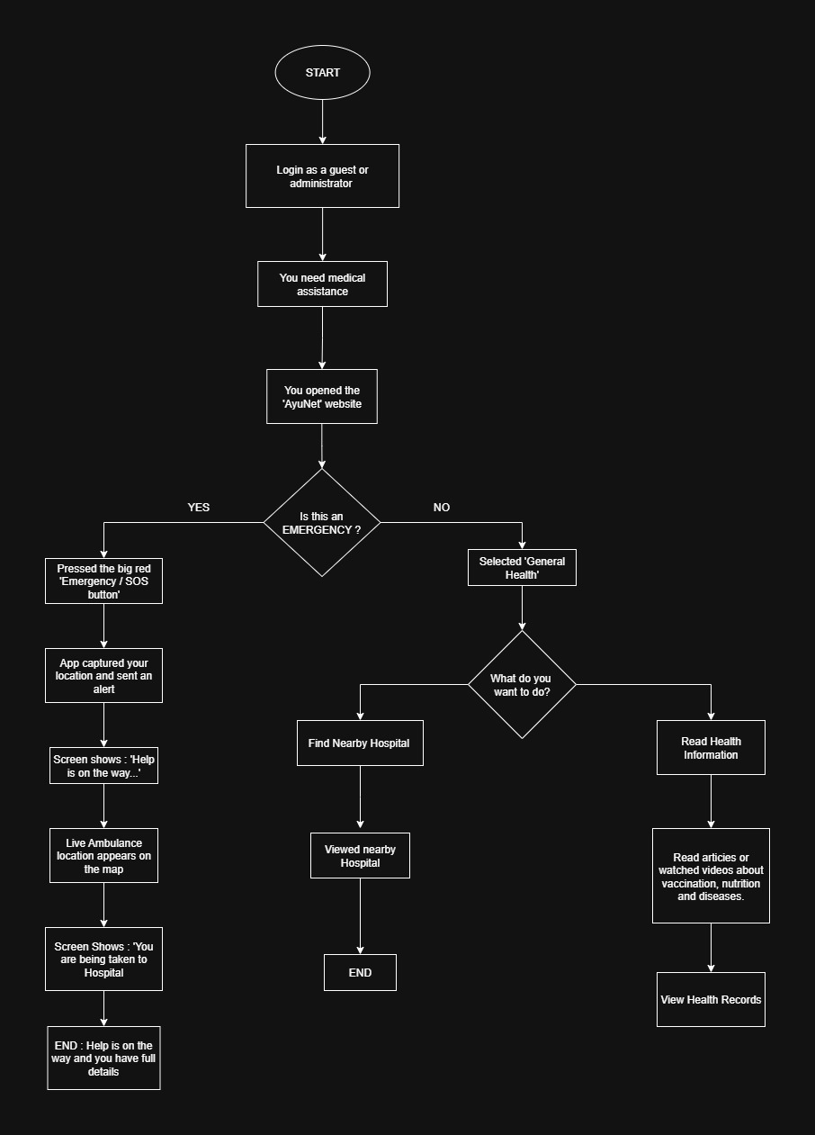

System Architecture

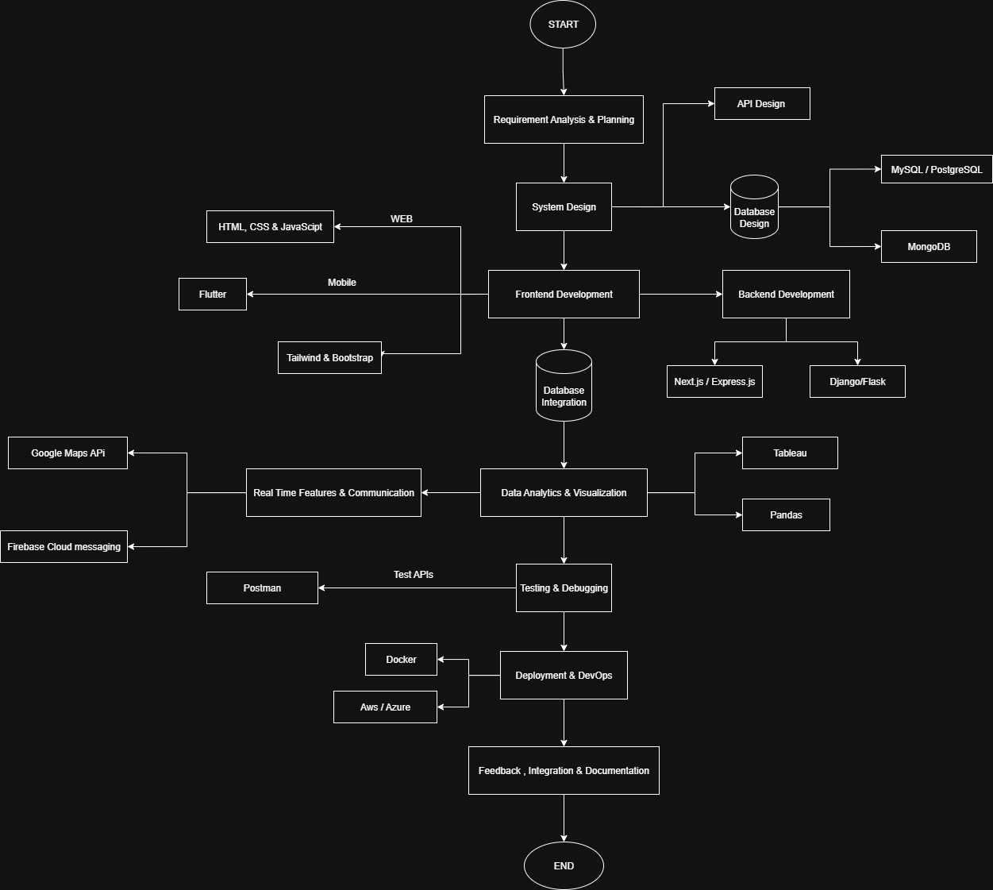

Tech Stack
- Frontend (User interface)
- WEB:
HTML, CSS and JavaScript: for creating and styling web pages.
React.js: to create reusable UI components.
- Mobile
React Native: Cross - platform mobile app for both Android and IOS.
- Backend (APIs)
- Flask: for implementing APIs.
- Django: includes Object Relation Mapping and tools for handling user authentication.
- Next.js and Node.js using Js 8 engine for fast processing and acquiring different interfaces/preview according to who is using.
- Database
- MongoDB: to handle unstructured data and provide high scalability.
- MySQL: SQL for structured health records and storing structured data and to manipulate data.
- APIs & Services
- Google Maps API: for tracking locations.
- Firebase: Push Notifications and SMS.
- Data Analytics
- Tableau: for monitoring visuals dashboards.
- Pandas: for data processing
- Deployment and DevOps
- PaaS (Platform as a service): Versel, Heruko and Docker for making the system live and scalable.
- Tools
- Version Control: Git, GitHub for tracking changes, manage code versions and facilitate collaboration among developers.
- Postman: for API Testing
- Figma: UI/UX Design for system
- Security and Monitoring:
- Firebase Auth for login credentials.

- Project Management & Collaboration
- Discord: for sharing updates, code snippets and documents.

Research / Early Work
In developing AyuNet, we conducted an in-depth review of reports from organizations such as WHO and NITI Aayog, along with an analysis of existing digital health solutions like Aarogya Setu and eSanjeevani. Our research revealed major shortcomings in the coordination between emergency medical services and preventive healthcare mechanisms. To address this, we envisioned AyuNet as a unified platform that delivers both real-time emergency support and long-term health management. Recognizing that building a large-scale project requires more than just a strong idea, we invested time in detailed planning and step-by-step system design. Through multiple stakeholder meetings, we mapped the complete flow of services—from patients and frontline workers to ambulances and hospitals—ensuring end-to-end coordination. To strengthen the foundation of our solution, we also validated the technical infrastructure, confirming that tools such as real-time databases, APIs, and geolocation services could be seamlessly integrated into the platform.

Implementation Plan
The development of the system will follow a phased approach, with each stage designed to align with the selected technology stack. This approach ensures smooth progress, modularity, and a reliable final solution.

1. Requirement Analysis & Planning
We’ll begin by defining the system goals: faster emergency response, real-time ambulance tracking, and outbreak monitoring. User roles such as citizens, doctors, health workers, and officials will be identified. At this stage, we also finalise the scope and features.

2. System Design
Next, we plan how the system works internally. Data flow diagrams will show movement of information between citizens, backend, hospitals, and officials. A hybrid database will be designed:
- MySQL/PostgreSQL for structured health records.
- MongoDB for real-time logs like ambulance tracking.
We’ll also design the API endpoints for communication. Tools: Draw.io/ Lucid chart, Figma.

3. Frontend Development (Web & Mobile)
The user interfaces will be built for both web and mobile:
- Web (React.js + Tailwind/Bootstrap): Citizen portal for emergency requests and ambulance Tracking. Health worker portal for patient data entry.
- Mobile (React Native): Citizen app with SOS and ambulance tracking. Health worker app for quick updates.

4. Backend Development & APIs
We’ll use Node.js + Express.js to handle requests and real-time communication. APIs will manage ambulance tracking, hospital coordination, and reporting. Security will be ensured with JWT/OAuth 2.0 and HTTPS.
Testing Tool: Postman.

5. Database Integration
The backend will integrate with both databases:
- MySQL/PostgreSQL: permanent storage of patients, hospitals, doctors.
- MongoDB: fast-changing data like ambulance locations. This ensures data is both structured and flexible.

6. Real-Time Features & Communication
Critical for emergencies, this stage focuses on:
- Socket.io: live ambulance location sharing.
- Google Maps API: navigation and nearest hospital routes.
- Firebase Cloud Messaging: instant push notifications.

7. Data Analytics & Visualization
Collected data will be analyzed for insights.
- Pandas / NumPy for processing health data.
- Chart.js / D3.js for interactive dashboards.

8. Testing & Debugging
- Security testing with encryption checks.
- Integration testing for system flow.
- Unit testing for individual components.

9. Deployment & DevOps
Once tested, the system will be deployed on the cloud.
- Docker for containerization.
- CI/CD pipelines for smooth updates.
- Hosting on AWS / Azure.

10. Feedback, Iteration & Documentation
Finally, we will gather stakeholder feedback to enhance both the usability and overall performance of the system. In addition, comprehensive documentation will be prepared—covering technical details such as APIs and database schemas for developers, as well as user guides tailored for end-users.

Core fundamentals of this plan:
- Matches the strengths of the chosen tech stack.
- Breaks the project into independent, manageable modules.
- Keeps real-time response and analytics at the core.

References
- WHO Digital Health Strategy
- NITI Aayog Healthcare Reports
- https://sih.gov.in/SIH_Themes.
National Family Health Survey (NFHS-5).
International Institute for Population Sciences (IIPS) and MoHFW, 2021.
👉 http://rchiips.org/nfhs/
Aarogya Setu Official Documentation.
Government of India, 2020. 👉 https://www.aarogyasetu.gov.in/

