**RAHUL AGGARWAL**

**190103120**

DESIGN OF COLLAPSIBLE FOOT BRIDGE MECHANISM

# **Goals**

Design of collapsible foot bridge mechanism with its motion study and kinematic analysis.

# **CAD Model**

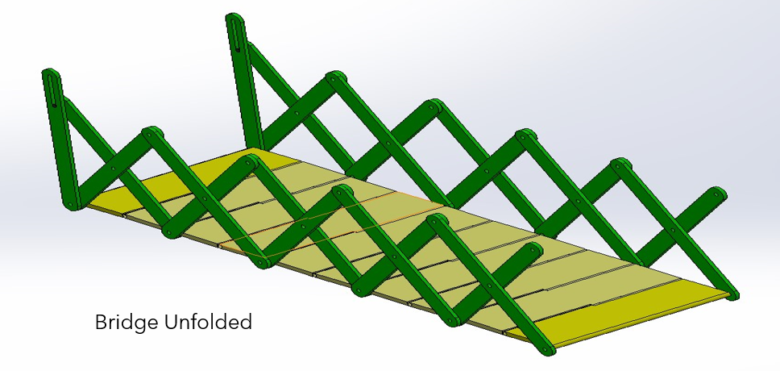

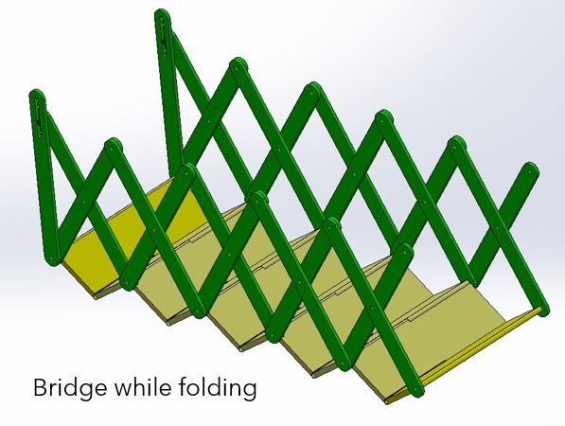

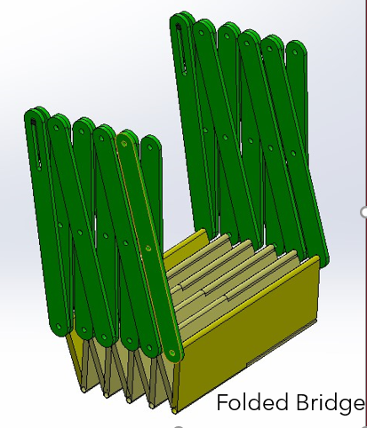

# **Parts Used**

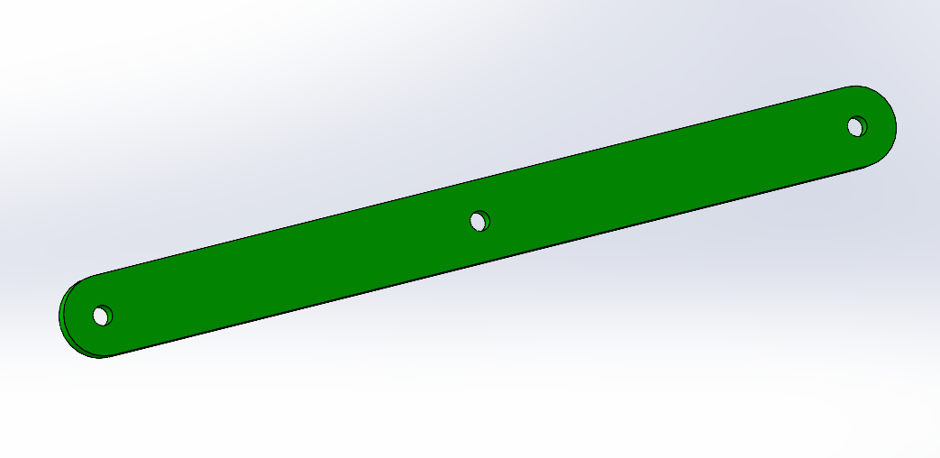

Side Bars

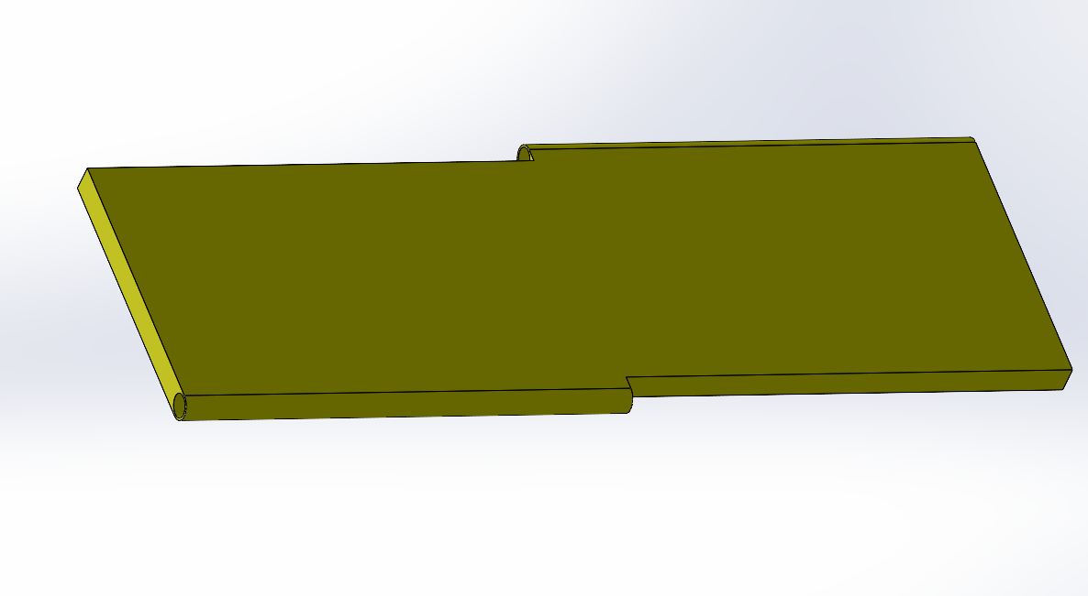

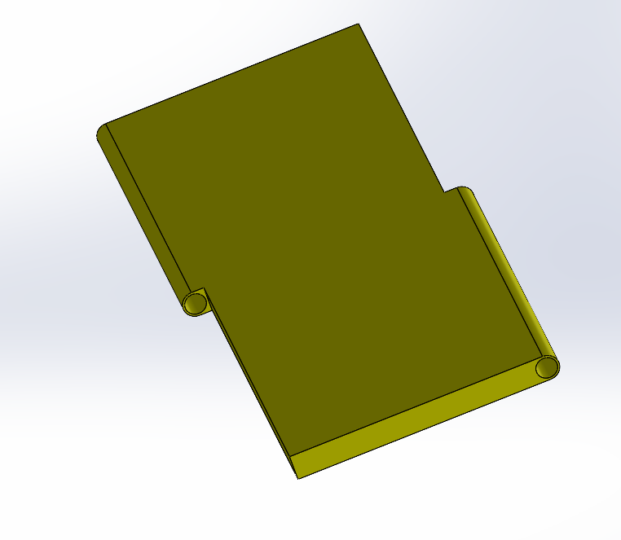

Footpath Base

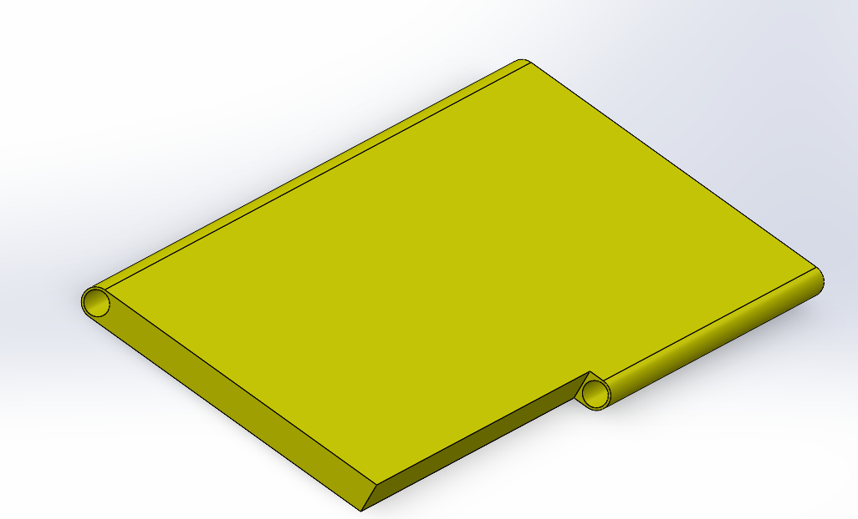

Footpath start and end base

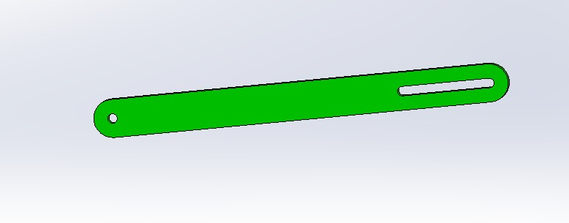

Pin Slot Bar

# **Mechanisms Used**

* **Scissor Mechanism**
  + The scissor mechanism is the **main mechanism** used to make this bridge.
  + This mechanism is used to design the collapsible mechanism of the foot bridge.
  + A scissor mechanism uses linked, support in a criss – cross pattern. When pressure is put on the extremum support, the cross struts are stretched out which unfolds our bridge.
  + The driving mechanism for a scissor mechanism can be hydraulic, pneumatic or mechanical (a leadscrew or rack and pinion system).
* **Pin in a slot mechanism**
  + This mechanism is used to provide the pressure to the scissor bridge to stretch it out.
  + The external mechanism to provide the necessary pressure to the bridge is attached to this pin such that when it moves in the provided slot, the bridge can fold and unfold.
* **Binary Revolute joints**
  + This joint is used to connect all the scissor bars and the footpath base together. It allows the rotatory motion so that all the parts of the assembly can fold and unfold.
  + This is the most used joint in our mechanism.

# **Degree to Freedom Analysis of the mechanism**

For Scissor Mechanism:

No. of links: 11

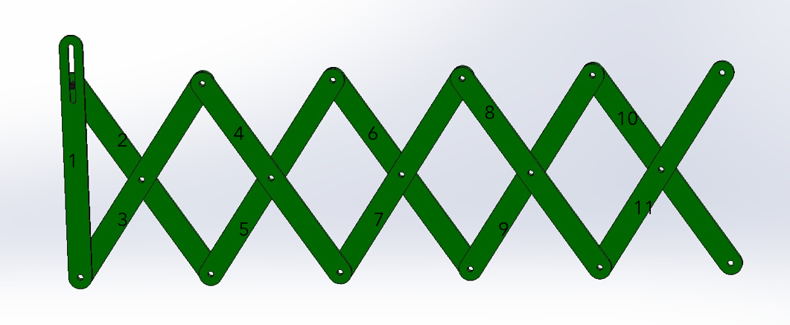

No. of Revolute Joints: 14

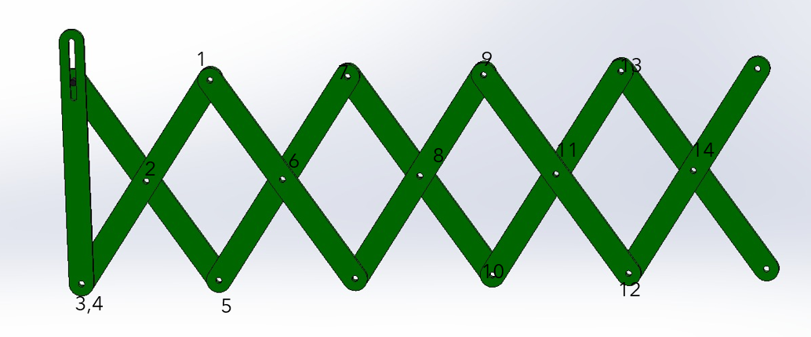

No. of Pin-in-a-slot Joints: 1

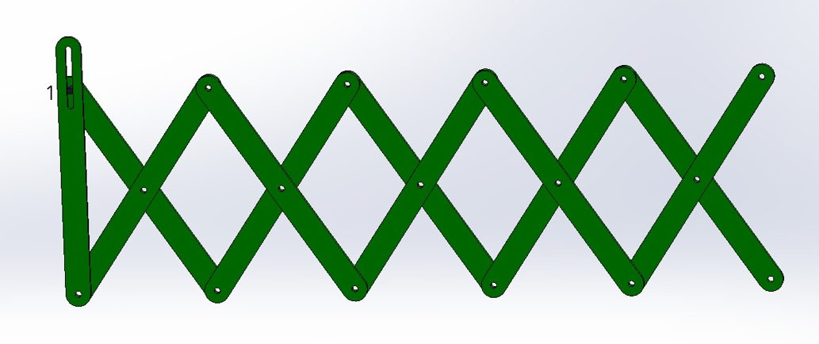

* No. of links (n) = 11
* No. of lower pair (P1) = 14
* No. of higher (P2)= 1
* This implies:
* DOF = 3(n-1) - 2(P1) – P2 =
* DOF = 3(11-1) – 2*14 - 1

**DOF = 1**