**package** firstpackage;

**public** **class** Arithemetic_Operators {

**public** **static** **void** main(String[] args) {

**int** Maths = 89;

**int** Science = 76;

**int** English= 92;

**int** TotalMarks= Maths + Science + English;

**int** AverageMarks = TotalMarks/3;

System.***out***.println("TotalMarks: " + TotalMarks);

System.***out***.println("AverageMarks: " + AverageMarks);

}

}

When data type is int for average marks

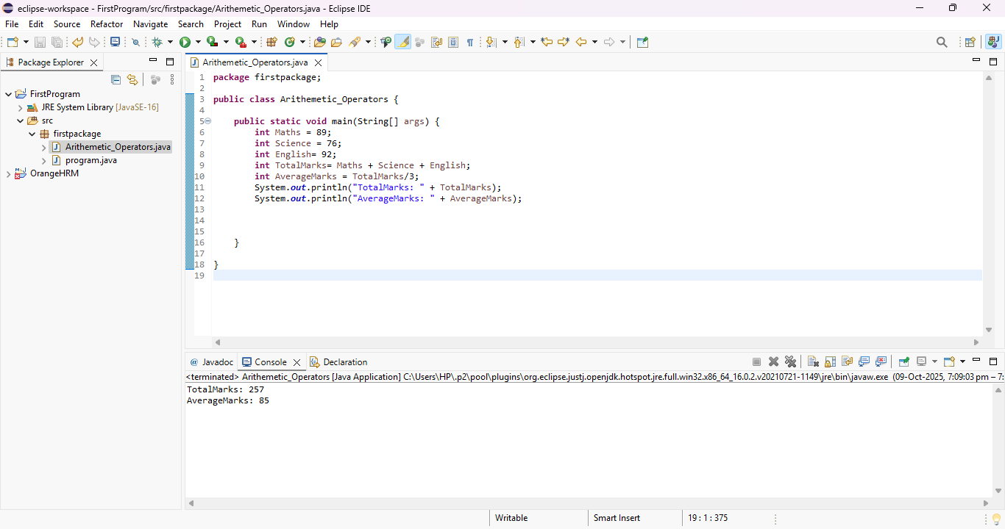

When Data type is double

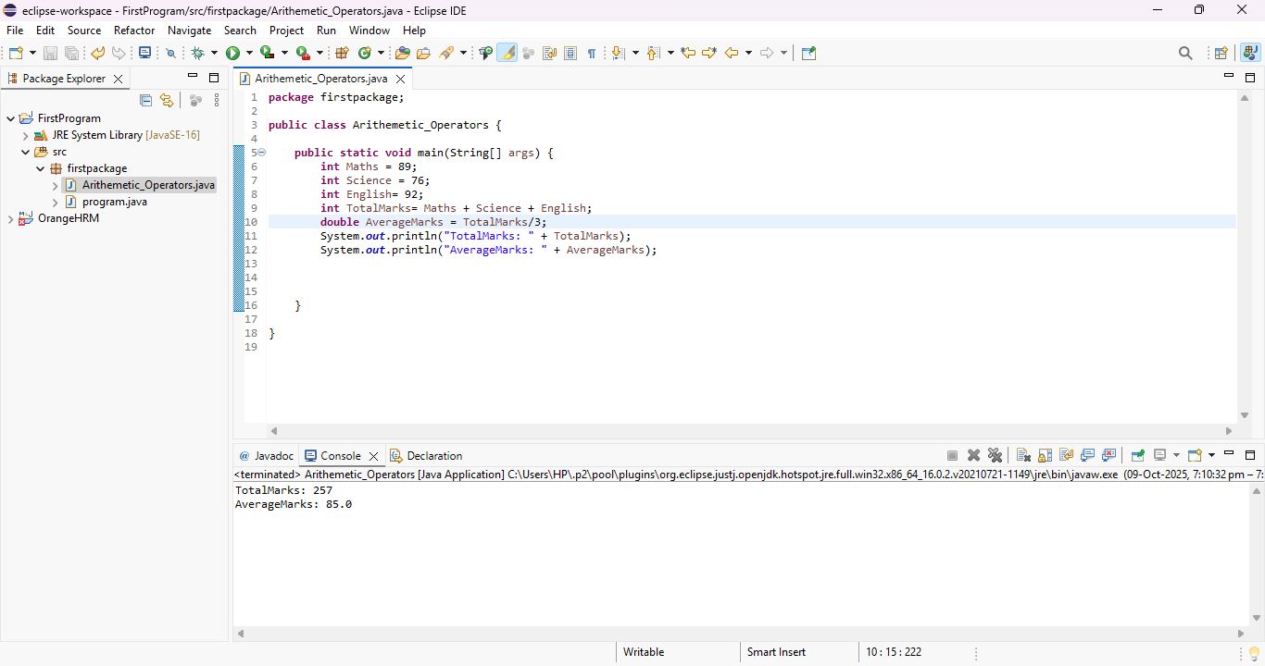

When data type is float

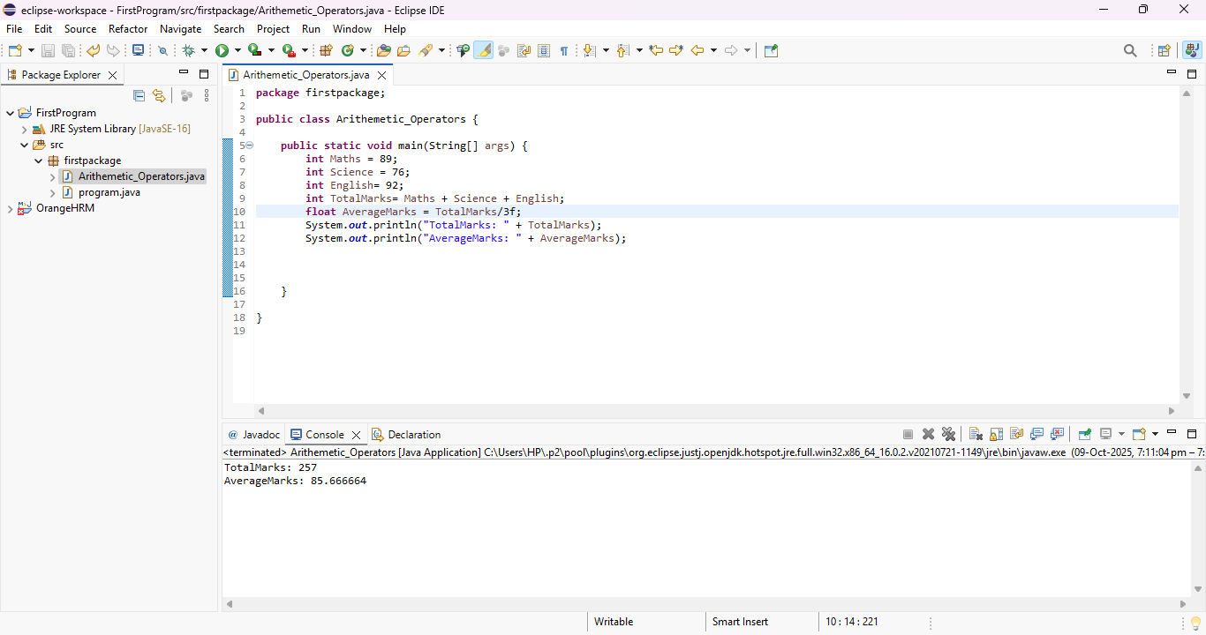

When data type is char

