## DEPARTMENT OF INFORMATION SCIENCE AND ENGINEERING

**Academic Year 2020-21**

Course Project Report on

“TOURISM”

Carried out By

**Batch No:04**

|  |  |
| --- | --- |
| Name of Students | USN |
| Akhila Kulkarni | 2GI19IS005 |
| Kavyashree Kiran Vernekar | 2GI19IS020 |
| Prerana Rao | 2GI19IS039 |
| Ruha Joshi | 2GI19IS041 |

Under the Guidance of

## Prof. Sudhindra B.Deshpande KLS, GIT, Department of ISE, Belagavi

**Course Name: WEB PROGRAMMING LAB**

**Semester: III Course Code: 18ISL36**

# Table of Contents:

1. INTRODUCTION
2. PROBLEM STATEMENT
3. WEB TOOLS
4. FLOW DIAGRAM
5. WEBPAGES
6. CONCLUSION
7. REFERENCES

### Course project report and ppt content

1. Title
2. Problem statement for that the project
3. Need Analysis, Variables involved
4. Atleast two alternate solutions to solve the problem defined or meet the need analysis
5. Comparison between the solutions and reason for selecting the final solution
6. Working model of the final solution

### Marks allocation:

|  |  |  |  |  |  |  |
| --- | --- | --- | --- | --- | --- | --- |
|  | Batch No. :15 | | | | | |
| 1. | Project Title: Website for bus /flight/train time table information. | Marks Range | USN | | | |
| 2GI20IS039 | 2GI20IS41 | 2GI20IS053 | 2GI20IS058 |
| 2. | Problem statement (PO2) | 0-1 |  |  |  |  |
| 3. | Need Analysis, Variables involved (PO1,PO2) | 0-2 |  |  |  |  |
| 4. | Alternate solutions to solve the problem(PO3) | 0-3 |  |  |  |  |
| 5. | Comparison between the solutions and reason for selecting the final solution(PO1,PO3,PO4) | 0-4 |  |  |  |  |
| 6. | Working model of the final solution (PO3,PO12) | 0-5 |  |  |  |  |
| 7. | Report and Oral presentation skill (PO9,PO10) | 0-5 |  |  |  |  |
|  | Total | 20 |  |  |  |  |

**\* 20 marks is converted to 10 marks for CGPA calculation**

**1.Engineering Knowledge:** Apply the knowledge of mathematics, science, engineering fundamentals and an engineering specialization to the solution of complex engineering problems. **2.Problem Analysis:** Identify, formulate, review research literature, and analyze complex engineering problems reaching substantiated conclusions using first principles of mathematics, natural sciences and Engineering sciences.

1. **Design/Development of solutions:** Design solutions for complex engineering problems and design system components or processes that meet the specified needs with appropriate consideration for the public health and safety, and the cultural, societal, and environmental considerations.
2. **Conduct investigations of complex problems:** Use research-based knowledge and research methods including design of experiments, analysis and interpretation of data, and synthesis of the information to provide valid conclusions.
3. **Modern tool usage:** Create, select, and apply appropriate techniques, resources, and modern engineering and IT tools including prediction and modeling to complex engineering activities with an understanding of the limitations.
4. **The engineer and society:** Apply reasoning informed by the contextual knowledge to assess societal, health, safety, legal and cultural issues and the consequent responsibilities relevant to the professional engineering practice.
5. **Environment and sustainability:** Understand the impact of the professional engineering solutions in societal and environmental contexts, and demonstrate the knowledge of, and need for sustainable development.
6. **Ethics:** Apply ethical principles and commit to professional ethics and responsibilities and norms of the engineering practice.
7. **Individual and team work:** Function effectively as an individual and as a member or leader in diverse teams, and in multidisciplinary settings.
8. **Communication:** Communicate effectively on complex engineering activities with the engineering community and with society at large, such as, being able to comprehend and write effective reports and design documentation, make effective presentations, and give and receive clear instructions.
9. **Project management and finance:** Demonstrate knowledge and understanding of the engineering management principles and apply these to one's own work, as a member and leader in a team, to manage projects and in multidisciplinary environments.
10. **Life-long learning:** Recognize the need for and have the preparation and ability to engage in independent and lifelong learning in the broadest context of technological change.

**ABSTRACT:**

A public transport timetable is a document setting out information on [public transport](https://en.wikipedia.org/wiki/Public_transport) service times, to assist passengers with planning a trip. Typically, the timetable will list the times when a service is scheduled to arrive at and depart from specified locations. It may show all movements at a particular location or all movements on a particular route or for a particular stop. Traditionally this information was provided in printed form, for example as a leaflet or poster. It is now also often available in a variety of electronic formats.

# INTRODUCTION

# In its relative short life, it has helped spawn a number of business ,one of it is Online Travel Agent(OLTA).It has turned traveler’s requirement into “One Stop Shops” for all our travel needs.

# The Online travel industry does not have an exact starting date. But we can say that over the past five years, the views and trends of the customers have changed towards their travel bookings. The traditional “brick and mortar “was changing into the online travel booking. Instead of the travel agents working on their trips, the travelers wanted to book and view their trip plan themselves. The travelers wanted to view the rates themselves.

# A travel agency is a private retailer or public service that provides travel and tourism-related services to the general public on behalf of accommodation or travel suppliers to offer different kinds of travelling packages for each destination. Travel agencies can provide outdoor recreation activities, airlines, car rentals, cruise lines, hotels, railways, travel insurance, package tours, insurance, guide books, VIP airport lounge access, arranging logistics for luggage and medical items delivery for travellers upon request, public transport timetables, car rentals, and bureau de change services. Travel agencies can also serve as general sales agents for airlines that do not have offices in a specific region. A travel agency's main function is to act as an agent, selling travel products and services on behalf of a supplier. They do not keep inventory in-hand unless they have pre-booked hotel rooms or cabins on a cruise ship for a group travel event such as a wedding, honeymoon, or other group event.

# PROBLEM STATEMENT

**Develop a website for bus/flight/train time table information for a particular date and destination.**

### OBJECTIVES

* To offer variety of travel services that are sure to match all customers priorities.
* To make strong relationship with customers so that they can enjoy their journey of their choice.

**HTML**

# WEB TOOLS

HTML stands for Hyper Text Markup Language. It is used to design web pages using markup language. HTML is the combination of Hypertext and Markup language. Hypertext defines the link between the web pages. Markup language is used to define the text document within tag which defines the structure of web pages. This language is used to annotate (make notes for the computer) text so that a machine can understand it and manipulate text accordingly. Most markup languages (e.g HTML) are human readable. Language uses tags to define what manipulation has to be done on the text. HTML is a markup language used by the browser to manipulate text, images and other content, in order to display it in the required format. HTML was created by Tim Berners-Lee in 1991. The first ever version of HTML was HTML 1.0, but the first standard version was HTML 2.0, published in 1999.

**<DOCTYPE! html>:** This is the document type declaration (not technically a tag). It declares a document as being an HTML document. The doctype declaration is not case-sensitive.

**<html>:** This is called the HTML root element. All other elements are contained within it.

**<head>:** The head tag contains the “behind the scenes” elements for a webpage. Elements within the head aren’t visible on the front-end of a webpage. HTML elements used inside the <head> element include:

* + - <style>
    - <title>
    - <base>
    - <script>
    - <meta>
    - <title>
    - <link>

**<body>:** the body tag is used to enclose all of the visible content of a webpage. In other words, the body content is what the browser will show on the front-end.

An HTML document can be created using any text editor . Save the text file using **.html** or **.htm**. Once saved as an HTML document, the file can be opened as a webpage in the browser.

## CSS

**C**ascading **S**tyle **S**heets, fondly referred to as CSS, is a simply designed language intended to simplify the process of making web pages presentable. CSS allows you to apply styles to web pages. More importantly, CSS enables you to do this independent of the HTML that makes up each web page. CSS is easy to learn and understood but it provides powerful control over the presentation of an HTML document.

### WHY CSS?

* + - **CSS saves time:** You can write CSS once and reuse same sheet in multiple HTML pages.
    - **Easy Maintenance:** To make a global change simply change the style, and all elements in all the webpages will be updated automatically.
    - **Search Engines:** CSS is considered as clean coding technique, which means search engines won’t have to struggle to “read” its content.
    - **Superior styles to HTML:** CSS has a much wider array of attributes than HTML, so you can give a far better look to your HTML page in comparison to HTML attributes.
    - **Offline Browsing:** CSS can store web applications locally with the help of offline cache. Using of this we can view offline websites.

### CSS Syntax

A CSS comprises of style rules that are interpreted by the browser and then applied to the corresponding elements in your document. A style rule set consists of a selector and declaration block.

* + - The selector points to the HTML element you want to style.
    - The declaration block contains one or more declarations separated by semicolons.
    - Each declaration includes a CSS property name and a value, separated by a colon.
    - Eg:

colour is the property and blue is the color and font size is property and 12px is value.

* + - A CSS declaration always ends with a semicolon, and declaration blocks are surrounded by curly braces.

# FLOW DIAGRAM

# 

# WEBPAGES

|  |  |  |
| --- | --- | --- |
| Sl.no | TITLE | WORKING |
| 1 | Start Page | Consists of images in form of imageslider And connects with the Home page. |
| 2 | Home Page | Gives the brief description of all the places with the images. |
| 3 | Packages | Allows customers to go through the details  of the places and various available packages and connects with the Hotels. |
| 4 | Hotels | Allows customers to go through available hotels with their ratings. |
| 5 | About Us | Allows the customer to connect with the admin and also displays the feedback given  by other customers. |
| 6 | Registration | This page allows the customers to register along with their full details. |
| 7 | Payment | Allows the customer to pay the bill. |
| 8 | Feedback | Confirmation of payment and allows to rate us. |

*Table 1 shows the WORKING OF WEBPAGES*

* 1. START PAGE:

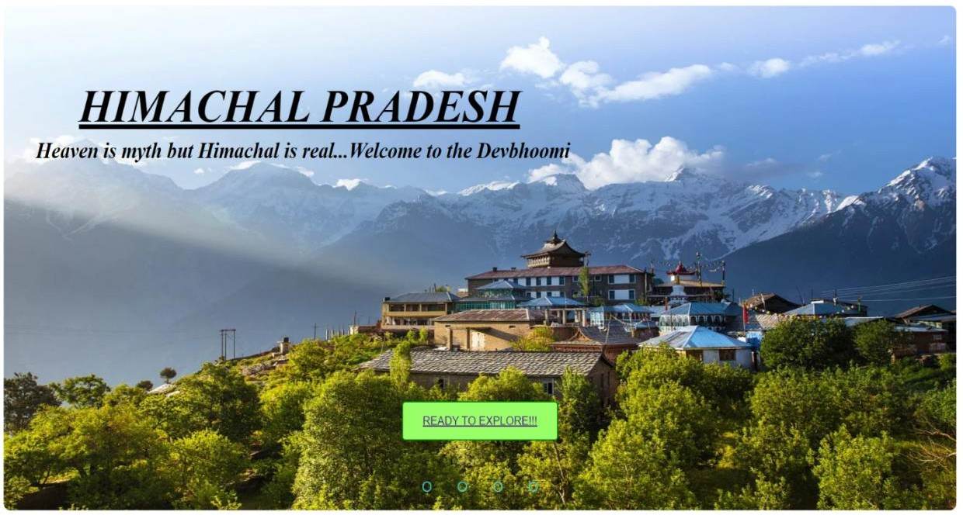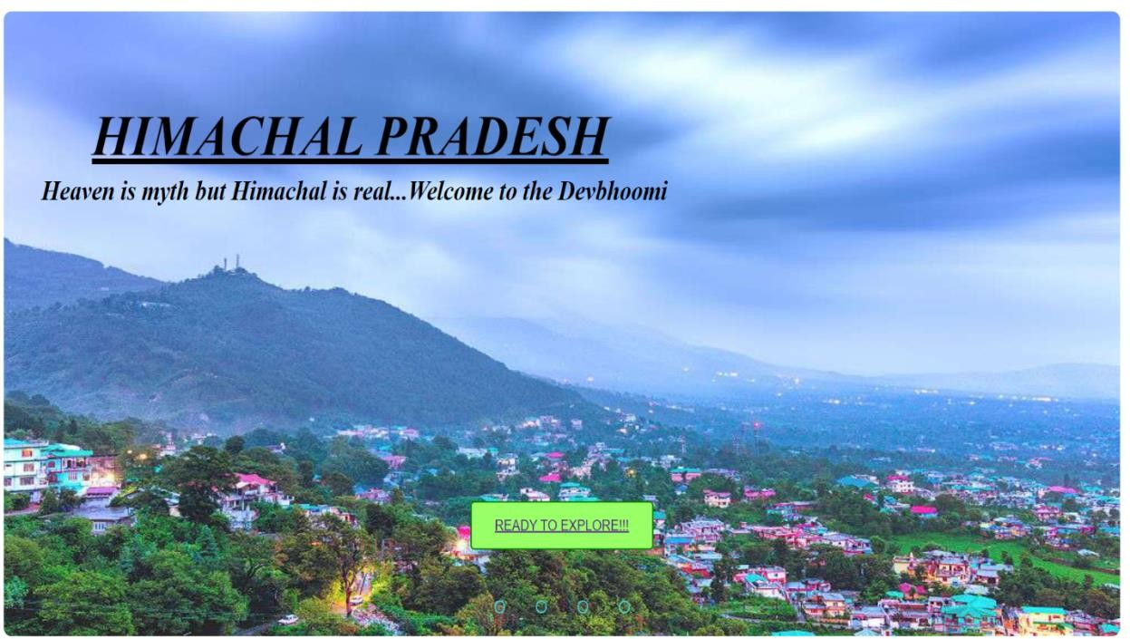

* 1. HOME PAGE:

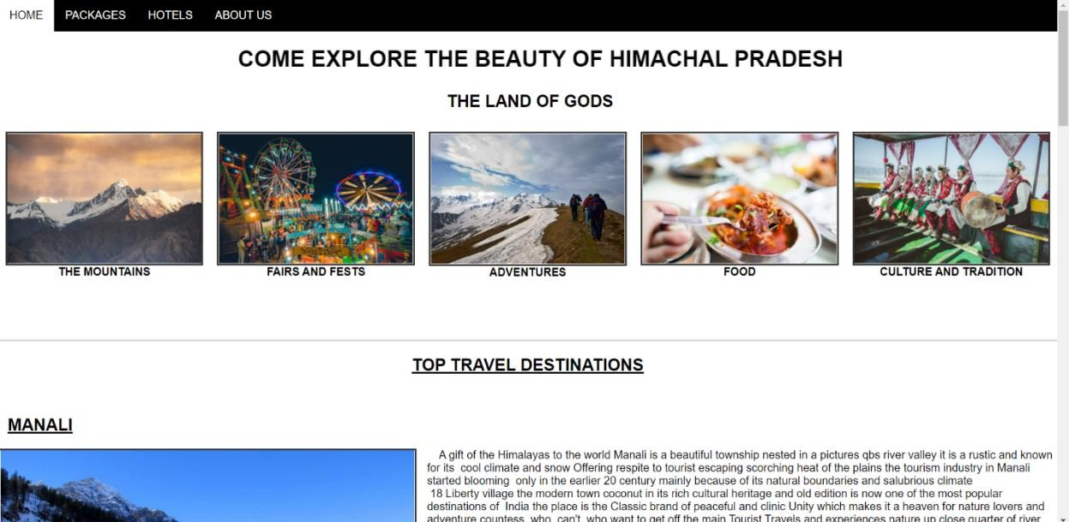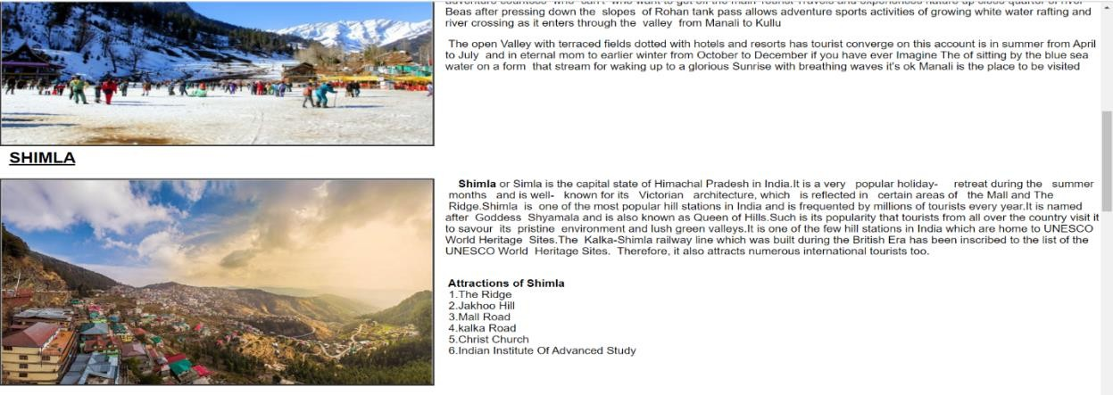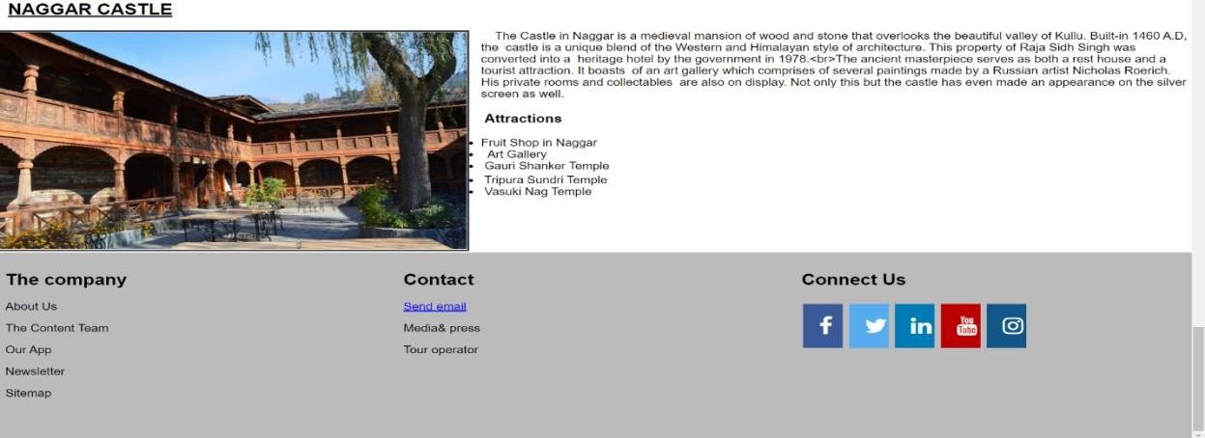

* 1. PACKAGES:

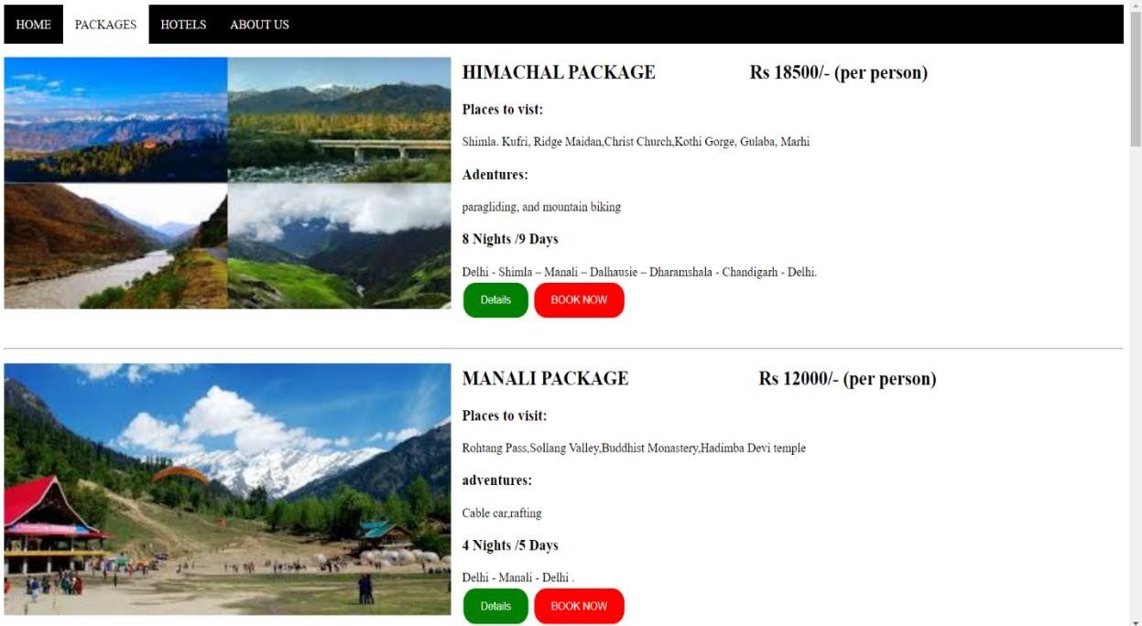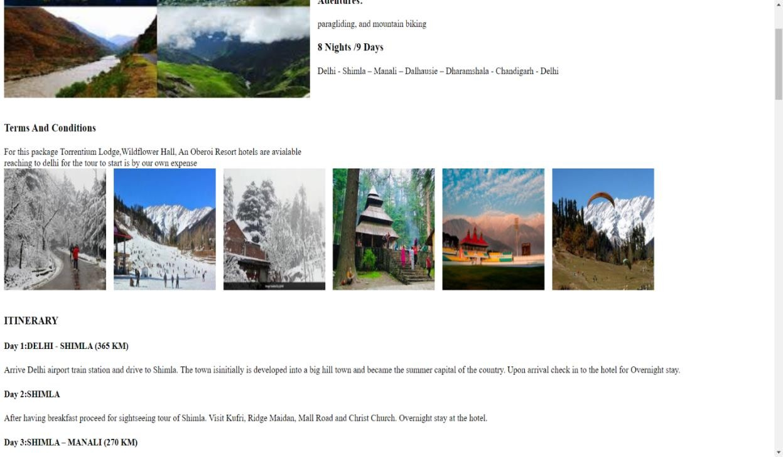

* 1. HOTELS:

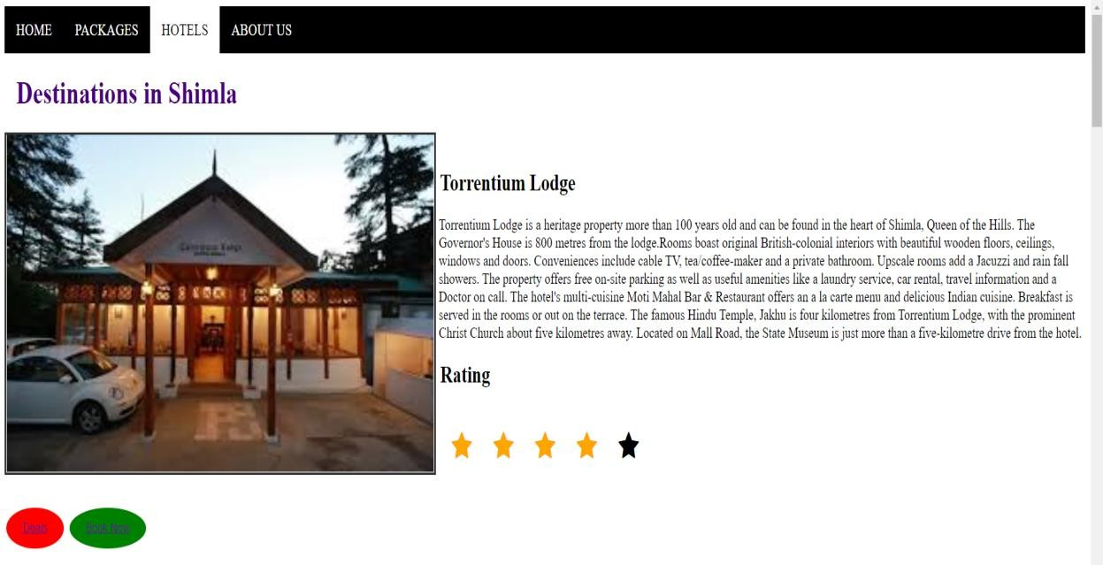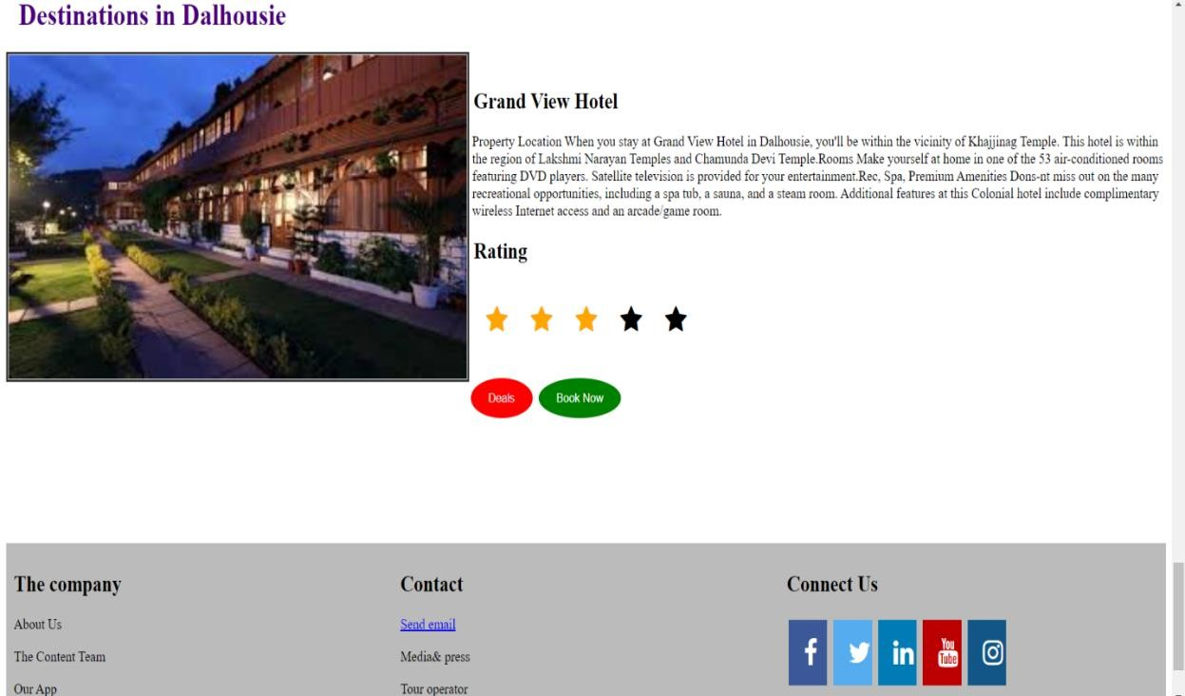

* 1. ABOUT US:

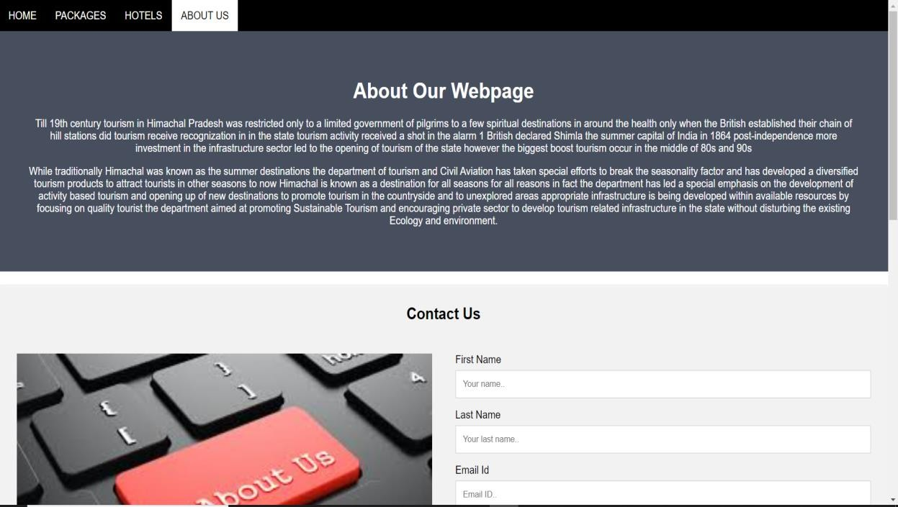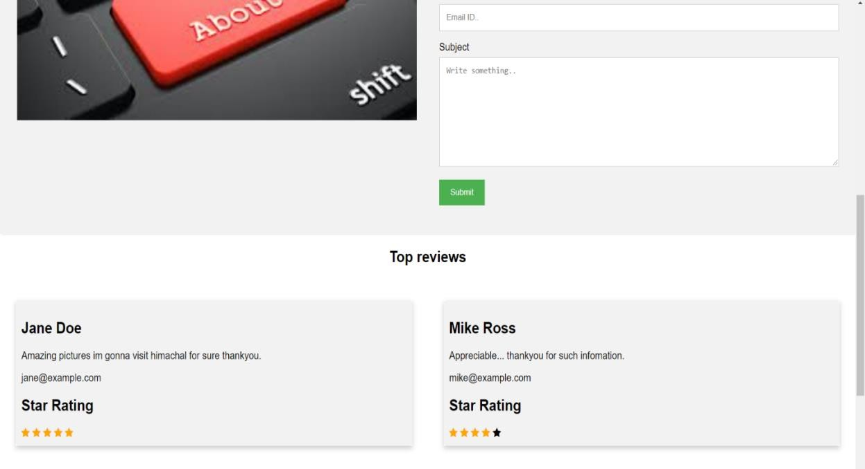

* 1. REGISTRATION:

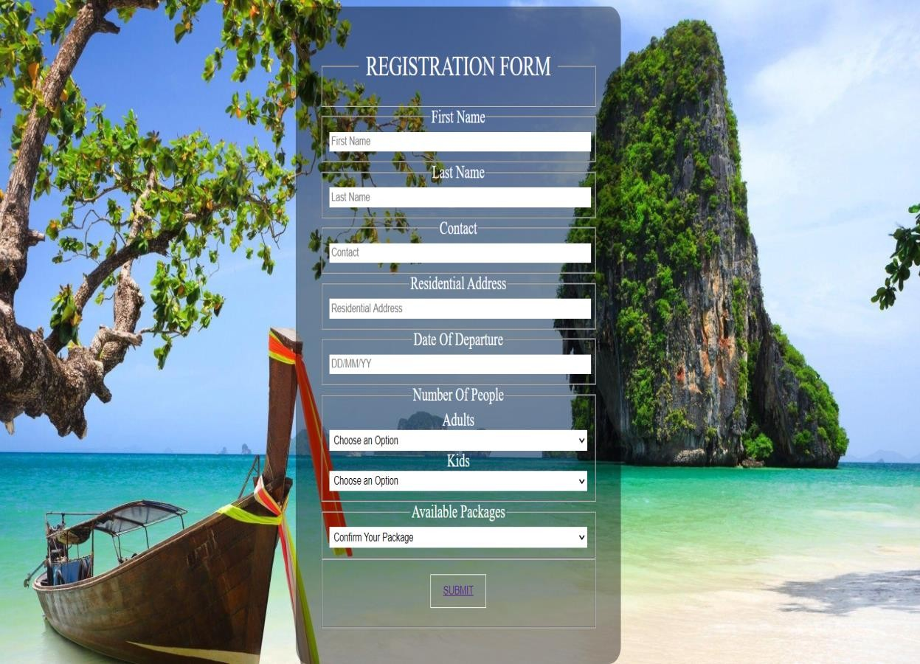

* 1. PAYMENT:

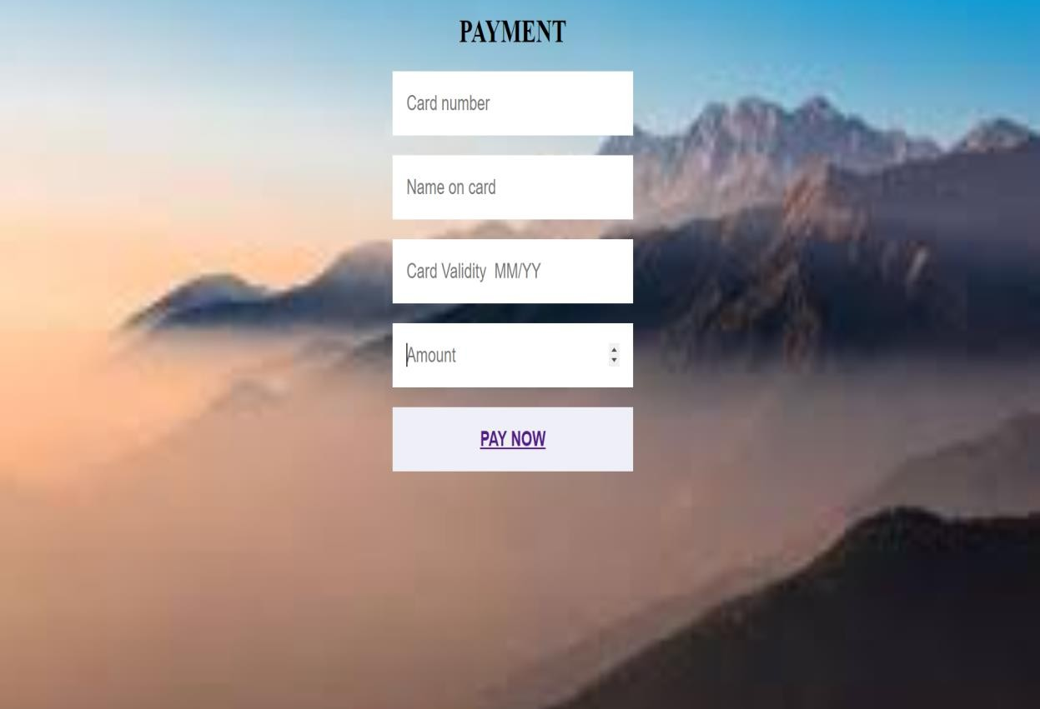

* 1. FEEDBACK:



* 1. **CONCLUSION**

We have created these webpages by using the webtools like HTML, CSS and Javascript. In this project we understood the usage of JavaScript and also how to design the page in much better way using CSS. These webpages helps user to know the about tourism places present in Himachal Pradesh. This also helps user to plan their holidays perfectly .The booking of places is easier and user friendly. We conclude that Travel and tourism management simplifies the management process in travelling. It gives fast processing and immediate results with high security. Minimizing human effort and cost efficient databases.

# REFERENCES

* + - <https://www.slideshare.net/>
    - [www.geeksforgeeks.org](http://www.geeksforgeeks.org/)
    - Leiper, N. The framework for tourism: towards a definition of tourism, tourist and the tourism industry. *Annals of Tourism Research.*
    - Archer, B. H. The Value of Multipliers and Their Policy Implications. *Tourism Management.*