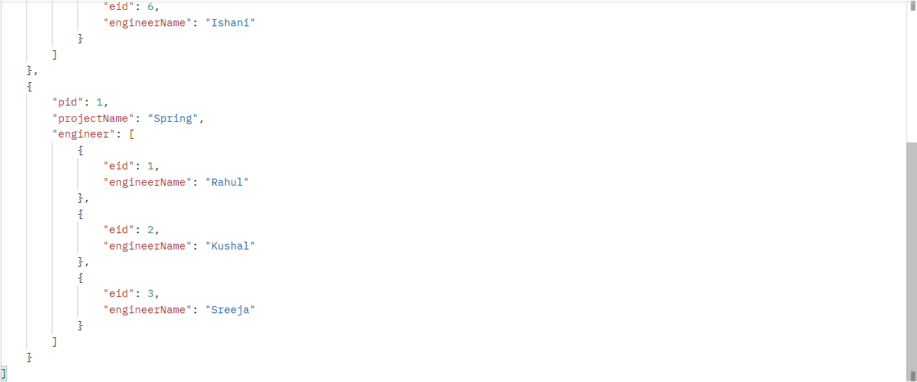PAGENATION & SORTING BY FETCHING RECORDS:  
  
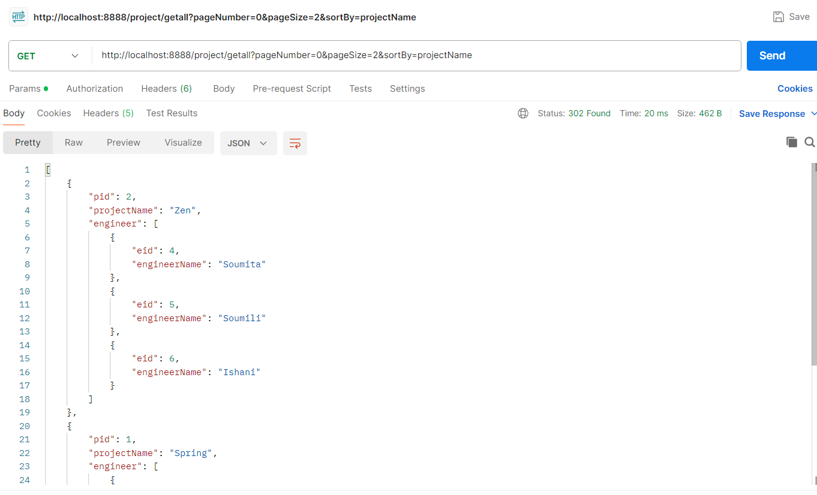

GETTING A PARTICULAR RESOURCE:  
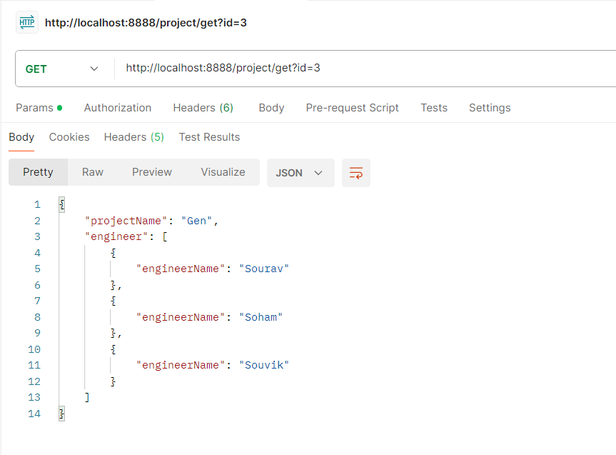

UPDATING THE PROJECT NAME:

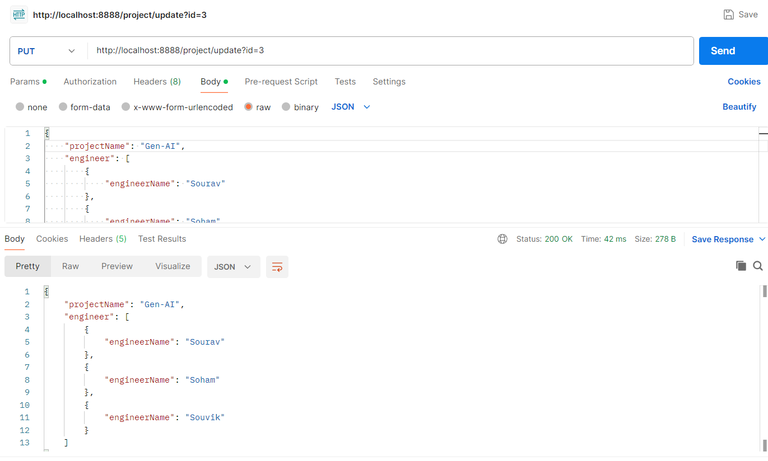

UPDATING PROJECT BY REMOVING AN ENGINEER FROM THE PROJECT:

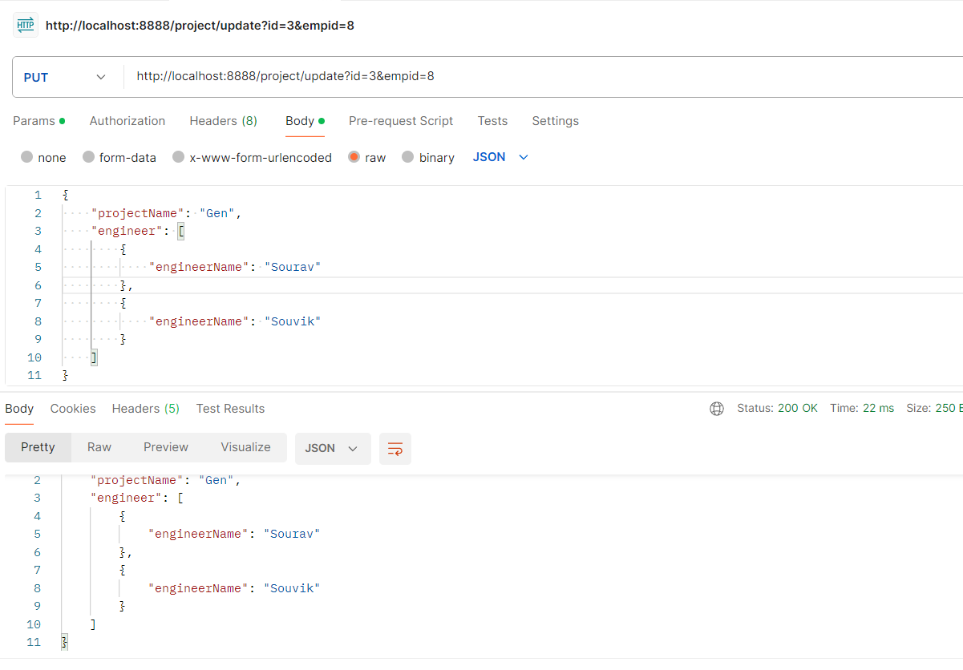

UPDATING PROJECT BY ADDING AN ENGINEER IN THE PROJECT:

1. CREATING AN ENGINEER FIRST:

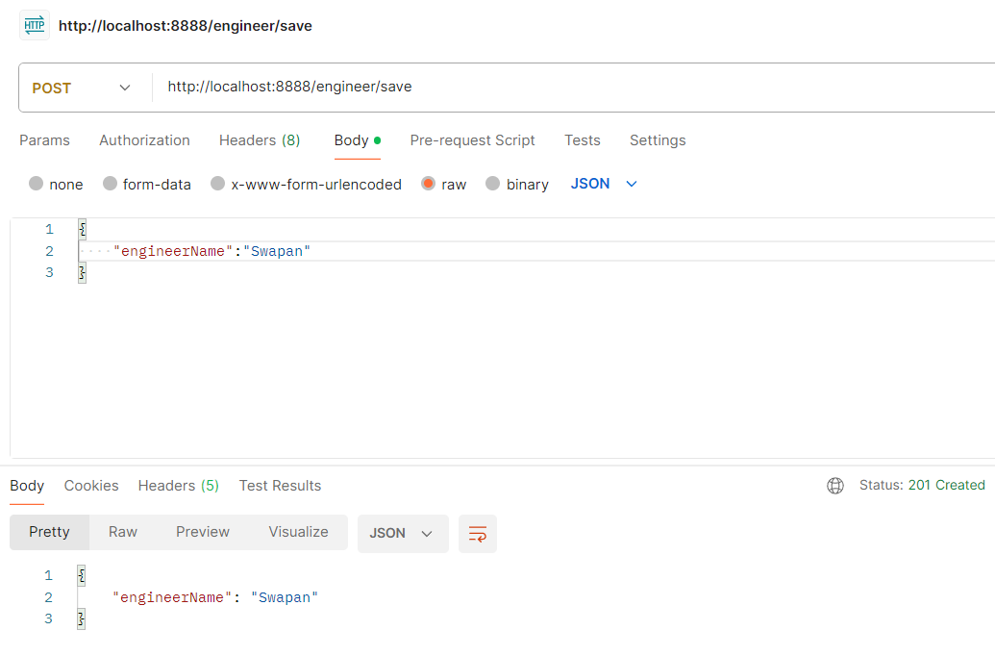

1. ADDING IN PROJECT:

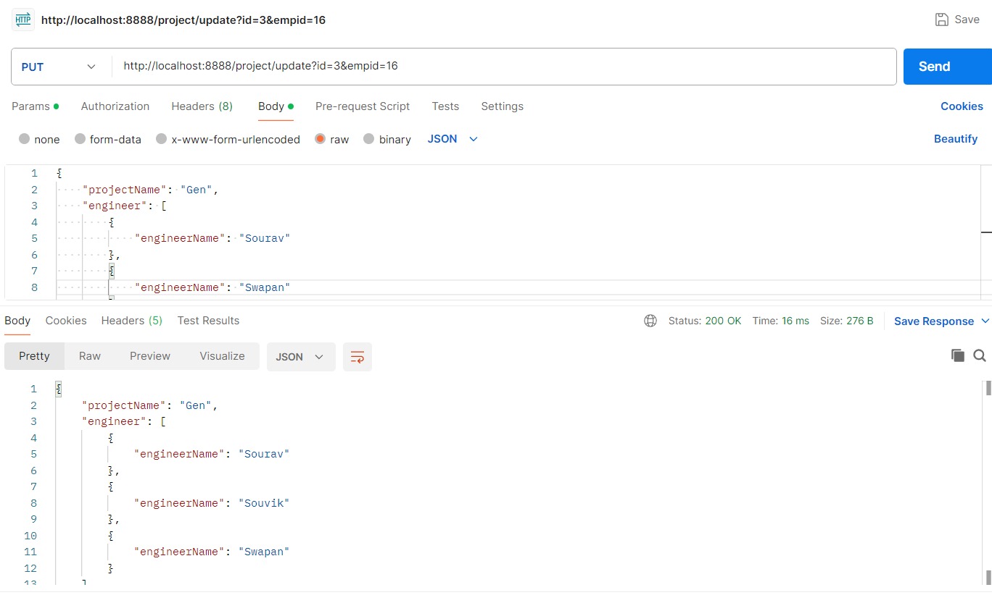

DELETING A PROJECT (WHICH ALSO DELETES THE ENGINEERS ASSOCIATED DUE TO CASCADING): 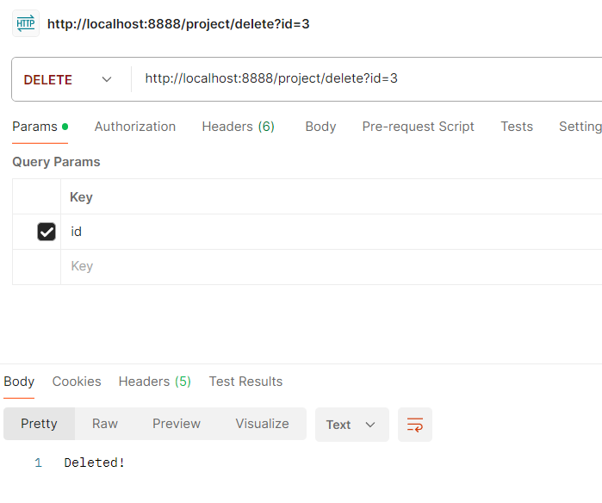

AFTER DELETING PROJECT 3

