ShopNest Store Power BI Capstone
Top 10 product Categories by sales
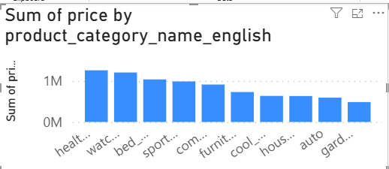
As we can see from visualisation – top 10 product ctaregories ranging from 1.2 milion to 45k
While health and beauty product being heighest sales product

Number of Delayed Product
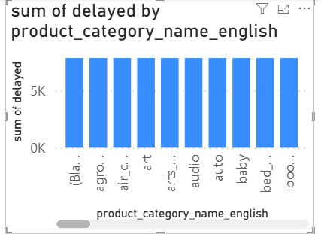
Here the observation is all product category have same number of deloayed order of 7827.
Monthly Delayed and on-time orders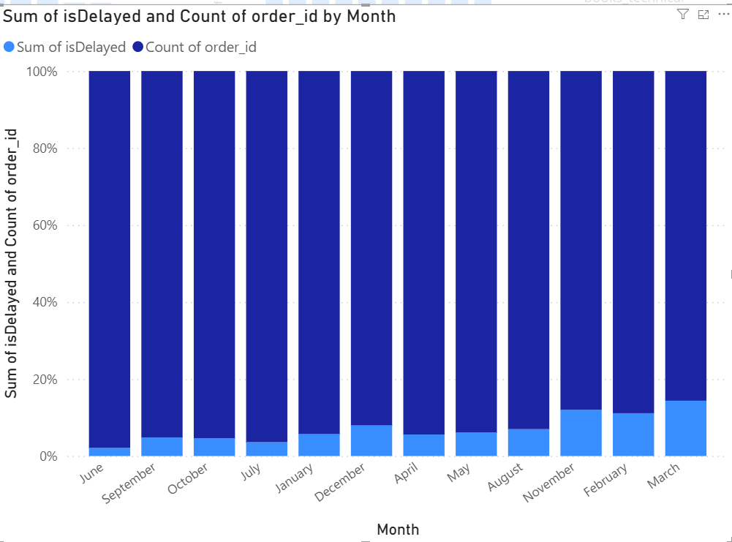

We can see that the % is very less for delayed item, march being the heighest delayed of about 14 %

Payment Method Analysis
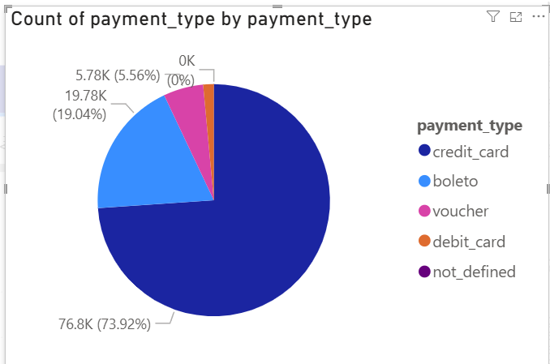
We can see credit card is most used payment method , so as that is unexpectedly used 74% , we need to make sure , that credit card payment has very less downtime , otherwise cit can affect the payment for our large customer group.

Rating Analysis
Top 10 product category according to rating
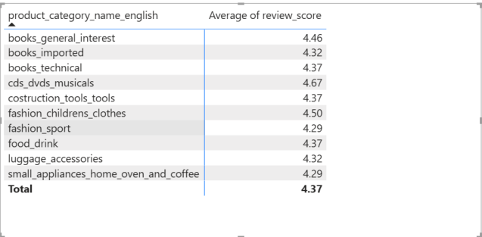
Botton 10 rated
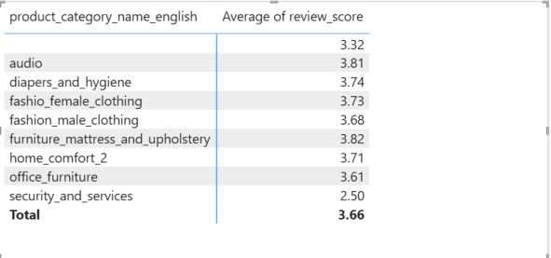
According to observation book and and fashion category in child and sports are mostly highly rated While we need to work on our male and female fashion category , we need to work on our security and services product as well , those are worst rated.

State Wise Sales
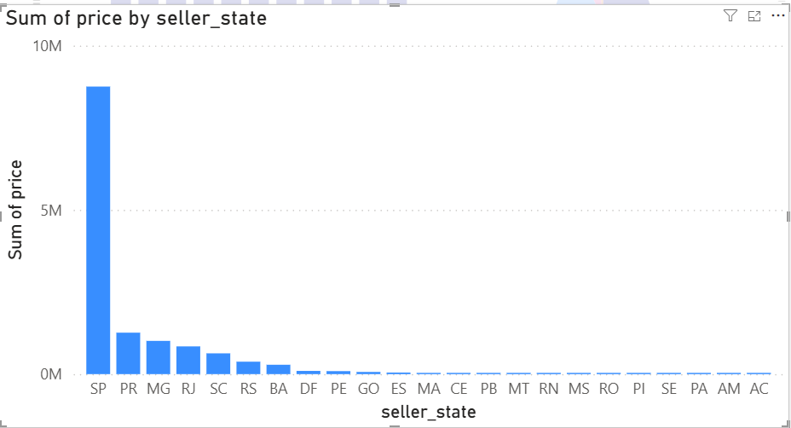
We can observe most sales are from SP state , this is creating too much dependency on one single state , we need to diversify our sellers in order to avoid any damage in case of some issue in that particular state.
Seasonal Sales Pattern
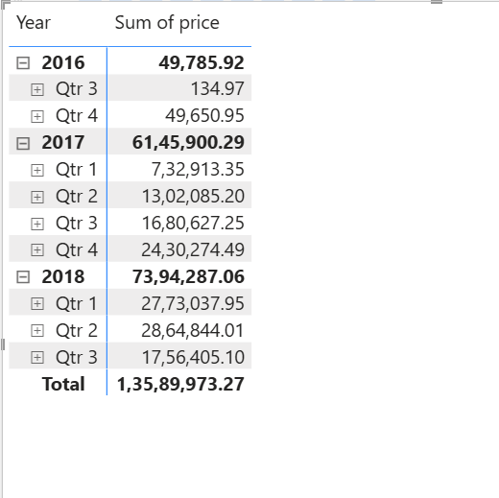
We can observe sales being increased every year from 2016 to 2018 , only point od concern is 2018 q3 , as this is first time our sales has dropped , need to investigate 2018 q3 results.

Yearly sales forcast
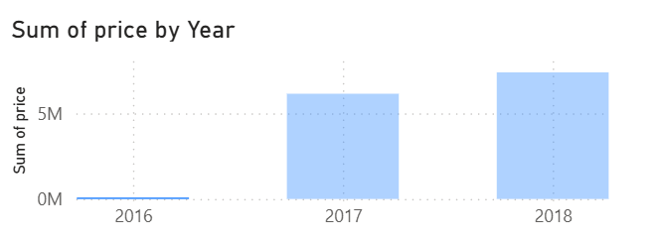
Sales has been constantly increasing year by year , it’s a good thing for company , but the % growth has dipped from 2017 to 2018 , we need to think about more scalable options .

