The University of Texas at Dallas
Machine Learning – Prof. Anjum Chida
Assignment #02

Explanation:
By filtering out stop words the classification becomes more accurate as classification on unwanted/low quality features is avoided.

In most cases, these low quality features give negative results and at the same time may not be that negative in some cases where it doesn’t affect classification just coincidentally.

Hence, classification is more accurately done in most of the cases when stop words are filtered out/ removed.

Naive Bayes |  | Logistic Regression  {a = 0.75, b = 0.75, N = 100}
Filter stopwords = No | Filter stopwords = Yes | Filter stopwords = No | Filter stopwords = Yes
95.46 | 92.22 | 79.07 | 85.56

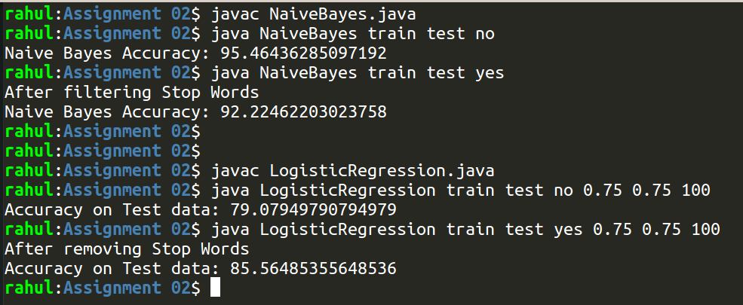
a :- eta/ learning rate, b :- lambda, and N :- No of iterations

For logistic regression, and upon filtering/ removing the stopwords, and N = 100:

a | b | Accuracy
0.5 | 0.5 | 82.63598326359832
0.9 | 0.5 | 83.89121338912135
0.5 | 0.9 | 85.98326359832636
1 | 0.75 | 86.40167364016736
0.75 | 1 | 82.00836820083683
0.9 | 0.9 | 87.44769874476988
0.5 | 0.9 | 84.93723849372385
0.05 | 0.9 | 80.9623430962343

