The University of Texas at Dallas
Machine Learning – Prof. Anjum Chida
Assignment #03

For this assignment submit implementation of *ONE of the following 4 problems.

*2. K-means clustering on images
In this problem, you will use K-means clustering for image compression. We have provided you
with two images.
- Display the images after data compression using K-means clustering for different values of K (2, 5, 10, 15, 20).
- What are the compression ratios for different values of K?
- Is there a tradeoff between image quality and degree of compression? What would be a good value of K for each of the two images?

We have provided you java template KMeans.java which implements various image input/output operations. You have to implement the function k-means in the template. See the file for more details. Note that your program must compile and we should be able to replicate your results. Otherwise no credit will be given.

What to turn in:
- Your code and datasets
- A README for your compiling/using your code
- A report (pdf or doc file) containing answers to the questions posed.

Ans. Images – Koala.jpg (780.8kB), Penguins.jpg (777.8kB), rahul.JPG (219.1kB)

Please see the attached <filename><K>out.png files after KMeans compression for K = {2, 3, 5, 7, 10, 15, 20}.

Compression Ratio = Original Size / Compressed Size

K | Koala.jpg |  | Penguins.jpg |  | rahul.JPG
K | Compressed Size (kB) | Compression Ratio | Compressed Size (kB) | Compression Ratio | Compressed Size (kB) | Compression Ratio
2 | 45.7 | 17.09 | 26.6 | 29.24 | 37.3 | 5.87
3 | 65.2 | 11.98 | 35.3 | 22.03 | 58.5 | 3.75
5 | 111.4 | 7.01 | 62.3 | 12.48 | 83.9 | 2.61
7 | 150.4 | 5.19 | 68.1 | 11.42 | 97.2 | 2.25
10 | 188.6 | 4.14 | 104.6 | 7.44 | 128.0 | 1.71
15 | 233.0 | 3.35 | 143.4 | 5.42 | 152.2 | 1.44
20 | 259.5 | 3.01 | 164.4 | 4.73 | 169.4 | 1.29
Observation:

As we reduce the K value, images are drastically compressed. More the K value, compression is lesser. Hence, more the compression, more the information loss, lower the image quality.

Thus, for K=20 we can see the images almost retain their qualities, and for K=2 we can see the images are highly compressed.

Comparison for rahul.JPG VS rahul<K>out.png

Original Image K = 2 K = 5




K = 10 K = 15 K = 20




Comparison for Penguins.jpg VS Penguins<K>out.png

Original Image K = 2 K = 3
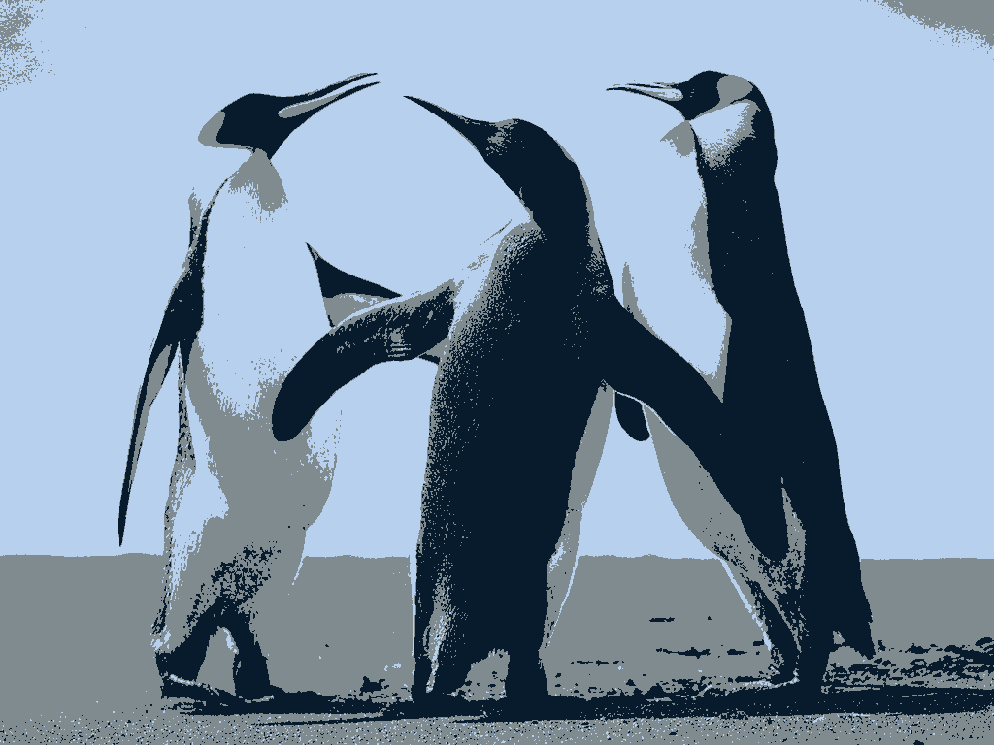
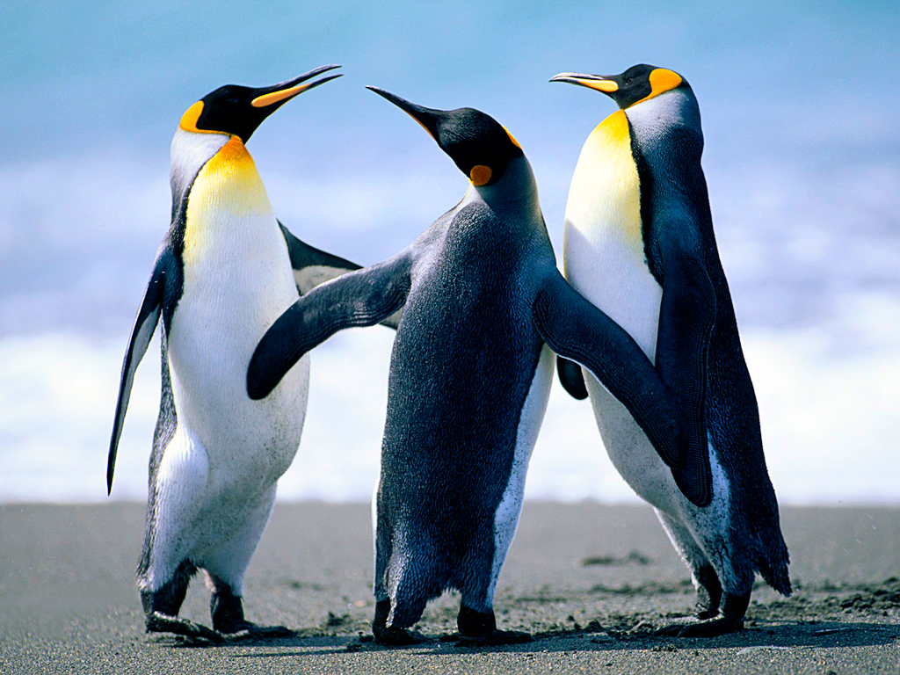
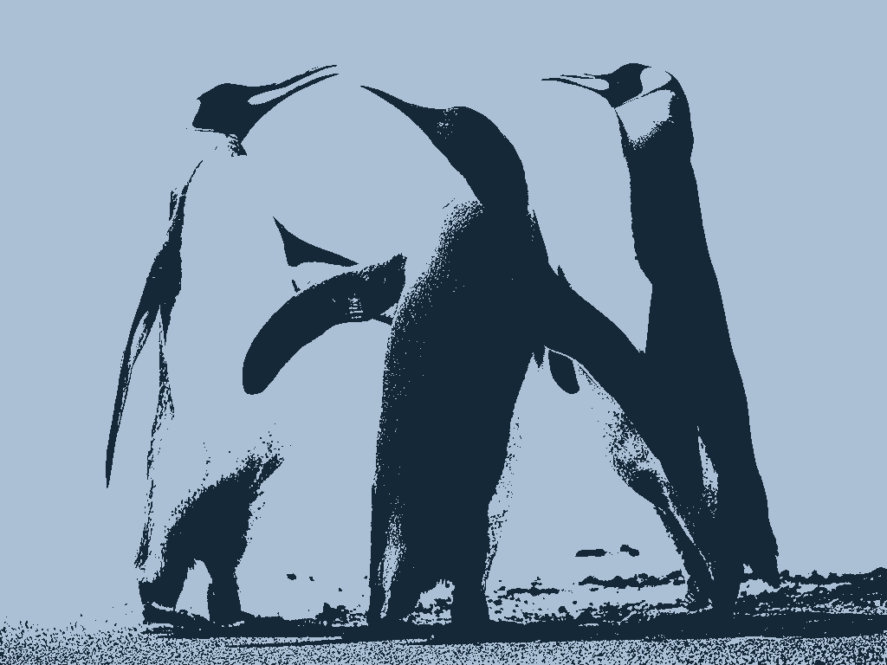

K = 5 K = 10 K = 15
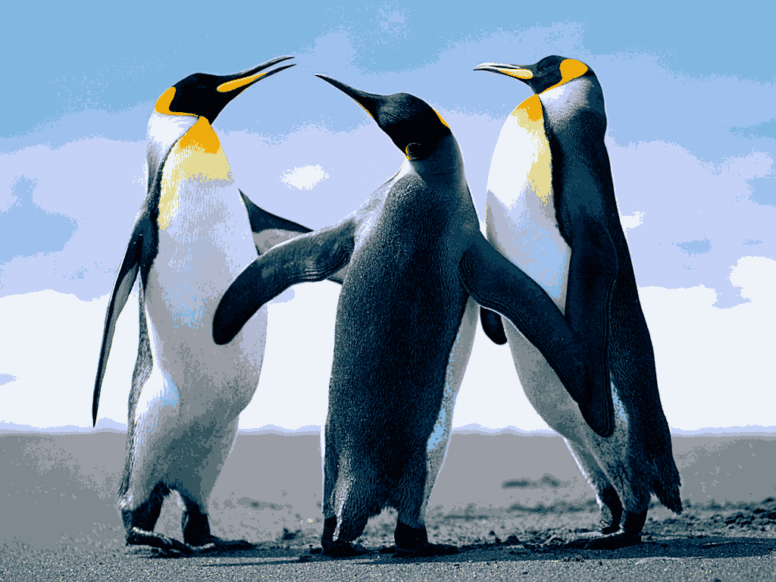
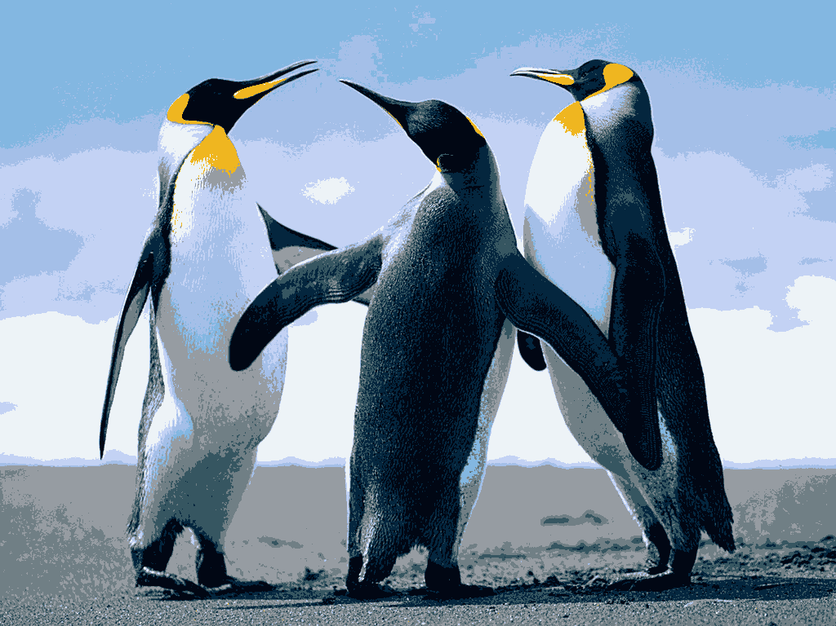
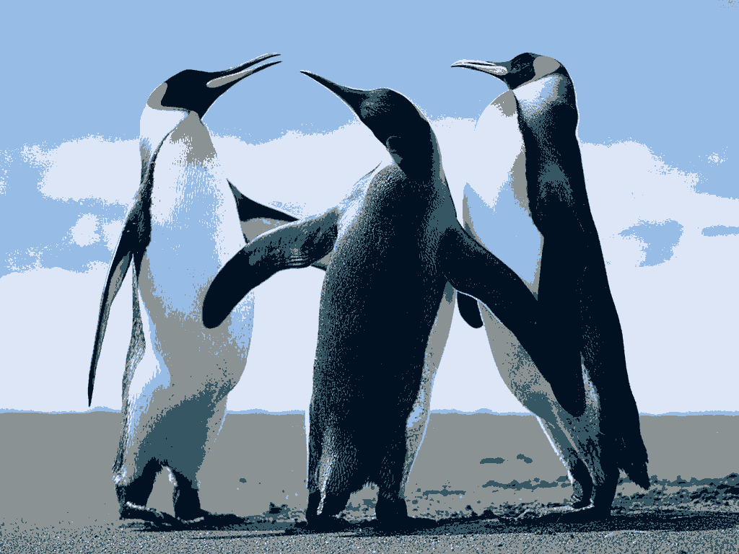

Comparison for Koala.jpg VS Koala<K>out.png

Original Image K = 2 K = 3
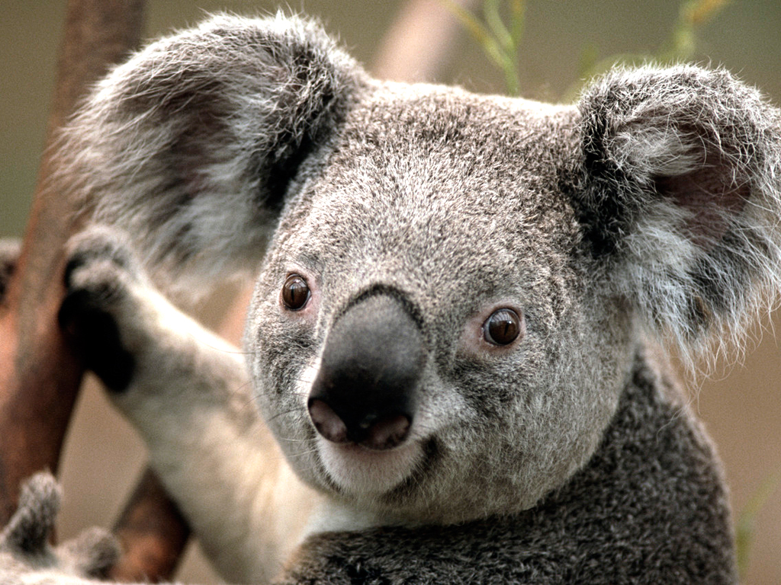
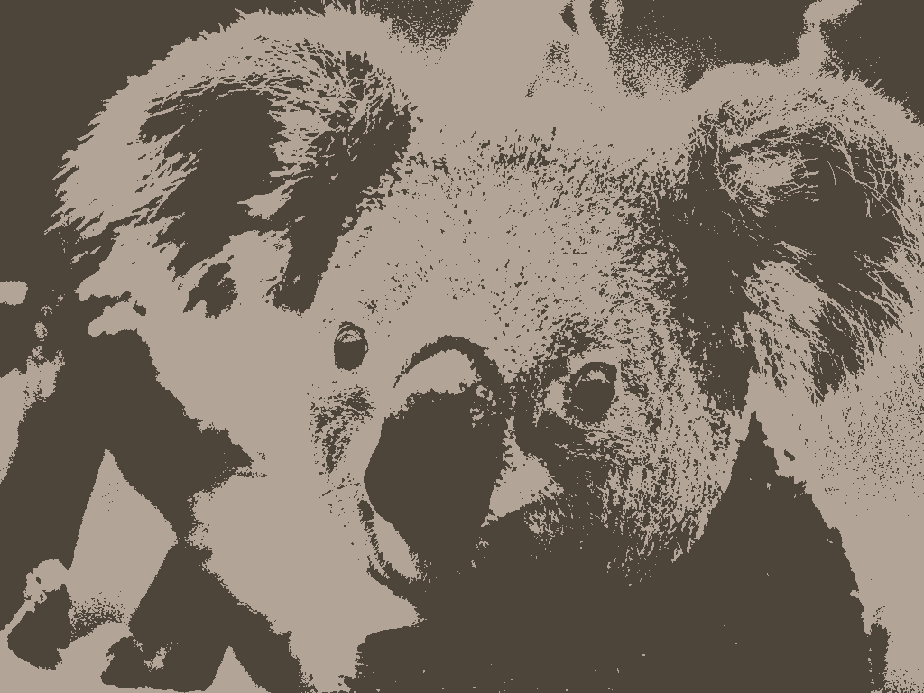
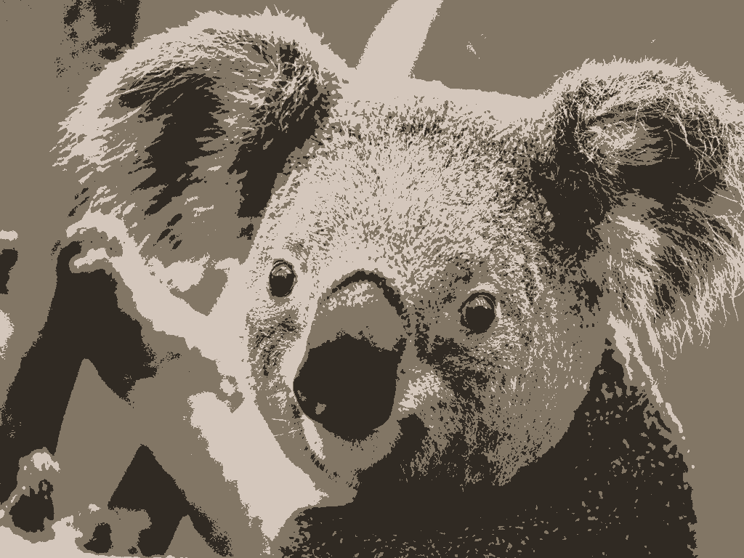

K = 5 K = 7 K = 10
