Indian Institute of Information Technology, Vadodara

CS308 – Introduction to Artificial Intelligence

Assignment #03

1. Implement Logistic Regression model with Gradient Descent method for minimizing E_{in}.

#Theory:
- Logistic regression algorithm:
step 1 – initialize the weights at t=0 to w(0)
step 2 – for t = {0, 1, 2, ..., B} B:= an upper bound for no of iterations
compute the gradient
▽E_{in} = — | 1 | _{n=1}∑^{N} | y_{n}x_{n}
▽E_{in} = — | N | _{n=1}∑^{N} | 1 + exp(y_{n*}w^{T}(t)*x_{n})
step 3 – update weights: w(t+1) = w(t) – ɲ▽E_{in}
step 4 – iterate until it is time to stop (t = B)
step 5 – return final weights w
Note: ɲ = 0.1 (learning rate)
randomization in initial weights helps (Stochastic Gradient Descent)
- Minimizing E_{in}:
E_{in}(w) = | 1 | _{n=1}∑^{N} | ln(1 + exp(-y_{n *} w^{T} * x_{n}))
E_{in}(w) = | N | _{n=1}∑^{N} | ln(1 + exp(-y_{n *} w^{T} * x_{n}))

#Source Code:
→ assign31.m
clear all;
close all;

M = load('-ascii', 'ex2data2.txt');

[N A] = size(M);
A--;

iterations = 150;

weights = logistic_reg(M, iterations);

Ein = gradient_des(M,weights);

plot(Ein);
hold on
grid on
xlabel('Iterations');
ylabel('Ein');

title('In sample error - Ein(w)');
print('Ein - Gradient Descent.png','-dpng');
hold off

l = length(weights);

G = weights(l,1:A+1);

plotting_cp(M,G);

#Output:
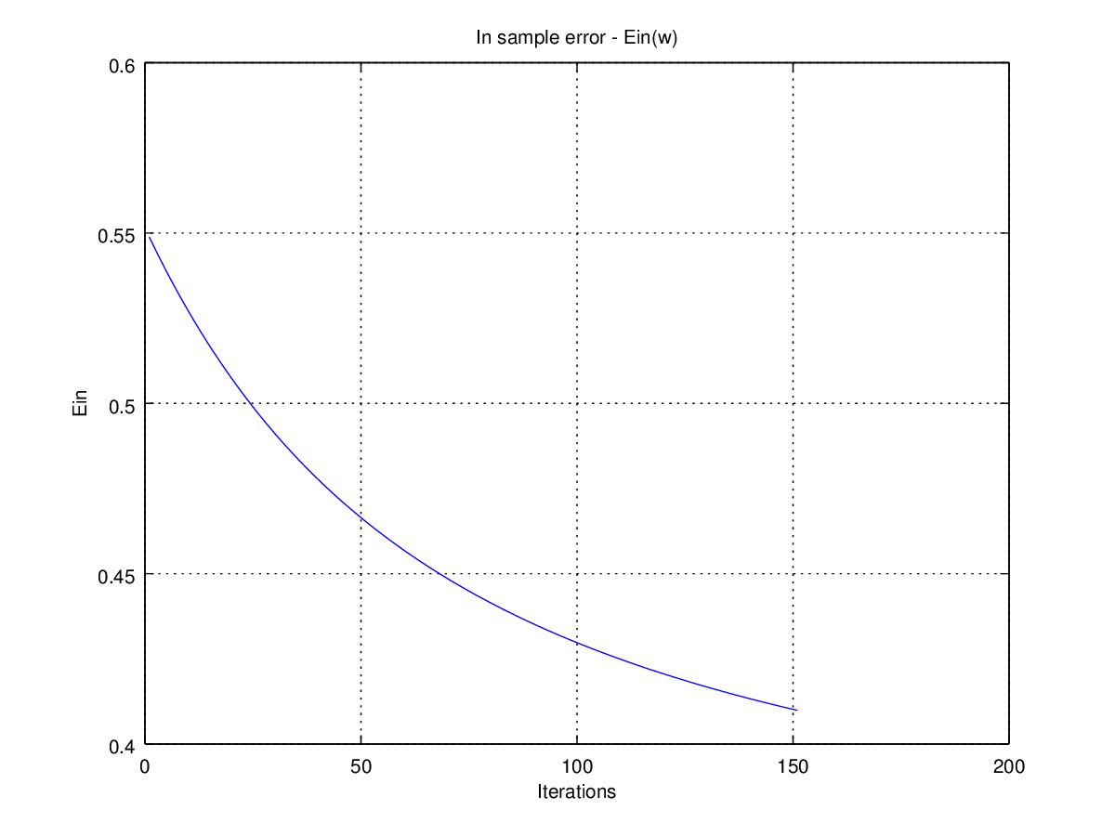
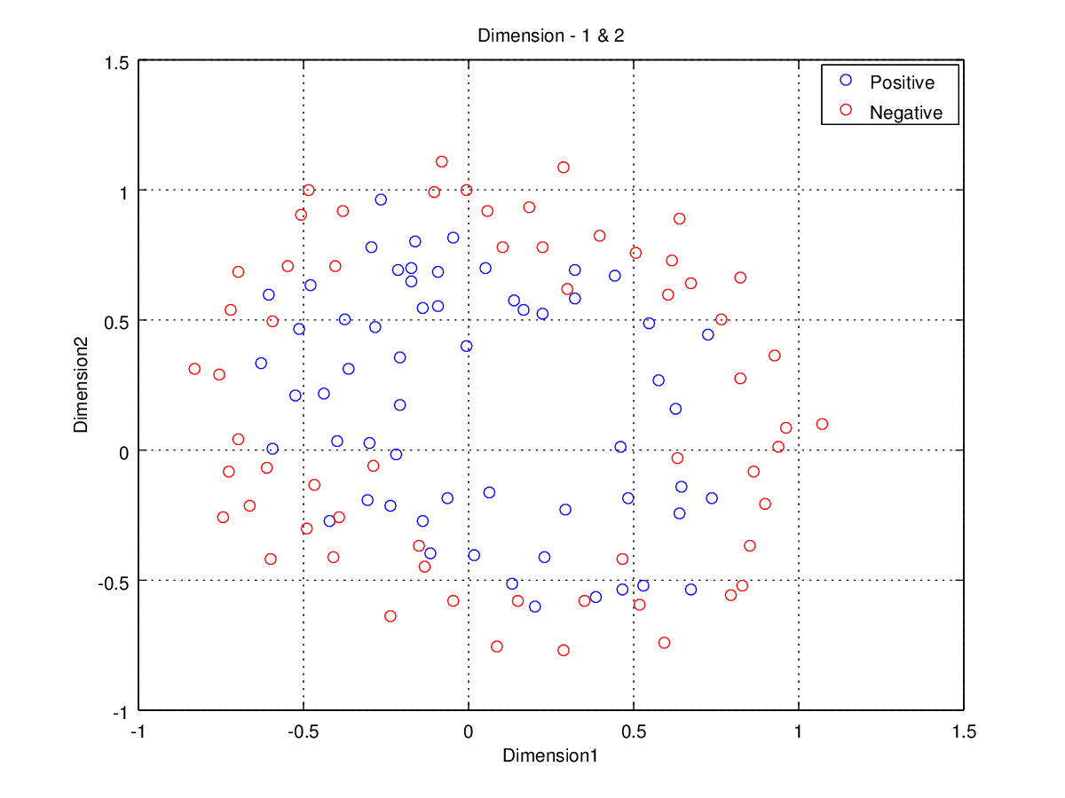

→ logistic_reg.m
function W = logistic_reg(M,Q)

% logistic_reg(matrix,Q) trains on the data given in the form of matrix
% M = [attribute1 attribute2 . . . attributeN targetFunction];
% Q = No of training iterations for w(t) where t = {1, 2, 3, ..., Q}
% produces hypothesis weights matrix where W = [w(1); w(2); w(3); ...; w(Q)] and
% w(t) = {w0, w1, w2, . . ., wN} matrix for each t

[N, A] = size(M);
A--;

X = ones(N,1);
X = [X M(1:N,1:A)];
T = M(1:N,A+1);

t = 1;

g = 0.1;

w(t,1:A+1) = rand(1,A+1);

for t=1:Q

for i=1:N
E(i,1:A+1) = (T(i)*X(i,1:A+1)) / (1 + exp(T(i)*w(t,1:A+1)*transpose(X(i,1:A+1))));
end

d_Ein(t,1:A+1) = (-1/N)*sum(E);

w(t+1,1:A+1) = w(t,1:A+1) - g*d_Ein(t,1:A+1);
end
W = w;
→ gradient_des.m
function E_IN = gradient_des(M,weights)

% gradient_des(matrix,weight_matrix) computes the in sample error - Ein using
% M = [attribute1 attribute2 . . . attributeN targetFunction];
% w = Matrix containing improvised weight vectors
% produces Ein corresponding to each weight vector from w

[N A] = size(M);

A--;

X = ones(N,1);
X = [X M(1:N,1:A)];
T = M(1:N,A+1);

P = length(weights);

for t=1:P

w = weights(t,1:A+1);

for i=1:N

E(i) = log(1 + exp(-1*T(i)*w*transpose(X(i,1:A+1))));

end

Ein(t) = (1/N)*sum(E);

end

E_IN = Ein;

→ plotting_cp.m
function plotting_cp(M,w)

% plots the data points with the Classifier Hyper plane base on the w
% M = [attribute1 attribute2 . . . attributeN targetFunction];
% w = [ w0 w1 w2 ... wd ] d = VC dimension

% NOT A GENERIC ONE, WORK IS IN PROGRESS, BUT WORKS COMPLETELY FINE FOR A=2

[len, A] = size(M);

A--;

X = [M(1:len,1:A)];

T = [M(1:len,A+1)];

p=0;
n=0;

for i=1:len

if(T(i) == 1)
Positive(++p) = i;
else
Negative(++n) = i;
end
end

if (A > 3)

for j=1:A

switch j

case A-1,
d1 = j;
d2 = j+1;
d3 = 1;

case A,
d1 = j;
d2 = 1;
d3 = 2;

otherwise,
d1 = j;
d2 = j+1;
d3 = j+2;
end

s0 = strvcat(["Classifier and Datapoints - Dimension - ",int2str(d1),", ",int2str(d2)," & ",int2str(d3)]);

s1 = strvcat(["Dimension",int2str(d1)]);
s2 = strvcat(["Dimension",int2str(d2)]);
s3 = strvcat(["Dimension",int2str(d3)]);

for k=1:length(Positive)

xp(k) = X((Positive(k)),d1);
yp(k) = X((Positive(k)),d2);
zp(k) = X((Positive(k)),d3);
end

for k=1:length(Negative)

xn(k) = X((Negative(k)),d1);
yn(k) = X((Negative(k)),d2);
zn(k) = X((Negative(k)),d3);
end

xc = linspace(min(X(1:len,d1)), max(X(1:len,d1)),1000);
yc = linspace(min(X(1:len,d2)), max(X(1:len,d2)),1000);

[XC, YC] = meshgrid(xc,yc);

ZC = (w(1)/w(d3+1))*1 - (w(d1+1)/w(d3+1)).*XC - (w(d2+1)/w(d3+1)).*YC;

plot3(xp,yp,zp,'bo',xn,yn,zn,'ro')
hold on
mesh(XC,YC,ZC);
grid on
xlabel(s1);
ylabel(s2);
zlabel(s3);
legend('Positive','Negative')
title(s0);
print(strvcat([ s0,".png"]),'-dpng');

end

elseif(A == 3)

d1 = 1;
d2 = 2;
d3 = 3;

s0 = strvcat(["Classifier and Datapoints - Dimension - ",int2str(d1),", ",int2str(d2)," & ",int2str(d3)]);

s1 = strvcat(["Dimension",int2str(d1)]);
s2 = strvcat(["Dimension",int2str(d2)]);
s3 = strvcat(["Dimension",int2str(d3)]);

for k=1:length(Positive)

xp(k) = X((Positive(k)),d1);
yp(k) = X((Positive(k)),d2);
zp(k) = X((Positive(k)),d3);
end

for k=1:length(Negative)

xn(k) = X((Negative(k)),d1);
yn(k) = X((Negative(k)),d2);
zn(k) = X((Negative(k)),d3);
end

xc = linspace(min(X(1:len,d1)), max(X(1:len,d1)),1000);
yc = linspace(min(X(1:len,d2)), max(X(1:len,d2)),1000);

[XC, YC] = meshgrid(xc,yc);

ZC = (w(1)/w(4))*1 - (w(2)/w(4)).*XC - (w(3)/w(4)).*YC;

figure2
plot3(xp,yp,zp,'bo',xn,yn,zn,'ro')
hold on
mesh(XC,YC,ZC);
grid on
xlabel(s1);
ylabel(s2);
zlabel(s3);
legend('Positive','Negative')
title(s0);
print(strvcat([ s0,".png"]),'-dpng');

elseif(A == 2)

d1 = 1;
d2 = 2;

s0 = strvcat(["Classifier and Datapoints - Dimension - ",int2str(d1)," & ",int2str(d2)]);

s1 = strvcat(["Dimension",int2str(d1)]);
s2 = strvcat(["Dimension",int2str(d2)]);

for k=1:length(Positive)

xp(k) = X((Positive(k)),d1);
yp(k) = X((Positive(k)),d2);
end

for k=1:length(Negative)

xn(k) = X((Negative(k)),d1);
yn(k) = X((Negative(k)),d2);

end

XC = linspace( min(X(1:len,d1)), max(X(1:len,d1)),1000);

YC = (-w(1)/w(3))*1 - (w(2)/w(3)).*XC;

plot(xp,yp,'bo',xn,yn,'ro',XC,YC,'k')
hold on
grid on
xlabel(s1);
ylabel(s2);
legend('Positive','Negative','Classifier')
title(s0);
print(strvcat([ s0,".png"]),'-dpng');

else

d1 = 1;

s0 = strvcat(["Classifier and Datapoints - Dimension - ",int2str(d1)]);

s1 = strvcat(["Dimension",int2str(d1)]);

for k=1:length(Positive)

xp(k) = X((Positive(k)),d1);

end

for k=1:length(Negative)

xn(k) = X((Negative(k)),d1);

end

plot(xp,'bo',xn,'ro')
hold on
grid on
xlabel(s1);
legend('Positive','Negative')
title(s0);
print(strvcat([ s0,".png"]),'-dpng');

end



  

