Indian Institute of Information Technology, Vadodara

CS308 – Introduction to Artificial Intelligence

Assignment #02

1. Implement Linear classification with analytical solution.

#Source code:
clear all;
close all;

m_train = load("-ascii", "iris_data_norm_train.txt");

m_test = load("-ascii", "iris_data_norm_test.txt");

[w, no_of_iterations, Ein] = training_pla(m_train);

printf("-------------------------------------------------------\n");
printf("Machine has completed learning,\n");
printf("from the given dataset.\n");
printf("So, weights obtained - \n");

w

[misclassifications, classifications] = testing_pla(m_test,w);
printf("-------------------------------------------------------\n");

misclassifications
classifications

printf("Accuracy = %f \n", (100*classifications)/ (misclassifications + classifications));
printf("-------------------------------------------------------\n");

m_both = load("-ascii", "iris_data_norm_both.txt");
plotting_datapoints(m_both);

#Output:
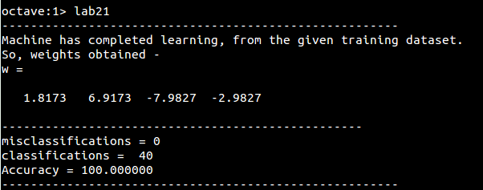

#Diagrams:
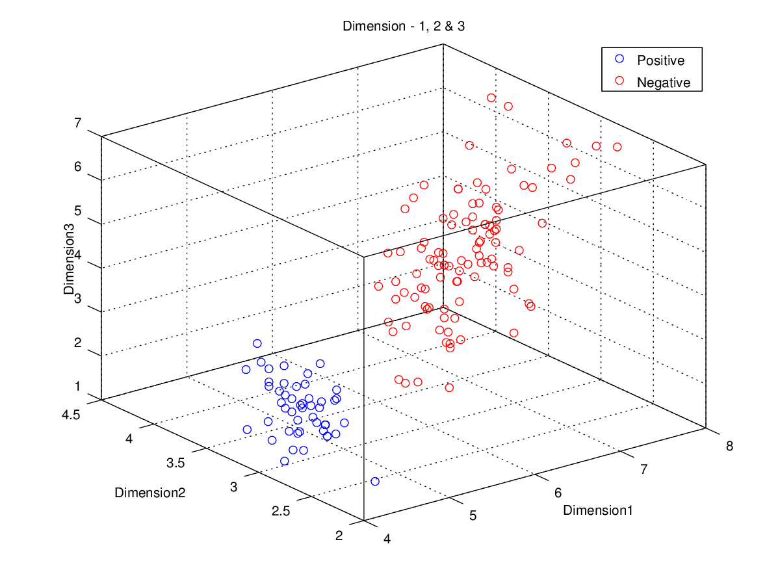
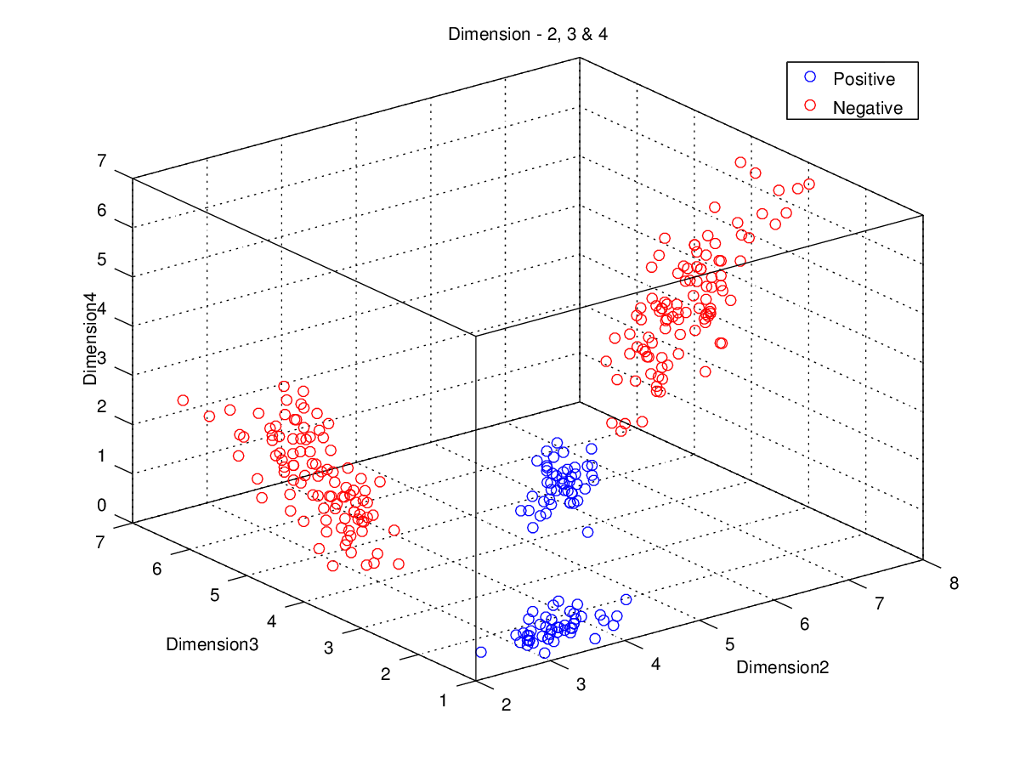

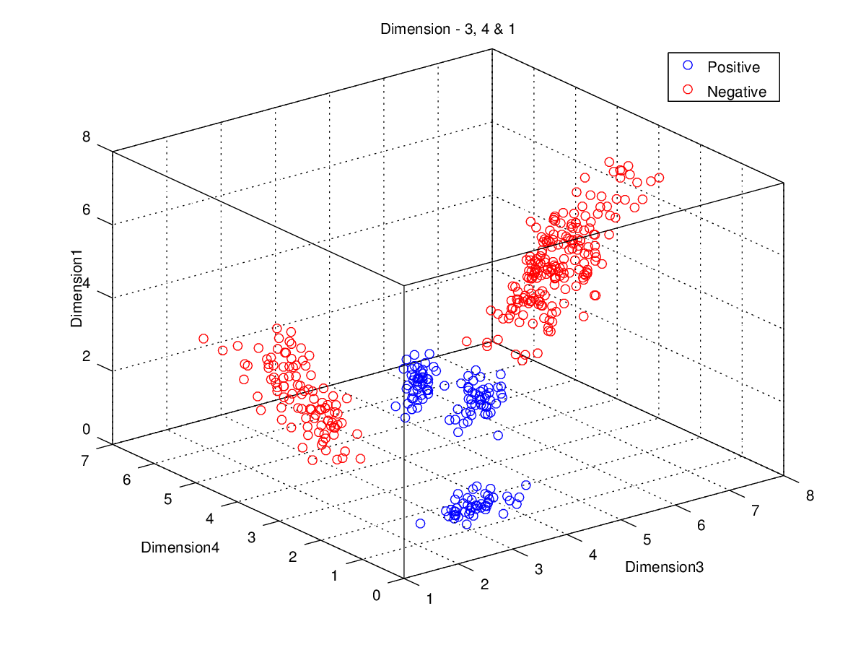
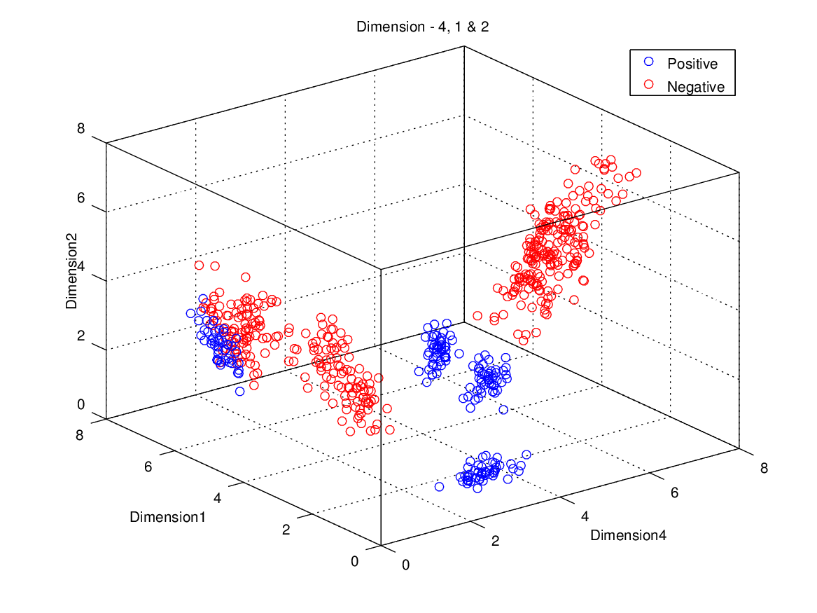

2. Shuffle the training data (using a common seed, 1234) and then prepare train-test partitions according to (30/70, 40/60, 50/50, 60/40 and 70/30) percent sizes. Train on train partition and test on both. Report E_in and E_out for each partition.

#Source Code:
clear all;
close all;

m_both = load("-ascii", "iris_data_norm_both.txt");

[L, W] = size(m_both);

p = input("Enter the training percentage: ");

N = (p/100)*L;

m_train = m_both(1:N,1:W);

m_test = m_both(N+1:L,1:W);

printf("-------------------------------------------------------\n");
printf("Machine has completed learning,\n");
printf("from the %d%% of the given dataset.\n");
printf("So, weights obtained - \n",p);

[weights, no_of_iterations, Ein] = training_pla_it(m_train)

w=zeros(1,W-1);

for i=1:no_of_iterations
w = weights(i, 1:(W-1));
[misclassifications, classifications] = testing_pla(m_test,w);
Eout(i) = misclassifications;
end

Eout

#Output:
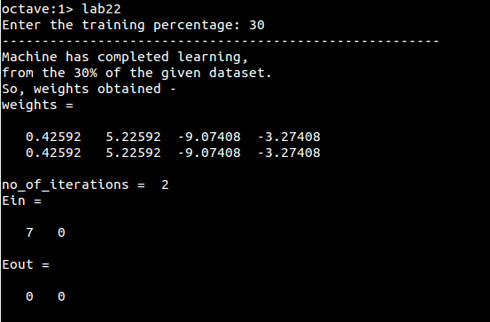
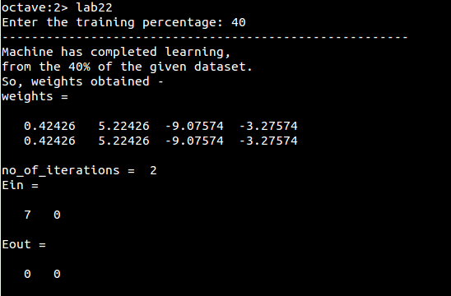

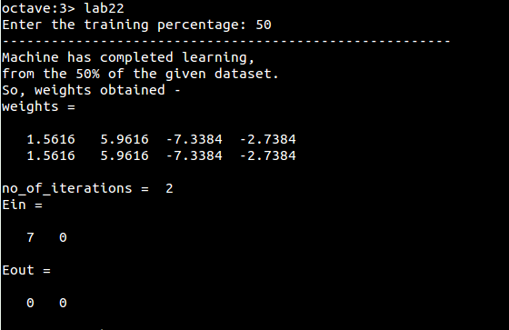
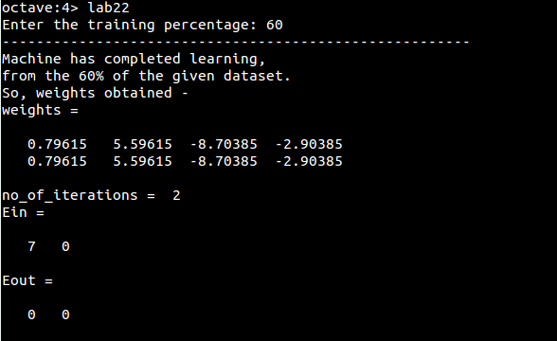

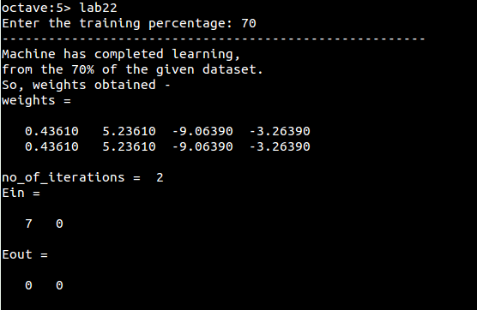

3. For PLA, plot learning curves. Where X axis will be number of iterations and Y axis will be normalized error (misclassifications) on train (E_in) and test E_out). Do it for each partitions prepared in task 2.

#Source Code:
clear all;
close all;

m_both = load("-ascii", "iris_data_norm_both.txt");

[L, W] = size(m_both);

p = input("Enter the training percentage: ");

N = (p/100)*L;

m_train = m_both(1:N,1:W);

m_test = m_both(N+1:L,1:W);

printf("-------------------------------------------------------\n");
printf("Machine has completed learning,\n");
printf("from the %d%% of the given dataset.\n");
printf("So, weights obtained - \n",p);

[weights, no_of_iterations, Ein] = training_pla_it(m_train);

w = zeros(1,W-1);

for i=1:no_of_iterations
w = weights(i, 1:(W-1));
[misclassifications, classifications] = testing_pla(m_test,w);
Eout(i) = misclassifications;
end

Eout;

weights

Einp = Ein.*(100/N)

Eoutp = Eout.*(100/(L-N))

% plotting the graph
plot(1:no_of_iterations, Einp,'b', 1:no_of_iterations, Eoutp,'r');
grid on;
hold on;
title(strvcat(["Ein and Eout v/s iterations for training ",int2str(p),"% of given dataset"]));
xlabel('epochs');
ylabel('Ein/Eout percentage');
legend('Ein', 'Eout');
print(strvcat(["Ein and Eout ",int2str(p),"%% dataset.png"]), '-dpng');

#Output: #Diagrams:
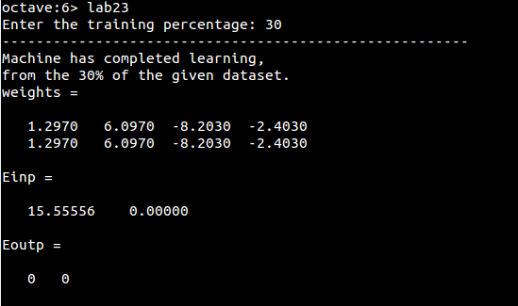
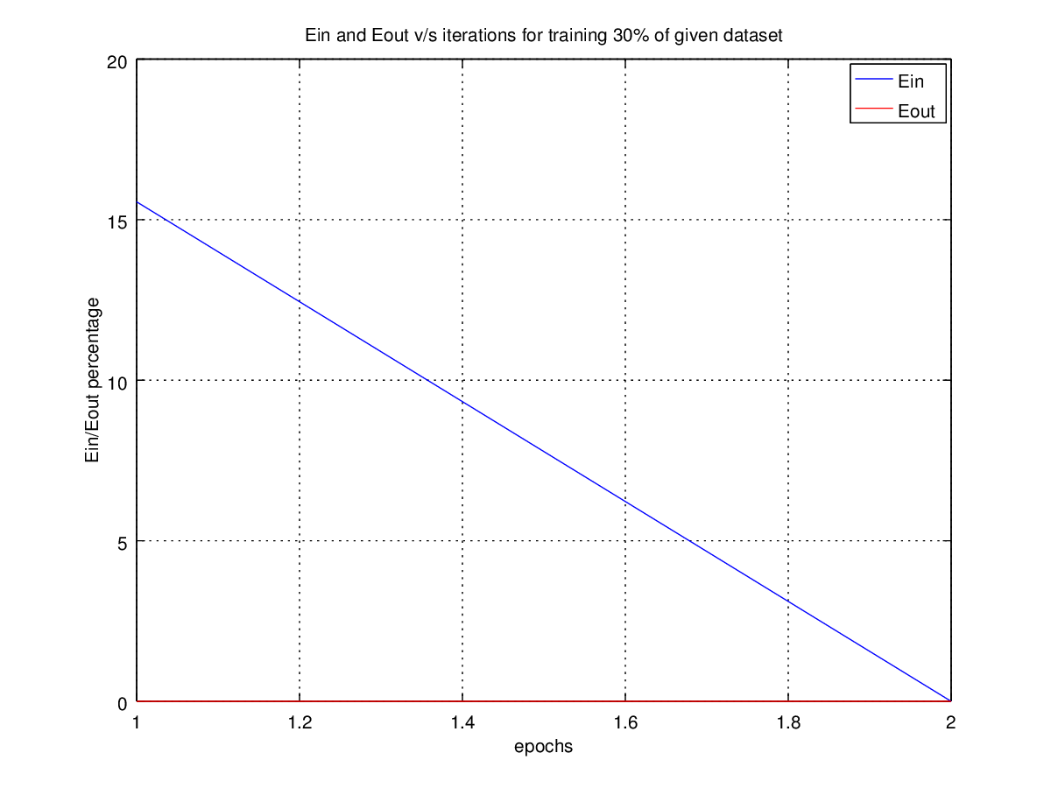

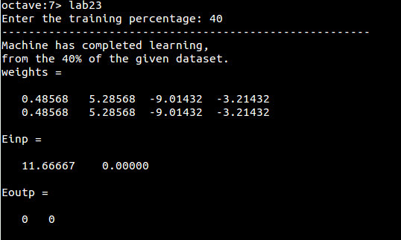
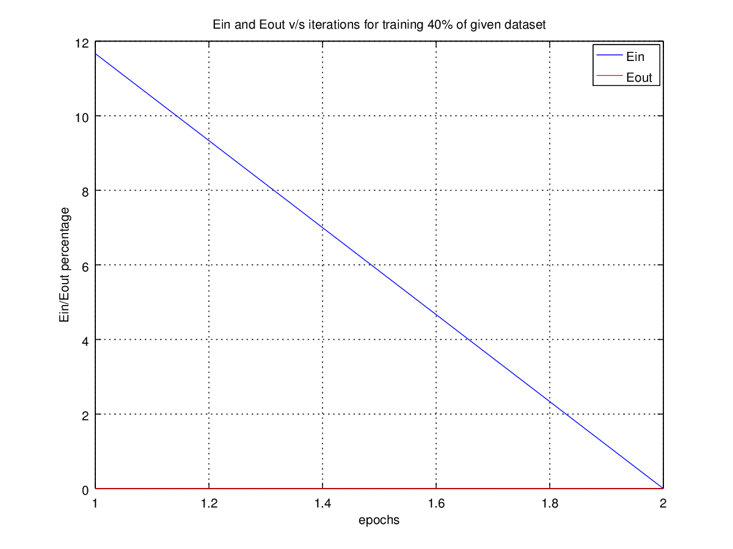

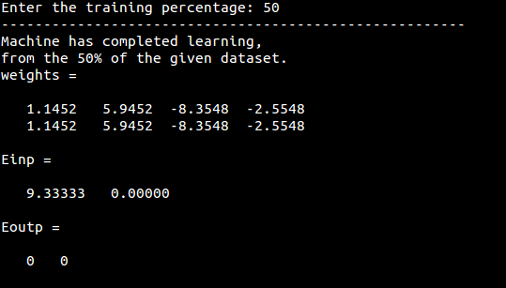
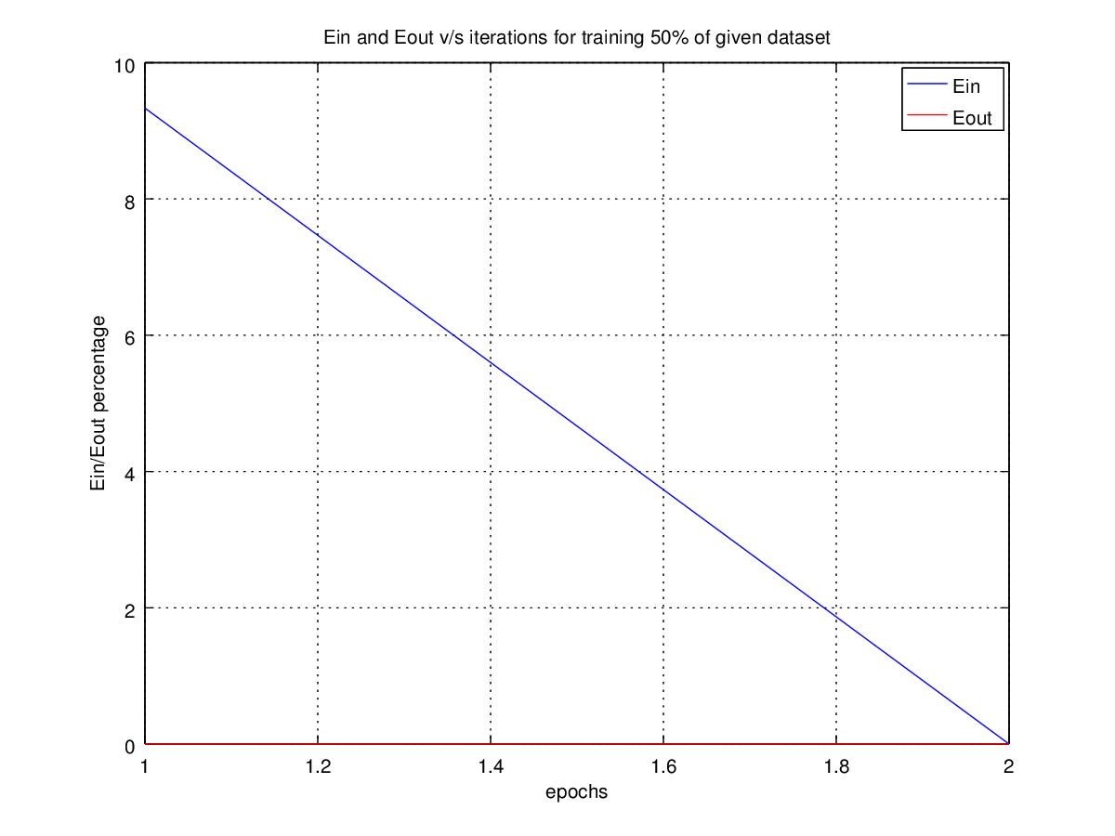

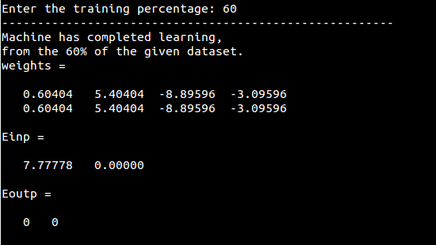
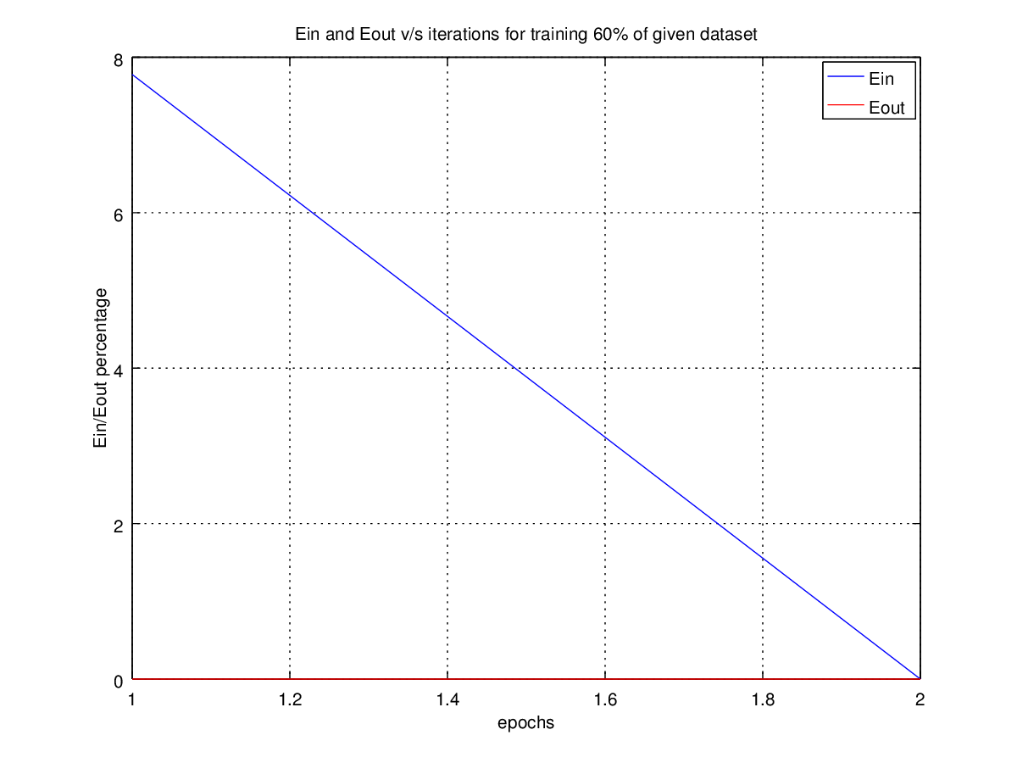

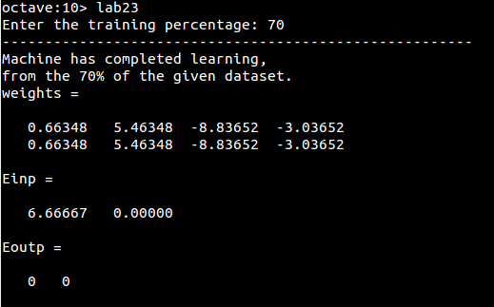
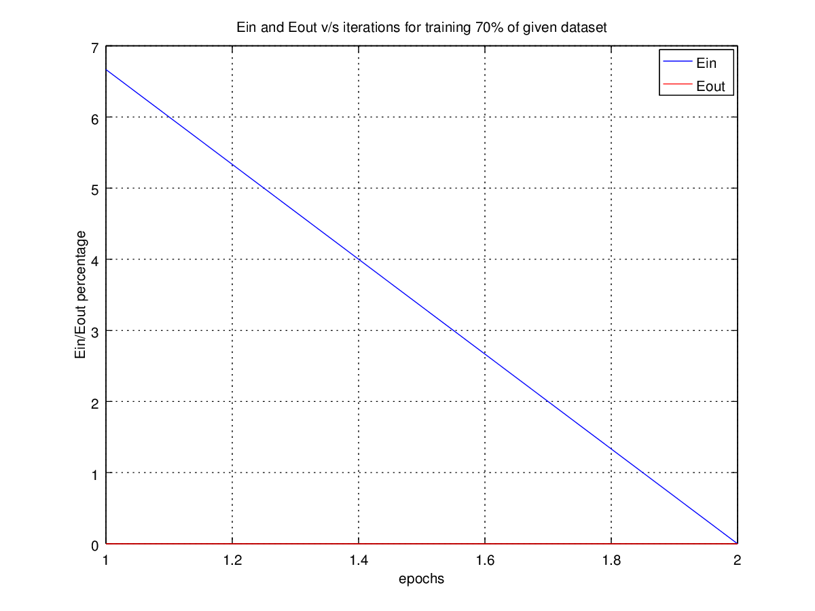

4. Implement Pocket algorithm for PLA. And replot task3 .

#Source Code:
clear all;
close all;

m_both = load("-ascii", "iris_data_norm_both.txt");

[L, W] = size(m_both);

p = input("Enter the training percentage: ");

N = (p/100)*L;

m_train = m_both(1:N,1:W);

m_test = m_both(N+1:L,1:W);

printf("-------------------------------------------------------\n");
printf("Machine has completed learning,\n");
printf("from the %d%% of the given dataset.\n");
printf("So, weights obtained - \n",p);

[weights, no_of_iterations, Ein] = training_pocket(m_train);

w=zeros(1,W-1);

for i=1:no_of_iterations
w = weights(i, 1:(W-1));
[misclassifications, classifications] = testing_pla(m_test,w);
Eout(i) = misclassifications;
end

Eout;

weights

Einp = Ein.*(100/N)

Eoutp = Eout.*(100/(L-N))

% plotting the graph
plot(1:no_of_iterations, Einp,'b', 1:no_of_iterations, Eoutp,'r');
grid on;
hold on;
title(strvcat(["Pocket: Ein and Eout v/s iterations for training ",int2str(p),"% of given dataset"]));
xlabel('epochs');
ylabel('Ein/Eout percentage');
legend('Ein', 'Eout');
print(strvcat(["Pocket: Ein and Eout ",int2str(p),"%% dataset.png"]), '-dpng');

#Output:
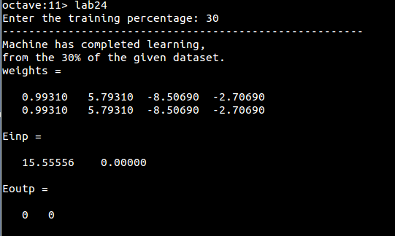
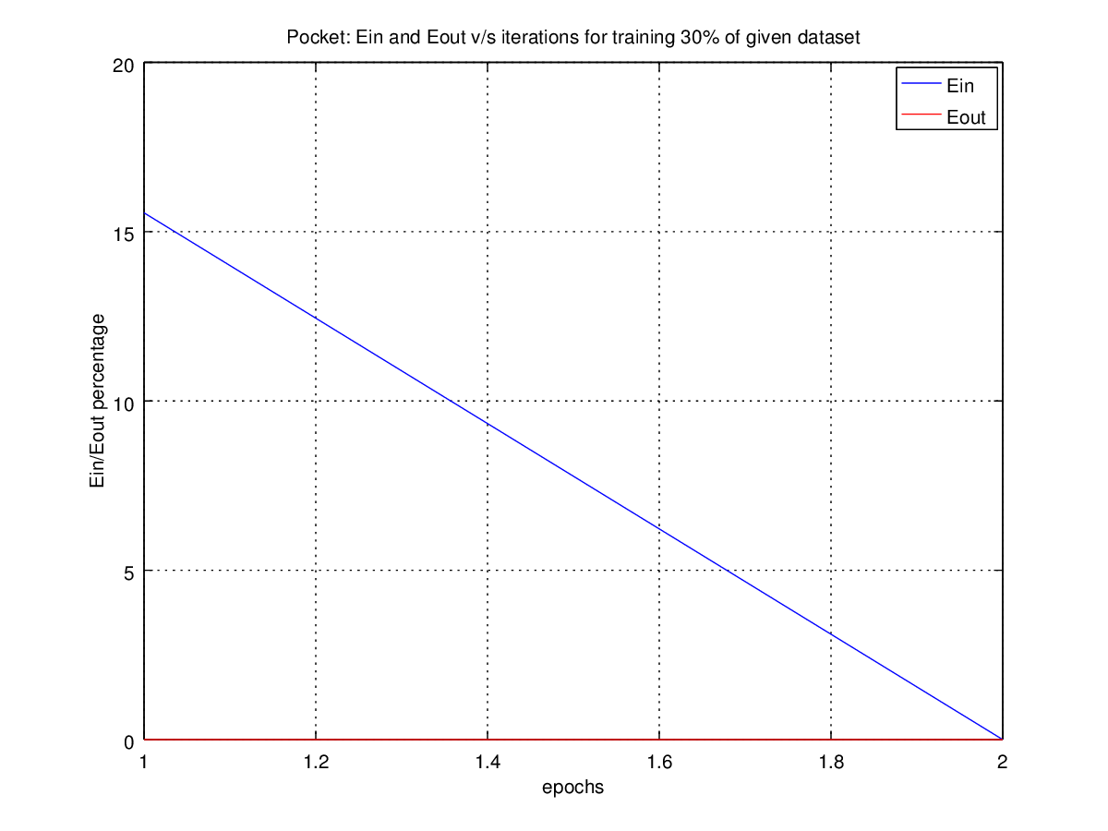

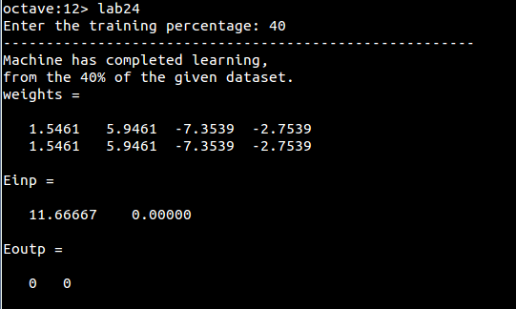
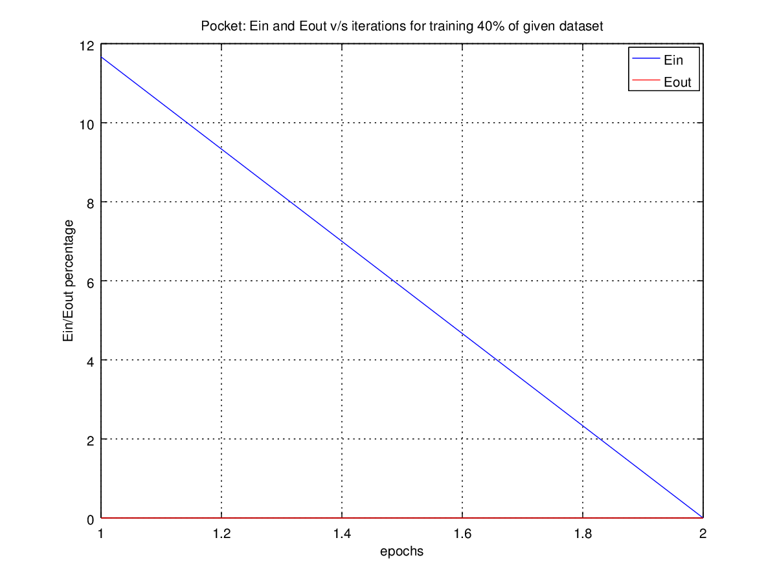

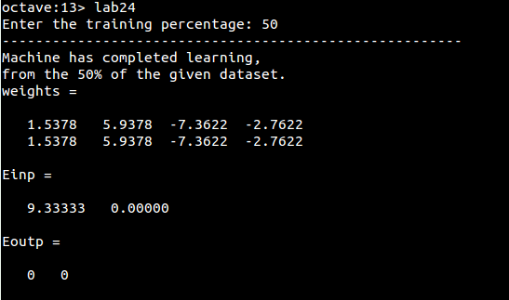
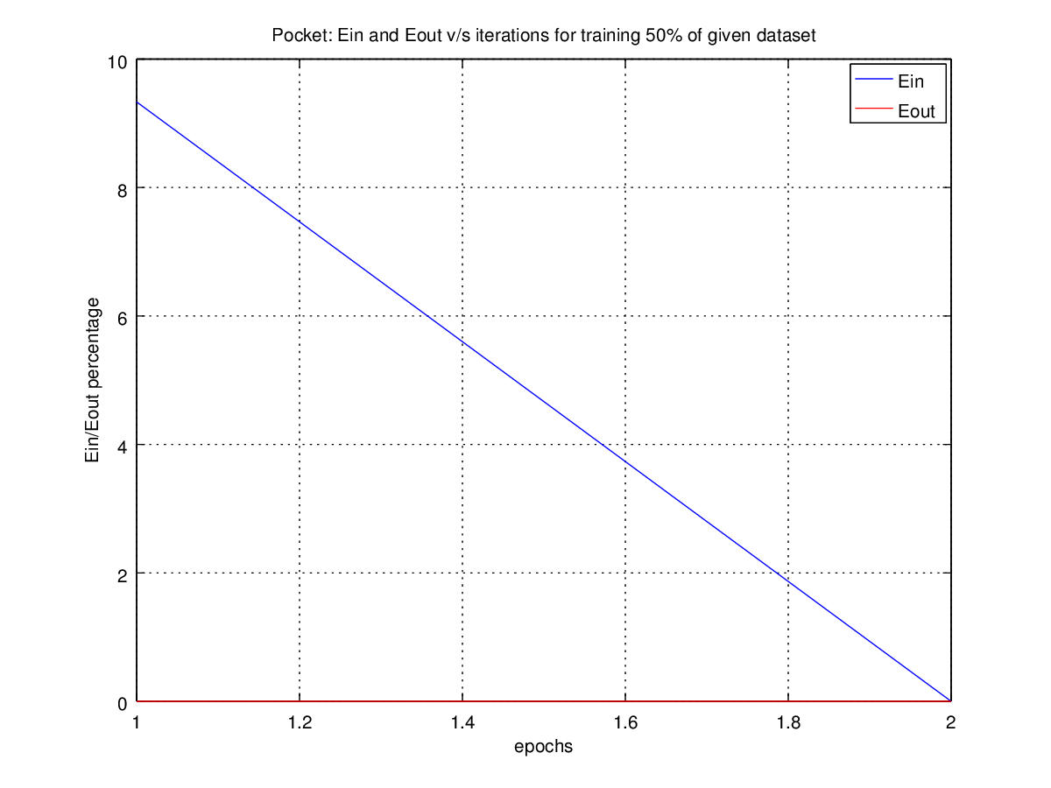

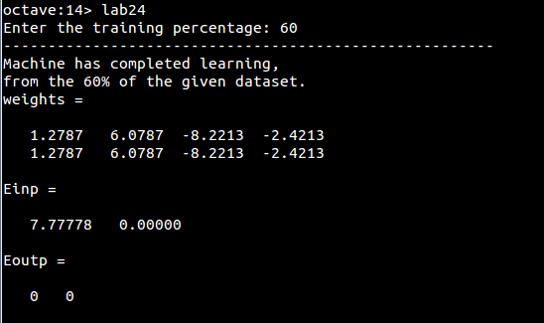
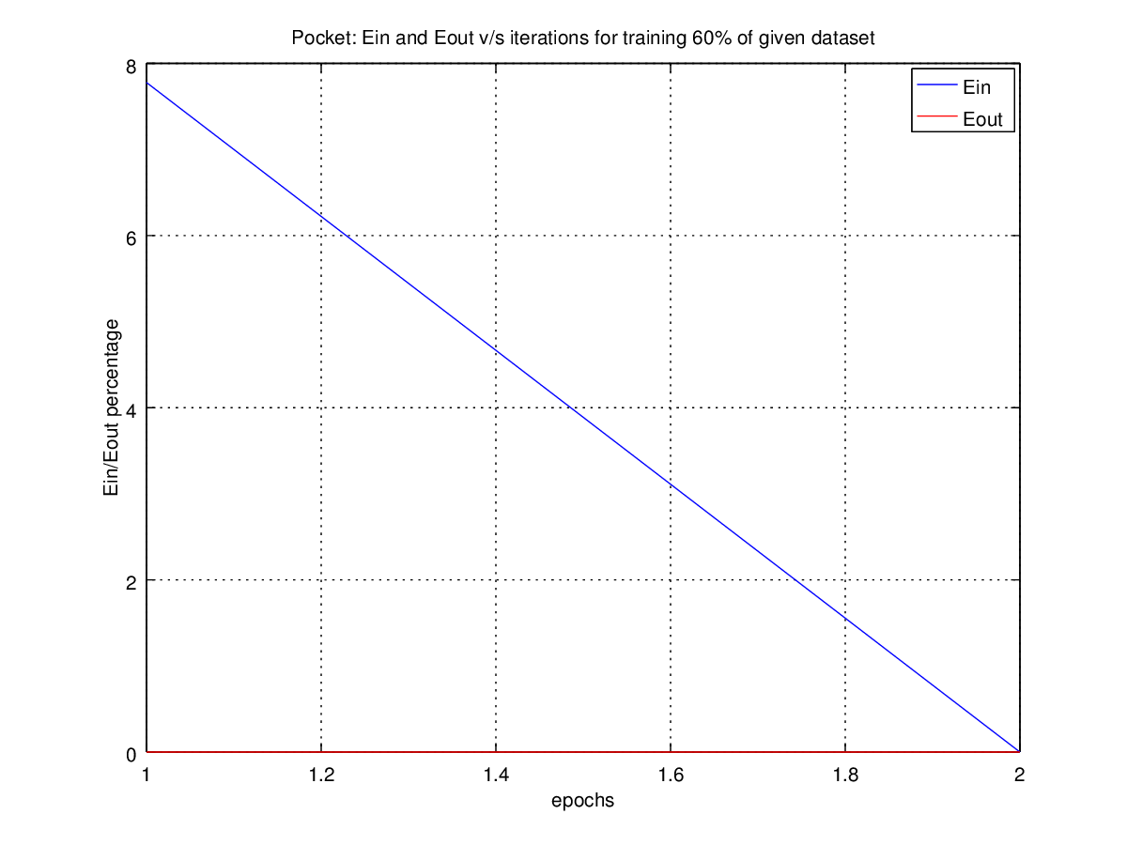

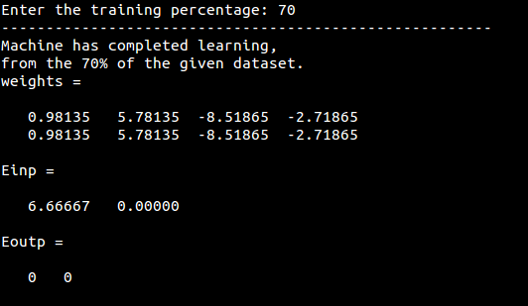
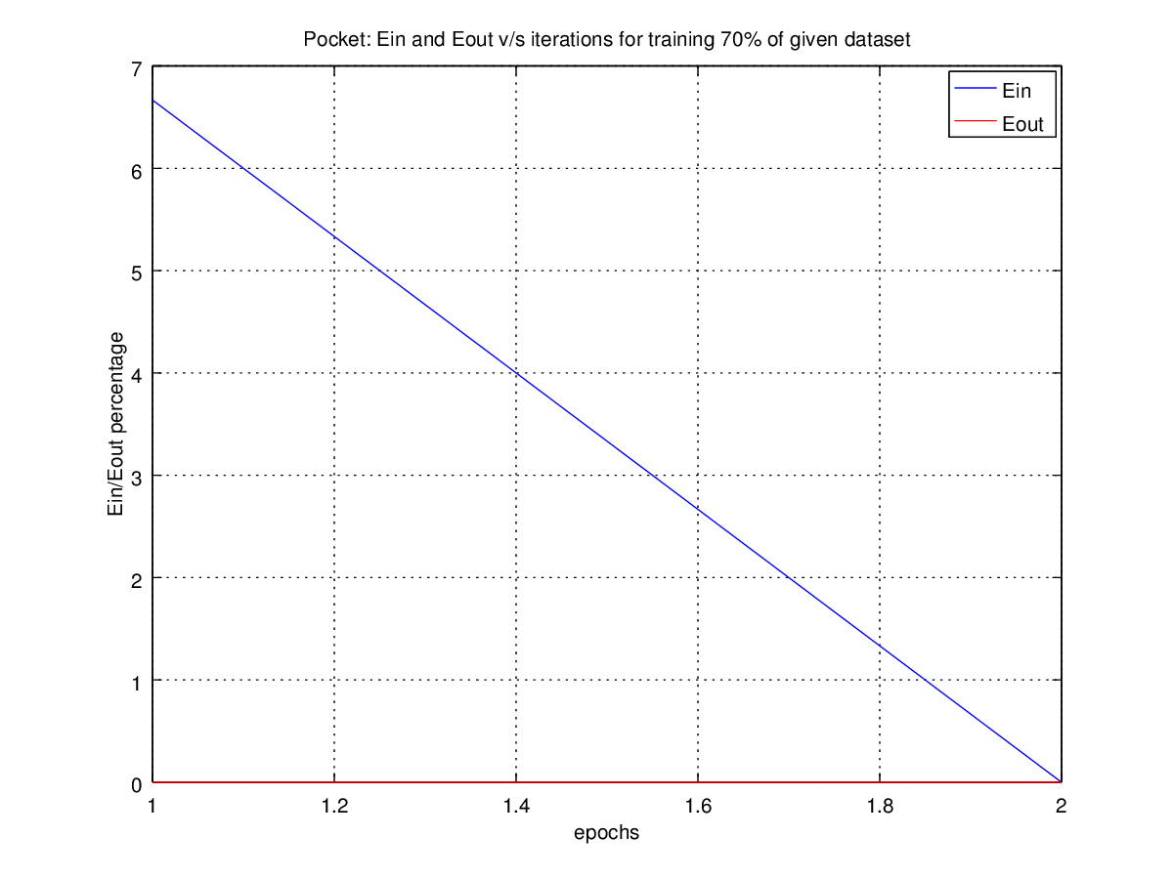

5. Implement the linear regression model on train dataset and test the result (w) on the test dataset. {as discussed during the lab hours}

#Source Code:
clear all;
close all;

m_train = load("-ascii", "iris_data_norm_train.txt");

w = training_linreg(m_train)

m_test = load("-ascii","iris_data_norm_test.txt");

printf("-------------------------------------------------------\n");
[misclassifications, classifications] = testing_pla(m_test, w)

printf("Accuracy = %f \n", (100*classifications)/(misclassifications + classifications));
printf("-------------------------------------------------------\n");

#Output:
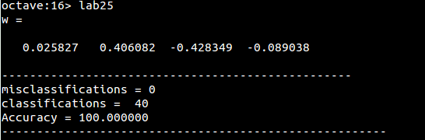

6. Implement the II order non-linear regression model for train dataset and output the results. {as discussed in the lab hours}

#Source Code:
clear all;
close all;

m_train = load("-ascii", "iris_data_norm_train.txt");

printf("The weight vector for II order non-linear regression:\n");

w = training_nonlin(m_train)

#Output:
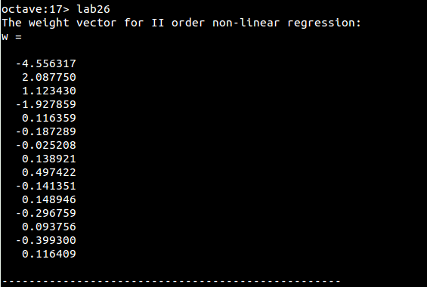

#Additional Functions Codes:

function plotting_datapoints(M)

% plots the data points taking 3 dimensions at a time
% M = [attribute1 attribute2 . . . attributeN targetFunction];
% produces all the 3 at a time 3D plots
% as Dimension - 1, 2 & 3.png (say, for first three dimensions)

[len, A] = size(M);
A--;

X = [M(1:len,1:A)];
T = [M(1:len,A+1)];

p=0;
n=0;

for i=1:len

if(T(i) == 1)
Positive(++p) = i;
else
Negative(++n) = i;
end
end

for j=1:A

switch j

case A-1,
d1 = j;
d2 = j+1;
d3 = 1;

case A,
d1 = j;
d2 = 1;
d3 = 2;

otherwise,
d1 = j;
d2 = j+1;
d3 = j+2;
end

s0 = strvcat(["Dimension - ",int2str(d1),", ",int2str(d2)," & ",int2str(d3)]);

s1 = strvcat(["Dimension",int2str(d1)]);
s2 = strvcat(["Dimension",int2str(d2)]);
s3 = strvcat(["Dimension",int2str(d3)]);

for k=1:length(Positive)

xp(k) = X((Positive(k)),d1);
yp(k) = X((Positive(k)),d2);
zp(k) = X((Positive(k)),d3);
end

for k=1:length(Negative)

xn(k) = X((Negative(k)),d1);
yn(k) = X((Negative(k)),d2);
zn(k) = X((Negative(k)),d3);
end

plot3(xp,yp,zp,'bo',xn,yn,zn,'ro')
hold on
grid on
xlabel(s1);
ylabel(s2);
zlabel(s3);
legend('Positive','Negative')
title(s0);
print(strvcat([ s0,".png"]),'-dpng');

end

function [W,ITERATIONS,E] = training_pla(M)

% trainig_pla(matrix) trains on the data given in the form of matrix
% M = [attribute1 attribute2 . . . attributeN targetFunction];
% produces hypothesis weights w = {w1, w2, . . ., wN}

[len, A] = size(M);
A--;

X = M(1:len,1:A);
T = M(1:len,A+1);

w(1:A) = rand();

iterations = 0;
improvements = 0;
i = 0;

while(i < len)

i++;

x = transpose(X(i,1:A));

product = w * x;

if((product < 0 && T(i) == 1) || (product > 0 && T(i) == -1))
improvements++;
w = w + T(i)* x'; % w <- w + yx
end

if (i == len && improvements == 0) % last iteration
iterations++;
errors(iterations) = improvements;
end

if(i == len && improvements > 0)
i = 0;
iterations++;
errors(iterations) = improvements;
improvements = 0; % restarting the iterations
end

end
W = w;
ITERATIONS = iterations;
E = errors;
endfunction

function [E,C] = testing_pla(M,w)

% testing_pla(matrix) tests on the data given in the form of matrix
% M = [attribute1 attribute2 . . . attributeN targetFunction];
% w = [w1 w2 . . . wN];
% produce E, percentage misclassifications

[len, A] = size(M);
A--;

X = [M(1:len,1:A)];
T = [M(1:len,A+1)];

err = 0;
corr = 0;

for i = 1:len

x = transpose([X(i,1:A)]);

product = w * x;

if((product < 0 && T(i) == 1) || (product > 0 && T(i) == -1))
err++;
else
corr++;
end
end

E = err;
C = corr;
endfunction

function [W,ITERATIONS,E] = training_pla_it(M)

% trainig_pla_it(matrix) trains on the data given in the form of matrix ITERATIVELY
% M = [attribute1 attribute2 . . . attributeN targetFunction];
% produces hypothesis weights w = {w1, w2, . . ., wN} for each ITERATION

[len, A] = size(M);
A--;

X = M(1:len,1:A);
T = M(1:len,A+1);

w(1:A) = rand();

iterations = 0;
improvements = 0;
i = 0;

while(i < len)

i++;

x = transpose(X(i,1:A));

product = w * x;

if((product < 0 && T(i) == 1) || (product > 0 && T(i) == -1))
improvements++;
w = w + T(i)* x'; % w <- w + yx
end

if (i == len && improvements == 0) % last iteration
iterations++;
errors(iterations) = improvements;
w_it(iterations,1:A) = w;
end

if(i == len && improvements > 0)
i = 0;
iterations++;
errors(iterations) = improvements;
w_it(iterations,1:A) = w;
improvements = 0; % restarting the iterations
end

end

W = w_it;
ITERATIONS = iterations;
E = errors;
endfunction

function [W,ITERATIONS,E] = training_pocket(M)

% trainig_pocket(matrix) trains on the data given in the form of matrix
% using POCKET ALGORITHM
% M = [attribute1 attribute2 . . . attributeN targetFunction];

[len, A] = size(M);
A--;

X = M(1:len,1:A);
T = M(1:len,A+1);

w(1:A) = rand();

iterations = 0;
improvements = 0;
i = 0;

while(i < len)

i++;

x = transpose(X(i,1:A));

product = w * x;

if((product < 0 && T(i) == 1) || (product > 0 && T(i) == -1))
improvements++;
w = w + T(i)* x'; % w <- w + yx
end

if (i == len && improvements == 0) % last iteration
iterations++;
errors(iterations) = improvements;

if(iterations == 1)
w_it(iterations,1:A) = w;
errors(iterations) = improvements;

elseif(iterations > 1 && errors(iterations-1) < errors(iterations) ) % Condition of POCKET ALGORITHM
w_it(iterations,1:A) = w_it(iterations - 1,1:A);
errors(iterations) = errors(iterations - 1);
else
w_it(iterations,1:A) = w;
errors(iterations) = improvements;
end
end

if(i == len && improvements > 0)
iterations++;
errors(iterations) = improvements;

if(iterations >= 2 && errors(iterations - 1) < errors(iterations) ) % Condition of POCKET ALGORITHM
w_it(iterations,1:A) = w_it(iterations - 1,1:A);
errors(iterations) = errors(iterations - 1);
else
w_it(iterations,1:A) = w;
errors(iterations) = improvements;
end
i = 0;
improvements = 0; % restarting the iterations
end

if(iterations == 1000)
break;
end

end

W = w_it;
ITERATIONS = iterations;
E = errors;
endfunction

function W = training_linreg(M)

% trainig_linreg(matrix) trains on the data given in the form of matrix
% using LINEAR REGRESSION
% M = [attribute1 attribute2 . . . attributeN targetFunction];
% produces hypothesis weights w = {w1, w2, . . ., wN}

[len, A] = size(M);
A--;

X = M(1:len,1:A);
T = M(1:len,A+1);

w = pinv(X)*T;
W = w';

function W = training_nonlin(M)

% trainig_momlin(matrix) trains on the data given in the form of matrix
% using NON LINEAR REGRESSION for degree = 2
% M = [attribute1 attribute2 . . . attributeN targetFunction];
% produces hypothesis weights w = {w1, w2, . . ., wN}

[len, A] = size(M);
A--;

Max = A*(A+1)/2;

x(1:len,1) = ones(len,1);

for i=2:A+1
x(1:len,i) = M(1:len,i-1);
end

for i=6:9
x(1:len,i) = M(1:len,(i-5)) .* M(1:len,(i-5));
end

x(1:len,10) = M(1:len,1) .* M(1:len,2);
x(1:len,11) = M(1:len,2) .* M(1:len,3);
x(1:len,12) = M(1:len,3) .* M(1:len,4);
x(1:len,13) = M(1:len,1) .* M(1:len,3);
x(1:len,14) = M(1:len,2) .* M(1:len,4);
x(1:len,15) = M(1:len,1) .* M(1:len,4);

T = M(1:len,A+1);

w = pinv(x)*T;
W = w;

# # #

