1. Go to <https://cloudpebble.net>

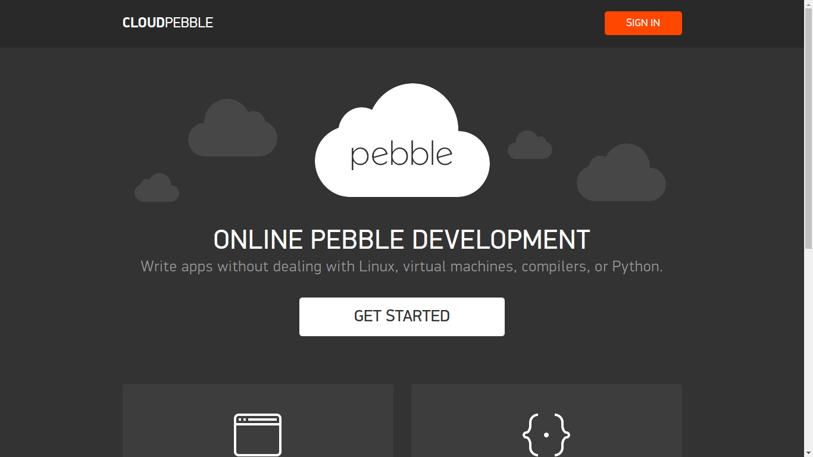

2.) click on “SIGNUP” at the top right corner

3.) click on “CREATE PEBBLE ACCOUNT”

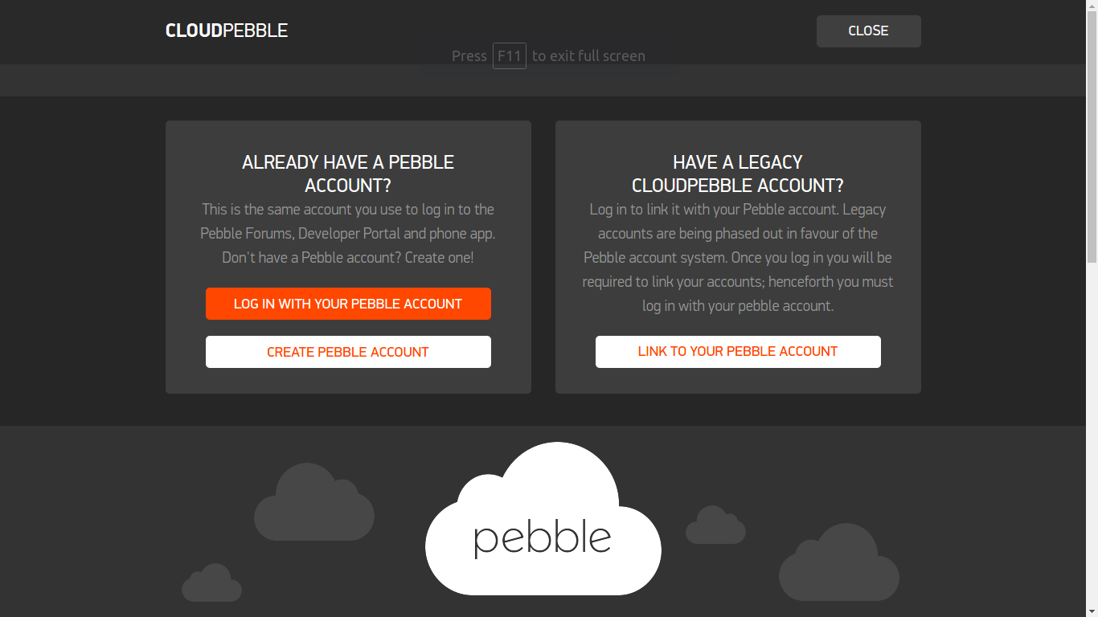

4.) after creating an account click on “GO TO CLOUD PEBBLE”

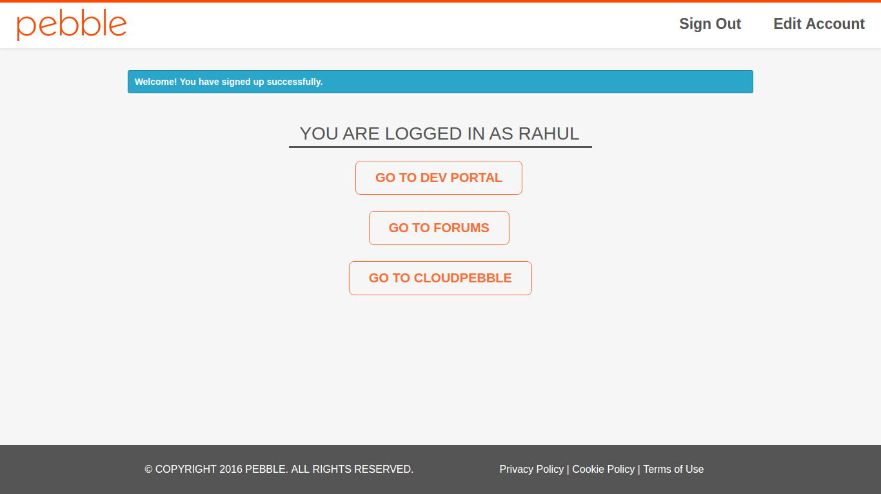

5.) here you click on the “IMPORT” button

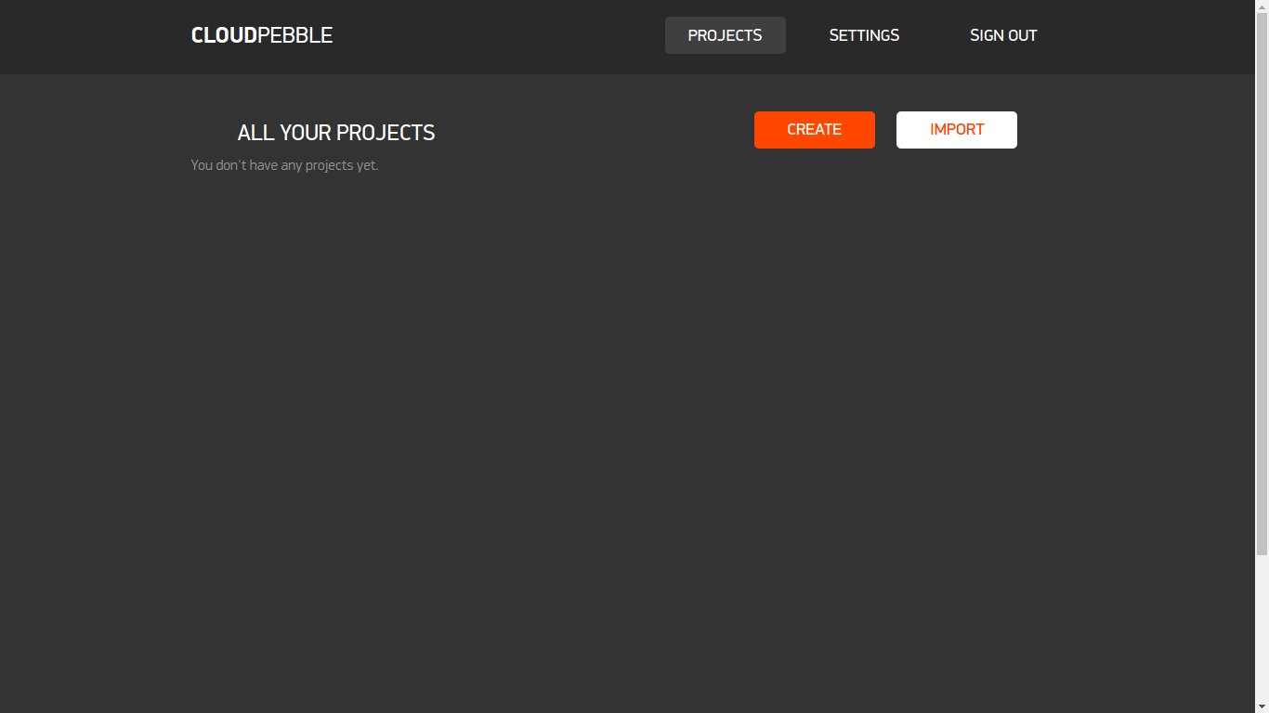

6.) next click on “IMPORT FROM GITHUB”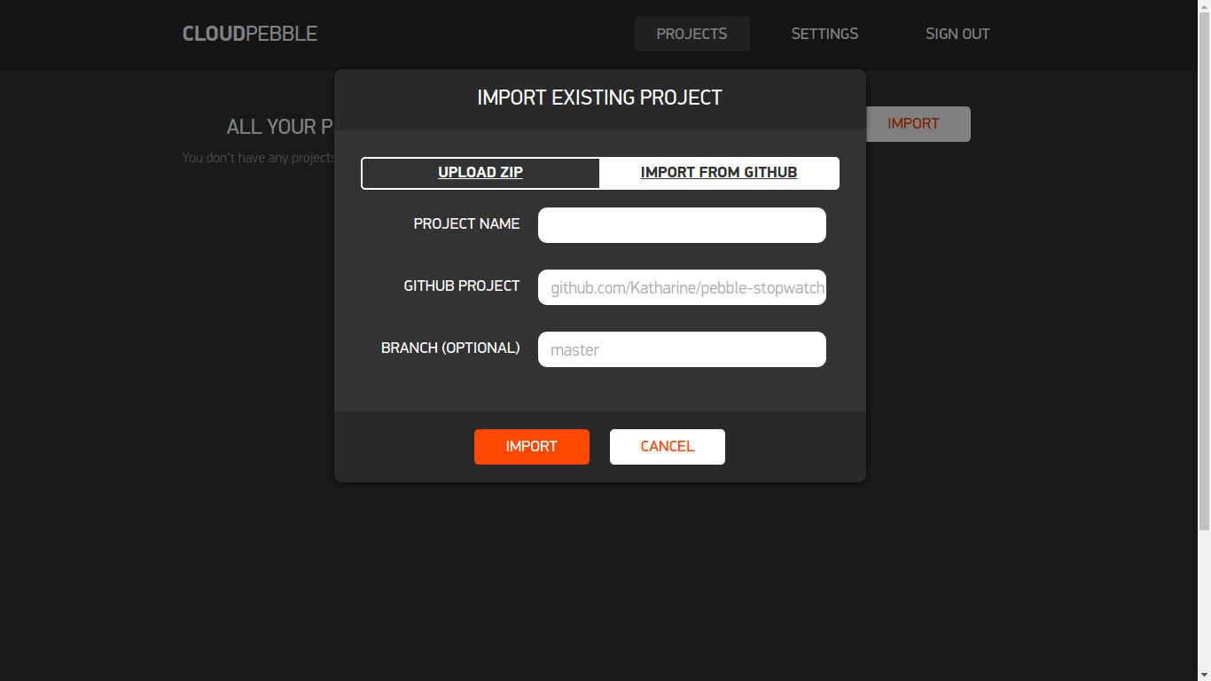

7.) give a project name and paste the github project path in “GITHUB PROJECT” and click on “IMPORT”

8.) click on Pebble_Flash.c on the left column below source files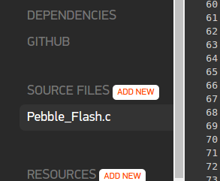

9.) change NUM_QUESTIONS 6 to number of questions you wanted to create for the test/quiz

Example: #define NUM_QUESTIONS 8 if No. of questions are 8

#define NUM_QUESTIONS 15 if No. of questions are 15Screenshot from 2016-06-20 17-30-10.png

10.) fill in the questions here and make sure you enter them in double quotes separated by a

comma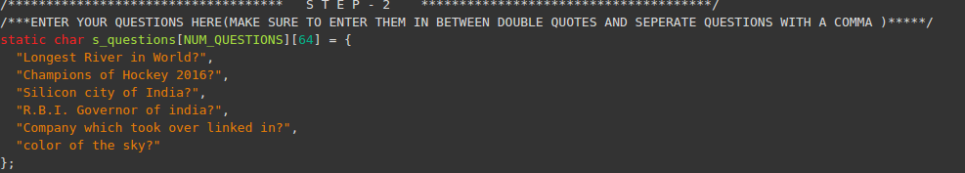

11.) enter the answers here and make sure you enter them in double quotes separated by a

comma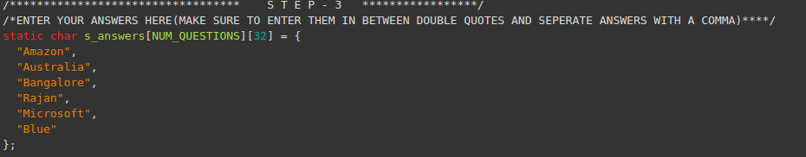

12.) after you completed all the 3 steps click this button at right corner

Screenshot from 2016-06-20 17-40-29.png

13.) now you are ready to take a test/quiz your flash cards