Task 1:

1.1 Write a Python Program to implement your own myreduce() function which works exactly like Python's built-in function reduce()

def myreduce(a, b):

c = b[0]

for i in b[1:]:

c = a(c, i)

return c

list =[4,5,6,7,8]

myreduce(lambda x,y:x+y,list)

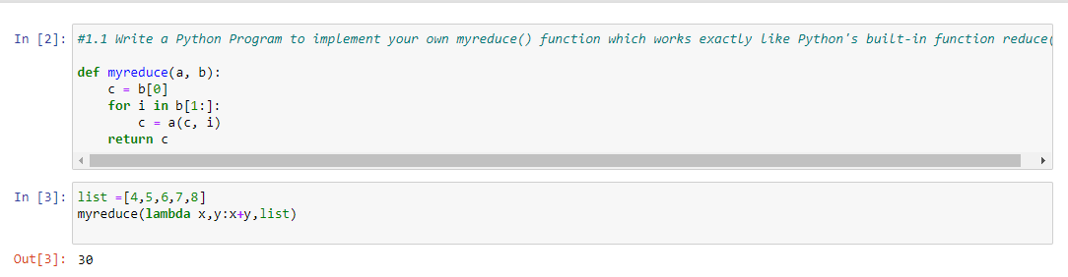

1.2 Write a Python program to implement your own myfilter() function which works exactly like Python's built-in function filter()

def myfilter(a, b):

c = []

for i in b:

if a(i):

c.append(i)

return c

list=[4,5,6,7,8,2,7,8]

myfilter(lambda x: x%2,list)

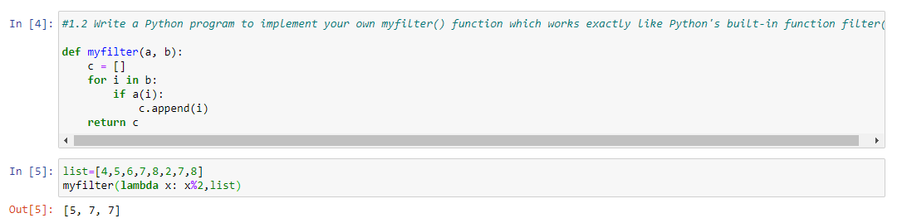

Implement List comprehensions to produce the following lists. Write List comprehensions to produce the following Lists

['A', 'C', 'A', 'D', 'G', 'I', ’L’, ‘ D’]

b = [i for i in "ACADGILD"]

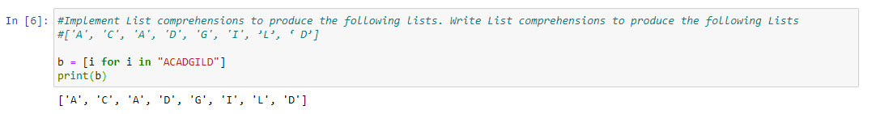print(b)

['x', 'xx', 'xxx', 'xxxx', 'y', 'yy', 'yyy', 'yyyy', 'z', 'zz', 'zzz', 'zzzz']

b=[i*a for i in ['x','y','z'] for a in range(1,5)]

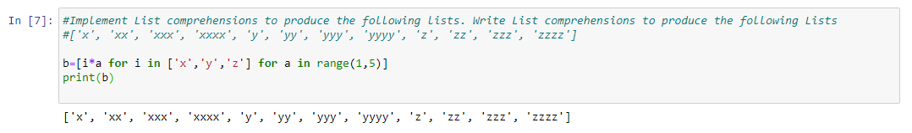print(b)

['x', 'y', 'z', 'xx', 'yy', 'zz', 'xx', 'yy', 'zz', 'xxxx', 'yyyy', 'zzzz']

b=[i*a for i in range(1,5) for a in ['x','y','z']]

print(b)

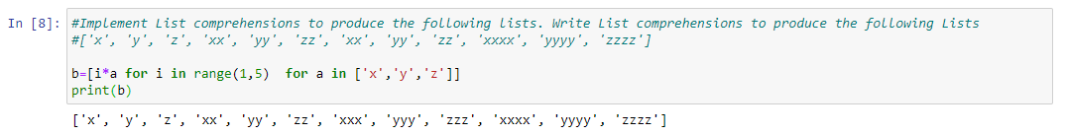

[[2], [3], [4], [3], [4], [5], [4], [5], [6]]

b=[[i+n] for i in [2,3,4] for n in range(0,3)]

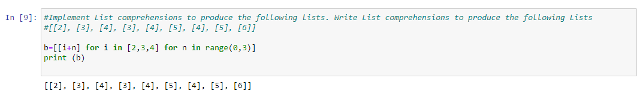print (b)

[[2, 3, 4, 5], [3, 4, 5, 6], [4, 5, 6, 7], [5, 6, 7, 8]]

b=[[i+n for i in [2,3,4,5]] for n in range(0,4)]

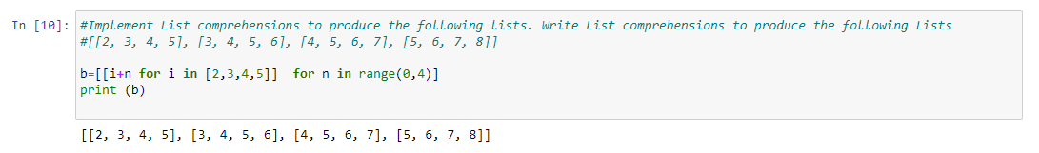print (b)

[(1, 1), (2, 1), (3, 1), (1, 2), (2, 2), (3, 2), (1, 3), (2, 3), (3, 3)]

b=[(n,i) for i in [1,2,3] for n in [1,2,3]]

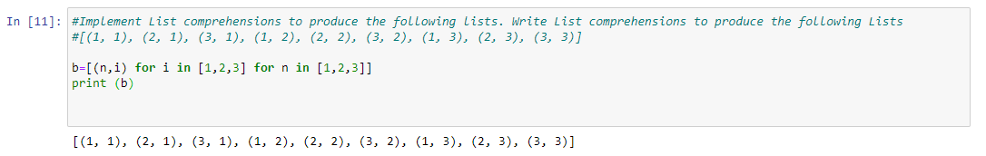print (b)

Write a Python Program(with class concepts) to find the area of the triangle using the below

formula.

area = (s*(s-a)*(s-b)*(s-c)) ** 0.5

Function to take the length of the sides of triangle from user should be defined in the parent

class and function to calculate the area should be defined in subclass.

S1 = int(input ("Enter side 1: "))

S2 = int(input ("Enter side 2: "))

S3 = int(input ("Enter side 3: "))

class Triangle :

def __init__(self,a,b,c):

self.a = a

self.b = b

self.c = c

def area(self):

s= ( self.a + self.b + self.c ) / 2

n= (s*(s-self.a)*(s-self.b)*(s-self.c))**0.5

return n

p = Triangle (S1,S2,S3)

print(p.a,p.b,p.c)

p.area ()

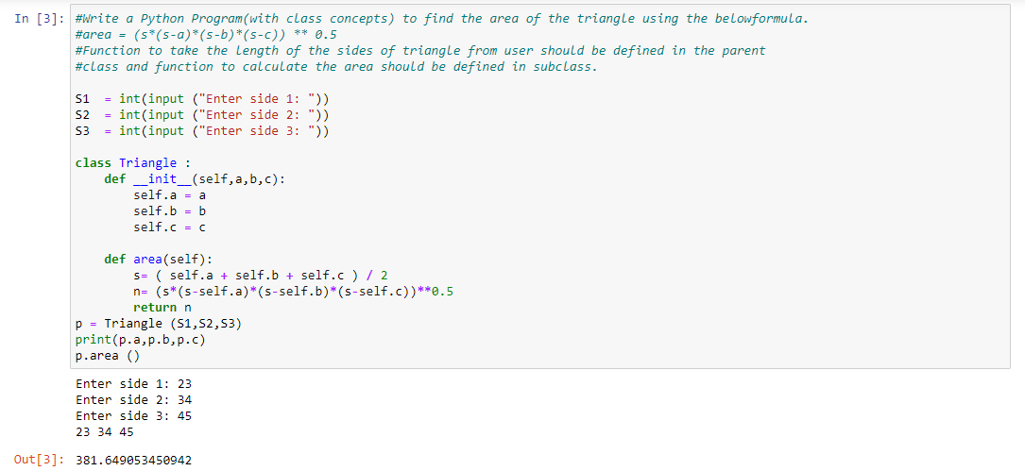

Write a function filter_long_words() that takes a list of words and an integer n and returns the list

of words that are longer than n.

def words(n, a):

b = []

c = a.split(" ")

for x in c:

if len(x) > n:

b.append(x)

return b

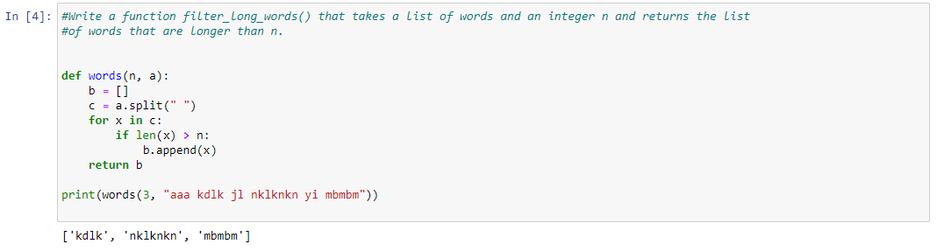print(words(3, "aaa kdlk jl nklknkn yi mbmbm"))

Write a Python program using function concept that maps list of words into a list of integers

representing the lengths of the corresponding words .

word = ["Hi","I","am","learning","Python"]

def leng(word):

return list(map(lambda x:len(x),word))

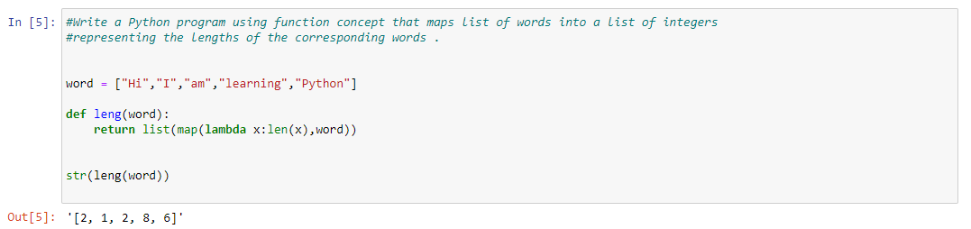str(leng(word))

Write a Python function which takes a character (i.e. a string of length 1) and returns True if it is

a vowel, False otherwise.

def vow(c):

x= ('a','e','i','o','u')

if c not in x:

return True

return False

