Task 1

2. Implement a Python program to generate all sentences where subject is in ["Americans",

"Indians"] and verb is in ["Play", "watch"] and the object is in ["Baseball","cricket"].

Hint: Subject,Verb and Object should be declared in the program as shown below.

subject=["Americans", "Indians"]

verb=["Play", "watch"]

obj=["Baseball","cricket"]

for sub in subject:

for vb in verb:

for ob in obj:

s = [sub +" "+ vb +" "+ ob]

for a in s:

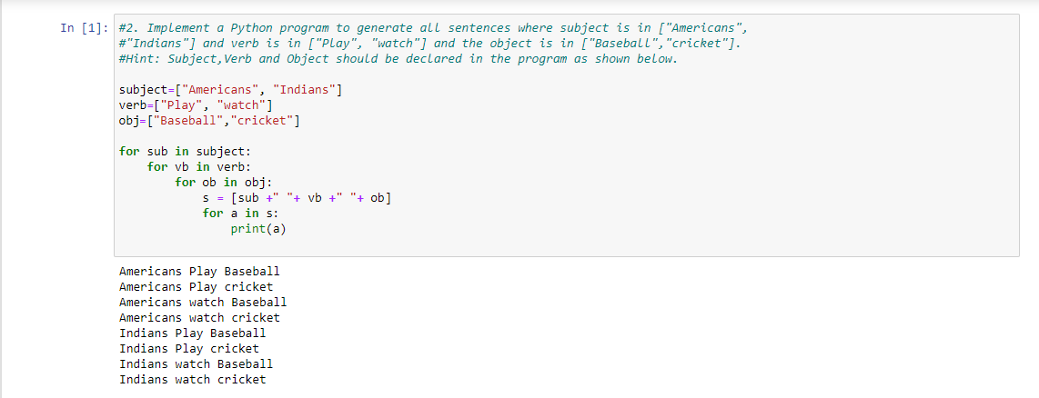 print(a)

1. Write a function to compute 5/0 and use try/except to catch the exceptions.

def Chkon(a):

try:

b=5/a

print (b)

except Exception as e:

print (e)

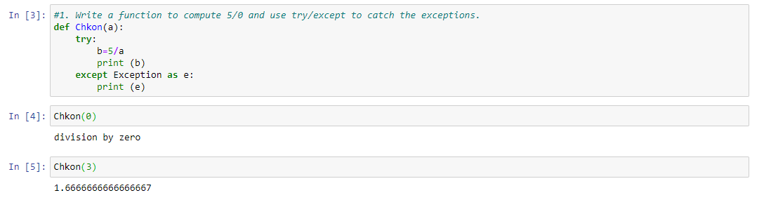

Task 2

1. Write a function so that the columns of the output matrix are powers of the input vector.

The order of the powers is determined by the increasing boolean argument. Specifically, when

increasing is False, the i-th output column is the input vector raised element-wise to the power

of N - i - 1.

Import numpy as np

x = np.array([1, 2, 3, 5])

N = 3

np.vander(x, N)

