**Lab-2**

**Q1: Provide snapshot of sheet1.**

Ans: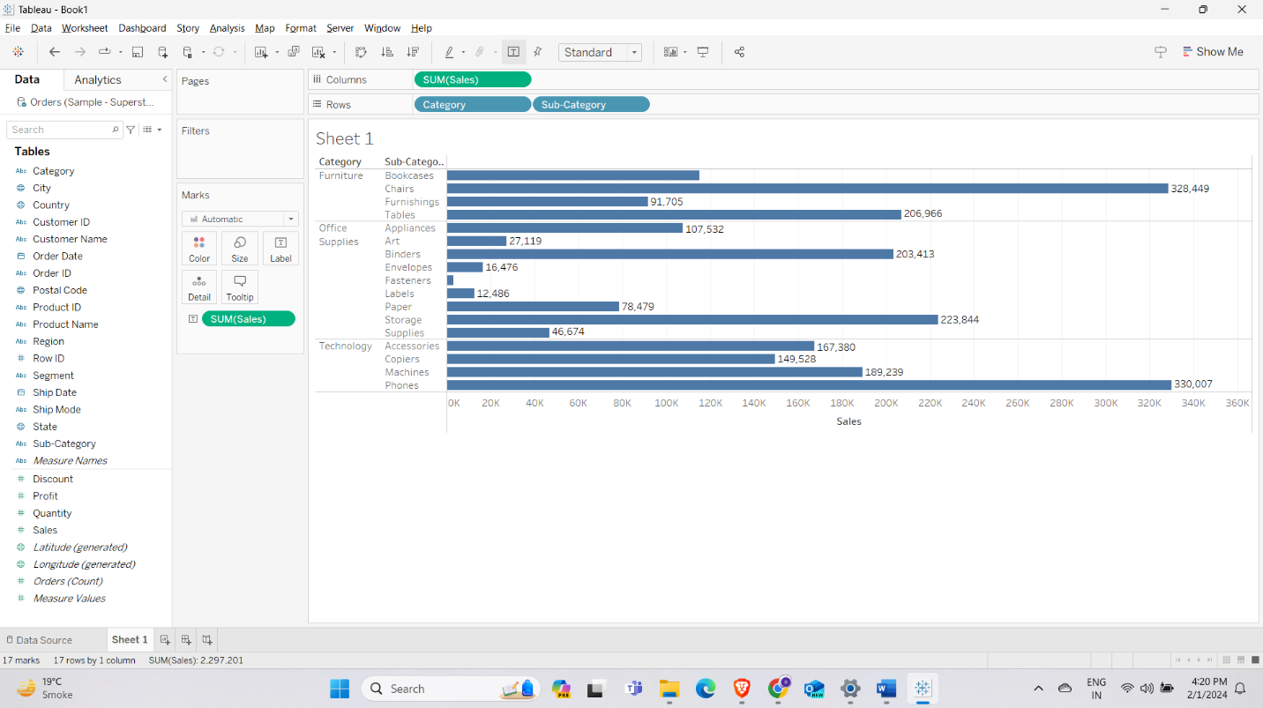

**Q2: How much is the “Sales” of “Paper”?**

Ans: The “Sales” of “Paper” is 78,479.

**Q3: Which “Sub-Category” in “Technology” sold the most?**

Ans: The “Phone” in “Technology” sold the most with sales of 330,007.

**Q4: Which “Sub-Category” in “Office Supplies” sold the least?**

Ans: “Fasteners” in “Office Supplies” sold the least with sales of 3,024.

**Q5: Provide snapshot of sheet2.**

Ans: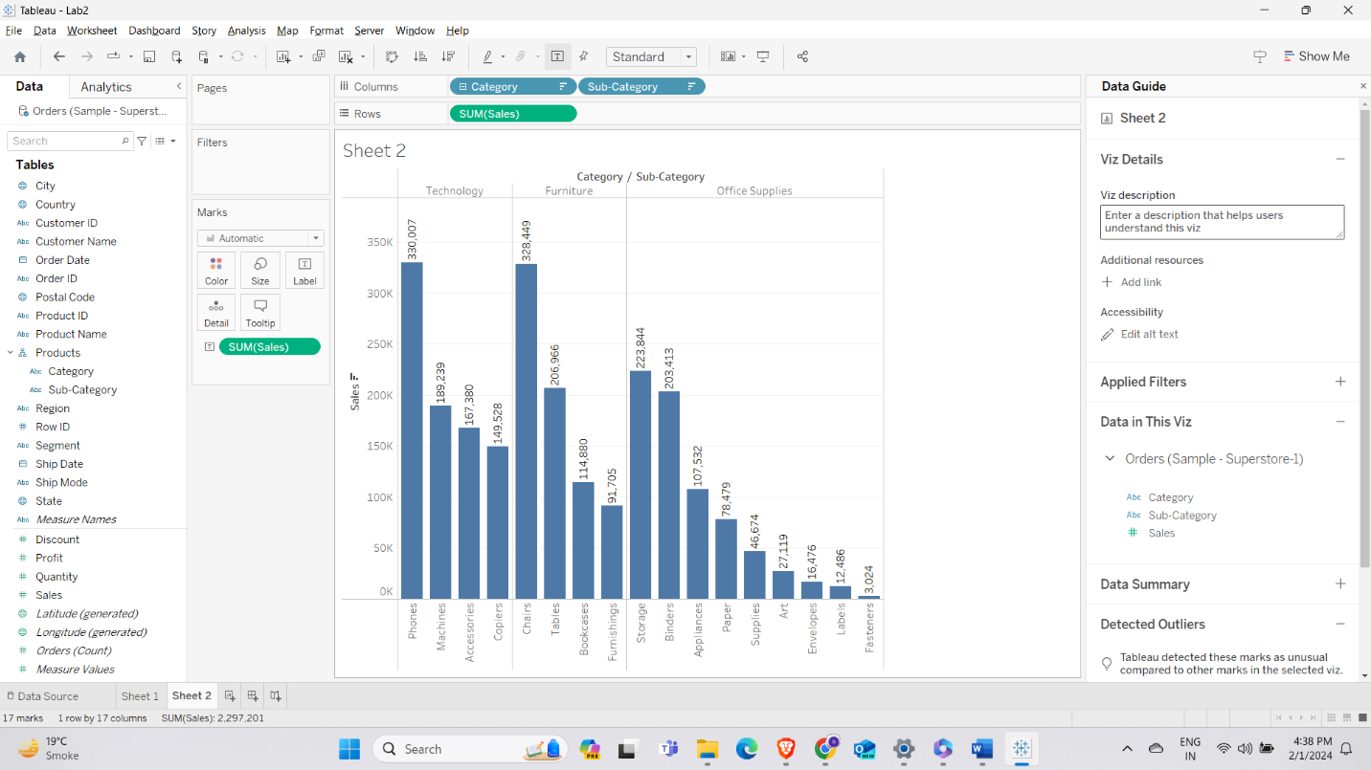

**Q6: Provide snapshot of sheet3.**

**Q7: Provide snapshot of sheet4.**

**Q8: Sort any column from “ABC”.**

Ans:

