**Name: Rahul Somabhai Chaudhary**

**Student Id: 11750265**

**Lab-5**

**INFO 5709-Data Visualization and Communication**

**

**Q2**:“Office Supplies” has the lowest sales in West region.

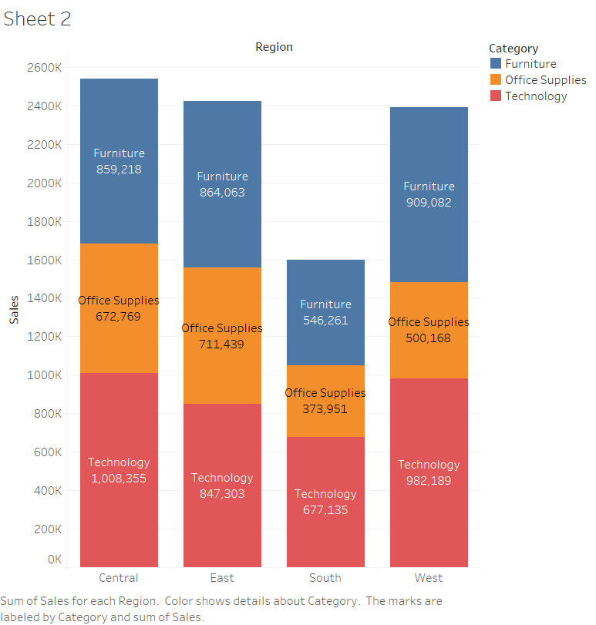

**Q3**: Furniture sold in the South Region is 546,261.

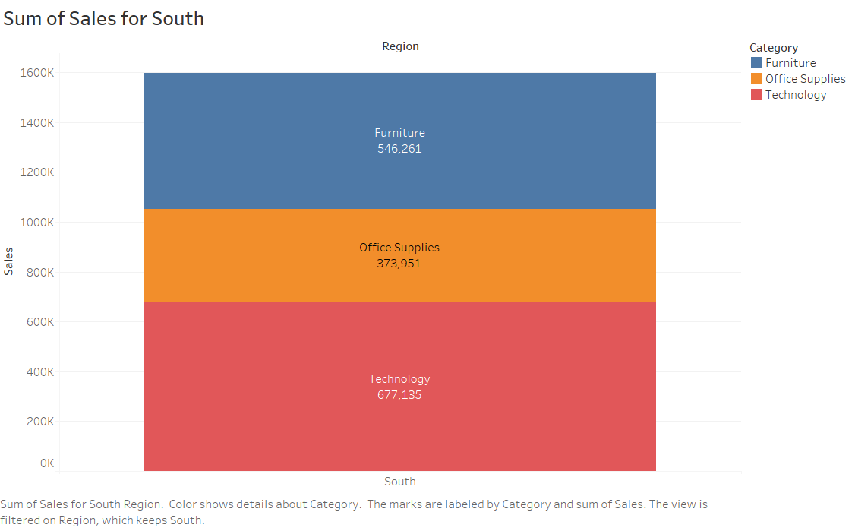

**

The image is not informative in terms of visualization as the images convey 4947 different points for each customer name and because of which there is a dense portion of points on certain areas of chart, so even to find the information of profit and sales for a single customer, it will be very difficult using this visualization.

**Q5**: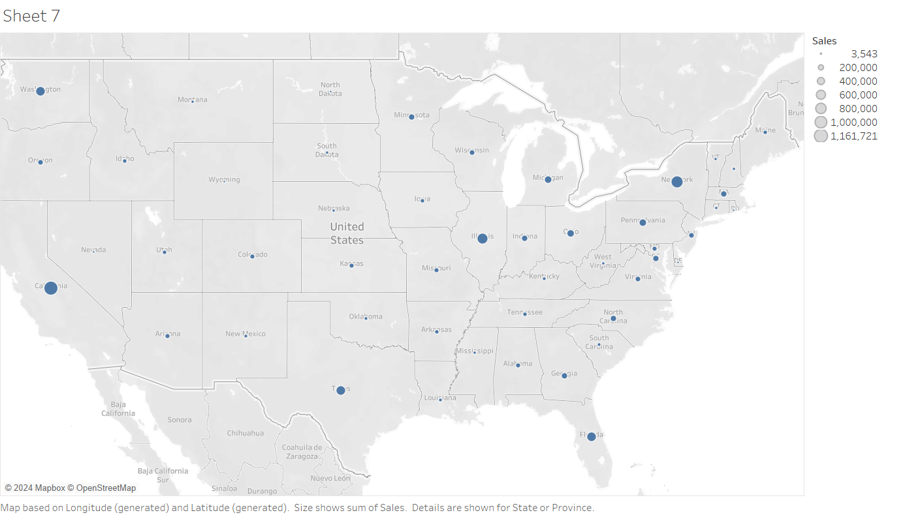

**Q6**: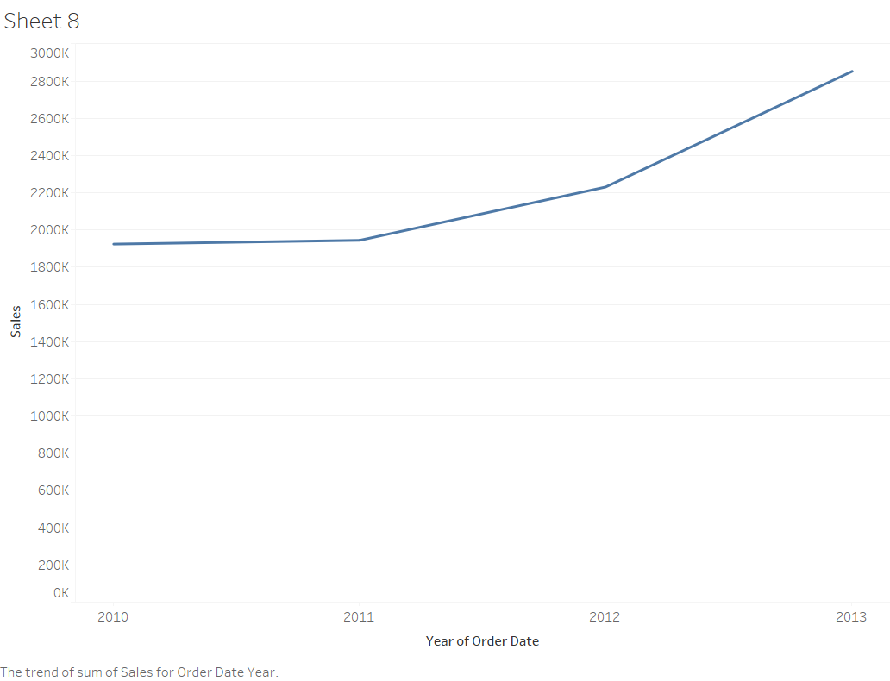

**Q7**:

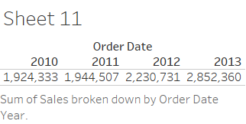

Here the “Text Table” has been used as a representation.

**Q8**:

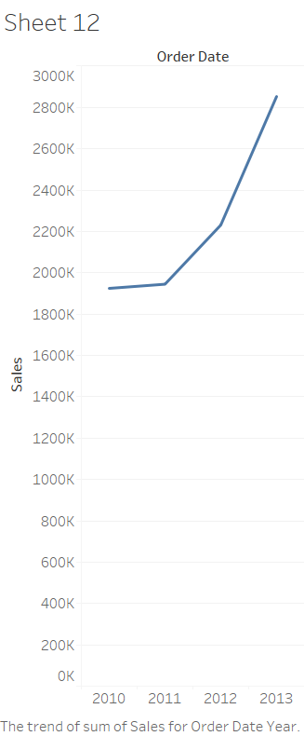

Here the “Line(discrete)” has been used as a representation.

**Q9**: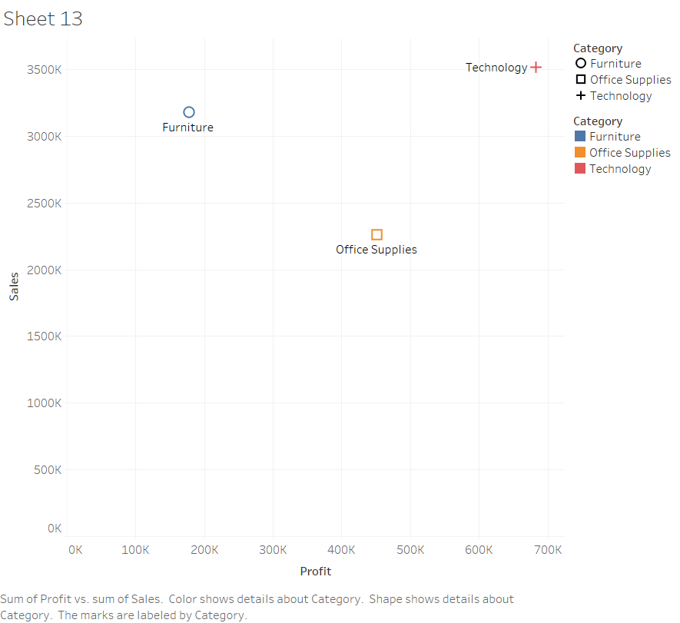

**Q10**:

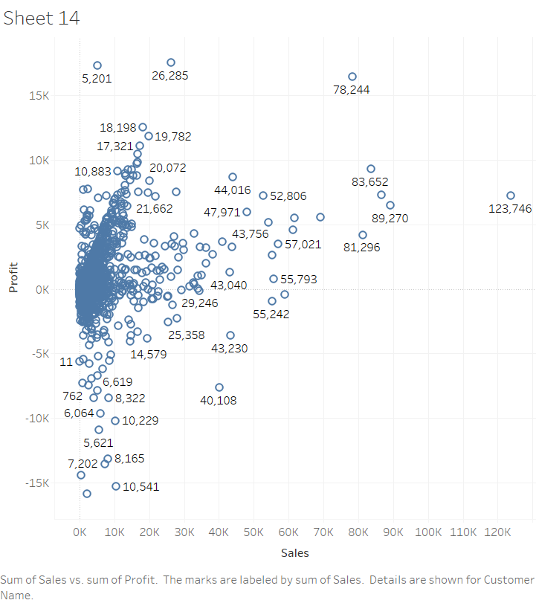

“Andrea Shaw” had made the most profit, with profit equals to 17,537.