**Name: Rahul Somabhai Chaudhary**

**Student Id: 11750265**

**Lab-6**

**INFO 5709-Data Visualization and Communication**

Q1: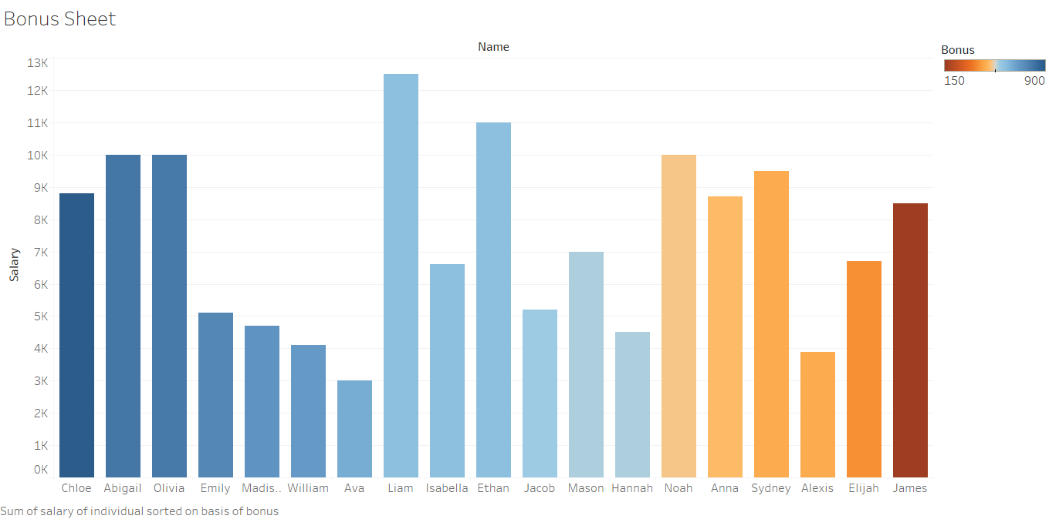

Q2:

From the visualization, I am not able to find any relationship between salary and bonus as bonus very from 150 to 900 while the salary ranges from 3000 to 12,500 and there is no relationship like the higher the salary greater the bonus or lower the salary lesser the bonus or vice-versa, so from this visualization I am unable to find any relationship between salary and bonus.

Q3:

“Liam” has got the maximum Total income, Total income is equal to 13,100, while the lowest income is of “Ava” and the Total income is 3,650.

Q4:

“Central” Region has the highest sales (2,540,342) and highest profit (519,826).

Q5:

For Furniture, “West” region has the highest amount of profit with profit is equal to 78,935.

Q6:

When Order Priority is “Medium” the “Sales” done by “California” is 198,506.

Q7:

Q8:

Q9:

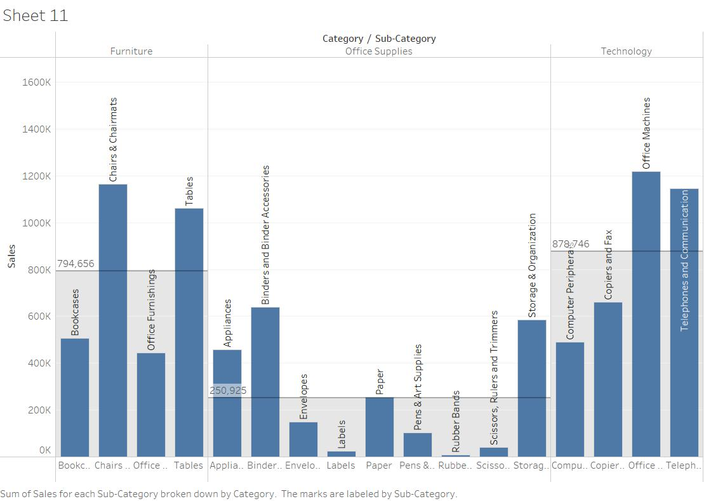

From the visualization we can conclude that, the “Computer Peripherals” and “Copiers and Fax” are with the less than average sales in “Technology”.

