**Name: Rahul Somabhai Chaudhary**

**Student Id: 11750265**

**Lab-6**

**INFO 5709-Data Visualization and Communication**

**Q1:**

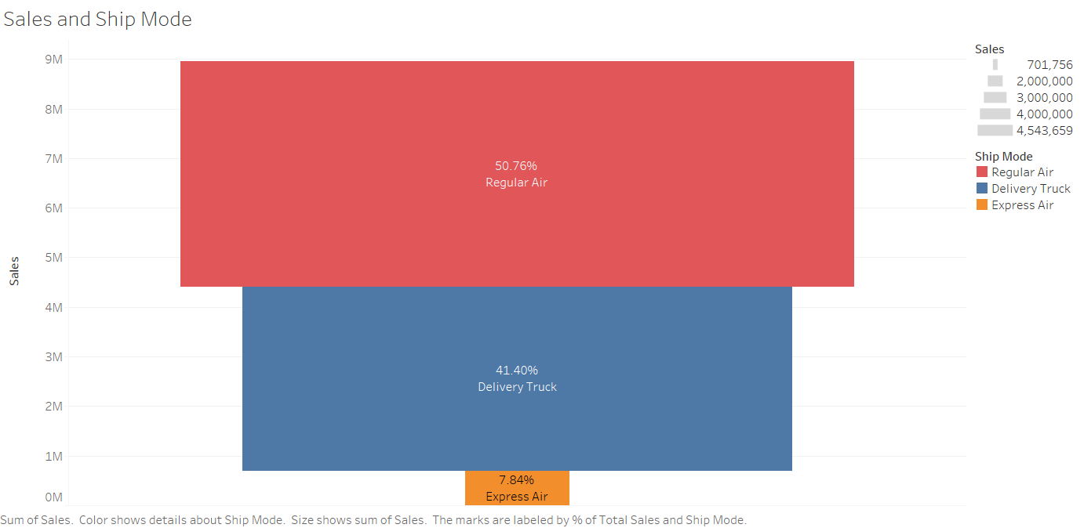

**Q2:**

“Regular Air” has the highest “Sales” and the “Sales” done by “Regular Air” is 50.76%.

**

**Q4**: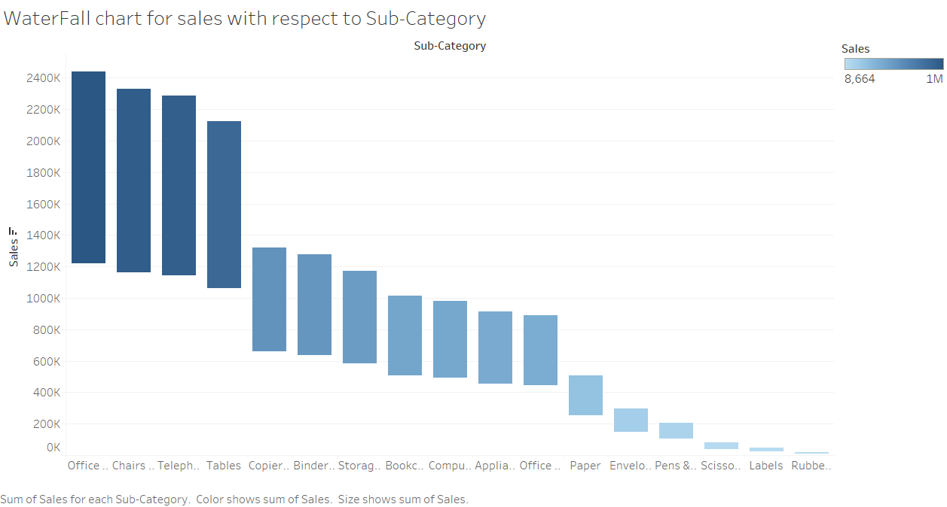

**Q5**: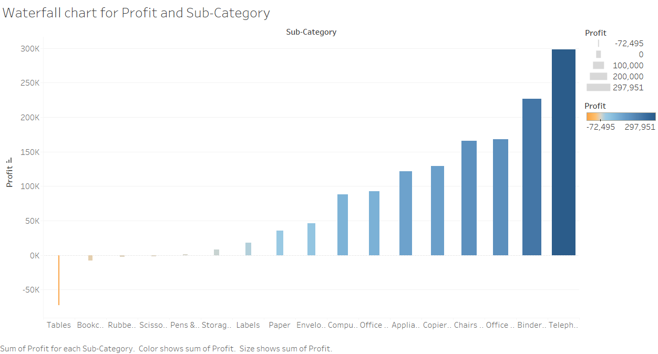

Yellow color represents the lesser profit while blue represents the more profit, so darker the yellow color is lesser profit is there while darker the blue color is more the profit is there.

**Q6**: 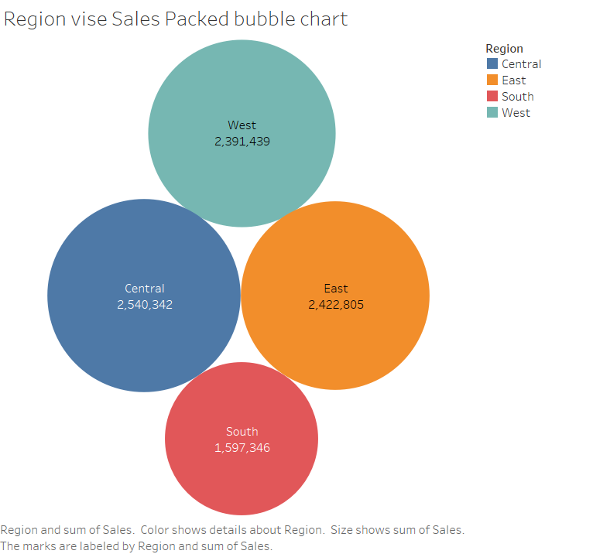

South region has the lowest sales and it is 1,597,346.

**Q7**: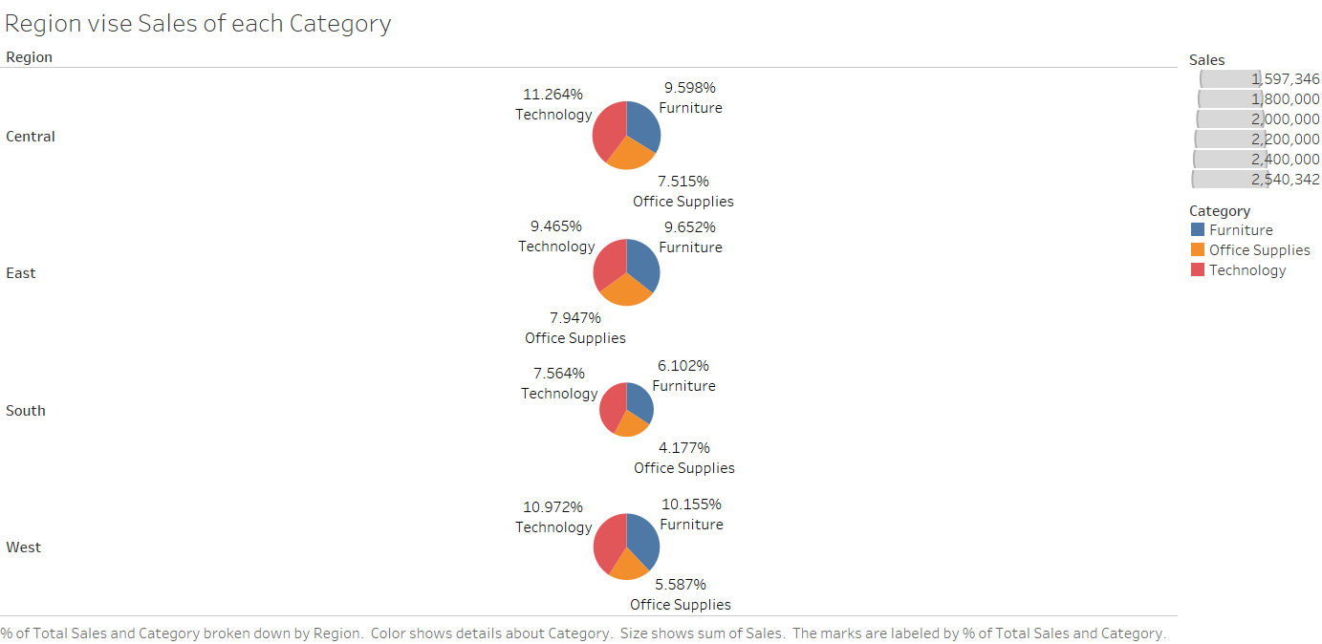

In the West region Office Supplies has the lowest sale which is 5.587%.

**Q8**: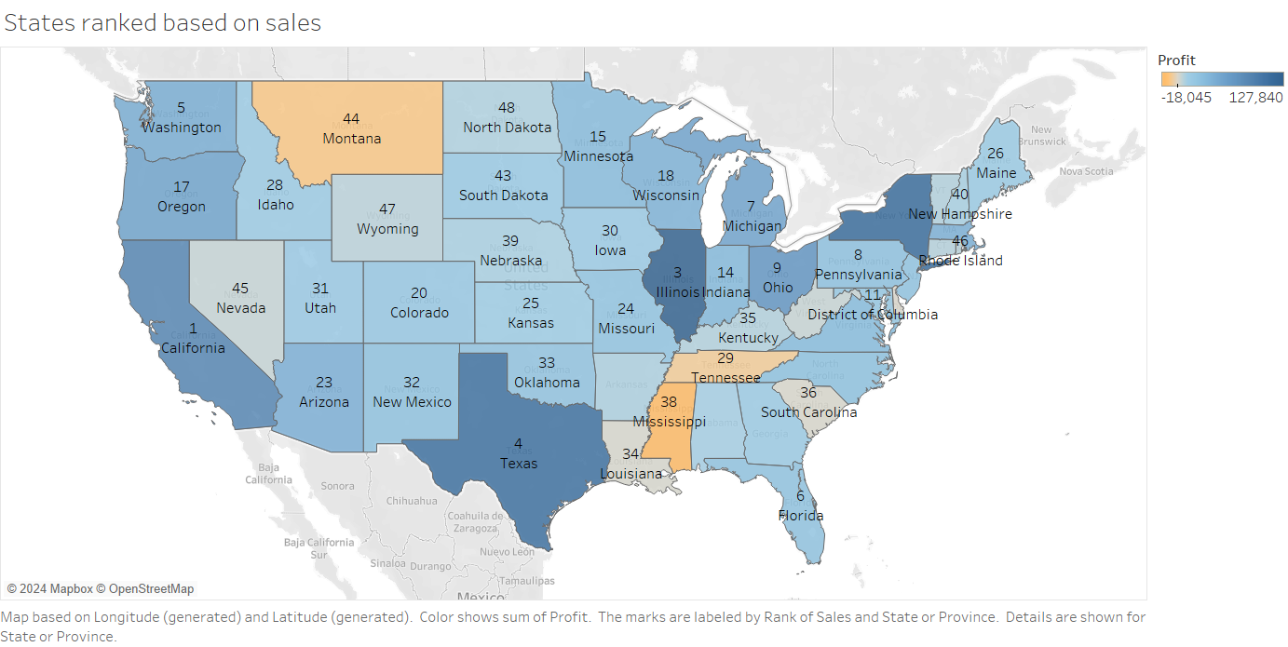

**Q9**: “Arizona” has been ranked 23rd and “Florida” has been ranked 6th in “Sales”.

**Q10:**