**Name: Rahul Somabhai Chaudhary**

**Student Id: 11750265**

**Lab-8**

**INFO 5709-Data Visualization and Communication**

Q1: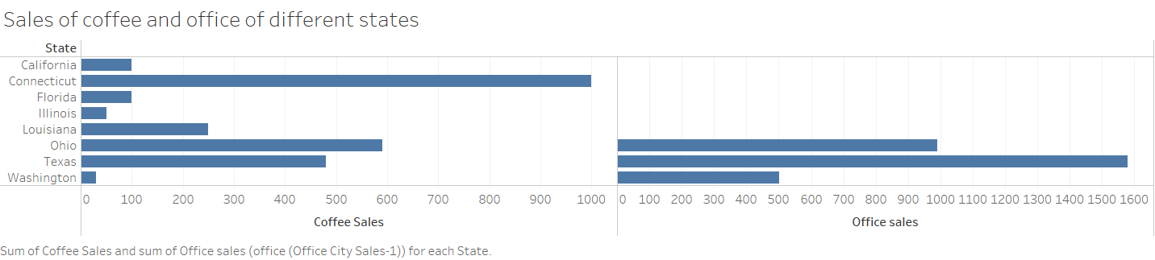

Q2: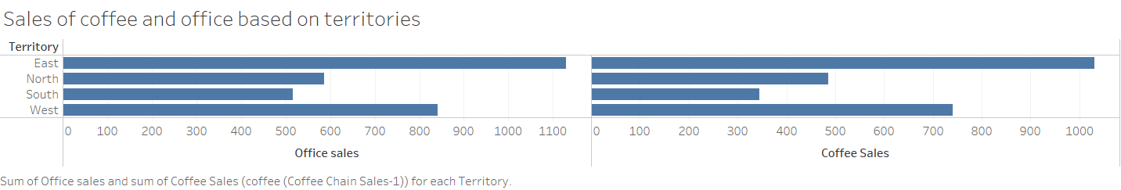

Q3:

The amount of coffee sale and office sale done in the south region is 345 and 516 respectively.

Q4: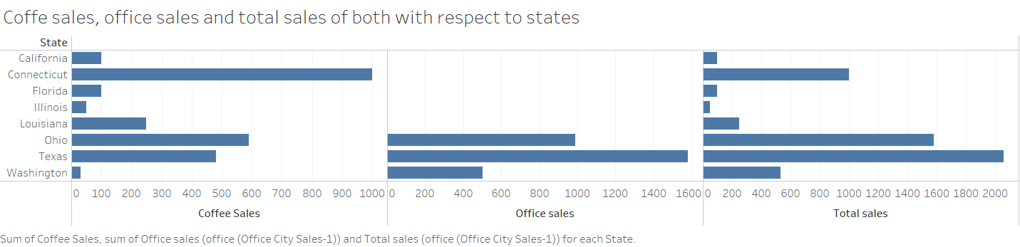

Q5:

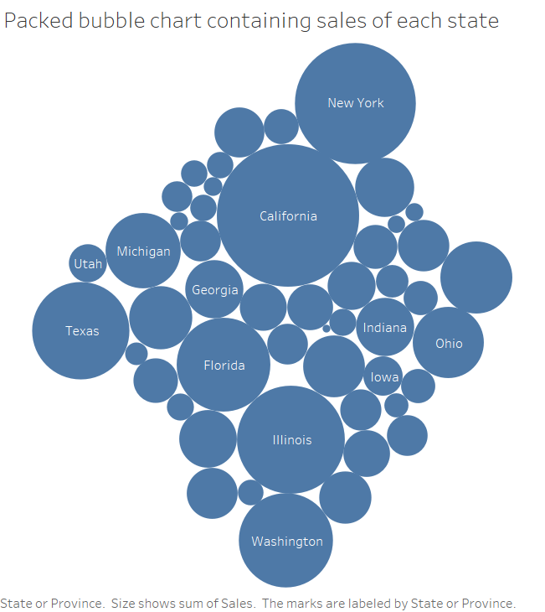

California has the highest number of sales, and it is 1,161,721.

Q6:

In South region, the lowest sale is done by office supplies, and it is 373,951, in Central region, the lowest sale is done by office supplies and it is 672,769, In East region, the lowest sale is done by office supplies and it is 711,439, In West region, the lowest sale is done by office supplies and it is 500,168.

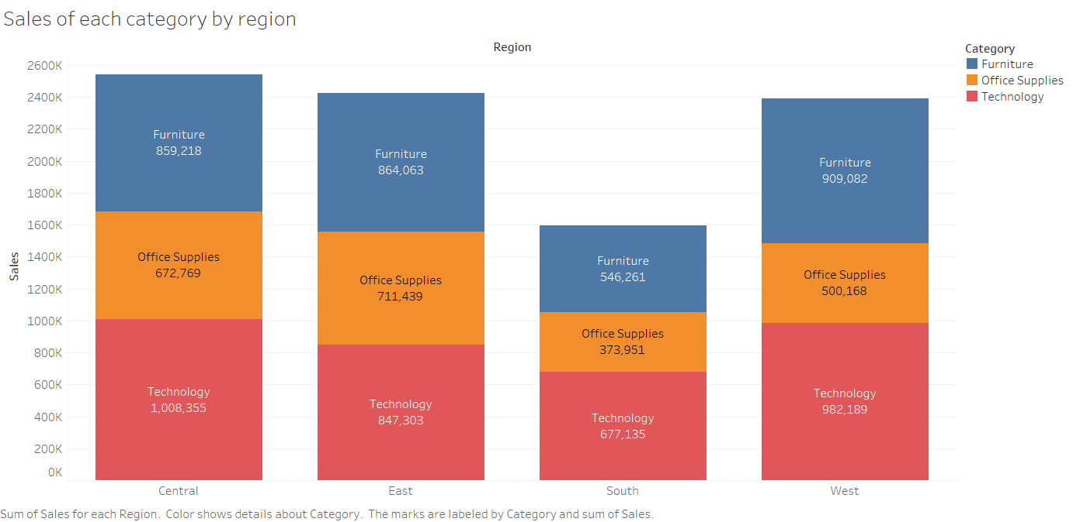

Q7:

Office supplies has the most sub-categories, which is equal to 9.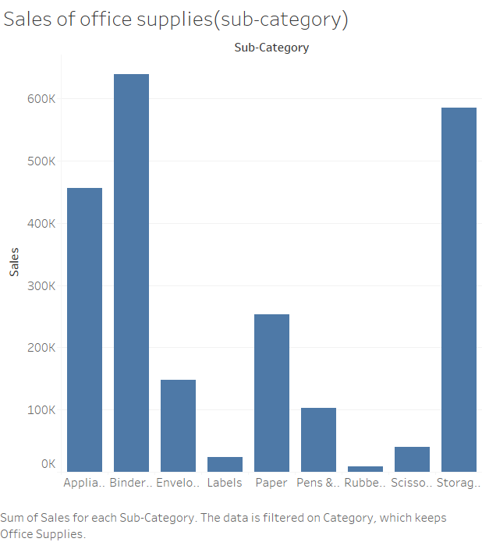

Q8: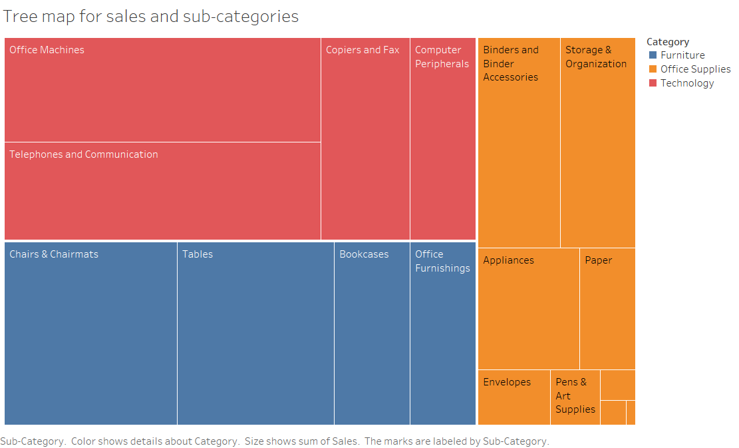

Q9: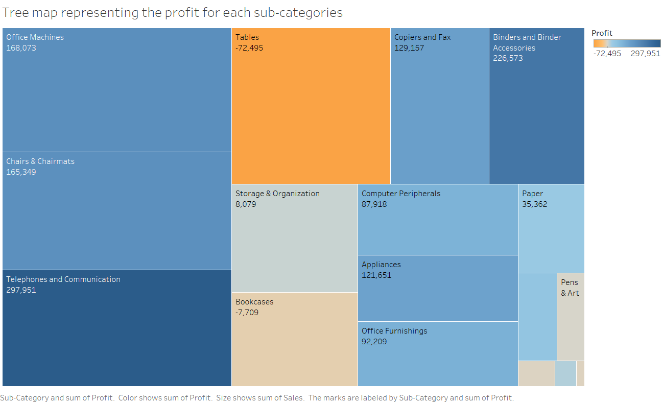

Tables has the lowest profit and that is equal to -72,495.

Q10: In 2010, Central region has the third rank. In 2013, Central region has the first rank.