**Name: Rahul Somabhai Chaudhary**

**Student Id: 11750265**

**Lab-9**

**INFO 5709-Data Visualization and Communication**

Q1: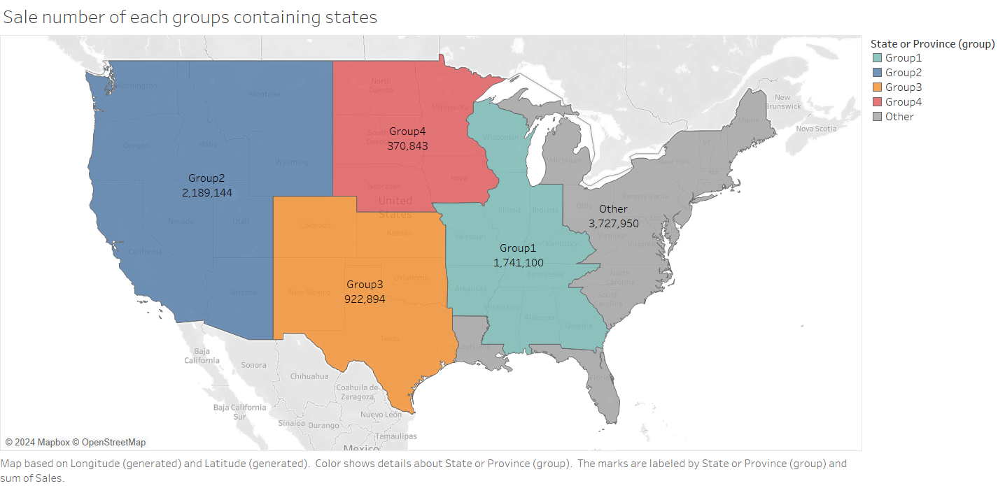

Q2: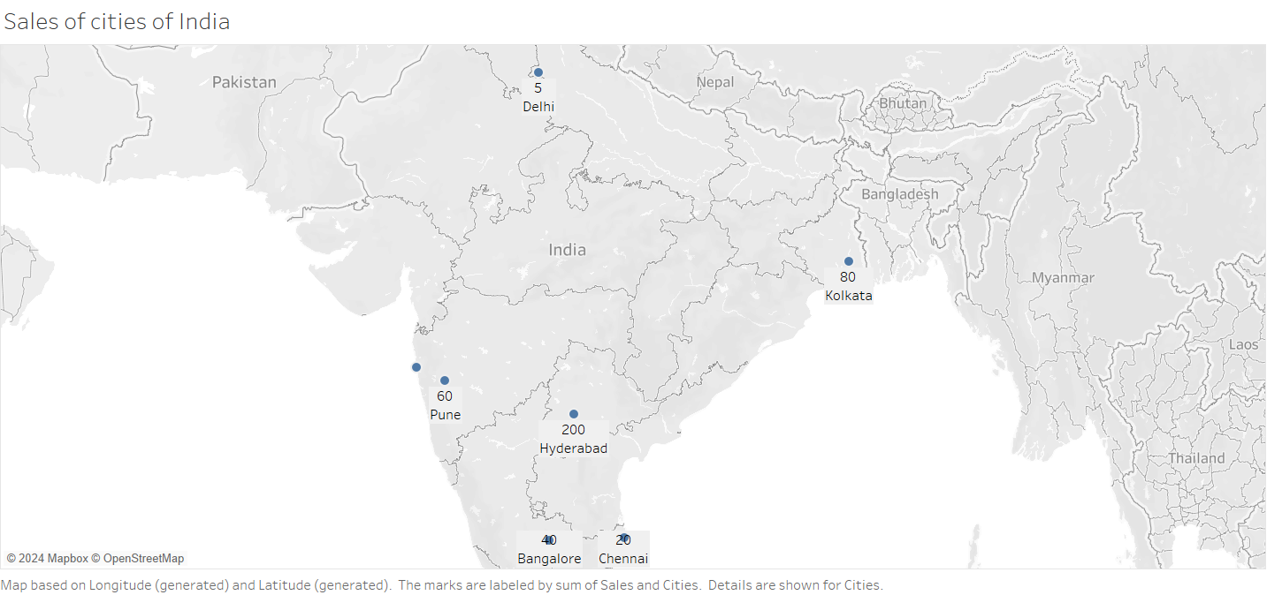

Q3: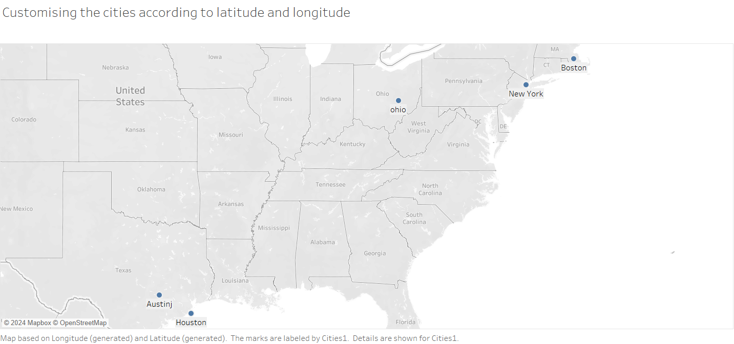

Q4: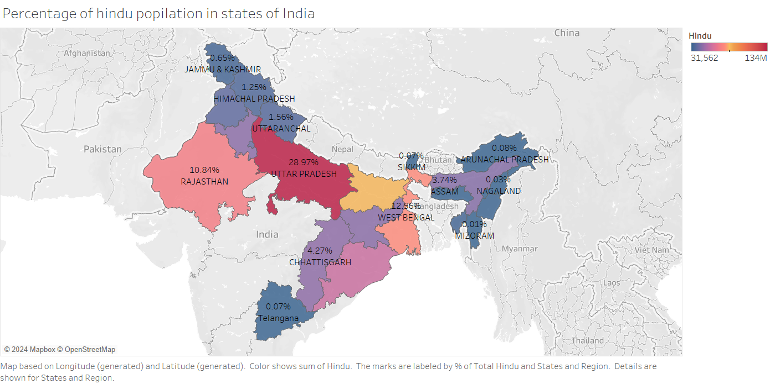

Q5: 10.84% Hindus live in Rajasthan.

Q6: 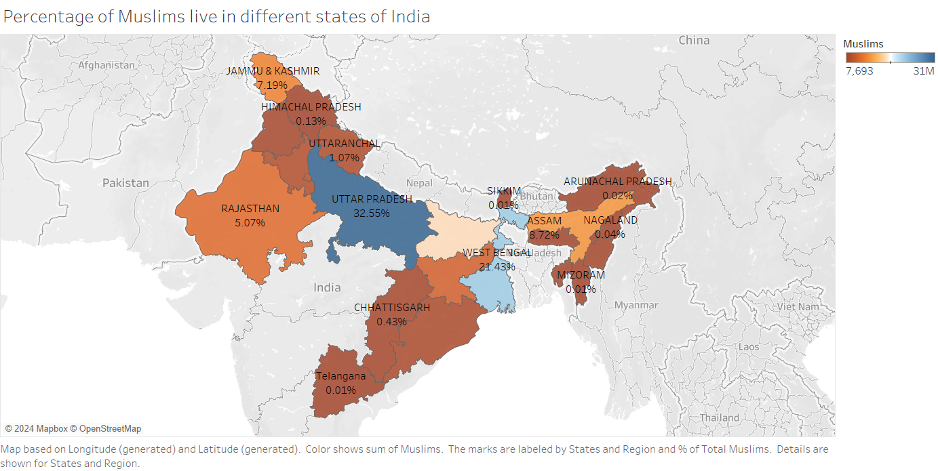

Q7: “Bihar” has a population of 14.53% of Muslims.

Q8: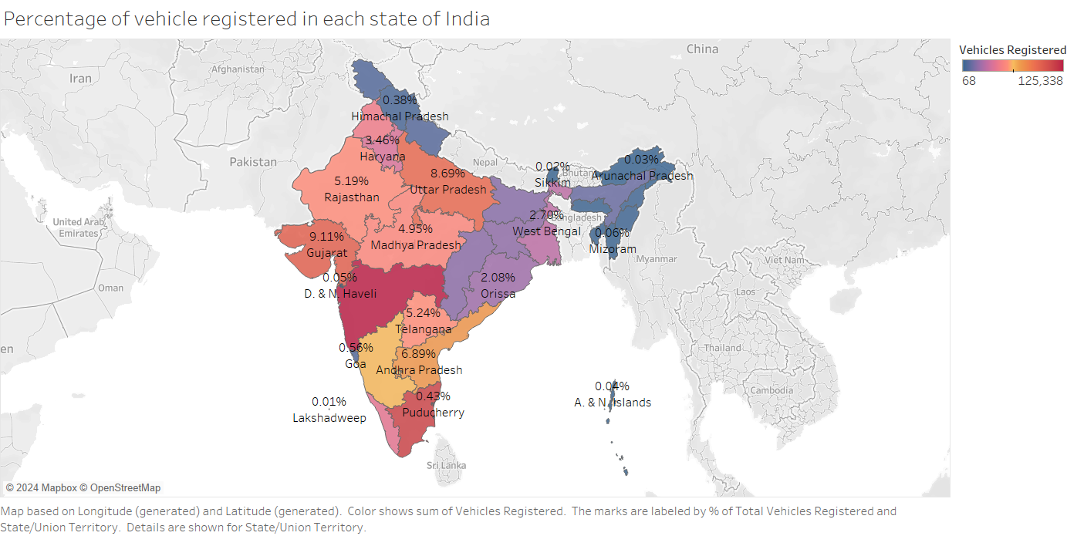

Q9: “Maharashtra” has the highest number of vehicles registered which is 11.74%.

Q10: “Jammu and Kashmir” has 0.57% of vehicles registered.