**Vivekanand Education Society’s Institute of Technology Department of Computer Engineering**



**Subject: Software Engineering Lab**

**Class:- T.E. (D12) Semester:- VI Div:- B**

|  |  |  |  |  |  |  |
| --- | --- | --- | --- | --- | --- | --- |
| Roll | Name: |  |  |  |  |  |
| No: | Nishikant Patil | | | | |
| 46 |  | | | | |
| Exp. | Title**:** |  |  |  |  |  |
| No:  9 | Change specification and make different versions using any SCM Tool. | | | | | |
|  |  | | | | | |
| DOP: | 30/04/21 | | | DOS: | 10/05/21 | |
| GRADE: |  | LAB OUTCOMES : |  | SIGNATURE: | | |
| LO2, LO3 |
|  |

**Experiment 9**

**Aim:** Change specification and make different versions using any SCM Tool

**Team Members:** Nishikant Patil(46), Pawan Lulla(34), Muheet Rashid(48), Harsh Singh(57)

**Theory:  
Version Control :**

➢ Version control combines procedures and tools to manage different versions of configuration objects that are created during the software process.

➢ Clemm [CLE89] describes version control in the context of SCM: Configuration management allows a user to specify alternative configurations of the software system through the selection of appropriate versions.

➢ This is supported by associating attributes with each software version, and then allowing a configuration to be specified [and constructed] by describing the set of desired attributes.’

**Software Configuration Management (SCM):**

The term "SCM" stands for Source code Management, a basic but essential part of any project developed in the current IT world. It is a kind of software that the developers usually use to manage their source code. It plays a vital role in the process of software development because it ensures that every member of the team stays on the top of source code changes in an ongoing project

**Reason to Use Github :**

Git is an incredibly fast tool. It is very efficient with large projects and it has an incredible

branching system for non-linear development. Some of the goals of the new system were as

follows:

➢ Speed

➢ Simple design

➢ Strong support for non-linear development (thousands of parallel branches)

➢ Fully distributed

➢ Able to handle large projects like the Linux kernel efficiently (speed and

data size)

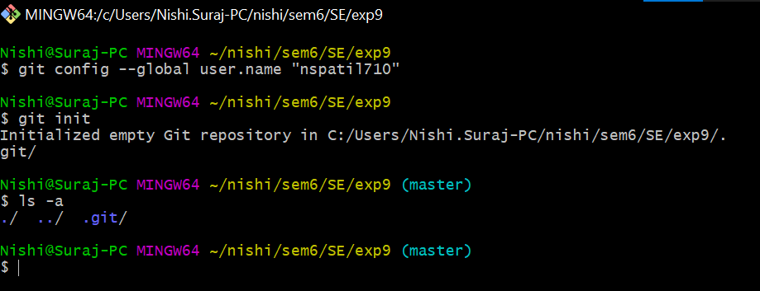

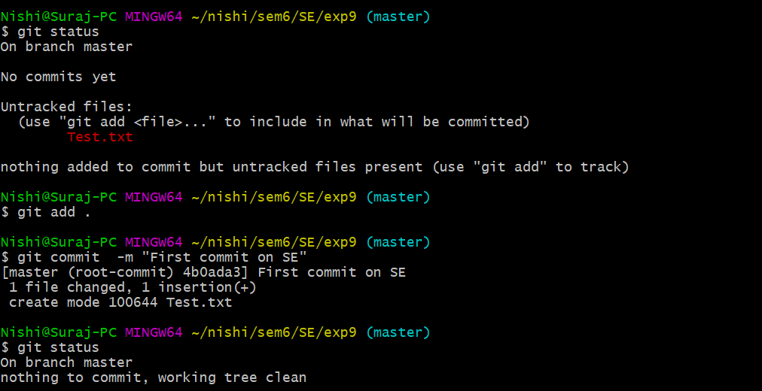

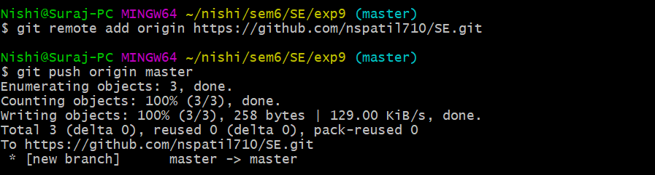

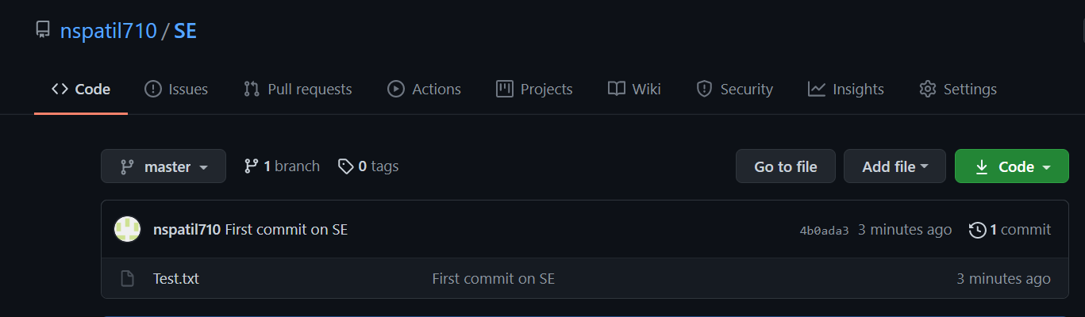

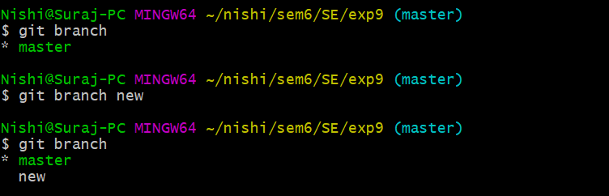

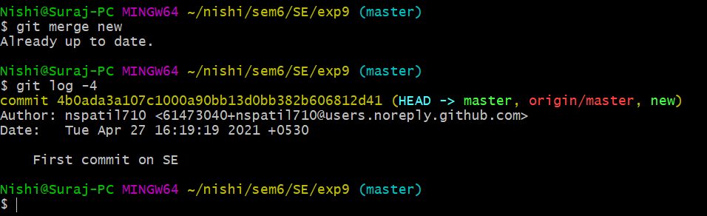

**Conclusion**: Hence we have studied Software Configuration Management (SCM) and implemented the same for our project using Git Tool.