Problem 1:

In this exercise, we will look at how variations on Tomasulo’s algorithm perform when running a common vector loop. The loop is the so-called DAXPY loop (double-precision aX plus Y) and is the central operation in Gaussian elimination. The following code implements the operation Y = aX + Y for a vector of length 100. Initially, R1 = 0 and F0 contains a.

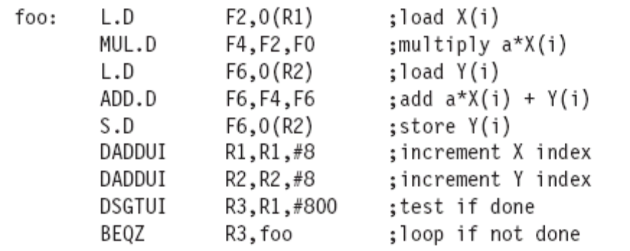

The pipeline function units are described in Figure 1 below.
Assume the following:
- Function units are not pipelined.
- There is no forwarding between function units; results are communicated by the CDB.
- The execution stage (EX) does both the effective address calculation and the memory access for loads and stores. Thus the pipeline is IF / ID / IS / EX / WB.
- Loads take 1 clock cycle.
- The issue (IS) and write result (WB) stages each take 1 clock cycle.
- There are 5 load buffer slots and 5 store buffer slots.
- Assume that the BNEQZ instruction takes 0 clock cycles.

- For this problem use the single-issue Tomasulo MIPS pipeline of Figure 3.2 with the pipeline latencies from Figure 2. Show the number of stall cycles for each instruction and what clock cycle each instruction begins execution (i.e., enters its first EX cycle) for three iterations of the loop. How many clock cycles does each loop iteration take? Report your answer in the form of a table like that in Figure 3.25.

- Using the MIPS code for DAXPY above, assume Tomasulo’s algorithm with speculation as shown in Figure 3.29. Assume the latencies shown in Figure 2. Assume that there are separate integer function units for effective address calculation, for ALU operations, and for branch condition evaluation. Create a table as in Figure 3.34 for the first three iterations of this loop.

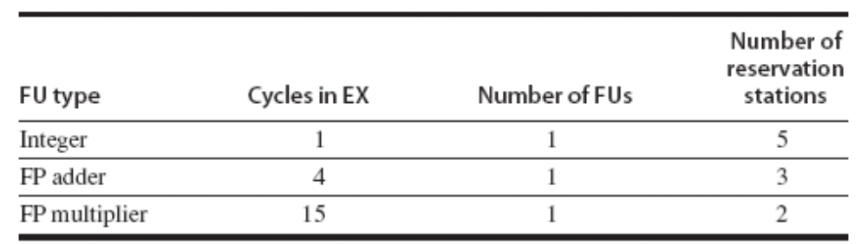
Figure 1: Information about pipeline function units.

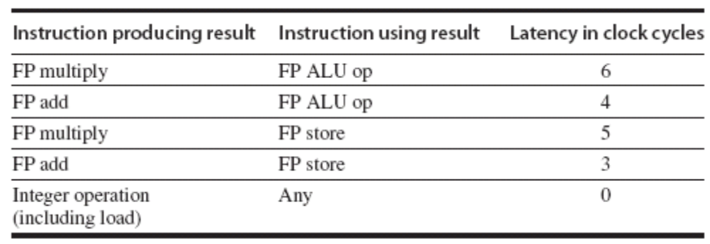
Figure 2: Pipeline latencies where latency is number of cycles between producing and consuming instruction.

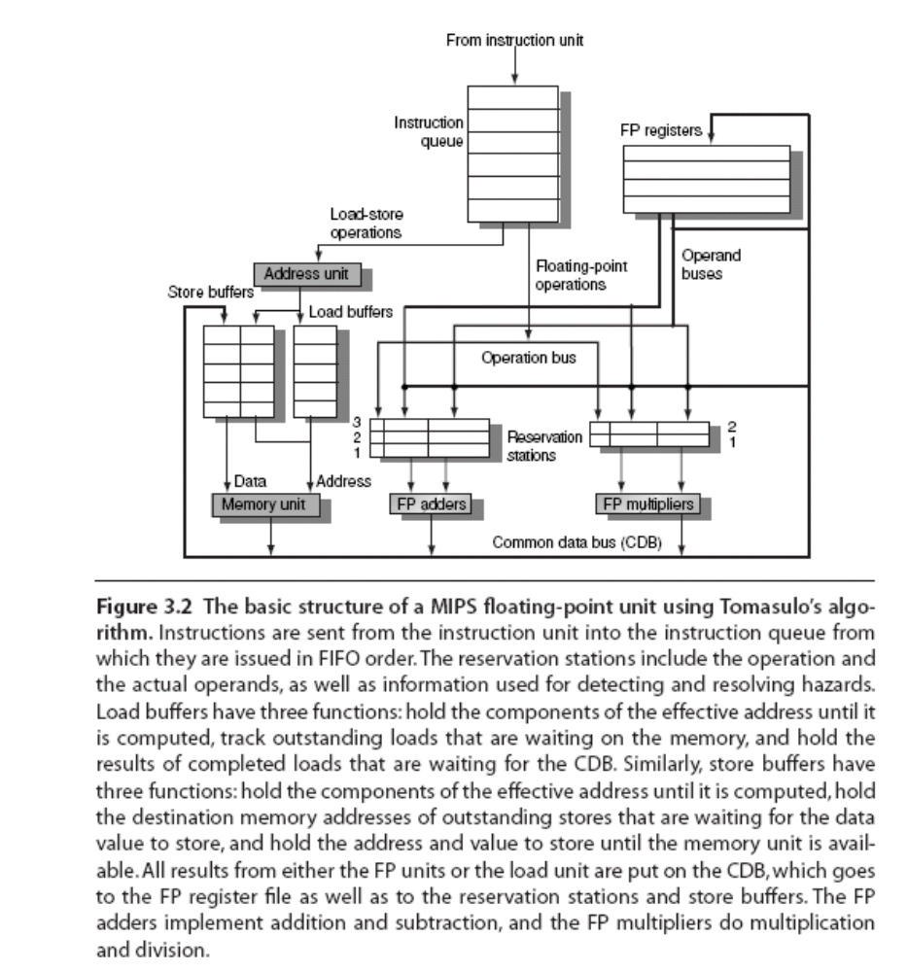
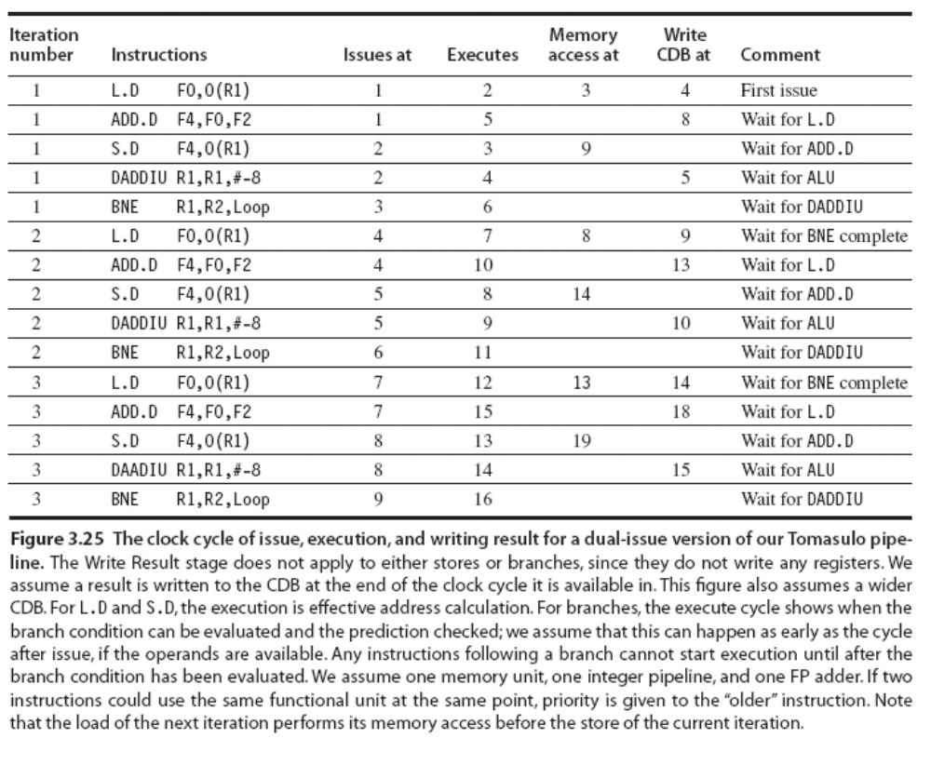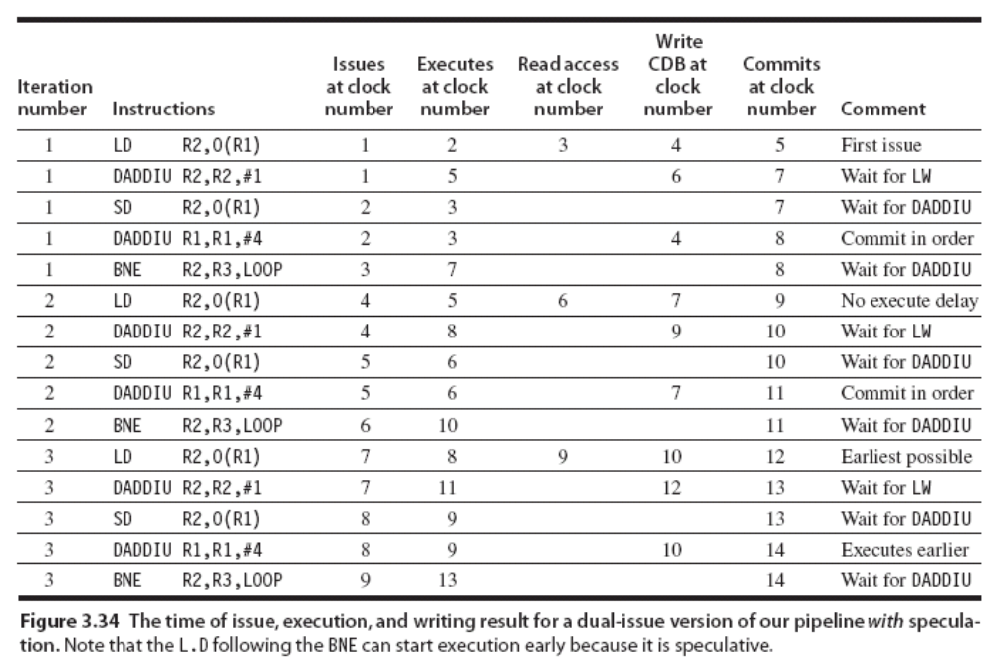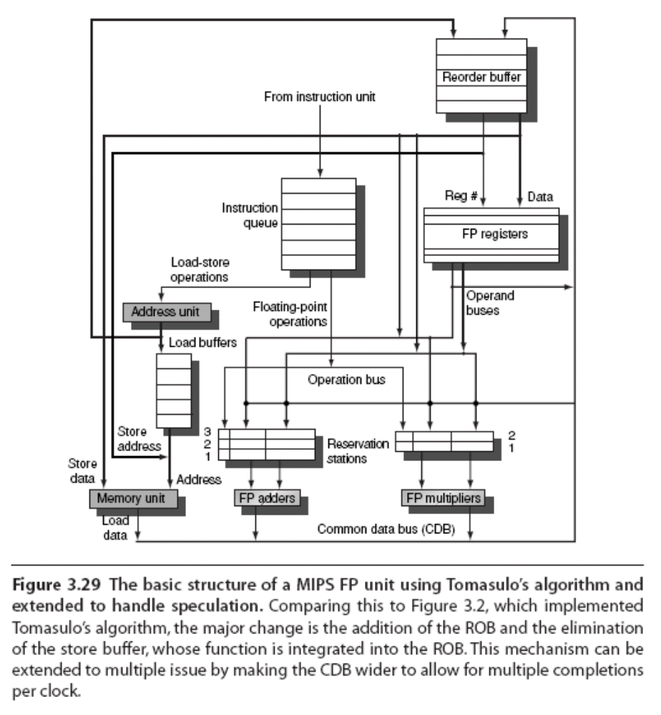
Problem 2:

Aggressive hardware support for ILP is detailed at the beginning of Section 3.9. Keeping such a processor from stalling due to lack of work requires an average instruction fetch rate, f, that equals the average instruction completion rate, c. Achieving a high fetch rate is challenging in the presence of cache misses. Branches add to the difficulty and are ignored in this exercise. To explore just how challenging, model the average instruction memory access time as h + mp, where h is the time in clock cycles for a successful cache access, m is the rate of unsuccessful cache access, and p is the extra time, or penalty, in clock cycles to fetch from main memory instead of the cache.

- Write an equation for the number of instructions that the processor must attempt to fetch each clock cycle to achieve on average fetch rate f = c.
- Using a program with suitable graphing capability, such as a spreadsheet, plot the equation from part (a) for 0.01 ≤ m ≤ 0.1, 10 ≤ p ≤ 100, 1 ≤ h ≤ 2 and a completion rate of 4 instructions per clock cycle. Comment on the importance of low average memory access time to the feasibility of achieving even modest average fetch rates.

Problem 3:

The following loop is a dot product (assuming the running sum in F2 is initially 0) and contains a recurrence. Assume the pipeline latencies from Figure 4.1 and a 1-cycle delayed branch.

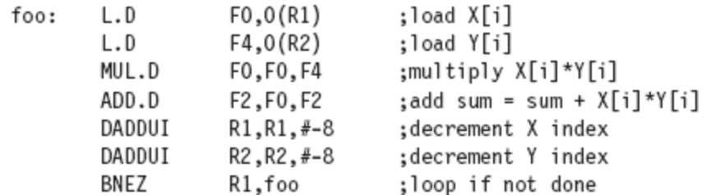

- Assume a single-issue pipeline. Despite the fact that the loop is not parallel, it can be scheduled with no delays. Unroll the following loop a sufficient number of times to schedule it without any delays. Show the schedule after eliminating any redundant overhead instructions. Hint: An additional transformation of the code is needed to schedule without delay.
- Show the schedule of the transformed code from part (a) for the processor in Figure 4.2. For an issue capability that is 100% greater, how much faster is the loop body?

