CALCULATION OF MONTHLY SOCIAL SECURITY INCOME:

* Initialize Social_Security object with path of excel file and sheet number.
* Call get_benefit_amount from this object. The parameters passed to this function are (age, retire_age, salary). These values should be in range of the data present in the excel sheet. E.g retire_age 61, 63, 72 etc all valid but 100 is not valid.
* E.g let’s say we passed age=15, retire_age=65 and amount=90000 to this function.

1. First, calculate the range of rows for the given age. Let’s call this age_band_row.
2. For each age_band_row, calculate the retirement age range.
3. For each retirement age range, calculate the salary range.
4. Now loop through the retirement age range for each age range and find the interpolated value of monthly social security income based on the current salary.
5. Once this is done, find the interpolated value of monthly social security income based on the retirement age.
6. Finally, calculate the interpolated value of monthly social security income based on the current age.

ISSUES:

1. For extreme upper values like monthly income of 127,200, the function was throwing an error as it was moving beyond the number of rows present in the excel sheet. We have fixed this (made following changes at line no. 44 and 63-68)



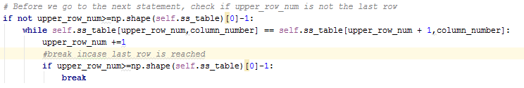

1. For the upper range of data which are not present in the excel sheet (E.g. monthly salary of 300000), it throws an error. We have put exception handling for this.
2. For the lower range of data which are not present in the excel sheet (E.g. monthly salary of 1000), it does the calculation incorrectly. This is in progress.