

# Course: Software Engineering

Assignment No. 4: Prepare a suitable cost es ma on model, WBS, Gan chart (using MS project tool), and all necessary estimations for your project

Prepared by:

1. Rahul Hiragond
2. Sakshi Chavan
3. Aditya Chaudhari
4. Shreeja Jiddewar
5. Vaibhav Mahangare
6. Dipak Mohite
7. Varun Khambayate

# Cost Estimation Model

1. Development Cost –

# Labour Costs:

Expenses for developers, designers, project managers, QA testers, etc., based on hourly rates or salaries.

# Technology Costs:

Expenses for development tools, so ware licenses,

frameworks, libraries, and development environments.

# Third-Party Services:

Costs for integrating third-party APIs, such as payment gateways and analysis platforms, vary depending on the specific requirements and services needed.

# Infrastructure Costs:

Hosting:

Expenses for cloud infrastructure providers.

# Database Costs:

Expenses for database services.

# Design and Content Costs: UI/UX Design:

Expenses for designing user interfaces, wireframes, prototypes, and design assets.

# Multimedia Content:

Costs for creating or sourcing videos, images,

animations, and interactive elements for courses.

# Content Development:

Expenses for developing course materials, coding exercises, quizzes, and assignments.

# Quality Assurance Costs: Testing Tools:

Expenses for testing tools and plat forms for manual and automated testing.

# QA Resources:

Costs for hiring QA testers or allocating resources for testing ac vi es and bug tracking.

# Operational Costs: Maintenance:

Ongoing expenses for so ware updates, bug fixes, server maintenance, and technical support.

# Customer Support:

Expenses for providing customer support services, such as helpdesk so ware and support staff salaries.

# Work Breakdown Structure (WBS)

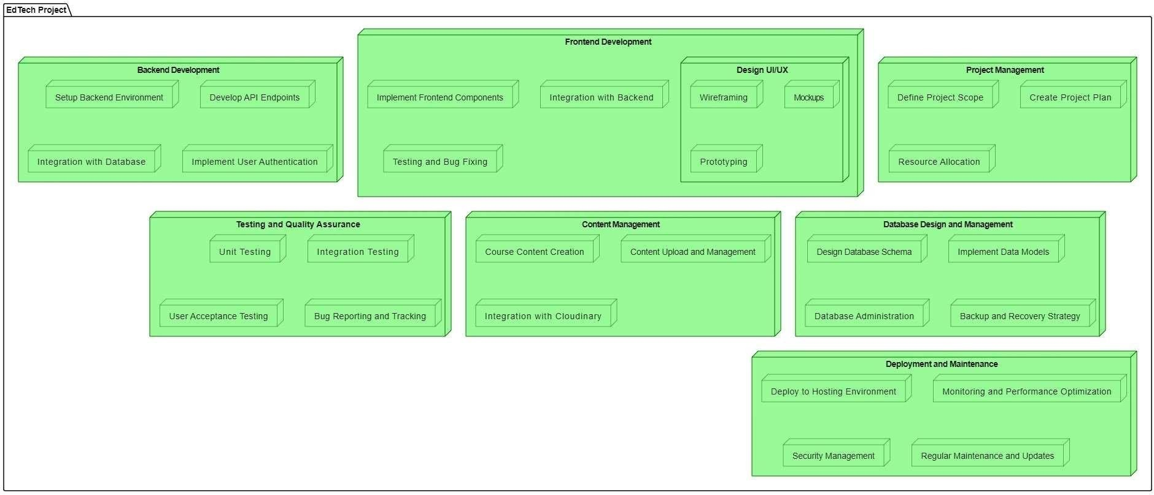

Fig: WBS for Study Notion

# Gan Chart

